
GUIDANCE FOR RESPIRATORY TRACT INFECTION [INCLUDING COVID–19]

Testing- Routine testing for COVID-19 on admission is no longer required.
- Only patients who are showing symptoms of respiratory infection should be tested.
- Any patient with symptoms of respiratory infection must be promptly isolated in bedrooms.
- Symptomatic patients should have a COVID-19 LFT, or a COVID-19 PCR for those symptomatic patients who are identified as clinically vulnerable and be medically reviewed.
- Ensure that all LFT (lateral flow tests) results are recorded in patients note on Rio.
- Staff are to wear FRSM or FFP3 mask (if wearing FFP3 mask ensure you have been fit tested) and other PPE based on risk assessment), when providing care to patient with respiratory symptoms.
- Inform the IPC team (elft.infectioncontrol@nhs.net) & Ward Manager/ service matron. for support and to confirm next steps

Positive LFD test result- If the patient tests positive for COVID-19;
- Maintain care in isolation for 10 days from the day of symptoms.
- Monitor their physical health frequently (4x daily) and escalate any signs of deterioration.
- They can end their isolation early on day 7, if they have 2 consecutive negative LFD results taken on day 6 and day 7, 24 hours apart.
- If any of these tests return a positive result, the patient must continue and complete 10 days isolation.

For symptomatic patients who test negative for COVID-19:
- Continue to maintain isolation.
- Perform a respiratory viral screen following discussion with assessing Doctor.
- Pathology form should detail a request for a full respiratory panel including Influenza A&B and RSV.
- The patient should remain in isolation until the result is confirmed.

Immuno-compromised positive patients- Negative but high-risk patients who are on a ward where a positive case/s are identified, must be encourage with protective isolation for their own protection from continuous exposure to the virus.

Positive Influenza result- For patients who test positive for Influenza, antiviral medicines should be considered for those in clinical risk groups as well as anyone at risk of severe illness or complications from influenza if not treated.
- For more information please refer to UKHSA https://www.gov.uk/government/publications/influenza-treatment-and-prophylaxis-using-anti-viral-agents/guidance-on-use-of-antiviral-agents-for-the-treatment-and-prophylaxis-of-seasonal-influenza

- Assessing doctors are to refer to local treatment protocols as appropriate.
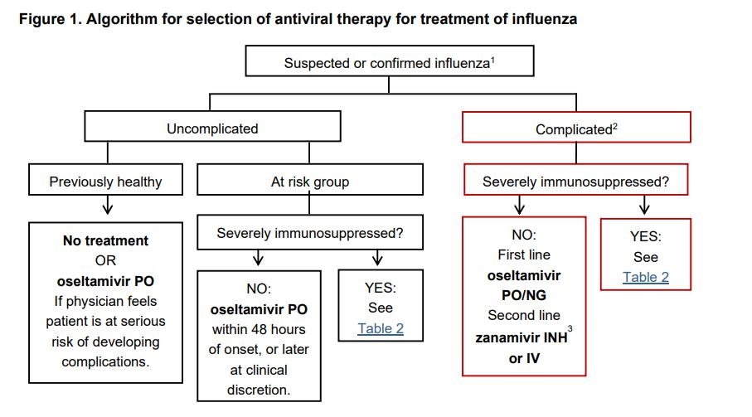

For all positive patients (COVID-19 & Influenza)-
- QDS observations [respirations, temperature, pulse] and consider sepsis screen and escalation as per NEWs score. Encourage patients to drink plenty of fluids.
- Those patients without en-suite facilities must be allocated a toilet for their sole use.
- Good respiratory hygiene must be encouraged, i.e. Use a disposable single use tissues to cover mouth and nose when coughing, sneezing, wiping or blowing noses; Dispose of tissues promptly and then wash hands.
- All linen of symptomatic patients must be double bagged i.e placed in red bags and then placed directly into a white laundry bag.
- Ensure their rooms and allocated toilets are prioritised for enhanced frequent cleaning [at least three time a day], focussing on frequently touched surfaces.
- Patients who are struggling with isolation are to be encouraged to wear mask when leaving room.
- Frequent escorted fresh air breaks can be offered to patients who have care in isolation.

Staff- routine testing by staff is no longer required- Staff who develop respiratory symptoms are to isolate form work for 5 days.

Further information on the management of COVID-19 and Respiratory illness please refer to ELFT Policies:

- Respiratory Policy Manual (Including COVID-19) https://www.elft.nhs.uk/system/files/2025-06/respiratory_infections_policy_6.0_.pdf

- IPC policy Manual
https://www.elft.nhs.uk/system/files/202506/infection_prevention_and_control_policy_manual_v13.pdf

Any further queries please contact the Infection Prevention and Control Team: elft.infectioncontrol@nhs.net

