
24hr Fluid Balance Chart
Purpose: To monitor a patient’s fluid intake and output to assess hydration status and detect fluid imbalance
TIME | FLUID INTAKE (ml)  Oral/Enteral/Subcutaneous/IV | FLUID OUTPUT (ml): Urine/Vomit/Faeces/Saliva | BALANCE (ml) -ve/+ve
00.00-01.00
01.00-02.00
02.00-03.00
03.00-04.00
04.00-05.00
05.00-06.00
06.00-07.00
07.00-08.00
08.00-09.00
09.00-10.00
10.00-11.00
11.00-12.00
12.00-13.00
13.00-14.00
14.00-15.00
15.00-16.00
16.00-17.00
17.00-18.00
18.00-19.00
19.00-20.00
20.00-21.00
21.00-22.00
22.00-23.00
23.00-00.00
TOTAL

Estimating Fluid Intake
Use below table to estimate oral intake, and use syringe readings for enteral:
1 cup | 250ml | 1 teaspoon 5ml
1 soup bowl | 350ml | 1 tablespoon 15ml
1 mug | 335ml | 1 can fizzy drink 330ml

Signs of Dehydration
Does the service user have hard stools?  (type 1-2) Yes or No  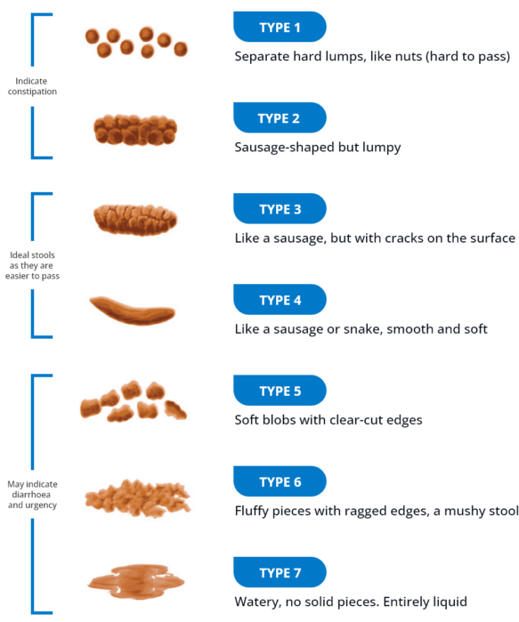 | Does the service user have dark urine?  (type 4 or more) Yes or No  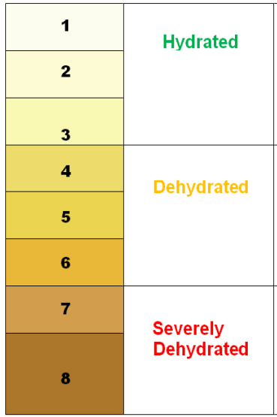
Does the service user have fluid losses? (sweating, diarrhoea, vomit)  Yes or No | Does the service user have fluid losses?(frequent urine output)  Yes or No

If YES to any of the above, and if no fluid restriction in place, encourage the person to take at least an additional 200 -300ml of water, three times over 24 hours, consider rehydration solution, and monitor signs regularly.

Comments:

