Preventing Dehydration
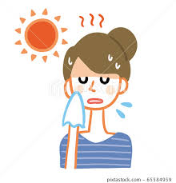 | What is Dehydration?  Dehydration is a harmful imbalance of fluid in the body, caused by not drinking enough, or excessive fluid losses.  Dehydration can be caused by difficulty swallowing, diarrhoea, vomit, feeling hot, not remembering to drink, diuretic medications
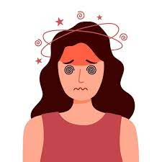 | Signs of dehydration include:  - dark urine  - dry mouth and cracked lips  - headache, dizziness and fatigue  - low blood pressure  - feeling thirsty and hungry
 | Impacts of dehydration  - delirium and reduced mental performance  - vomiting  - risk of falls and injury  - urinary tract infection  - hospitalization  - confusion, fainting
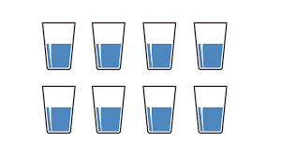 | Preventing Dehydration  Drink at least 8 full glasses of fluid daily, and more on hot days or if feeling unwell.  All fluids count, including still and sparkling water, juice, tea, milk.
 | Try decaffeinated tea, coffee and fizzy drinks, and choose no added sugar fluids instead of regular varieties.
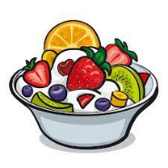 | Eat fluid-rich foods like fruits, vegetables, yoghurt, smoothies, custard, pudding, jelly, soups and stews.
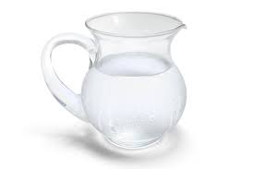 | Drink rehydration solution, made with 6 tbsp sugar, ½ tsp salt and 1L water. Sachets bought over the counter are also suitable.
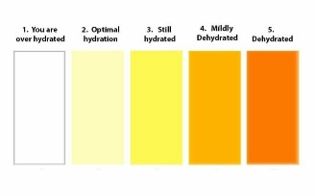 | Check urine colour, aiming for pale yellow, and monitor urine frequency. Set reminders to drink and ask for help.

