Dragon Medical One – Formatting

Formatting in Autotexts
1. Select Manage Autotext from the menu
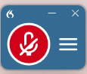
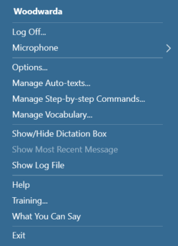

2. Click on the Blue ‘+’ icon to add an Autotext
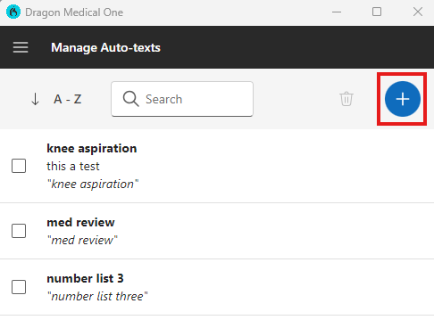

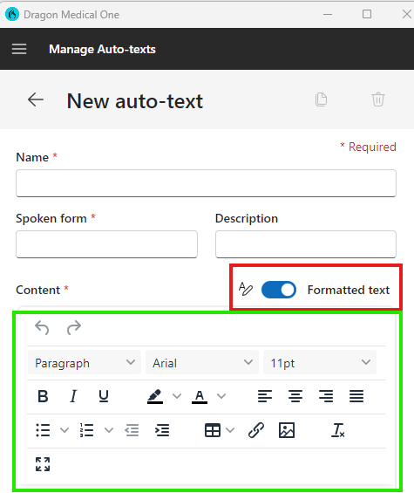
3. Toggle the ‘Formatted text’ switch to on.
4. You will observe the formatting options.
5. Complete all required fields, including Content.
6. Apply the desired formatting options.
7. Select Save to finalise your changes.

Formatting Rules in Dragon Medical One
Dragon Medical One has the ability to change formatting rules, i.e. Date format, Times formatting. To Locate these options navigate to the DMO ‘Manage Vocabulary’ found in the menu, then navigate to the ‘Hamburger’ icon, then select ‘Manage Formatting’

