

End of Life Care Policy

Version number: | 5.0
Consultation Groups | Clinical Policies Alignment committee  Mental Health Senior Nurses Group
Approved by (Sponsor Group) | Nursing Development Steering Group
Ratified by: | Quality Committee
Date ratified: | 23rd December 2025
Name of originator/author: | Lead Nurse for Palliative Care, Bedfordshire  Lead for End-of-Life Care, Tower Hamlets Interim Lead Nurse for Palliative Care, Bedfordshire
Executive Director lead: | Director of Nursing
Implementation Date: | December 2025
Last Review Date | December 2025
Next Review date: | December 2028

Services | Applicable
Trust wide | All services working with adults.
Mental Health & LD
Community Health Services

Version Control Summary

Version | Date | Author | Status | Comme nt
1.0 | 05/03/14 |  | Final
2.0 | 07/12/15 |  | Final
3.0 | 31/01/2020 |  | Final Approved – Chief Medical Officer
4.0 | 12/04/2023
5.0 | Dec 2025 |  | Final | Changes to this policy were made for operational clarity and to strengthen reporting processes to the Coroner’s Office

.
Members of ELFT Community Services Clinical Polices Alignment Group are:
- Caroline Ogunsola – Professional Development Nurse for Community Services - Convener
- Kikelomo Pinheiro Community Services Pharmacist – Bedfordshire
- Nike Bademosi – Lead Nurse – Tower Hamlets
- Fiona Davies – Clinical Lead – Tower Hamlets
- Chantal Riviera – Clinical Lead Newham
- Caroline White – Clinical Lead - Bedfordshire
- Juliette Fiore-Fuller – Deputy Lead Nurse, Newham
- Georgina Amparado – Molina – Clinical Lead Tower Hamlets
- Fatima Hafesji – Lead Pharacist – Tower Hamlets
- Davinder Kaur – Clinical Lead - Tower Hamlets
- Sharon Eplett – Head of Quality & Performance, Bedfordshire
- Rashida Goswami – In-Reach Team Lead, Tower Hamlets

Contents

Section | Heading | Page
1 | Introduction | 4
2 | Purpose of Guidance | 4
3 | Consent | 5
4 | Capacity | 5
5 | Identifying People approaching the End of Life and other people who are important to them | 5
6 | Co-ordination of Care | 6
7 | Advance Care Planning | 6
8 | Patients making a Will | 6
9 | Resuscitation | 7
10 | Identifying that someone is in the last days of life | 8
11 | Communication with patients at the end of life & their carers | 8
12 | Patient Centred Care Planning | 9
13 | Anticipatory Prescribing | 9
14 | Eating and Drinking in the Last Days of Life | 10
15 | Transfers to another Care Setting | 10
16 | Verification and Procedure for Expected Death | 10
17 | Informing Relatives when a Patient dies | 11
18 | Patients detained under the Mental Health Act & Mental Capacity Act (DoLs) | 11
19 | Care after Death | 12
20 | Registration of Death | 12
21 | Bereavement Support | 12
21 | Education, Development and Training | 12
22 | Related Documents | 13
23 | References | 14
Appendix
1 | Supportive & Palliative Care Indicators Tool | 15
2 | GSF – Prognostic Indicator Guidance | 16
3 | Priorities of Care for the Dying Person | 21
4 | Care After Death | 34
5 | Bereavement support organisations | 36

- Introduction

  - East London NHS Foundation Trust (The Trust) recognises the need to support standards and a programme of education for all staff to deliver high quality, compassionate care to service users who have an advanced life limiting illness in the community or in hospital and provide support to their carers.

1.2 This guidance is underpinned by the NICE Quality Standards (2011, updated 2021) End of Life Care for Adults, NICE Quality Standards (2017) Care of Adults in the Last Days of Life and NICE (2019) End of Life Care for Adults: Service Delivery.

It is also supported by NHS England (2021) Ambitions for Palliative and End of Life Care: A national framework for local action 2021 – 2026 and Hospice UK (2022) Care after Death: Guidance for staff.

The target audience for the policy is all staff working with adults in East London NHS Foundation Trust. Staff caring for young people should refer to separate guidance.

1.3 The tools to support this policy include:

1.3.1 The Gold Standards Framework (GSF) which:

- Identifies patients in the last year of life
- Assesses their care needs and preferences
- Develops a proactive plan of care

Further information about the GSF can be found on the Gold Standards Framework website.

1.3.2 The five priorities of care for the dying person set out in: One Chance to Get it Right:
- Recognise
- Communicate
- Involve
- Support
- Plan & Do

1.3.3 The Supportive & Palliative Care Indicators Tool (SPICT)

2.0 Purpose of Guidance

2.1 To give staff the confidence to recognise that a patient or service user is entering the last year of life and begin to plan their care accordingly.

2.2 To support staff to work with the wider integrated team to have conversations with patients who may be in the last year of life and to enable advance care planning.

2.3 To enable teams to work in partnership with specialist palliative care teams and other teams supporting patients at the end of life.

2.4 To support staff to develop person centered holistic care plans that ensure that symptoms are as controlled as possible and that consider the physical, psychological, spiritual, social and cultural end of life care needs of the patient.

2.5 To support patient choice at the end of life, including supporting patients to choose their preferred place to die as far as is reasonably possible.

2.6 To ensure that patients are treated with dignity and respect at the end of life.

2.7 To ensure that family, carers and others who are important to patients are supported, appropriately informed, enabled and empowered throughout the end of life of their relative or friend.

2.8 To improve staff confidence, communication and partnership working through the provision of standards of practice and education.

3 Consent

3.1 Patients have a fundamental legal and ethical right to determine what happens to them.
The practice of seeking consent is further endorsed by the requirements of the Human
Rights Act 1998.

3.2 The Trust’s Consent to Treatment Policy sets out standards and procedures that define consent as a patient’s agreement for a health professional to provide care.

3.3 Consent may be indicated non-verbally, orally or in writing for consent to be valid. It is essential that all healthcare professionals clearly document patient consent to interventions.

4 Capacity

4.1 The Trust has a duty to support people with impaired mental capacity so that they can make their own decisions about health and social care that they receive. People needing such support might include people with severe and enduring mental illness, people with dementia, people with learning disabilities and people at the end of a terminal condition.

4.2 Where an adult patient lacks the mental capacity (temporarily or permanently) to give or withhold consent for himself/ herself, no one else can give consent on their behalf unless there is an identified ‘Lasting Power of Attorney’ in relation to health matters as well as financial matters.

4.3 Treatment may be given if it is in the patients’ best interests as long as it has not been refused in a valid and applicable Advance Decision to Refuse Treatment (ADRT), as stipulated in the Mental Capacity Act (2005) Code of Practice. In determining best interests, any Advance Statements the patient has made (verbal or written) should be taken into account during the decision-making process. This must be clearly documented in the patient’s notes.

5. Identifying people approaching the end of life and other people who are important to them

5.1 In line with NICE guidelines and to enable advance care planning, teams should aim to identify patients who might be at risk of dying within the next 12 months. Patients or service users may be identified as likely to be in the last year of their life by any health care professional involved in their care.

5.2 Tools available to identify people who may be approaching the end of their lives include the Supportive & Palliative Care Indicators Tool (SPICT) [Appendix 1] and the Gold Standards Framework (GSF) Prognostic Indicator Guidance [Appendix 2].

5.3 Teams should also aim to identify carers and other people who are important to patients or service users who may be approaching the end of their lives. This may include children, partners, friends and other family members.

6. Co-ordination of Care

6.1 Care for people nearing the end of life should be well co-ordinated both within and across different services and organisations, and there should be an integrated approach to care planning.

6.2 Patients approaching the end of life should be added to the local palliative care register and be allocated a named nurse to lead on the co-ordination of the patient’s care.

6.3 Regular multi-disciplinary discussions should be held, including specialist palliative care teams. There should be regular reviews of advance care plans and of care and support needs.

6.4 With the consent of the person or if they lack capacity in their best interests, wishes around advance care planning should be recorded and shared with all those involved in their care.

6.5 In community settings discussions around advance care planning should be documented in the shared Universal Care Plan (UCP) or System one records where these exist or in emergency treatment plans such as ReSPECT or PACT.

7 Advance Care Planning

7.1 Patients approaching the end of life should be offered the opportunity to have an honest, informed and sensitive conversation about death and dying and to create a personalised advance care plan. Opportunities to talk about advance care planning and to review existing plans should be offered regularly.

7.2 Advance care plans should allow people to express their preferences for their future care and what matters to them most, including their preferred place of care and place of death. They might also include setting personal goals for the time that they have left.

7.3 Where the person approaching the end of life agrees, carers and other people who are important to them should also be offered the chance to be involved in the discussions around advance care planning.

7.4 Additional support should be sought where needed to support advance care planning for example for people with learning disabilities or dementia

7.5 Advance care planning may also involve setting up Lasting Power of Attorney, whereby someone appoints another person to make decisions on their behalf in the event that they lose their mental capacity in future. Lasting Power of Attorney must be registered with the Court of Protection and there must be valid documentation to show this.

7.6 Advance Decision involves clarifying any specific treatments that people may not want to receive in future. For example, someone may make an advanced decision to refuse to be ventilated or to have other life sustaining treatment. In order to be valid advanced decision may only be made by someone who has mental capacity.

8. Patients Making a Will

8.1 Patients wishing to make a will in community settings should be supported to do so, by referring on to local support services such as Age UK. If patients express a wish to make or alter a will whilst in in-patient settings, the team should seek advice from the Trust’s Mental Health Department.

8.2 For inpatient settings, the Responsible Clinician (RC) in charge of the patients medical care should sign and date in the patient’s records that the patient is capable of making a will (has mental capacity) and comment about the patient’s mental state and where there are any doubts about the patient’s ability to write a valid will.

8.3 Health care staff including non-clinical staff involved with a patient cannot act as witnesses for the signing of the will. Staff should be aware of the vulnerability of patients to pressure from those who might have an interest in the will.

9 Resuscitation

9.1 Considering whether or not to attempt CPR is an important part of good quality end of life care and advance care planning.

9.2 The DNACPR decision should be made on the basis of a careful assessment of the person’s individual situation. Where a patient is nearing the end of life and it is appropriate to consider a DNACPR decision, this should be done at the earliest possible opportunity.

9.3 The DNAPR decision should be made by the most senior clinician in charge of the patient’s care and discussed with the wider health care team. In community settings (such a district nursing) this will usually be the GP.

9.4 DNACPR decisions should be discussed with and explained to the patient and those close to them, and the opportunity to challenge the decision provided. Discussions about DNACPR may be sensitive and complex and should only be carried out by experienced clinical staff.

9.5 Where there is uncertainty about whether CPR is appropriate, resuscitation should be started straight away.

Please see Trust Decisions Relating to Cardiopulmonary Resuscitation Policy for further information.
10. Identifying that someone is in the Last Days of Life

10.1 In addition to identifying patients who may be approaching the end of life to enable advance care planning, teams should also aim to identify when someone may be entering the last days of their life or may die in the next few days or hours [Appendix 3 – Priorities of Care for the Dying Person]. This may not always be easy; however advice can be sought from the specialist palliative care team / palliative care nurses. Reversible causes such as opioid toxicity should be ruled out.

10.2 Signs & symptoms that could indicate that someone is in the last days of their life include:
- progressive weight loss, deterioration in consciousness, noisy respiratory secretions, mottled skin, agitation
- increased fatigue, reduced desire for food & fluid, deterioration in swallow
- deteriorating mobility & social withdrawal

10.3 Where it is felt that someone is in the last days of life, this should be discussed with the integrated team

11 Communication with Patients at the end of life and their Care rs

11.1 Where it is felt that someone may be in the last days of life, a discussion should be held with the patient and their carer and / or those who are important to them explaining the potential for dying and the rationale for this. The team should decide who may be best placed to have this discussion.

11.2 A person-centered, holistic care plan should be discussed with both the patient and those who are important to them. Patients should be offered the chance to be involved in all aspects of their care including their preferred place of care and place of death.

11.3 In order to support patients to participate in the decision making at end of life, information should be provided taking into account their communication needs and preferences.

11.4 Communication should be sensitive and appropriate to individual circumstances and preferences. Information should be offered including what to expect, medications including anticipatory prescribing, practical support available and care options.

11.5 The contact numbers of carers and others who are important to patients should be confirmed as well as who to contact if the patient’s health should deteriorate. In in-patient settings times for family or next of kin to be contacted should also be agreed and documented.

11.6 If patients are in a hospital setting, carers should be offered the opportunity to support their relatives / friends at all times if appropriate to the patient’s wishes. This should be supported by professional staff and overnight facilities provided in patient areas where possible.

12. Person Centered Care Planning

12.1 A holistic needs assessment should be carried out with the person approaching the end of life and those who are important to them, in order to enable the right support to be provided.

12.2 Where possible in order to support co-ordination of care and to reduce duplication, the holistic needs assessment should be completed with the patient and those who are important to them by the multi-disciplinary team. A person-centered care plan should then be agreed with the patient and shared with all those involved in the patient’s care.

12.3 The individualised care plan should be completed according to local protocol and may include communication, symptom control, psychological support, social support and spiritual support and care after death.

12.4 The care plan should manage physical pain and symptoms but should acknowledge that distress may be caused by or exacerbated by emotional or psychological anguish, social or spiritual distress.

12.5 The practical and emotional support needs of those who are important to the dying person / carers should also be assessed. Carers should be supported to access a carer’s needs assessment where applicable.

12.6 A Fast Track (Continuing Health Care) assessment should be also completed where appropriate in order to access urgent care support. In community settings patients and their families may be offered support from voluntary organisations such as Marie Curie.

12.7 Contact numbers for support services should be provided for patients and those who are important to them, including for out-of-hour support.
.

13. Anticipatory Prescribing

13.1 For patients at the end of life, it is important also to consider anticipatory prescribing as part of the care plan, explaining the rationale to the patient and family clearly. Medications should be prescribed in anticipation of symptoms to enable rapid relief if a patient develops distressing symptom. This should be documented in the patient’s electronic care record.

13.2 Medications should be prescribed based on the individual needs of the person. These should be prescribed in advance and as early as possible to avoid delay in obtaining medicines that may be needed quickly. Advice may be sought on what to prescribe from the Specialist Palliative Care team.

13.3 Prescriptions and authorisation charts should specify the indications for use of any anticipatory medication prescribed and the dosage, starting with the lowest effective dose.

13.4 If patients are not able to swallow or tolerate oral medication, subcutaneous injections should be given.

13.5 Where more than 2 or 3 doses of an as required medication are given in a 24 hour period, continuous medication via a syringe pump should be considered. If already on established dose of oral medications, predicted dose should be converted in collaboration with specialist palliative care.

14. Eating and Drinking in the Last Days of Life

14.1 It is common to lose interest in food in the last days of life and everyone with a terminal illness eventually stops eating and drinking. This is not usually distressing for the person who is dying however it can be very difficult for family and friends.

14.2 Family and friends often ask about artificial hydration for example subcutaneous fluids. For some conditions this may be an option however for other conditions at end of life there is no evidence that artificial hydration will either extend life or improve the quality of life.

14.2 Staff should explain to family that eating and drinking less in the last days of life is normal. Where the dying person and / or their family ask about subcutaneous fluids, this should be discussed with the multi-disciplinary team and the risks and benefits explained. (See Adminstration of Subcutaneous Fluids Policy for further guidance)

15 Transfers to another Care Setting e.g. Hospice

There may be instances when a patient’s needs are best met in another care setting, for example in a hospice, care home or acute hospital. Decisions such as these should be made at the earliest opportunity involving the patient and their carers and / or those who are important to them wherever possible. Trust staff will support continuity of care throughout the transfer process by providing a comprehensive handover of care and treatment to the receiving care team

16 Verification and Procedure for Expected De ath

16.1 When the patient is known to have an advanced, incurable terminal illness and there is no active intervention to prolong life, this is regarded as an expected death. An expected death is recognised as a death that was anticipated as imminent by the patient, carer and by the multidisciplinary team.

16.2 Verification of death refers to confirmation that life has ceased, based on a physical assessment by someone who is competent to do so. Death can only be verified by a doctor or nurse who has been trained in verification of death.

If a patient dies at home, their family or friends should be supported to contact the deceased patient’s GP, the out of hours service or a nurse able to carry out verification of expected death where relevant. The time the death is verified is the official time of death.

16.3 A registered medical practitioner who has attended a deceased person within the last 28 days prior to death is required to issue the Medical Certificate of the Cause of Death, stating the cause of death "to the best of his/her knowledge and belief".

The certificate requires the doctor to state the date on which they saw the deceased person alive and whether or not they have seen the body after death. The doctor is not obliged to view the body, but good practice requires that if they have any doubt about the fact of death, the doctor should satisfy themselves in this way

Patients identified as nearing the end of life i.e. a prognosis of weeks, should receive regular reviews from their GP to ensure that the above arrangements are met and to avoid any unnecessary delays after death.

16.4 Where a patient has not been seen by their GP within 28 days before their death, the death may need to be referred to the Coroner. Other circumstances where a death should be reported to the Coroner include: the cause of death is not known, the death was sudden or unexplained, the death was violent or unnatural, or the death may have been caused by an industrial disease.

16.5 All deaths of patients currently being seen by the Trust must be reported using the Trust incident reporting system (DATIX).

The deaths of any mental health patients discharged from the Trust’s care within the last 12 months should also be reported via DATIX. Additionally the death of any community health service patient discharged from our care within the last 6 months should also be reported.

17. Informing Relatives when a Patient dies

17.1 It is also important to consider if a patient’s next of kin or carer wishes to be contacted if the patient is noted to be deteriorating and to document this in the record. This is important in both hospital settings and in community settings where the patient may live alone. It should also be noted whether the carer or next of kin wishes to be contacted at night

17.2 If relatives or other key contacts are not present when the person dies, sensitive and honest communication should take place with them. Informing relatives of a patient’s death, can be very difficult and stressful for staff. Staff should receive training in the skills of breaking bad news and support as required after a patient dies.

17.3 In the event of the patient not having any known family or friends or that the family are unable to be with the dying patient, it is good practice for staff to contact someone able to provide spiritual support, such as the hospital chaplain or to make arrangements for a staff member to be with the patient. This would depend on the patient’s preferences if known.

17.4 If the named next of kin or carer cann ot be contacted after six hours staff should inform the police station local to the named relative. The police may be requested to call at the home and notify the next of kin/carer in person. Alternatively the police can leave a message asking the relatives to contact the hospital, home or community team.

17.5 If a third party is requested to contact the family, the nurse in charge must check with the third party (e.g. the police) to ensure that this communication has taken place.

17.6 It is noted that there will be occasions in both hospital and community settings where patients may die in sudden and unexpected ways. Staff may also be exposed to difficult and challenging deaths. In these instances it is important that staff are supported according to local protocols.

18 Patients Detained Under the Mental Health Act, Mental Capacity Act (DoLs) and Patients under the Care of the Forensic Directorate

18.1 If a patient is detained under the Mental Health Act (1983) at the time of death or subject to a Community Treatment Order, the Care Quality Commission (CQC) must be informed within 72 hours, as well as the relevant Trust Mental Health Act Administration Team. The Trust’s local Mental Health Law office should also be notified.

18.2 The death of a patient at the time that they are deprived of their liberty under the Mental Capacity Act 2005, is also the subject of a coroner’s investigation. This means that the person is considered to be ‘in state detention’ at the time of death if subject to a deprivation authorisation. In these circumstances, the coroner must be informed of the death as soon as possible.

Therefore, all staff caring for the deceased need to ensure they are familiar with deaths that require such a referral as this will facilitate the correct personal care and enable staff to prepare the family both for the potential delay in receiving the Medical Cause of Death certificate and the possibility of a post-mortem examination. Forms are usually completed by the team responsible for the deceased’s care. The Deprivation of Liberty Policy provides more detail as to the forms which are to be used.

19 Care after Death

19.1 Personal care after death in hospital settings (sometimes known as “last offices”) should be carried out by a Registered Nurse. Personal care after death in community settings may be undertaken by family or carers of the person who has died. However, community nurses should offer support with this if appropriate, especially if they are present when the person has died. Please see Appendix 4 on the Procedure for Personal care after Death.

19.2 Personal care after death may include washing and dressing the person who has died and removing medical aids such as syringe drivers and catheters. It is important always to ensure the privacy, dignity and respect of the person who has died.

19.3 Care after death also includes supporting the spiritual, religious and cultural wishes of the person as well as their family and carers.

19.4 Other aspects of care after death may include arranging the removal of equipment and supporting with the disposal of controlled drugs. (Please see Safe Management of Controlled Drugs in a Domiciliary Setting Policy for further guidance)

20. Registration of Death / Funerals

20.1 The relatives where possible, should arrange for the death to be registered. In order to do so, the relatives will need the Medical Certificate of Cause of Death which should be issued the next working day in hospital settings and can be obtained from the patient’s GP in community settings.

20.2 Relatives should be advised to register the death within 5 days and that funerals can only take place after the death is registered.

20.3 Where a person dies and they have no next of kin, or where their next of kin, family or friends are unable or unwilling to arrange a funeral, they are entitled to a public health funeral arranged by the local authority.

21 Supporting and caring for those who are important to the dying person, including bereavement support

21.1 Good palliative care also includes giving care and support to the families, friends, carers and all those who are important to the dying person. This includes good bereavement care.

21.2 Bereaved people should be offered support at the time of death, but may also need support on a longer term basis, as well as before the death.

21.3 Support for people dealing with bereavement may include:
- Preparing them for what to expect when the person dies
- Acknowledging that everybody grieves in a different way and there is no right or wrong.
- Answering any questions they may have about what happens next.
- Supporting with self care for example getting enough sleep, taking a walk, getting outside

21.4 While many people find that talking to friends and family is the main support they need, when grieving, other people may find they need more support. (Please see appendix 5 for national and local organisations providing bereavement support).

22 Education, Development and Training

22.1 Staff should have access to appropriate training and education around caring for patients and service users at the end of their lives, enabling patients to die in a place of their choice wherever possible. This should also include advanced communication skills training for core staff.

22.2 All staff have individual responsibility regarding their competency in the skills required to support patients with advanced life limiting illness and at end of life.

22.3 Team leads should ensure that this policy is disseminated to all staff and monitor its implementation.

22.4 Service leads must ensure that staff have access to appropriate training, and that team leaders are aware of their responsibility for the implementation of this policy.

22.5 Service leads should have strategies in place to support and nurture staff, so they are able to deliver compassionate care to patients at the end of their lives and those who are important to them.

22.6 Staff should be given time to debrief and reflect on end-of-life care, particularly when this has been emotionally challenging.

23 Related Operational Documents

- Advanced Decision to Refuse Treatment Policy
- Decisions Related to Cardiopulmonary Resuscitation Policy
- Health and Safety Policy
- Infection Control Manual
- Mental Capacity Act (2005) Code of Practice
- Physical Healthcare Policy
- Pressure Ulcer Prevention And Management – Clinical Practice Guideline
- Safeguarding Vulnerable Adults at Risk – Policy Guidance for Trust Staff
- Verification of Death local guidelines

24 References

Department of Health (2009) End of Life Care Strategy: quality markers and measures for end-of-life care.

Hospice UK (2022) Care after Death, Fourth Edition

Leadership Alliance for the Care of Dying People (2014) How quality care for all, now and for future generations.

NHS England (2021) Ambitions for Palliative and End of Life Care: a national framework for local action 2021 - 26

NICE (2018) Care and support for people growing older with learning disabilities

NICE (2018) Dementia: assessment, management and support for people living with dementia and their carers

NICE (2011, updated 2021) End of Life Care for Adults: Quality Standards

NICE (2019) End of Life Care for Adults: Service Delivery

NICE (2004) Improving Supportive and Palliative Care for Adults with Cancer

University of Edinburgh (2017) Supportive & Palliative Care Indicators Tool

The Royal Marsden Manual of Clinical Procedures; Care after Death (2020) Wiley-Blackwell

Appendix 1

Appendix 2
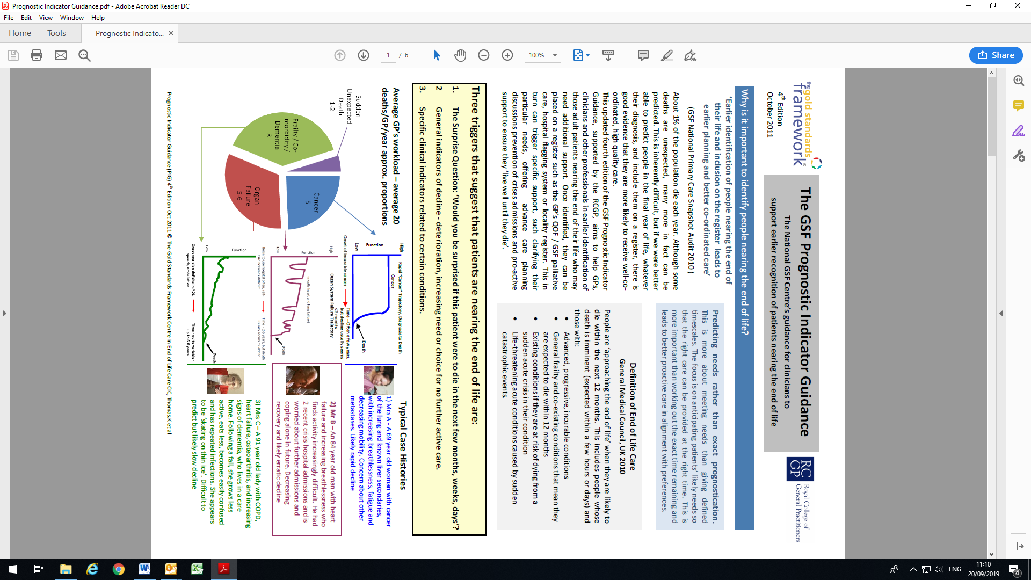
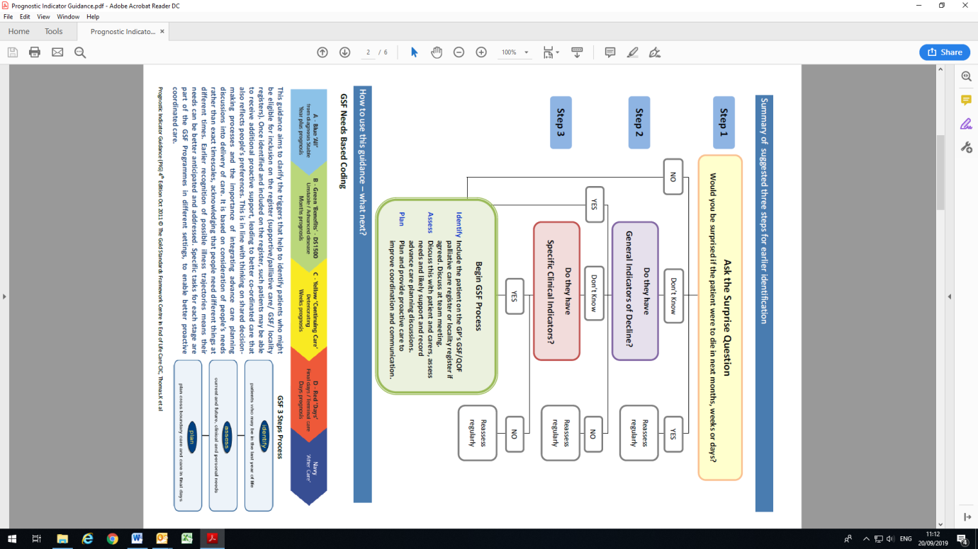
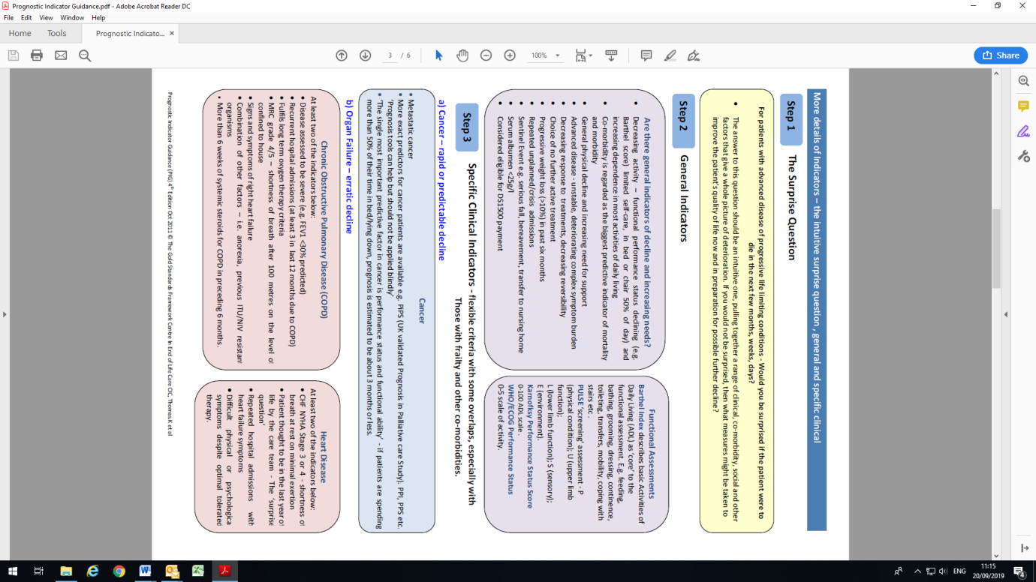
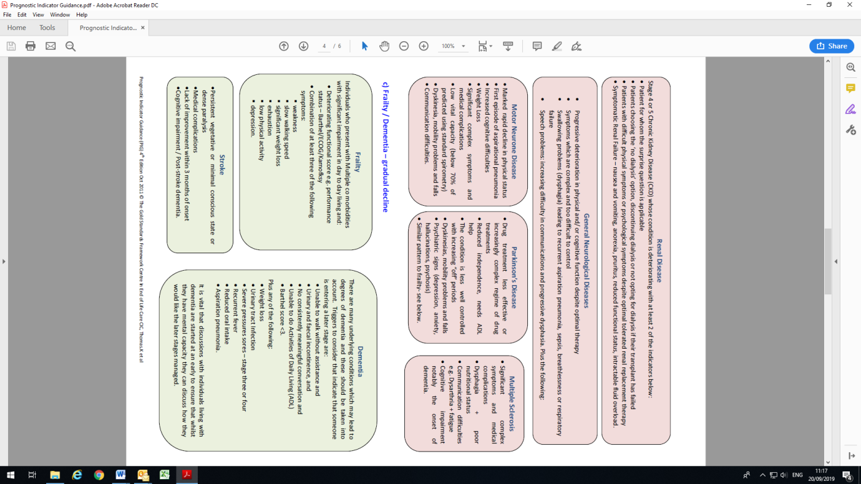


Appendix 3

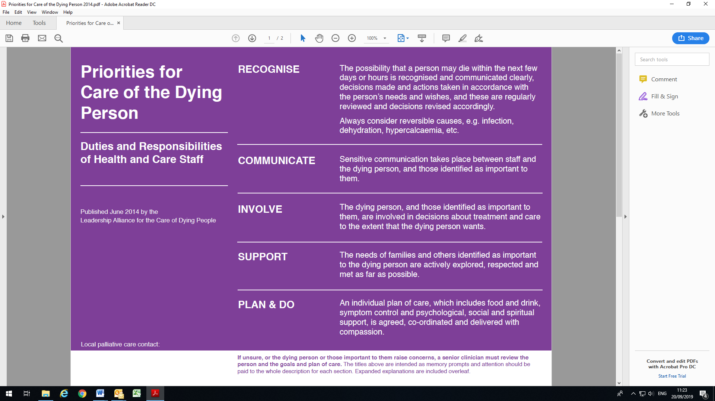
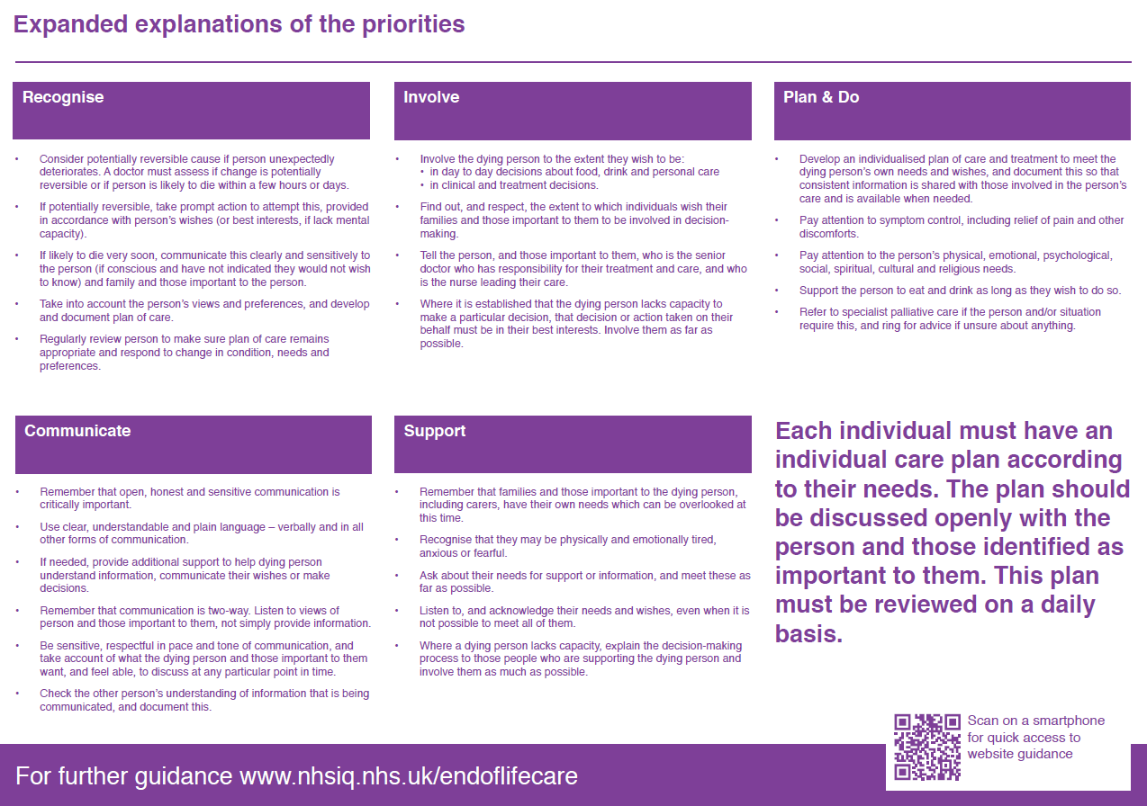

Personal Care After Death – Community Services
Appendix 4

A member of East London NHS Foundation Trust (ELFT) staff may attend the patient’s home if appropriate, for example to verify the death or to remove equipment.

During this visit the member of staff should offer to perform personal care if the patient’s family would like this.

Procedure | Rationale
Apply gloves and apron | Personal protective equipment (PPE) must be worn when performing Last Offices, and is used to protect yourself and all your patients from the risks of cross-infection (Fraise and Bradley 2009, E, HSAC 2003, C; Pratt et al. 2007, C, R2b; RCN 2005, C).
If the patient is on a pressure-relieving  mattress or device, leave the mattress running. | If the mattress deflates too quickly, it may cause a manual handling challenge to the nurses undertaking personal care after death
Lay the patient on their back with the assistance of additional nurses if required and straighten any limbs as far as possible (adhering to your own organisation's manual handling policy). | To maintain the patient's privacy and dignity  (NMC 2008, C) and for future nursing care of the body. Stiff, flexed limbs can be difficult to fit easily into a mortuary trolley, mortuary fridge or coffin and can cause additional distress to any carers who wish to view the body. However, if the patient's body cannot be straightened, force should not be used as this can be corrected by the funeral director (Green and Green 2006, E).
Remove any medical aids such as syringe drivers, heel pads and catheters once verification is complete. Apply gauze/tape to syringe driver sites and document disposal of medication (adhering to your own organisation’s disposal of medication policy.) Consider leaving prosthetics in situ as appropriate (e.g. limb, dental or breast prosthetics.) | To prepare the body for burial or cremation
Exuding wounds or unhealed surgical scars  should be covered with a clean absorbent dressing and secured with an occlusive dressing (e.g. Tegaderm). Stitches and clips should be left intact. Consider leaving intact recent surgical dressings for wounds that could potentially leak, for example large amputation wounds. Reinforcement of the dressing should be sufficient. | The dressing will absorb any leakage from the  wound site (Naylor et al. 2001, R2b). Open wounds and stomas pose a health hazard to staff coming into contact with the body (RCN 2005, C). Disturbing recent large surgical dressings may encourage seepage and leakage (Travis 2002,E).
Stomas should be covered with a clean bag.
Wash the patient, unless requested not to do  so for religious/cultural reasons or carer's preference. Male patients should be shaved unless they chose to wear a beard in life.  If shaving a man, apply water-based emollient cream to the face. | For hygienic and aesthetic reasons. As a mark  of respect and point of closure in the relationship between nurse and patient (Cooke 2000, C).
It may be important to family and carers to  assist with washing, thereby continuing to provide the care given in the period before death. | It is an expression of respect and affection, part  of the process of adjusting to loss and expressing grief (Berry and Griffie 2001, E).
Mouth and teeth should be cleaned with  foam sticks or a toothbrush. Insert clean dentures if the patient normally used them. Apply petroleum jelly to the lips and perioral area. | Teeth and mouth are cleaned for hygienic and  aesthetic reasons (Cooke 2000, C) and to remove debris. Petroleum jelly can prevent skin excoriation or corrosion if stomach contents aspirate.
Dress the patient in personal clothing provided by the family. | For aesthetic or religious and cultural reasons, and to meet the needs of the family. (Green and Green, C, 2006)
Remove gloves and apron. Dispose of equipment according to local policy and wash hands. | To minimise risk of cross-infection and contamination. (Fraise and Bradley, E, 2009)
Discuss with the patient’s family regarding contacting a chosen funeral director once verification has occurred. | To avoid decomposition which occurs rapidly,  particularly in hot weather and in overheated rooms. Many pathogenic organisms survive for some time after death and so decomposition of the patient's body may pose a health and safety hazard for those handling it ( Cooke 2000, E). Autolysis and growth of bacteria are delayed if the patient's body is cooled.
Remove all equipment from the patient’s home, including any syringe drivers and consumables.
Do not remove medication, advise the patient’s family to return these to a pharmacy.
Record all details and actions within the nursing documentation. | To record the time of death, names of those present, and names of those informed. (NMC, 2015)

Appendix 5

National bereavement support services

Age UK
Bereavement support for older people including carers. www.ageuk.org.uk

At a Loss
Support & signposting for all those who are bereaved:
www.ataloss.org

Child Bereavement UK
Support for children, young people, parents and families. 0800 02 888 40 or visit www.childbereavementuk.org

Cruse Bereavement Care
Support for all those who are bereaved - call for free on 0808 808 1677 or
visit www.cruse.org.uk

The Good Grief Trust
Run by people who have experienced a bereavement themselves: www.thegoodgrieftrust.org

Marie Curie
Support for all who are bereaved, including pre-bereavement – 0800 090 2309 or visit https://www.mariecurie.org.uk/help/support/bereavement

Macmillan
Advice and information if the person who died also had cancer. Visit www.macmillan.org.uk/cancer-information-and-support/supporting-someone/coping-with-bereavement.

Sudden
Support for those affected by a sudden death. 0800 2600 400 or visit www.sudden.org

Support after suicide
Support after suicide: supportaftersuicide.org.uk

Survivors of bereavement by suicide.
https://uksobs.org/

Winston’s Wish
Support for children and young people. www.winstonswish.org

Local bereavement support services
Adult Services

Cruse Bereavement Care – Bedford area
Tel 0300 200 4108 or email bedfordshire@cruse.org.uk

City and East London Bereavement Service (CELBS)
specialist bereavement service for residents of Tower Hamlets & the City.
Visit www.celebs.or.uk

Newham Bereavement Service
delivered by Mind for adults living in Newham. Visit www.mithn.org.uk
To make a referral call 0207 510 1081 or 0207 510 4268 or by emailing referral@mithn.org.uk.

NHS Talking Therapies (IAPT)
Offering psychological interventions for common mental health problems, such as anxiety, low mood. Self-referrals are welcomed and encouraged.
Newham: www.newhamtalkingtherapies.nhs.uk
or call: 020 8475 8080
Tower Hamlets: towerhamletstalkingtherapies.nhs.uk
or call: 020 8475 8080

Hospice Bereavement Services

Keech Hospice Care
Bereavement support for people in Bedfordshire
https://www.keech.org.uk/

St Joseph’s Hospice
Specialist bereavement support available where the person who died was under the care of the hospice. (East London) www.stjh.org.uk

Sue Ryder St John’s Hospice
Bereavement support for people in Bedfordshire
https://www.sueryder.org/how-we-can-help/sue-ryder-st-johns-hospice

Children’s Services

Child Bereavement UK East London
specialist bereavement service for children, young people & their families in East London. Visit londonsupport@childbereavementuk.org

CHUMS Bereavement Service
specialist bereavement service for children, young people & their families cross Luton & Bedfordshire. Visit chums.uk.com/bereavement-service

