

Policy for the safe and secure use of FP10 Prescriptions

Version number: | 5.0
Consultation Groups: | CHS Clinical Policies Alignment Group  Nursing Development Steering Group
Approved by (Sponsor Group): | Medicine Committee
Date approved | 10th September 2025
Ratified by: | Medicines Committee
Date ratified: | 10th September 2025
Name of originator/author: | Interim Deputy Chief Pharmacist, London  Lead Pharmacist, Newham CHS  Lead Pharmacist Tower Hamlets CHS  Professional Development Lead Nurse
Executive Director lead: | Chief Medical Director
Implementation Date: | September 2025
Last Review Date: | September 2025
Next Review date: | September 2028

Services | Applicable
Trustwide | 
Mental Health and LD
Community Health Services

Version Control Summary

Version | Date | Author | Status | Comment
1.0 | 19/08/15 | Manpreet Saini | Draft
2.0 | 08/06/16 | Andrea Okoloekwe | Final | Addition of audit process
3.0 | 25/07/18  12/11/18 | Chinedu Ogbuefi  Kikelomo Pinheiro | Final | Sec 5.5 - Addition of processes and procedures to follow when posting FP10 prescriptions in the mail in section  Appendix 4 - Addition of Bedfordshire CHS local procedure
4.0 | 08/11/22  03/02/23 | Chinedu Ogbuefi  Dawn McMahon |  | Removed references to CCG and added ICB  5.3 - Added records to be kept on receipt of prescriptions and updated storage responsibilities  5.4.1 Transporting or taking prescription stationery home  5.9 – Updated destruction and disposal of FP10s  4.6 – Ordering and collection of FP10s within CMHTs – detail of process added  4.7 – Ordering and collection of FP10s within CHS - amended structure  5.6 – Audits to be conducted quarterly in line with CFA guidance, previously annually  5.7 – Loss or theft of prescriptions, forged/altered prescriptions, duplicate/spoiled prescriptions – updated and restructured in line with CFA guidance  Key contacts added as annex A  Previous annexes A-E removed or updated in line with CFA guidance  Previous annex F & appendix 1 (BCHS local process) removed  Previous appendix 4 removed – covered in updated section 5.7 & annexes A-C
5.0 | 10.09.2025 Earlier review to support auditing requirements | Rajesh Jethwa | Final | Addition of Appendix 4 – Log for prescribers to record issue of prescriptions  Clarity around outpatient use of FP10 prescriptions  Minor amendements to appendix 2  Reference to datix – Replaced with Inphase  Addition of appendix 5 – Paper version of quarterly audit  Harvard style referencing

Contents

Table of Contents
Version Control Summary 3
1. INTRODUCTION 6
3. DEFINITIONS 6
4. DUTIES 6
5. MANAGEMENT OF FP10 PRESCRIPTION FORMS 8
UNDER NO CIRCUMSTANCES SHOULD A PRESCRIBER LEAVE SIGNED BLANK PRESCRIPTIONS FOR THE USE OF OTHER MEMBERS OF THEIR TEAM. 11
6. INFORMATION FOR PATIENTS 14
7. TRAINING 15
9. REFERENCES 16

Annexes
A | Key Contacts for Reporting Incidents Relating to FP10 Forms | 17
B | Incident Response Table | 18
C | Key responsibilities in incident investigations | 19
Appendices
Appendix 1 | Record of Receipt / Issue of FP10 (HP) forms | 20
Appendix 2 | Record of destruction of unwanted prescription pads | 21
Appendix 3 | Prescribing staff specimen signatures | 22
Appendix 4 | FP10 Prescriber issuance Log | 23
Appendix 5 | Quarterly audit tool | 24

INTRODUCTION

Prescribing for patients in community settings will often occur on FP10 prescription forms which can be taken by the patient to a community pharmacist for dispensing. Whilst the use of these prescription forms allows patients to choose which pharmacy they obtain their medication from, they are controlled stationary and therefore must be managed safely and securely. Inappropriate use may also have a financial impact on the Trust.

The Trust has to pay for the cost of the drugs plus a dispensing fee if a prescription is issued from one of its services. The exception to this are if prescriptions are written by a non-medical prescriber from any of the Community Health Services (CHS) in London or Bedfordshire such as a District Nurse, Tissue Viability Nurse, Community Matron and Health Visitors or services such as West Ham Lane Clinic which have their own remuneration set up with their respective Integrated Care Board (ICB).

These prescription forms are controlled stationery because stolen or counterfeit prescription forms may be used to obtain drugs of abuse and other items at considerable cost to the NHS. There are a number of different types of FP10s that are used, for further advice and guidance contact a member of pharmacy staff.

- PURPOSE

- To ensure that patients in need of immediate treatment can be issued with a prescription that can be taken to a community pharmacy of their choice.
- To ensure a secure system is in place for the ordering, storage and use of FP10 prescription pads.
- To provide clarity on governance processes related to FP10 forms and maintain consistency across service areas.
- For audit purposes.

DEFINITIONS

ELFT - East London NHS Foundation Trust
CMHT – Community Mental Health Teams
ICB - Integrated Care Board
CHS – Community Health Services
CHN – Community Health Newham
BCHS – Bedfordshire Community Health Services
THCHS – Tower Hamlets Community Health Services
FP10PN - Prescription pad used by Community Nurse Prescribers
FP10-HNC - Prescription pad used by outpatient services
FP10 MDA - Prescription pads used for instalment prescribing of drugs of addiction
FP10SS - Prescription pads used by GPs and other Independent prescribers, generated by computer
NMP – Non-medical prescribing/prescriber

Within the policy, the term FP10 covers all types of prescriptions written by prescribers within ELFT and given to patients, who may then present them at a community pharmacy.

DUTIES

The Medicines Committee
Will approve and ratify the policy prior to being made available on the ELFT intranet website.

Prescribers
- Will only use the FP10 pads in the situations stated.
- Will return any pads they have at the end of the clinic/day for secure storage.
- Will sign for any individual pads they receive and return any that they no longer require to their manager who will then pass the unused part or whole prescription pads to the, local ELFT pharmacy office as appropriate
- When they leave the Trust, will ensure any pads in their possession are returned to their manager who will then pass the unused part or whole prescription pads to the llocal ELFT pharmacy office as appropriate
- Are responsible for the safekeeping of any prescriptions in their possession.
- Must ensure a record is kept of all prescriptions that they issue and what they write on patient’s records (See section 5.3).
- Report any missing prescriptions immediately (See section 5.7).
- Adhere to this policy.

Line managers of NMPs
Must inform the NMP lead of prescribers under their management who will be leaving and those who have left the Trust. This will allow NMP registers to be kept up-to-date, and ensure NMP lead is aware of pads that should be returned.
- Ensure prescribers have completed all necessary competencies prior to FP10s being requested.
- Refer to NMP policy for further details.

Team/Service Managers
Where the individual prescriber is not specifically named on the prescription pad, for example in a CMHT setting, the team/service manager shall be responsible for:
- Appointing a nominated person and deputy for the ordering, storage and issuing of the prescription pads within the team.
- Ensuring that this policy is followed.

ELFT Pharmacy (excludes CHS)
- Will issue pads on receipt of the required form
- Will maintain a central register of managers/team leaders and the post of the nominated person for each team that holds FP10s

  - Nominated persons for ordering of prescription pads, and ELFT Pharmacy (for CMHTs)

Ordering of FP10s
- Directorate pharmacy teams keep a stock of FP10s for CMHTs and replenish those once the numbers are low by ordering via Pharmacy Procurement. Records are kept of FP10 pads ordered and received as per appendix 1.
- Nominated person within CMHT sends a request via relevant Pharmacy team’s generic email inbox, stating the name of the team and the number of FP10s required.
- Pharmacy Technician or Assistant Technical Officer (ATO) undertakes checks to ensure the request is from the nominated person or deputy, then prepares the FP10s ready to be picked up.
- Pharmacy Technician/ATO contacts team via email to make them aware that FP10s are ready and arrange a pick up date.

Collection of FP10s
- London CMHTs: Nominated person within CMHT picks up FP10 prescriptions from directorate pharmacy office and signs relevant paperwork (appendix 1).
- Luton & Bedfordshire CMHTs: FP10s are collected from Pharmacy by G4S drivers and delivered to the relevant team, with confirmation returned on receipt. A local SOP is in place for this process which is managed by the directorate Pharmacy team.

Non-Medical Prescribing Lead and CHS Pharmacy Lead (for CHS)

Ordering of FP10s
- Non-medical prescribers (NMPs) to email request to CHS Pharmacy Lead or their nominated deputy. A record of the names and roles of nominated deputies will be kept by the NMP lead.
- On receipt of email request, CHS Pharmacy Lead or nominated deputy will carry out necessary assurance checks and order prescriptions. For THCHS and CHN, Pharmacy Leads/nominated deputies will liaise with Pharmacy Procurement Lead to order.
- Pharmacy Lead is responsible for the local NMP register ensuring quarterly review, update and sharing with NMP lead.
- Non-medical prescribing lead will maintain a central register of all non-medical prescribers in the service.

Collection of FP10s
- CHN and BCHS: FP10 prescription pads will be delivered to locality team for collection by NMPs or nominated administrative officer.
- THCHS: FP10 prescription pads will be delivered to Mile End dispensary for collection by NMPs.

MANAGEMENT OF FP10 PRESCRIPTION FORMS

Use of FP10 forms

It is expected that the hospital consultant/specialist service clinician should provide a prescription during the out patient consultation in the following circumstances
- The clinical responsibility for prescribing should remain with the consultant/specialist services clinician
- When a new medication is started or when changes are made to existing medications

For outpatient attendance, the patient should receive a 28 day supply of medication or the nearest pack (unless another clinically indicated amount is neccesary

Where the care of the patient is maintained by ELFT services, FP10 prescriptions may be used e.g. during the initial stabilisation period for medication subject to shared care arrangements or for hospital only medications.

If applicable, medical prescribers must prescribe using team prescription pads or the computer prescriptions in accordance with local formularies. Non-medical prescribers must prescribe using their personalised prescription pads for patients on their caseload according to their scope of practice, competency and role and within local formularies. Please refer to the ELFT Non-Medical Prescribing policy.

Prescribing on FP10 forms
FP10 forms must not be used to prescribe for inpatients or discharge patients. The only exception to this is where patients require urgent medication after prescribers have left the premises and Mile End Pharmacy do not stock the item for immediate dispensing.
- FP10 forms must not be used to prescribe for private patients.
- FP10 forms must not be used for hospital staff or their families unless they are under the care of ELFT with an identifiable consultant.
- Medicines should be prescribed generically where possible, unless branded prescribing is recommended as per ICB medicines management recommendations. This will enable community pharmacists to dispense any available product thereby saving delay to the patient and expense to the NHS.
- Generally, no more than 28 days supply shall be prescribed except where overdose risk has been identified in which case the quantity to be supplied will be limited, pack sizes are limited, or patient requirements dictate longer supplies.
- When considering the quantity to be prescribed, prescribers should consider the risks to the patient of self-harm or the risk of diversion of the prescribed item and if there is deemed to be a risk in either of these areas, smaller supplies e.g. 7 days should be prescribed.
- A contact telephone number must be included on the FP10 in case the community pharmacist needs to contact the prescriber.
- Prescribers issuing prescriptions charged to the ICS need to include the ICS prescribing code (if not already pre-printed).
- Prescribers must document in the patient record what has been prescribed (including the quantity). This may be facilitated by scanning a copy of the FP10 into the patient record.
- Within Community Mental Health Teams, FP10s should not be routinely used to supply repeat medication supplies that should be obtained via the patients GP. Where it is felt clinically necessary to supply repeat medication, in an emergency only a small quantity of medication should be prescribed and the patient supported in obtaining further supplies via the GP.

Ordering, storage and access to FP10
FP10 prescriptions are "controlled stationery" with street monetary value. It is subject to theft and misuse as they can be used to obtain medications illegally. In order to ensure security of FP10 prescription forms, the following processes must be followed:
- FP10s are ordered from pharmacy for ELFT’s services and will ensure the secure storage until re-distribution.
- For CMHTs, nominated persons in liaison with Pharmacy order prescription pads using required documentation as appropriate – see section 4.6.
- For CHS, the NMP lead in liaison with Pharmacy lead orders prescription pads using the required documentation as appropriate – see section 4.7.
- A record will be kept of stocks of prescription forms that are delivered and stored. These records will be kept at each stage of the delivery process, e.g. by Pharmacy and for CHS, by locality executive assistant. The following information should be recorded on a stock control system:
  - Date of delivery
  - Name of the person accepting delivery
  - What has been received (quantity and serial numbers)
  - Where it is being stored
  - When it was issued
  - Who issued the prescription forms
  - To whom they were issued
  - The number of prescriptions issued
  - Details of prescriber
  - Serial numbers of prescriptions issued
- ELFT services and TH CHS staff prescriptions shall be collected from Mile End Pharmacy and be signed for using the relevant paperwork by the providing pharmacy.
- For CHS staff in Newham and Bedford, prescription pads must be collected from the Locality Executive Assistant.
- When not in use they must be stored in a locked cupboard, drawer or safe. Access to this must be restricted to those responsible for prescription forms. Keys or access rights should be controlled and an authorisation procedure implemented that includes details of those allowed access. This should allow a full audit trail in the event of any security incident.
- Prescribers are responsible for the security of prescription forms once issued to them and should ensure that they are locked away securely when not in use and never left unattended. Prescribers must keep a record of the serial numbers of prescription forms issued to them and relevant information on issuance to patient by completing the FP10 Prescriber issuance log (appendix 4). This will help to identify any prescriptions lost or stolen.
- Only prescriptions issued to a particular individual or team may be used by that individual or clinical team.
- The pharmacy team will be responsible for ordering sufficient quantities of all prescription pads for ELFT’s services and will ensure the secure storage until re-distribution. Each team is assigned their own code which will be the Trust code RWK, followed by two further letters and this code should be used when ordering a supply.
- Community Health Services codes may vary due to the set up with local ICS. This code will appear already printed on the FP10 pads. Some services that use computer generated prescriptions may receive prescription forms that may not have these codes on them and thus will have to ensure that the correct code is printed onto the prescriptions for each prescription that they produce for a patient.
- The pharmacy lead in respective services should be notified of any changes to the name of the team, address or telephone number as far in advance as possible.

Redistribution of FP10 Prescriptions
  - All FP10 prescription pads, whatever the order point, have to be delivered to a nominated delivery point within the Trust from the printers. Until re-distributed or collected, the pads will be stored in a locked cabinet.
  - The delivery will be checked against the original order(s) and the delivery note. The pads will be repackaged for each team and an email will be sent to the nominated person within the team to notify them of the delivery. The pads should then be collected and signed for by an authorised individual.

Collection of FP10 Prescriptions by Authorised Personnel
  - Only authorised personnel will be eligible to collect prescription pads in their own or team name from the pharmacy or designated collection point. In all cases the person collecting the prescriptions must have with them proof of identity in the form of a Trust security badge or be known personally to the staff involved in issuing the prescriptions.
  - All issues must be recorded at the designated collection points. The record must have the following data as a minimum:
    - The unique numbers of the prescriptions released
    - The team/prescriber code on the prescriptions
    - The date released
    - The name of the prescriber/team to which the pad is being allocated
    - The signature and printed name of the person collecting the prescriptions
    - The signature of the person issuing the prescriptions
    - This record should be kept for a minimum of five years.

Issuing of prescription pads that do not identify the individual prescriber
  - Each team/service manager shall be responsible for ordering or appointing a nominated person and deputy for the ordering, storage and issuing of the prescription pads.
  - A prescriber must also ensure that any unused prescription pads are returned when a prescriber leaves the Trust. These shall be recorded prior to the pads being reissued, or returned to pharmacy if no longer required. For prescribers with
personalised prescription pads, unused pads must be returned to their line managers/team managers for onwards referral to the local pharmacy team

Where each prescriber within the team is issued with a pad of prescriptions
  - A signed record that prescribers have read and understood the policy and a record of pads supplied shall be made.
  - The prescriber is responsible for the security of the pad at all times and must ensure the pad is stored in a locked cupboard, drawer or safe. Access to this must be restricted to authorised personnel only.
  - The prescriber shall keep a record of all prescriptions issued. This shall be kept separately from the prescription pad. Details to be recorded include date, prescription number, NHS number and name of prescriber. The prescription number is required in case the pad is lost or stolen.

Where a single prescription pad is shared between team prescribers
  - Prescribers may be issued with one or more prescriptions at a time.
  - A record will be kept indicating that all prescribers have read and understood this policy.
  - A record of all prescriptions issued to each prescriber will also be kept to include details of prescriptions written or returned to stock.
  - At the end of the clinic, any prescription issued to a prescriber but not used must be returned to the nominated person.

Security of Pads in Community Teams
It is the responsibility of each individual issued with a prescription pad to keep it secure at all times. Loss of a pad will lead to significant inconvenience to the team, possible misuse and additional costs to the Trust. When blank FP10s are given to a prescriber or a team, that prescriber or team manager (respectively) are responsible for the security of the prescription forms and to ensure that all staff who handle them use them correctly and understand their responsibility.

    - Transporting and Taking Prescription Stationery Home
- Teams that work across many sites, visit patients at home or cover a large geographical area will need to transport prescriptions and may need to take them home at the end of the day.
- Prescribers working in the community should take suitable precautions to prevent the loss or theft of prescriptions such as ensuring prescription pads are carried in an unidentifiable lockable carrying case and out of sight in a vehicle (e.g. glove compartment or boot).
- Only a small number of prescriptions should be transported based on the days’ anticipated workload to minimise loss.
- Staff should record the serial numbers of prescriptions that they are carrying.
- As far as possible, prescriptions should not be left unattended in a vehicle, they should be stored out of sight in a locked compartment and the vehicle should be fitted with an alarm.
- At the end of the shift, FP10 pads should be returned to the respective ELFT service, however in exceptional circumstances or if service needs necessitates, the prescription pad may be taken home. The prescriptions should be stored in a safe and secure location in the house and must be returned back to base the next working day. Prescriptions must not be left in the car overnight.

UNDER NO CIRCUMSTANCES SHOULD A PRESCRIBER LEAVE SIGNED BLANK PRESCRIPTIONS FOR THE USE OF OTHER MEMBERS OF THEIR TEAM.

Access to FP10s must be controlled and all those with access must be made aware of the need for security. In addition, a system must be put in place to record serial numbers of the forms received and issued. This is essential to ensure that if a pad is stolen or lost the serial numbers of the remaining prescriptions can be notified to the appropriate authorities.

It is essential that pads are not left unattended, pre-signed or stored unlocked in a public building when not in the possession of the prescriber.

  - Prescriptions posted in the mail

The preferred and safest options for patients to obtain a signed prescription form from their prescriber are face to face during the consultation or collected on their behalf by a named representative such as the care coordinator.

Using any of these options reduces the opportunity for fraudulent activity to occur involving a genuine prescription form. However, sometimes none of these options is suitable to patients and some teams post signed prescription forms to patients at their home address or directly to their nominated pharmacy.

A signed prescription form from a legitimate prescriber with all the relevant information brings to mind the potential risks in the event that a posted signed prescription form does not reach the legitimate recipient. The risks are greater if the prescription is for Controlled Drugs (CDs), therefore it is recommended that these types of prescription forms are not posted and alternative arrangements are made to ensure the patient receives the medication. This can include arrangements with the patient’s local pharmacy service.

When posting prescriptions to patients using the mail service, it is vital that this option is used only in exceptional circumstances following a risk assessment. This should include a process with established checks, to ensure as far as possible that the prescriptions actually reach the intended recipient(s). Therefore, if signed prescription forms are sent in the post to patients, a number of precautions should be taken to ensure it is delivered and dispensed to the legitimate patient. These may include, but are not limited to:
- Checking that the patient address is up to date
- Considering if there are known individuals at the patient address with substance misuse issues
- Keeping records of the date the prescription form was posted, name and address of recipient, expected delivery date and items prescribed/dosages/amounts
- Discreet information on external envelope/packing so that the item is not easily identified
- Return address if the item cannot be delivered
- Using a postal service with tracking information
- Getting the item signed for at point of delivery to ensure it can be traced in the event it has not been received by the intended recipient
- Reconciliation checks to ensure that the patient did receive the prescription form
- Escalation and reporting actions for staff in the event the patient reports non-receipt of the prescription form

  - Audit of FP10 prescription pads
Quarterly audit to be carried out by the Team clinical lead using Inphase platform to account for the movement, security, use or destruction of FP10s. Audit results should be forwarded to the locality Lead Pharmacist. See appendix 5 (Paper version of audit)

Incidents relating to security of FP10 prescription forms

Loss or theft of FP10 prescriptions
As there is the possibility that an attempt could be made to forge prescriptions, in the event of a pad being stolen, or misplaced and not found within a reasonable time, the team/service manager/chief pharmacist must be informed, and appropriate steps must be taken as per NHS CFA guidance – see annex B. Details of key contacts are available in annex A.

- When it is relevant to contact the police (as per annex B), contact the local police station and provide the following details:
- The number of prescriptions missing
- The serial number of the prescriptions missing
- The details at the bottom of the prescriptions
- The date, the time and the place of the incident if known.
- The team name, address and the Trust identification number as printed on the prescription
- If there is some uncertainty about the serial numbers involved or the Trust identification number, contact the department supplying the pads at the earliest opportunity
- Full details of the circumstance i.e. location, time last seen, evidence of a break in, etc.
- Obtain a crime or incident number

- In accordance with annex B, incidents must be reported using the organisation’s incident reporting system, Inphase. Any theft or loss report must include the following details:
  - Date and Time of loss/theft
  - Date and Time of reporting loss/theft
  - Place where loss/theft occurred
  - Type of prescription stationery
  - Serial numbers
  - Quantity
  - Details of local police station to whom the incident has been reported

- In accordance with annexes A & B, the Chief Pharmacist or, in their absence, the Deputy Chief Pharmacist must be contacted in their role as the person with overall responsibility for prescription forms at the organisation.
- They will contact NHS Shared Business Services who will activate the stolen FP10 protocol with local and neighbouring ICB (Newham, Tower Hamlets, City and Hackney, Barking and Dagenham, Redbridge and Havering and Bedfordshire and Luton ).
- Further communications will be made from NHS Shared Business Services who may also recommend writing prescriptions in a different ink colour for a period of time until the risk of rogue prescription presentation at community pharmacies has lowered.

    - Forged prescriptions/ unauthorised alterations

If there are any signs of alteration not authorised by the prescriber (i.e. initialled and dated), the dispensing chemist should contact the prescriber to confirm authenticity of the prescription via telephone.

If a forgery or unauthorised alteration is confirmed, the following details of the caller should be recorded by the person taking the call:
- Name of caller and contact number
- Name and address of pharmacy
- Details of prescription and date of issue

A trust incident report must be completed on Inphase. Further guidance on forged prescriptions is available via the General Pharmaceutical Council at www.pharmacyregulation.org. See annex B for further information on who should be contacted.

    - Duplicate and spoiled prescriptions

If a duplicate prescription is accidentally written or if an error is made on a prescription, best practice is for the prescriber to do one of the following:
- Put a line through the script and write ‘spoiled’ on the form, signed and dated by the prescriber
- Cross out the error, sign and date the error then write the correct information

There may be reasons for a prescription to be deemed spoilt other than error. Rather than just destroying or returning these forms, best practice is to retain them securely for local auditing purposes for at least 2 weeks before destruction. See appendix 2 for destruction log.

5.8 Return of FP10 Prescriptions on Termination of Employment

During the notice period leading to termination of employment or a change of team, all prescribers have a responsibility to return any unused prescriptions to their local supply point. This department must record, against the original issue record, the number of individual prescriptions returned along with their unique number and the date they were returned.

In the unlikely event that a prescriber only discovers they have some prescriptions in their possession after leaving the area they must phone the appropriate department to notify them of the prescriptions they have and then destroy them. The department must make a record of the phone call and record the number of individual prescriptions that will be destroyed, along with their unique number and the date the department was notified.

5.9. Destruction and Disposal

New prescription forms should not be issued to prescribers who have left or moved employment or who have been suspended from prescribing duties, and all unused prescription forms relating to that prescriber should be recovered and securely destroyed. The person responsible for the recovery and destruction of forms should be in a position of suitable seniority.
This will require liaison within NHS England and subsequently NHS Business Services Authority Prescription Services (NHSBSAPS) to ensure suppliers of the forms are aware of prescriber changes. In the case of personalised forms, suppliers will reject order details that do not match the data supplied by the NHSBSAPS. The individual responsible for distributing prescription forms should regularly check the list of authorised prescribers with the NMP lead to ensure that records are up to date.

Prescription forms which are no longer in use (including where the prescriber has left the Trust) should be securely destroyed (e.g. by shredding) before being put into confidential waste, with appropriate records kept. The person who destroys the forms should make a record of the serial number of the forms destroyed. Best practice would be to retain these prescription forms for local auditing purposes for a short period prior to destruction. The destruction of the forms should be witnessed by another member of staff. Records of forms destroyed should be kept for at least 3 years.

5.9.1 Destruction of used FP10 prescriptions
On the occasion a prescription is written for a patient, but this prescription is not collected and therefore is no longer required. In this scenario, a note should be made on electronic clinical records detailing:
- Date on prescription
- Prescription serial number
- Name, strength and quantity of medication
- Statement that the prescription was destroyed following non-collection
The prescription should be marked as void, and a copy should be scanned and uploaded to the patient’s record on electronic clinical records . The prescription should then be shredded as confidential waste. See appendix 2 for more information

INFORMATION FOR PATIENTS

Clinic staff/prescribers should explain to outpatients that the FP10 prescription should be taken to a community pharmacy for dispensing.

TRAINING

Mandatory Training
There is no mandatory training associated with this policy.

Specific Training not covered by Mandatory Training
There is no specific training that is not covered by mandatory training.

RELATED TRUST POLICY
- Non-Medical Prescribing policy
- Incident reporting policy

REFERENCES

    - NHS Counter Fraud Authority (NHSCFA) (2018) Management and control of prescription forms: A guide for prescribers and health organisations. Version 1.0. [online] Available at: https://cfa.nhs.uk/resources/downloads/guidance/Management_and_control_of_prescription_forms_v1.0_March_2018.pdf [Accessed 7 Aug. 2025].

    - Northamptonshire Healthcare NHS Foundation Trust (2012) Policy for the use of FP10 prescription forms. Internal document. Northampton: NHFT.

    - East London NHS Foundation Trust (2022) Non-Medical Prescribing Policy. [online] Available at: https://www.elft.nhs.uk/sites/default/files/2022-01/da3725_appendix_8_da3725.pdf [Accessed 7 Aug. 2025].

    - Sussex Partnership NHS Foundation Trust (2009) Handling FP10 in Substance Misuse Teams. . Sussex: SPFT

    - Kent and Medway NHS & Social Care Partnership Trust (2009) Use of FP10 Prescription Pads Procedure. Internal policy document. Kent: KMPT.

    - Leicestershire Partnership NHS Trust (2023) Secure Handling and Storage of Prescription Stationery Policy. Version 3.0. [online] Available at: https://www.leicspart.nhs.uk/wp-content/uploads/2023/09/Secure-Handling-and-Storage-of-Prescription-Stationery-Policy_exp-Sept-26.pdf [Accessed 7 Aug. 2025].

    - Camden and Islington NHS Foundation Trust (2019) FP10 HNC Prescription Policy

    - East London NHS Foundation Trust & Bedfordshire, Luton and Milton Keynes Integrated Care Board. (2025). Prescribing Specification: Mental Health Services 2025/26. Final version.

Annex A – Key Contacts for Reporting Incidents Relating to FP10 Forms

Designated person with overall responsibility for prescription forms at ELFT | Chief Pharmacist
Nominated deputy designated person with overall responsibility for prescription forms at ELFT | Deputy Chief Pharmacist (London/Luton & Bedfordshire)
Controlled Drugs Accountable Officer (CDAO) – to be alerted in the case of incidents involving prescriptions including CDs | Chief Pharmacist
Local Counter Fraud Specialist (LCFS) | Details available on Trust intranet
NHS Counter Fraud Agency (NHSCFA) | Fraud & Corruption Reporting Line 08000284060, or online at https://cfa.nhs.uk/reportfraud

Annex B – Incident Response Table

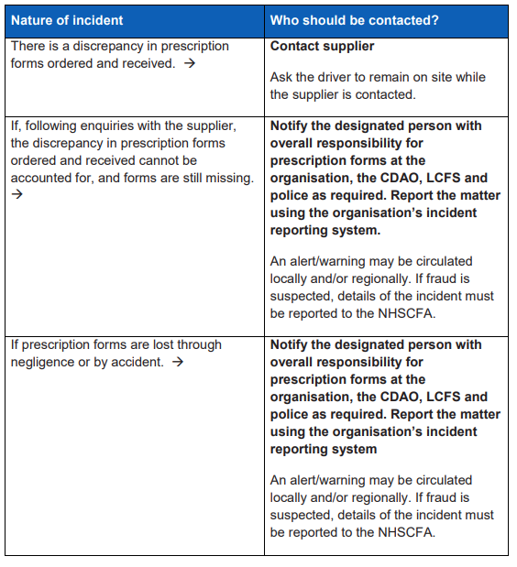
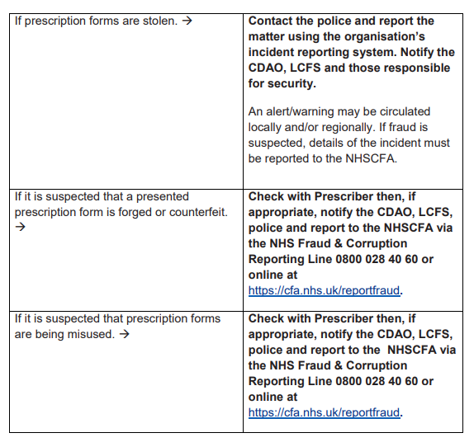
Annex C – Key responsibilities in incident investigation
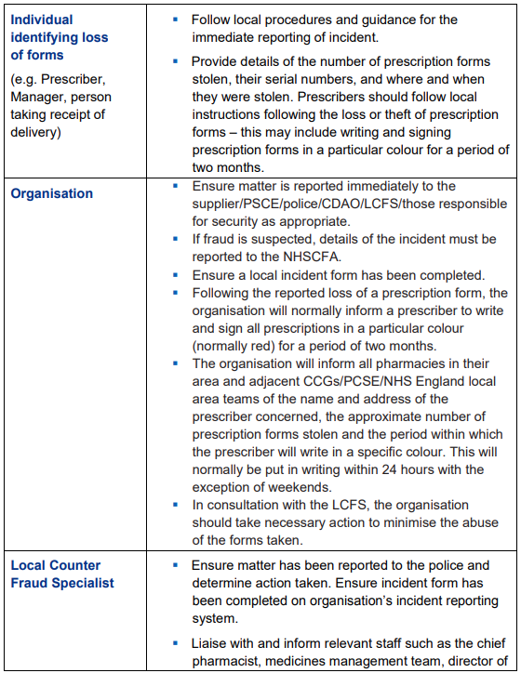
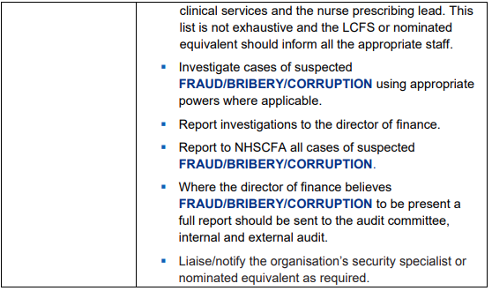

Appendix 1 – Record of Receipt / Issue of FP10 forms
This form should be completed every time FP10s are issued to or returned by a member of medical staff to administrative staff. By signing this form, the FP10s become the responsibility of the prescriber involved. The prescriber must ensure that FP10s are stored appropriately and are only used within Trust policies (available on the Trust intranet). On leaving the Trust or the clinical locality or speciality, it is the responsibility of the prescriber to return all unused FP10HPs to the line manager who will then forward on to the local pharmacy team

Date ordered | Ordered by (print name) | Method of order | Amount ordered | Order number | Date received | Amount received | Received by (print name) | First serial number of FP10 pad | Last serial number of FP10 pad | Stored by (print name) | Date taken for use | Taken by (print name) | Taken by (signature)

Appendix 2
RECORD of DESTRUCTION of UNWANTED PRESCRIPTION PADS

Name of Person returning Prescription Pad(s)
Signature
Date
Name of Person Receiving Prescription Pad(s)
Signature
Date

Name on Prescription Pad | Prescribing number | 1st Serial Number | Last Serial Number | Number of forms | Date of destruction | Destroyed by(Signature)& print name in capitals | Witnessed by(Signature)&print name in capitals

Retain this record for 3 years after the date of last entry
Destroy after (date) ……………………………………………….
Notes for Completion:
- Where it is not possible to destroy prescription pads immediately, the returner and receiver should complete the form except the last 3 columns.
- Pharmacy and one senior nurse (Band 6 and above) to be involved as part of destruction process for FP10’s

Appendix 3

PRESCRIBING STAFF SPECIMEN SIGNATURES

Title:  Dr Mrs Mr Miss Ms |  |  | Registered Name (in Full) :
Position: |  | Base or Unit:
Full signature: |  |  |  | Initials used: | Date:
Trust e-mail address:
Contact telephone no:
GMC / NMC / GPhC / GDC / HCPC registration (PIN) number:
Prescribing Qualification (please circle):

MEDICAL
INDEPENDENT COMMUNITY PRACTITIONER SUPPLEMENTARY
Date of appointment/qualified as prescriber: | Locum / permanent |  |  | Expected finish date (locums):
Name of Previous Trust (if applicable:
Name of Manager / Consultant :
Full signature of Manager / Consultant: |  |  |  | Date:
Please email a copy of this form to your locality Pharmacy Lead

Appendix 4
FP10 Prescriber issuance Log

Date | Prescription Serial number | Name of prescriber  &  Registration number | Name of patient  &  NHS number | Date of issue | Type of patient (Outpatient/ Inpatient/ Private)

Appendix 5 – Quarterly FP10 Audit

Questions
Statement at top: Please ensure your team details are correct on the ODS platform. Any changes to team details please consult with local ELFT pharmacy team
Stock Management |  |  | Additional information for this question
Qualifying Question: Does your team stock or issue FP10's | Yes/No. If yes all below questions open up
In the last quarter, all FP10 prescription forms received are as per the teams original order | Yes/ No | Additonal freetext box
In the last quarter, all received FP10 prescription pads have been accurately logged | Yes/ No | Additional freetext box | date of delivery, name of the person accepting delivery, what has been received (quantity and serial numbers), where it is being stored,
In the last quarter, all FP10 prescription forms have been stored securely in a locked cupboard, drawer or safe with restricted access to authorised persons only. | Yes/ No | Additional freetext box
Issue
In the last quarter, all FP10 prescription forms have been issued to an ELFT patient and logged accurately | Yes/ No | Additional freetext box | When was it issued, who issued the prescription, whom it was issued to, number of prescription issued, details of prescriber, serial number of prescriptions
In the last quarter, all FP10 prescriptions have been signed out on the log sheet as per appendix 1 of trust policy | Yes/ No |  | Date, Prescription number, NHS number of patient, name of prescriber
In the last quarter, all FP10 prescription forms have only been used by the individual or team to whom they were issued and the clinic or service name/address on the prescription matches the intended user | Yes/ No | Additional freetext box
Check 5 prescriptions from prescribers FP10 issuance logs (appendix 4). Has the FP10's been uploaded on to the clinical record system (RIO, EMIS, SystmOne) for each of these patients | Yes/No
If yes have all of these FP10 prescriptions had documentation in the clinical record stating what has been prescribed including quantity | Yes/ No
Check 5 prescriptions. All FP10 prescriptions issued are for the treatment of community based patients | Yes/ No
Check 5 prescriptions, all FP10 prescriptions issued are for urgent supply defined as 'treatment initiation or dose change neccesary within 5 days or as neccesary' | Yes/ No/N.A | Additonal freetext box
Security loss and prevention
For the last quarter, any missing, lost or stolen FP10 forms have been reported onto Inphase and team manager has been informed | Yes/No/N.A
If yes to above - Line manager, lead pharmacist, The chief/ deputy chief/ | Yes/ No
In the last quarter, were there any FP10 prescriptions/pads that have been pre signed or left unattended | Yes/ No | Additional freetext box
Audit and reporting
In the last quarter have there been any changes in prescriber or team details | Yes/ No | Additional freetext box
If yes to above has this been communicated to the lead pharmacist of the service | yes/no
Destruction and Disposal
In the last quarter, all prescription forms which are no longer in use have been securely destroyed and then placed in confidential waste | Yes/No/N.A
If yes. All prescription forms destroyed have been witnessed by a senior nurse (B6 and above) | Yes/ No
There is a log of any prescriptions destroyed within the last 3 years | Yes/ No
Other
In the last quarter have there been any concerns or issues identified that may raise concern on the use of the FP10 prescriptions | Yes/ No | Additional freetext box | Use for private patient's or staff, prescribing over 28 days, prescription of non urgent medicines, general use within the team

