To access the InPhase Risk Application simply select the Risk icon from the InPhase landing page.

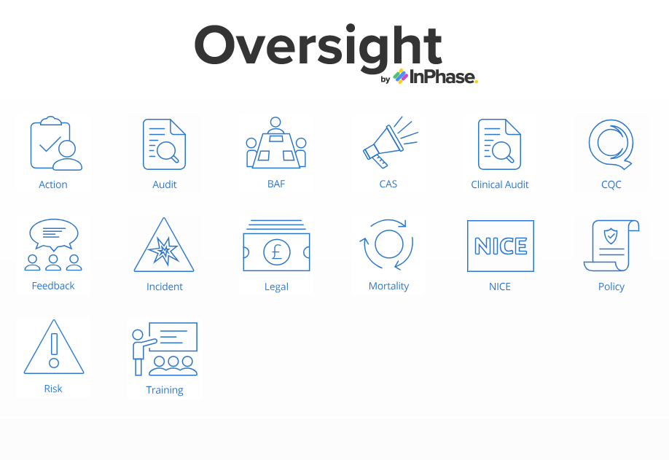

The following screen will appear
Simply click on the appropriate tab to select your directorate risk register.
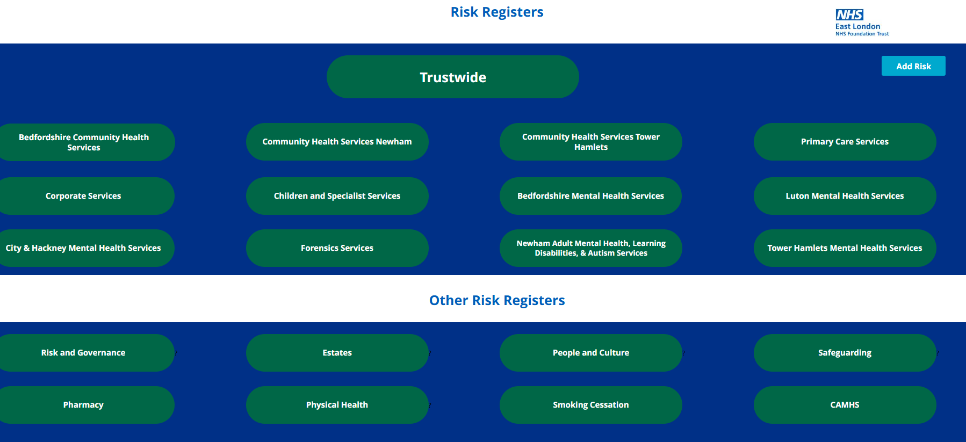

To enter a new risk select add risk and the following screen will appear, indicates where help information is available, is a mandatory field.
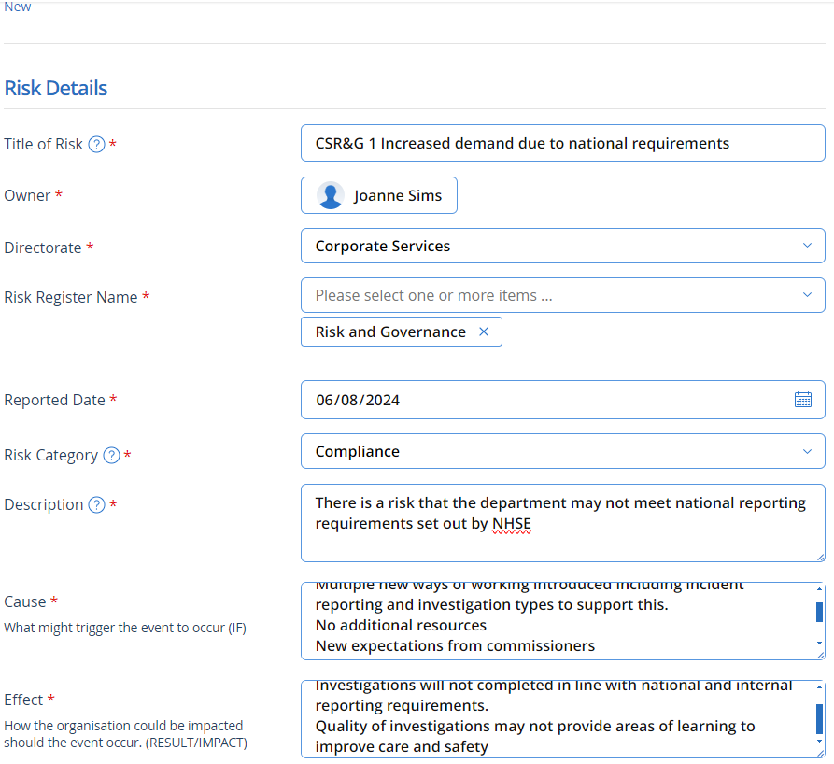
Add the cause and effect; carefully think about what events / conditions and potential impacts
Select your directorate then your risk register name form the drop downs
Add the risk description. A risk is something that could have an effect on the organisation, staff or patients. It is not something that has already happened this is an incident
Select the risk category, you may pick multiples
If you are not the risk owner pick the name form the list
Begin with initials of the directorate, followed by initials of the team and a brief description of the risk

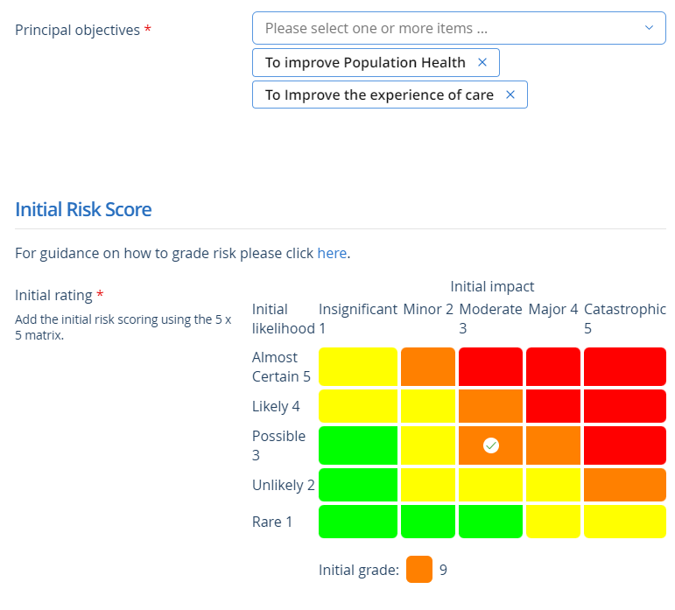
Add the initial risk scoring using the Trusts approved scoring matrix.
Select the appropriate objective – these are the Trusts Strategic Objectives, you may select more than one
Trust risk scoring matrix available here

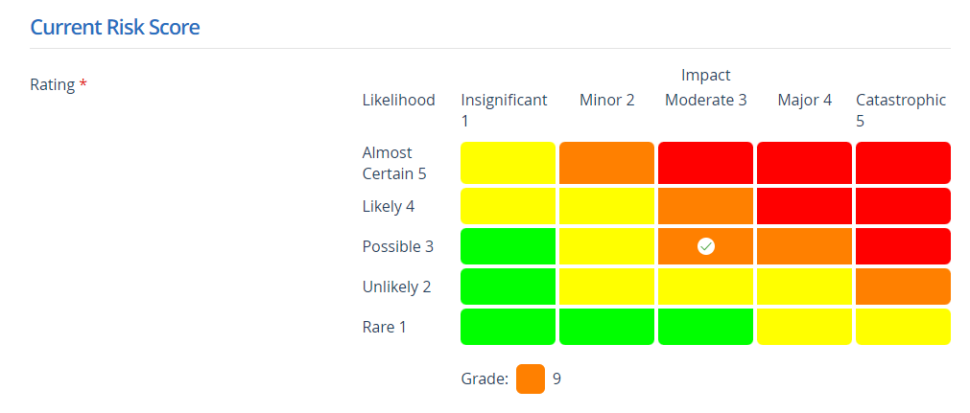
Add the current risk score, important to note that when first adding the risk to the system the initial risk and current risk will be the same. As mitigating actions are completed the current risk rating should decrease, if not, mitigating actions should be revisited
Links to – this section is where you add the directorate the risk applies to and the service line it refers to. Please note that service lines does not relate to the team but the type of service that they are providing i.e. podiatry. This information will enable the organisation to identify risks in services across different localities and directorates.

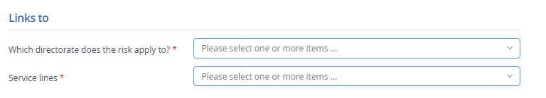

Adding Controls a controls and assurances

Controls are measures and precautions that are put into place to reduce the probability or impact of the potential risk, this may include strategies, systems, policies, safety procedures or people. Controls may be comprised of a number of individual actions, which need to be taken together to become effective.
Assurance is the way the organisation and stakeholders gain confidence that controls within an organisation is both efficient and effective. This includes the monitoring of each control i.e. training attendance monitoring, action plan monitoring, and compliance levels, how do we know our controls are working!
Gaps in control occur when a control does not exist, does not effectively mitigate a risk or is not operating effectively.
To add a control complete the controls section
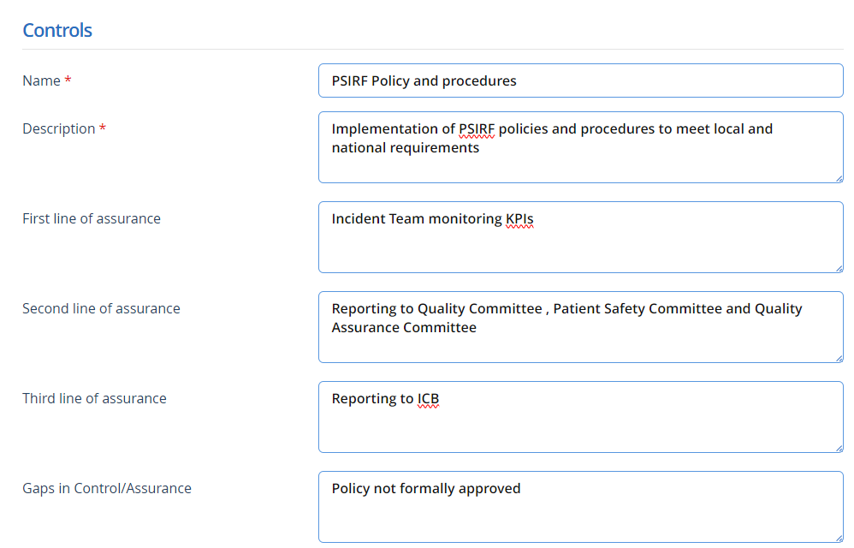

Include any gaps in controls or assurance here, any gaps in controls or assurance should be supported by an action to address the gap.

You can add multiple controls, select additional controls

You can add a summary of actions, this will enable you to share an update in reports etc

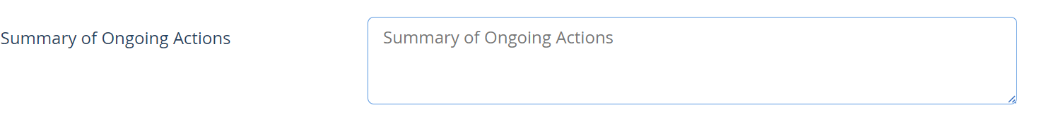

In addition to this you can add a live action using the InPhase action functionality; assigning timescales and owners.

For further information on actions refer to the actions guidance.

As with most InPhase applications you have the functionality to add and save documents, this is really useful when saving full risk assessments, evidence of controls and assurances. Some risks may be supported by a standalone action plan, these should be saved in the documents area the form, and regularly updated and refreshed.

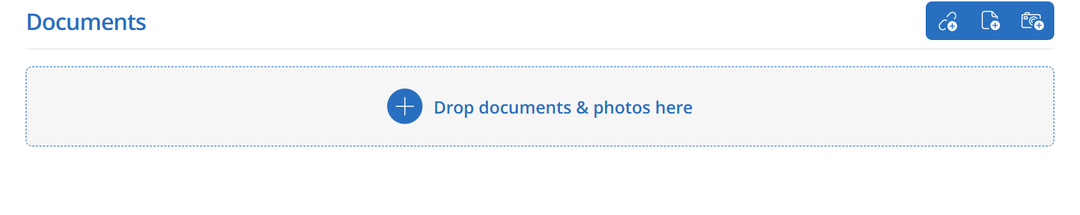
Once you are happy with the information you have entered, select the manager to approve from the drop down 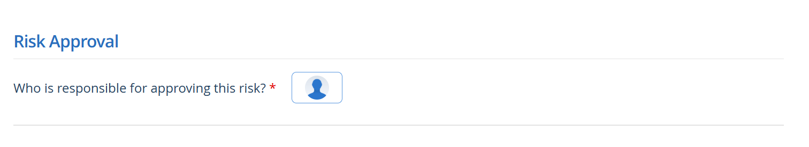
Press send for approval, this will automatically create an email and send a link to the authorising manager.

Approving a risk
Once a risk has been submitted the director / senior manager responsible will receive an email see example below
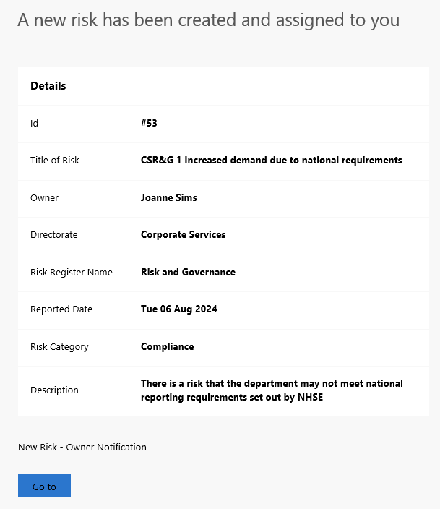
Click go to, this will take you directly to the risk

Carefully review the risk and information entered, complete the following section to authorise entry onto the directorate risk register

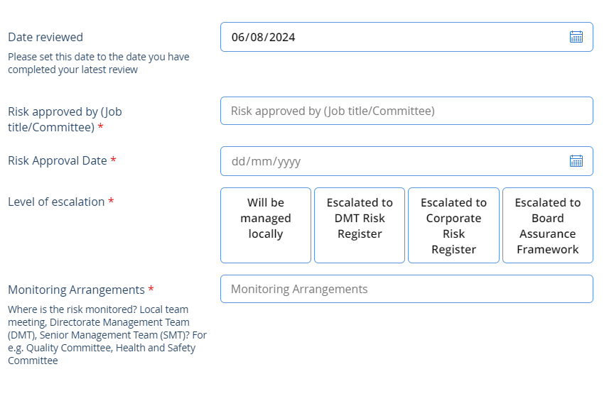
Consider carefully the level of escalation. Will this be managed at a local level, DMT / SMT , escalated to the CRR or BAF
You will also need to add the target risk score to the matrix
Save your changes
Levels of escalation (see flowchart)
Risks scored 15 or above should be considered for escalation to the Corporate Risk Register. Risks scored at 15 or above can be held locally but rationale should be recorded.
Escalations to the CRR should be discussed at DMT / SMT and approved by the Service Director.
Escalation to the BAF should be agreed at the Service Delivery Board chaired by the Chief Executive Officer

Once you are happy with the information entered, save any changes you have made, then select open to approve the risk, any missing information will be highlighted in red and will require input.


Once the risk has been opened, review regularly and add comments.

Updating Risks
When reviewing and updating risks, record any changes in the update comments field, press add, then save.
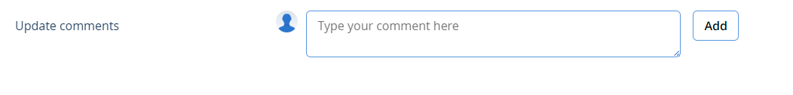
The name of the staff member entering the comment will be recorded, together with the date.
Include a summary of any updates including changes to risk scoring or progress updates. Include any rationale supporting a change to the risk scoring and also commentary why a risk score is unchanged.
Controls and assurances can be updated simply by adding the information and press save. Any information within the form can be updated and changed.
Always remember to press save.

To close a risk
When you in a the position to close a risk, this may be for a number of reasons;
- The risk has been reduced to an acceptable level
- The risk has been realised
- The risk no longer exists due to a change in policy, target , etc

This should be agreed at your directorate DMT /SMT or by the Service Director
Enter notes into the updates comments section and save.
Then select the close button
If you close a risk you will always have the option to re-open



Searching and Filtering Risks
The InPhase risk app is very transparent, easy to use and designed to be used real-time by end users for adding, managing and monitoring risks.
From the risk landing page select Trustwide Risk Register as the most effective way to search for an individual risk or your risk register by using the pre-determined filters.

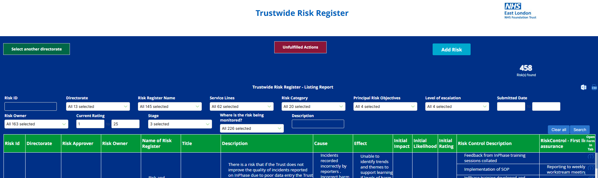

Joanne Sims, January 2026, Version 2

