Venous Thromboembolism
Reducing Risk Policy

Version number | 4.0
Consultation Groups | Physical Health Committee, Trust-wide Physical Health in Mental Health Group
Approved by (Sponsor Group) | Physical Health Group
Date approved | 13 February 2026
Ratified by | Quality Committee
Date ratified | 25 February 2026
Name and Job Title of author | Clinical Directors in Mental Health
Executive Director Lead | Physical Health in Mental Health Committee
Implementation rate | February 2026
Last review date | February 2026
Next review date | February 2029

Services | Applicable
Trust wide | X
Mental Health and LD (Learning Disabilities)
Community Health Services
Primary Care

Version Control Summary

Version | Date | Author | Status | Comment
1.0 | 16/3/13 | Trust Physical Health Lead |  | Approved clinical effectiveness Committee
2.0 | October  2019 | Deputy Director of IPC Physical Health Lead Nurse |  | Updated in line with the below guidance 2018
3.0 | April  2021 | Lead Pharmacist |  | Updated to reflect risk in Covid-19see section 9.2 No 15 and 16 ref
3.1 | November 2021 | Medical Director Community services |  | Incorporate NICE QS 201 and Rio template Appendix
3.2 | 10 March 2023 | Interim Medical Director, London Mental Health Services |  | Clarifications of roles/responsibilities, updating of appendices and of prescribing tables
4.0 | March  2026 | Trust Physical Health Lead Nurse/ and in patient physical Health Pharmacist | Full policy review and update: | Full policy review and update:  • Confirmed NG89 (2018) guidance with 2024 surveillance  • Added baseline platelet count requirement prior to LMWH  stop LMWH and seek urgent advice if Heparin-Induced Thrombocytopenia (HIT  Updated Nice Guidance on pharmacological treatments

Table of Contents

Section |  | Page
 | Introduction | 5
 | Venous Thromboembolism definition | 5
 | Purpose | 5
 | Duties  4.1 Duties within the Organisation | 6
 | VTE Prevention Quality Standard | 6
 | Risk Factors for VTE  6.1 VTE Risk Factors | 6
 | Clinical Presentation of DVT  7.1 Common Presenting Features | 7
 | Risk Assessment for VTE  8.1 Community Health Services Inpatient Wards  8.2 Community Services  8.3 Mental Health Inpatient Wards  8.4 All patients  8.5 Interventions for pregnant women and women who gave birth or had a miscarriage or termination of pregnancy in the past 6 weeks  8.6 Interventions for people having palliative care  8.7 Interventions for people with acute coronary syndromes or acute stroke or for acutely ill patients  8.8 Interventions for people with renal impairment  8.9 Interventions for people with cancer  8.10 Interventions for people admitted to critical care  8.11 Interventions for people with psychiatric illness  8.12 Interventions when using anaesthesia  8.13 Interventions for people having orthopaedic surgery  8.14 Interventions for people having elective spinal surgery or cranial surgery or people with spinal injury  8.15 Interventions for people with major trauma  8.16 Interventions for people having abdominal, thoracic or head and neck surgery  8.17 Interventions for people having cardiac or vascular surgery | 8
 | Preventative Regimes for Patients at Risk of Thromboembolism  9.1 Low Molecular Weight Heparin (LMWH)  9.2 Reducing the risk of VTE with COVID-19 | 12
 | Making the Decision Not to Treat with LMWH | 13
 | Procedures to be Followed if DVT is Suspected | 14
 | Discharging from Inpatient Units / Wards | 14
 | Training | 14
 | Audit | 14
 | Review | 14
 | Further Information | 15
 | References | 15
- Appendices

Appendix 1 | Flowchart for VTE Assessment | 17
Appendix 2 | Department of Health Risk Assessment for VTE | 18
Appendix 3 | Risk Factors for VTE in Pregnancy/Puerperium | 20
Appendix 4 | Blood clots Easy Read Leaflet for Service users | 21
 | Equality Impact Assessment | 22

1.0 Introduction

In March 2018, the National Institute for Health and Care Excellence (NICE) published the guideline Venous thromboembolism in over 16s: reducing the risk of hospital-acquired deep vein thrombosis or pulmonary embolism (NICE guideline NG89) and this was last substantively updated in August 2019, with minor editorial amendments in 2025.

East London NHS Foundation Trust will implement the NICE guidance, to ensure that all adult service users admitted are risk-assessed for VTE and where appropriate receive thrombo-prophylaxis and treatment.

This policy describes the processes for:
- Identifying at risk patients on our inpatient wards and implementing the NICE guidance.
- Thromboprophylaxis implementation and management.

This policy is aligned with NICE NG89 (2018, updated 2019, minor amendments 2025).

2.0 Venous Thromboembolism Definition

- Venous Thromboembolism (VTE) is a term used to include the formation of a blood clot (a thrombus) in a vein which may dislodge from its site of origin and travel in the blood, a phenomenon called embolism. A thrombus most commonly occurs in the deep veins of the legs; this is called deep vein thrombosis. A dislodged thrombus that travels to the lungs is known as a pulmonary embolism.

- VTE encompasses a range of clinical presentations. Venous thrombosis may be completely asymptomatic or it may cause pain and swelling in the leg. Part or all of the thrombus/clot can come free and travel to the lungs as a potentially fatal pulmonary embolism. Symptomatic venous thrombosis carries a considerable burden of morbidity, sometimes long-term due to chronic venous insufficiency. This in turn can cause venous ulceration and development of a post-thrombotic limb (characterised by chronic pain, swelling and skin changes).

3.0 Purpose

The purpose of this policy is to ensure that patients in community bedded units and mental health in-patient units are appropriately assessed for their risk of developing a VTE, they receive appropriate treatment and that the level of risk is reviewed throughout their stay on any of the inpatient wards.
- To reduce the risk of VTE in service users / patients found to have risk factors.
- To ensure that all patients are assessed for their individual risk of VTE and that the outcome is documented with regard to appropriate risk-reduction measures.
- To ensure a provision of appropriate risk reduction measures including adequate information to staff and patients.

4.0 Duties

4.1 Duties within the Organisation

Trust directors are accountable for all procedures within their area of operation.
A director will nominate a procedure lead to carry out the development work in accordance with this policy. They will ensure that all new and revised policies are effectively implemented and monitored.

5.0 VTE prevention quality standard

- All patients, on admission, must receive both an assessment of VTE and bleeding risk using the clinical risk assessment criteria described in the national tool.
- Patients/carers are offered verbal and written information on VTE prevention as part of the admission process.
- Patients must be assessed as soon as possible after admission (ideally within 6 hours and no later than 24 hours), or by first consultant review for risk of VTE and Bleeding.
- Patients are re-assessed during admission whenever their ability to mobilise changes for risk of VTE and bleeding.
- Patients assessed to be at risk of VTE are offered VTE prophylaxis in accordance with NICE guidance.
- Patients/carers are offered verbal and written information on VTE prevention as part of the discharge process. Shared decision-making, reasonable adjustments, MCA compliance where capacity is lacking.

6.0 Risk Factors for VTE

Venous thromboembolism (VTE) includes several manifestations of the same disease process: deep-vein thrombosis (DVT), ischemic stroke, and pulmonary embolism (PE). Without thrombo-prophylaxis, the incidence of objectively documented DVT ranges from 16% to 55%

The assessment of a patient’s risk is based on a number of risk factors that have been identified from epidemiologic studies. Some of the more defined risk factors are briefly summarized in the following section.

The risk of developing VTE depends on the condition and/or procedure for which the patient is admitted and on any predisposing risk factors (such as age, obesity and concomitant conditions).

In mental health inpatient settings, additional risks include seclusion, catatonia, rapid tranquillisation, severe depression, reduced mobilisation, and increased observation levels.

NICE Guidance recommends that:
- Assess all patients on admission to identify those who are at increased risk of VTE.
- Regard patients as being at increased risk of VTE if they have had or are expected to have:
- significantly reduced mobility for 3 days or more or
- ongoing reduced mobility relative to their normal state together with one or more of the risk factors shown in 6.1 below
- In ELFT inpatient settings (including but not limited to mental health wards), risk factors may include being bedbound, unable to walk unaided or likely to spend a substantial proportion of the day in bed or in a chair. This could be secondary to prolonged seclusion, catatonia, rapid tranquilisation or severe depression.

6.1 VTE Risk Factors

Details of risk factors for VTE can be found in the NICE Guidance on reducing the risk and on the associated Risk Assessment from the Department of Health (Appendix 2 in this policy). Relevant factors include:

- Recent immobility
- Some medications (e.g. antipsychotics)
- Obesity (BMI greater than 30kg/m2)
- Dehydration
- Seclusion
- Long term conditions, such as those listed in appendix 2.
- Previous DVT
- Intravenous drug user
- Long haul air flight
- Underlying malignant disease
- Family history thrombosis
- Known thrombophilic defect
- Use of HRT
- One or more significant medical co-morbidities
- Greater than 60 years old
- Recent surgery
- Recent injury or trauma
- Covid-19 and other infectious diseases.

7.0 Clinical presentation of DVT

A diagnosis of DVT is usually suspected in patients who complain of a painful swollen limb.

However, the clinical picture can vary widely and none of the clinical features is sufficiently specific to be diagnostic. Less than a third of patients referred for tests after initial history and clinical examinations prove to have a DVT. Clinical diagnosis is notoriously difficult as the manifestations of venous thromboembolism (VTE) are constantly changing.

7.1 Common Presenting Features

- Pain or tenderness of the leg (calf or thigh)
- Swelling of calf or thigh
- Pitting oedema
- Palpable venous thrombosis
- Increased temperature in the leg
- Fever
- Discoloration or erythema of the leg
- Venous distension

8.0 Risk Assessment for VTE

Assess all patients to identify the risk of venous thromboembolism (VTE) and bleeding (see the recommendation for all medical patients, for all surgical patients, for all pregnant women and all women who gave birth or had a miscarriage or termination of pregnancy in the past 6 weeks, for all people admitted to the critical care unit and for all acute psychiatric patients). [2018]

8.1 Community Health Services inpatient wards

For patients on the community bedded units an initial risk assessment must be completed (within 4-6 hours) and, where appropriate, prophylaxis prescribed within 14 hours of admission by doctors. Staff must use the NICE guidance/VTE risk assessment and make referral to the GP/ward duty doctor for full assessment and if prophylaxis treatment is indicated. Re-assessment must occur when mobility, clinical condition, medication, level of observation, or seclusion status changes.

8.2 Community Services

Most patients will present with symptoms to their GP either at the surgery or in their own home. Community teams are not required to complete the risk assessment but must immediately refer any patients they see to their GP if clinical features of DVT are present or suspected. This must be documented in the patient’s care record and communicated to the GP.

8.3 Mental Health inpatient wards

- All patients admitted to mental health inpatient wards must have a baseline physical history, lifestyle and medication assessment and an initial physical examination by medical staff and baseline observations undertaken by a nurse on admission.

- All patients admitted to mental health inpatient wards must have a VTE risk assessment completed by the admitting medical staff. This should be carried out as soon as possible on admission (within 4-6 hours) and recorded on the “Risk Assessment for Venous Thromboembolism” form on RiO, which can be found in the Physical Health (MH) Folder. Prophylaxis, where indicated, must be prescribed within 14 hours of admission.

- Nursing and Medical staff have a responsibility to keep this under review and remain mindful of the risk factors for VTE. This is included in the “Observations and Measurements” form located within the Physical Health (MH) folder on RiO, that is completed by nursing staff that is completed on a regular basis (at least weekly), but concerns should be responded to as soon as they are observed to occur. Nursing staff should highlight any concerns warranting further assessment to the medical staff, such as when mobility changes or other VTE risk factors heighten (see section 6.1 for areas to consider). The doctor should then complete a full clinical assessment, including the “Risk Assessment for Venous Thromboembolism” form and consideration of VTE prophylaxis.

- As noted in Section 6, seclusion potentially increases the risk of VTE. This would be a time when keeping the risk under review would be important.

- The above recommendations are in keeping with NICE (2018) guidance. The Trust has more stringent guidance for when assessments should occur. The NICE guidance states the following for mental health inpatient wards.
- Assess all acute psychiatric patients to identify their risk of VTE and bleeding:
  - as soon as possible after admission to hospital or by the time of the first consultant review
  - using a tool published by a national UK body, professional network or peer-reviewed journal.
  - A tool commonly used to develop a treatment plan for surgical patients is the Department of Health VTE risk assessment tool. (Reproduced with the permission of the Department of Health and Social Care under the Open Government Licence.)

- Reassess all people admitted to an acute psychiatric ward for risk of VTE and bleeding at the point of consultant review or if their clinical condition changes. Structured bleeding risk assessment including active bleeding, thrombocytopenia, liver disease, hypertension, anticoagulants, alcohol misuse.

- Consider pharmacological VTE prophylaxis with LMWH for people admitted to an acute psychiatric ward whose risk of VTE outweighs their risk of bleeding.

- Consider pharmacological VTE prophylaxis with fondaparinux sodium if LMWH is contraindicated for people admitted to an acute psychiatric ward whose risk of VTE outweighs their risk of bleeding.

- Continue pharmacological VTE prophylaxis for people admitted to an acute psychiatric ward until the person is no longer at increased risk of VTE.

8.4 All Patients

Mechanical prophylaxis.
In mental health settings, ligature and safety risks must be considered.

Do not offer anti-embolism stockings to people who have:
- suspected or proven peripheral arterial disease
- peripheral arterial bypass grafting
- peripheral neuropathy or other causes of sensory impairment
- fragile skin, dermatitis, gangrene or recent skin graft
- known allergy to material of manufacture
- severe leg oedema
- Major limb deformity or unusual leg size or shape preventing correct fit.
- Use caution and clinical judgement when applying anti-embolism stockings over venous ulcers or wounds.

Where anti-embolism stockings are indicated:
- Ensure that people who need anti-embolism stockings have their legs measured and that they are provided with the correct size of stocking. Anti-embolism stockings should be fitted and patients shown how to use them by staff trained in their use.
- Ensure that people who develop oedema or postoperative swelling have their legs re-measured and anti-embolism stockings refitted.
- If arterial disease is suspected, seek expert opinion before fitting anti-embolism stockings.
- Use anti-embolism stockings that provide graduated compression and produce a calf pressure of 14 15 mmHg. (This relates to a pressure of 14–18 mmHg at the ankle and is in line with British Standards BS 6612:1985 Specification for graduated compression hosiery and BS 7672:1993 Specification for compression, stiffness and labelling of anti-embolism hosiery.)
- Encourage people to wear their anti-embolism stockings day and night until they no longer have significantly reduced mobility.
- Remove anti-embolism stockings daily for hygiene purposes and to inspect skin condition. In people with a significant reduction in mobility, poor skin integrity or any sensory loss, inspect the skin 2 or 3 times a day, particularly over the heels and bony prominences.
- Monitor the use of anti-embolism stockings and offer assistance if they are not being worn correctly.
- Stop the use of anti-embolism stockings if there is marking, blistering or discolouration of the skin, particularly over the heels and bony prominences, or if the person experiences pain or discomfort. If suitable, offer intermittent pneumatic compression as an alternative.
- Do not offer intermittent pneumatic compression to people with a known allergy to the material of manufactureise the person to wear their device for as much time as possible.

8.5 Interventions for pregnant women and women who gave birth or had a
miscarriage or termination of pregnancy in the past 6 weeks

These may be of particular importance for the mental health inpatient Mother and Baby Units, but the
principles apply across all services.

Follow NICE NG89 recommendations:
https://www.nice.org.uk/guidance/ng89/chapter/Recommendations#interventions-for-pregnant-women-and-women-who-gave-birth-or-had-a-miscarriage-or-termination-of

8.6 Interventions for people having palliative care

Follow NICE NG89 recommendations:
https://www.nice.org.uk/guidance/ng89/chapter/Recommendations#interventions-for-people-having-palliative-care

8.7 Interventions for people with acute coronary syndromes or acute stroke or for
acutely ill patients,

Follow NICE NG89 recommendations: https://www.nice.org.uk/guidance/ng89/chapter/Recommendations#interventions-for-people-with-acute-coronary-syndromes-or-acute-stroke-or-for-acutely-ill-patients

8.8 Interventions for people with renal impairment

Follow NICE NG89 recommendations:
https://www.nice.org.uk/guidance/ng89/chapter/Recommendations#interventions-for-people-with-renal-impairment

8.9 Interventions for people with cancer

Follow NICE NG89 recommendations:
https://www.nice.org.uk/guidance/ng89/chapter/Recommendations#interventions-for-people-with-cancer

8.10 Interventions for people admitted to critical care

Follow NICE NG89 recommendations:
https://www.nice.org.uk/guidance/ng89/chapter/Recommendations#interventions-for-people-admitted-to-critical-care

8.11 Interventions for people with psychiatric illness

Follow NICE NG89 recommendations:
https://www.nice.org.uk/guidance/ng89/chapter/Recommendations#interventions-for-people-with-psychiatric-illness

8.12 Interventions when using anaesthesia

Follow NICE NG89 recommendations:
https://www.nice.org.uk/guidance/ng89/chapter/Recommendations#interventions-when-using-anaesthesia

8.13 Interventions for people having orthopaedic surgery

Follow NICE NG89 recommendations:
https://www.nice.org.uk/guidance/ng89/chapter/Recommendations#interventions-for-people-having-orthopaedic-surgery

8.14 Interventions for people having elective spinal surgery or cranial surgery or
people with spinal injury
Follow NICE NG89 recommendations:
https://www.nice.org.uk/guidance/ng89/chapter/Recommendations#interventions-for-people-having-elective-spinal-surgery-or-cranial-surgery-or-people-with-spinal

8.15 Interventions for people with major trauma

Follow NICE NG89 recommendations:
https://www.nice.org.uk/guidance/ng89/chapter/Recommendations#interventions-for-people-with-major-trauma

8.16 Interventions for people having abdominal, thoracic or head and neck surgery

Follow NICE NG89 recommendations:
https://www.nice.org.uk/guidance/ng89/chapter/Recommendations#interventions-for-people-having-abdominal-thoracic-or-head-and-neck-surgery

8.17 Interventions for people having cardiac or vascular surgery
Follow NICE NG89 recommendations:
https://www.nice.org.uk/guidance/ng89/chapter/Recommendations#interventions-for-people-having-cardiac-or-vascular-surgery

9.0 Preventative Regimes for Patients at Risk of Thromboembolism.

Following a positive risk assessment a decision will be made on management, utilising the guidelines below as recommended by NICE and our local pharmacy team.

Prior to the development of low molecular weight heparins (LMWH) the traditional management of DVT was to treat the patient on an inpatient basis. However, uncomplicated DVT is now widely managed on an outpatient basis and most patients can be treated at home without problems (Winter et al, 2005).

9.1 Low Molecular Weight Heparin (LMWH)

LMWH is recommended for many patients at risk of developing venous thromboembolism and is used as a prophylaxis. LMWH produces an immediate anticoagulant effect whereas oral anticoagulants act slowly and their effect builds up over 2-3 days.

A baseline platelet count must be taken prior to starting LMWH. If HIT is suspected (sudden drop in platelets or new thrombosis), stop LMWH immediately and seek urgent advice from haematology or a specialist clinician

LMWH will be prescribed by the GP/Responsible Clinician/medical prescriber and administered by the nursing staff. Treatment will generally last for the period of reduced immobility.

If a prescriber is unsure of the most appropriate prescribing options, they should seek advice from another clinician. The appropriateness of the guidance below may be impacted by the presence of other medical conditions or medications.

Direct Oral Anticoagulants (DOACs) are oral medications that directly inhibit clotting factors (Factor Xa or thrombin). Examples include apixaban, rivaroxaban, edoxaban, and dabigatran. Use in mental health inpatient settings should only occur with specialist or pharmacy advice

There are a variety of available LMWHs available. Inpatients in East London NHS Foundation Trust should generally be prescribed.

Drug | Patient’s Weight | Dose
Enoxaparin (Clexane) | <50kg | 20mg (Once daily)
Enoxaparin (Clexane) | 51-100kg | 40mg (Once daily)
Enoxaparin (Clexane) | 101-150kg | 60mg (Once daily)

9.2 Reducing the risk of VTE in Covid-19

- Patients with acute infection, including COVID-19, must be managed in line with NICE NG89 and current rapid guideline on managing COVID-19.

On admission
- Assess patient risk for VTE as for all newly admitted patients, as detailed in section 8 above.
- If pharmacological VTE prophylaxis is indicated, and there are no contraindications, prescribe Enoxaparin as directed:

In those who are low risk (have a D-dimer <3):

Weight | CrCl > 30 ml/mil | CrCl < 30 ml/mil
<50kg | 20mg OD | 20mg OD
50-100kg | 40mg OD | 20mg OD
100-150kg | 60mg OD | 20mg OD
> 150kg | 80mg OD | 20mg OD

In those who are high risk (have a D-Dimer >3):

Weight | CrCl > 30 ml/mil | CrCl < 30 ml/mil
<50kg | 40mg OD | 20mg OD
50-100kg | 40mg BD | 40mg OD
100-150kg | 60mg BD | 60mg OD
>150kg | 80mg BD | 80mg OD

- During inpatient stay:
  - If the patient’s clinical condition changes, assess risk of VTE in the same way recommended for all patients, as per section 8 above.

- At discharge
  - Ensure that patients will be completing pharmacological VTE prophylaxis after discharge
  - Prescribe an extra 14 days thromboprophylaxis if patient is expected to have reduced mobility (or considered high risk for VTE) after discharge.
    - 1st line – Apixaban PO 2.5mg BD
  - Where the prescriber is unsure about the approach or which prescribing to undertake, they should seek advice from an appropriately qualified clinician.

10.0 Making the Decision not to treat with LMWH

Decision must be based on documented VTE vs bleeding risk with rationale and review plan
LMWH such as Enoxaparin, Tinzaparin are contraindicated in groups of patients with the following physical health problems. For these service users it is recommended that advice is sought from the medical team.

- Actively bleeding patients or those at risk of bleeding.
- Patients at high risk of falls
- Those with a severe hepatic disease
- Patients with a platelet level of less than 75
- Patients with a BP > 200 systolic or > 120 diastolic
- If patient is already on anticoagulants or antiplatelet medication
- Patients with renal impairment. Renal impairment alone is not an absolute contraindication. Dose adjustment or alternative anticoagulation may be required following specialist advice
- Consider other factors for increased bleeding risk, such as age and alcohol use.

11.0 Procedures to be followed if DVT is suspected

Medical staff are encouraged to seek advice from appropriate specialists if lacking confidence in appropriate management of DVT.

If DVT is suspected, the responsible doctor should take bloods for D-dimer tests and organise an ultra-sound scan to image the leg. Ultrasound scan (USS) has become the investigation of choice in the diagnosis of DVT. It will detect more than 90% of proximal DVTs (i.e. popliteal vein and above). It is less sensitive for calf vein thrombosis (about only 50% are detected) but pulmonary embolism from this site is rare and unlikely to cause significant haemodynamic disturbance even if it occurs. While this is being organised, treatment for possible DVT should begin, seeking advice about this if needed.

12.0 Discharging from Inpatient Units/Wards

VTE risk assessment must be completed at discharge, including decision on continuation or
Cessation of prophylaxis

Discuss with the GP practice nurse, district nurses or Community Mental Health Team if continuing treatment is required and document this in the care record.

Necessary information should be included in verbal transfer/handover information sheets. Prior to transfer, clearly state the duration of treatment on the discharge summary and transfer of care form.

13.0 Training

All qualified nursing staff working in adult inpatient mental health wards and community inpatient units will receive training in completing the risk assessment and administering appropriate treatment as part of their local induction. For more details on the local induction process, please refer to the Induction Training Policy.

14.0 Audit

Audits will take place within directorates to monitor completion of the Risk Assessment for Venous Thromboembolism form on admission and the Observations and Measurements form that is completed on a regular basis. Audit findings will be presented to the Physical Health in Mental Health group via Business intelligence dashboard on defined KPIs (assessment within 24h, reassessment, with appropriate prophylaxis.

Information regarding patients diagnosed with VTE will be collected as part of Datix incident management.

15.0 Review

This Policy will be reviewed every 3 years or sooner if deemed necessary.

16.0 Further Information

NICE. (2018). venous thromboembolism in over 16s: reducing the risk of hospital-acquired deep vein thrombosis or pulmonary embolism. Available: https://www.nice.org.uk/guidance/NG89

Royal College of Obstetricians and Gynaecologists. (2015). Reducing the Risk of Venous Thromboembolism during Pregnancy and the Puerperium. Available: https://www.rcog.org.uk/globalassets/documents/guidelines/gtg-37a.pdf

Venous thromboembolism in adults Quality standard [QS201] Published: 19 August 2021 https://www.nice.org.uk/guidance/qs201

17.0 References

Dentali, F., Douketis, J.D., Gianni, M., et al. (2007) ‘Meta-analysis: anticoagulant prophylaxis to prevent symptomatic venous thromboembolism in hospitalised medical patients’, Annals of Internal Medicine, 146, pp. 278–288.

Department of Health (2007) Report of the Independent Expert Working Group on the Prevention of Venous Thromboembolism in Hospitalised Patients. London: Department of Health.

East London NHS Trust (2019) Venous thromboembolism – reducing the risk. Version 1. London: ELFT.

Geerts, W.H., Bergqvist, D., Pineo, G.F., et al. (2008) ‘Prevention of venous thromboembolism: the eighth ACCP conference on antithrombotic and thrombolytic therapy’, Chest, 133(6 Suppl), pp. 381S–453S.

House of Commons Health Committee (2005) The prevention of venous thromboembolism in hospitalised patients. 2nd Report of Session 2004–2005. London: HMSO.

National Institute for Health and Care Excellence (2018, updated 2019, surveillance confirmed 2024) Venous thromboembolism in over 16s: reducing the risk of hospital-acquired deep vein thrombosis or pulmonary embolism (NG89). London: NICE. Available at: https://www.nice.org.uk/guidance/NG89 [Accessed 19 Jan 2026].

National Institute for Health and Care Excellence (2021) Reducing the risk of venous thromboembolism (VTE) in over 16s with COVID-19 pneumonia. Available at: https://www.nice.org.uk/guidance/ng186/resources/covid19-rapid-guideline-reducing-the-risk-of-venous-thromboembolism-in-over-16s-with-covid19-pdf-66142025041093 [Accessed 19 Jan 2026].

National Institute for Health and Clinical Excellence (2007) Venous thromboembolism – reducing the risk of venous thromboembolism (deep vein thrombosis and pulmonary embolism) in patients undergoing surgery. London: NICE.

National Institute for Health and Clinical Excellence (2010) Venous thromboembolism: reducing the risk. NICE Clinical Guideline 92. Available at: http://www.nice.org.uk/nicemedia/live/12695/47195/47195.pdf [Accessed 19 Jan 2026].

Nursing and Midwifery Council (2008) The Code: Standards of Conduct, Performance and Ethics for Nursing and Midwifery. London: NMC.
Partsch, H. and Blattler, W. (2000) ‘Compression and walking versus bed rest in the treatment of proximal deep vein thrombosis with low molecular weight heparin’, Journal of Vascular Surgery, [details of volume/issue/pages if available].

Royal College of Obstetricians and Gynaecologists (2015) Reducing the risk of venous thromboembolism during pregnancy and the puerperium. Available at: https://www.rcog.org.uk/globalassets/documents/guidelines/gtg-37a.pdf [Accessed 15 Aug 2019].

Scottish Intercollegiate Guidelines Network (2010) Prevention and management of venous thromboembolism. SIGN Publication No. 122. Available at: http://www.sign.ac.uk/pdf/sign122.pdf [Accessed 19 Jan 2026].

Winter, M., et al. (2005) ‘Procedures for the outpatient management of patients with deep vein thrombosis’, Clinical and Laboratory Haematology, 27, pp. 61–66.

18. Appendices

Appendix 1: Flowchart for VTE Assessment

This flowchart (based on risk assessments before these were done on RiO) does not replace the need to complete the “Risk Assessment for Venous Thromboembolism” form on RiO, but may help as a visual aid.

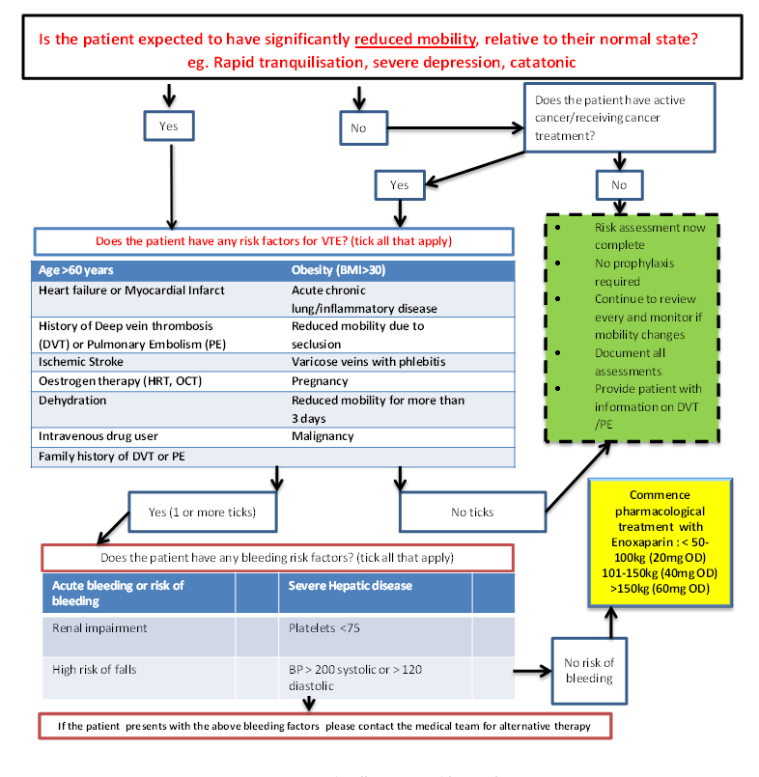

Appendix 2: Department of Health Risk Assessment for VTE

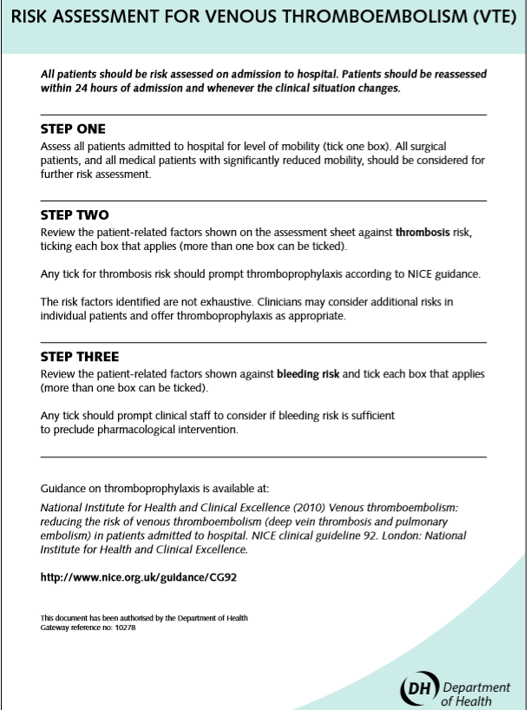

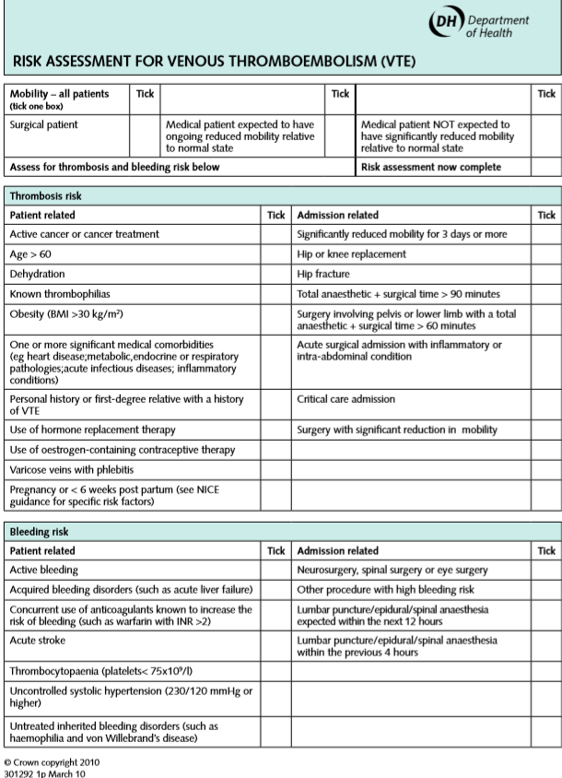
Appendix 3: Risk Factors for VTE in Pregnancy/Puerperium

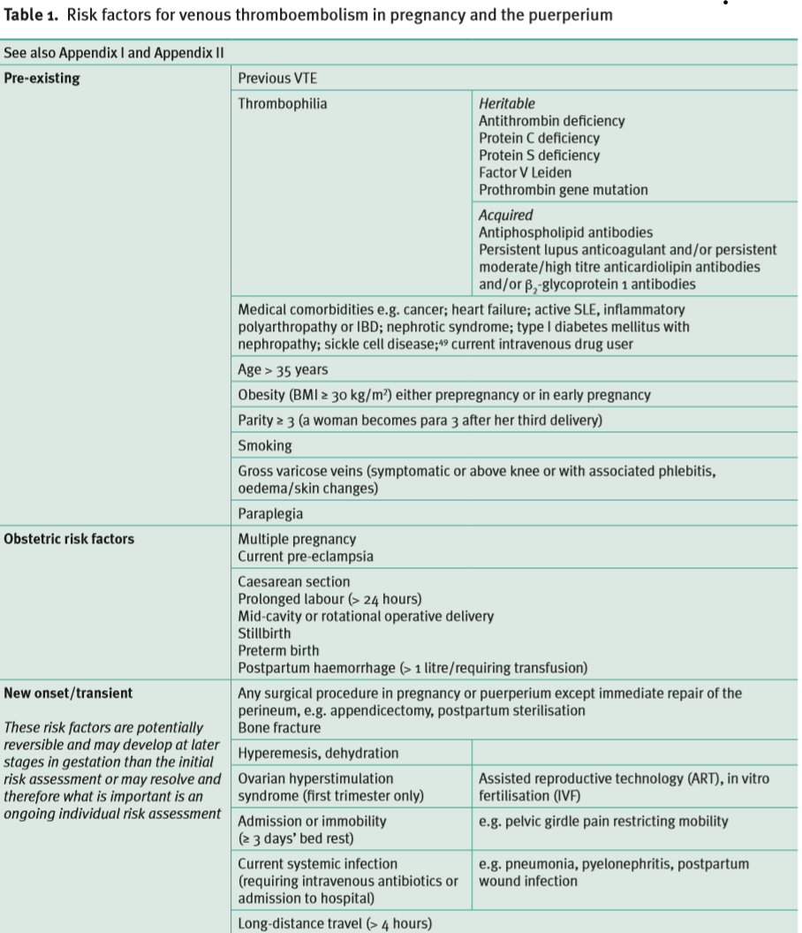

Royal College of Obstetricians and Gynaecologists. (2015). Reducing the Risk of Venous Thromboembolism during Pregnancy and the Puerperium. Available: https://www.rcog.org.uk/globalassets/documents/guidelines/gtg-37a.pdf Last accessed 15th August 2019

Appendix 4: Blood clots Easy Read Leaflet for Service users

19. Equality Impact Assessment

Name of service, function or policy | Reducing VTE Risk Policy
Brief description of service, function or policy (purpose)
Is the service, function or policy | ☒ Existing | ☐ New |  |  |  |  | ☐ Under review
Directorate  (If all groups are impacted, please state ‘Trust-wide’) | Trust-wide
Who is completing the EIA?  (name/role) | Bernadette Kinsella – Trust-wide Lead Physical Health Nurse
Which Trusts Strategies are supported by the service? | Population Health |  |  |  |  |  | ☒
Which Trusts Strategies are supported by the service? | The Experience of Care |  |  |  |  |  | ☒
Which Trusts Strategies are supported by the service? | Staff Experience |  |  |  |  |  | ☒
Which Trusts Strategies are supported by the service? | Improved Value |  |  |  |  |  | ☒
Which Trusts Strategies are supported by the service? | None |  |  |  |  |  | ☐
Who will benefit from the service, function or policy? | ☒ Workforce |  |  | ☒ Patients, Service Users, and Carers
How will the service, function, or policy be implemented to:  - Ensure access  - Meet health needs  - Provide a safe and positive experience for everyone? | The policy will be published on the Trust Intranet and promoted via the Communications Team.  Managers will be responsible for cascading the policy within their local teams to ensure staff understand their responsibilities.  Key aspects of the policy will be included in local induction programmes and discussed during supervision/appraisals.
How will the service, function or policy be implemented? | Approval at Physical Health Committee, Trust-wide Physical Health in Mental Health Group, Chair’s Action by Chief Nurse and Quality Committee.
What are the intended outcomes by delivering the activity?

How will these outcomes be measured?

Who are the key stakeholders for this activity and how have they been involved?

Does this service, function or policy impact other existing policies? | ☐ Yes |  |  | ☒ No
Is there any data available that  influences, affects, or shapes this Equality Impact Assessment? | ☐ Yes |  |  |  | ☒ No
Are there gaps in information?  Consider groups that you have not directly engaged with, or existing data that does not provide then full picture. | ☐ Yes |  |  | ☒ No
Does the service, function or policy have a negative impact on any particular group? | Protected Characteristic |  |  |  |  | Yes |  | No | Unclear
 | Age |  |  |  |  | ☐ |  | ☒ | ☐
 | Disability |  |  |  |  | ☐ |  | ☒ | ☐
 | Race |  |  |  |  | ☐ |  | ☒ | ☐
 | Marriage and Civil Partnership |  |  |  |  | ☐ |  | ☒ | ☐
 | Pregnancy and Maternity |  |  |  |  | ☐ |  | ☒ | ☐
 | Gender re-assignment |  |  |  |  | ☐ |  | ☒ | ☐
 | Religion or belief |  |  |  |  | ☐ |  | ☒ | ☐
 | Sex |  |  |  |  | ☐ |  | ☒ | ☐
 | Sexual Orientation |  |  |  |  | ☐ |  | ☒ | ☐
Could the way the service, function, or policy is implemented have an adverse impact on equality of opportunity or good relations between different groups? | ☐ Yes |  |  |  | ☒ No
 | N/A
Where a negative impact has been identified, can changes be made to minimise it? | N/A
Is the service, function, or policy indirectly discriminatory, and can it be justified? | ☐ Yes |  | ☒ No
 | N/A
Is the service, function, or policy intended to increase equality of opportunity by permitting Positive Action or Reasonable Adjustment? | ☐ Yes |  | ☒ No
 | N/A

Please select one option
☐ | This EIA indicates that there is insufficient evidence to judge whether there is differential impact.
☒ | This EIA shows that the service/function has a differential impact which is not negative.
☐ | This EIA reveals a differential impact which amounts to a negative impact.

Submit the completed Initial Equality Impact Assessment to Project Lead/Sponsor and EDI Team elft.edi-team@nhs.net for review.

EDI Team sign-off:

Reviewed by EDI Team | ☐ Yes | ☐ No
Date

Project Lead/Sponsor sign-off:

Has a negative or potential negative impact been identified? | ☐ Yes | ☐ No
Name
Role
Date

