

Enteral Feeding Policy for Children and Young People

Version number: | 2.0
Consultation Groups | Nurse Development Steering Group; Specialist Children and Young People’s Service- Clinical Governance Group. The Coburn Centre for Adolescent Mental Health. North-East London (NEL) Community Children’s Nursing Services
Approved by (Sponsor Group) | Specialist Children and Young People Service- Clinical Governance Group.
Date approved | 12th November 2025
Ratified by: | Quality Committee
Date ratified: | 28 January 2026
Name of originator/author: | Practice Development Facilitator.
Executive Director lead: | SCYPS Service Director
Implementation Date: | January 2026
Last Review Date: | November 2025
Next Review date: | November 2028

Services | Applicable
Trust wide
Mental Health and LD
Community Health Services

Version Control Summary

Version | Date | Author | Status | Comment
1.0 | May 2022 | Practice Development Facilitator (BG) | New policy drafted | Nasogastric tube feeding policy due to be reviewed and there is no current policy for all enteral feeding devices. Therefore, both combined into one policy.
2.0 | October 2025 | Practice Development Facilitators (Bianca Ansah and Natalia Campbell) | Policy reviewed and update | Disclaimer statement added.  Section 8.3: NEX measurement changed to NUMU measurement.  Section 8.3.1. New section added relating to therapeutic holding techniques for nasogastric tube insertion.  Section 8.7: Updated X-ray, tube position confirmation and safety guideline- including procedure for patients receiving acid-reducing medication.  Section 10.2: Balloon gastrostomy changes extended from every 3 months to every 4-6 months. Information and management of initial placement of the balloon gastrostomy added. pH Testing Upon Insertion of Balloon Gastrostomy Tube added.  Section 11.1: Updated reusable syringes for jejunal devices.  Section 12.3 updated: criteria for single use syringes updated- also in relation to jejunal devices.  Section 13: En-plugs updated to reflect changes from manufacturers.  Section 17: Troubleshooting information updated and flow charts added.  Section 17.12: Buried bumper syndrome information updated.  Section 18: Update on staff training.  Section 21: Added to include steps to take for agreed permanent removal of the balloon gastrostomy.  Appendices: Appendix 21 removed. Passing the nasogastric tube and feeding via the nasogastric tube have now been combined.

Executive Summary

This policy sets out the Trust-wide approach to the safe management of enteral feeding for children and young people aged 0–18 years within East London NHS Foundation Trust, primarily in community and specialist children’s services. It responds to the increasing number of children requiring enteral feeding and the need for consistent, safe, and evidence-based practice.

The policy aims to ensure high-quality nutritional care, reduce clinical risk, and support compliance with national guidance, medical device safety standards, and infection prevention requirements. It provides clear guidance on assessment, risk management, device selection and care, confirmation of tube placement, emergency procedures, and ongoing review.

Implementation is supported through defined multidisciplinary roles and responsibilities, robust competency and training requirements for staff, parents, carers and schools, and the use of standardised documentation and audit processes.

Adoption of this policy will strengthen patient safety, improve consistency of care, enhance family confidence, and support effective governance across children’s enteral feeding services within the Trust.

Contents

Paragraph |  | Page
1 | Introduction | 6
2 | Purpose | 6
3 | Definitions | 6
4 | Roles, Responsibilities and Referral Criteria | 8
5 | Indications for enteral feeding | 10
6 | Risk assessment | 11
7 | Infection control | 11
8 | Enteral Feeding Devices | 12
8.1 | Enfit | 13
8.2 | Nasogastric Tubes | 13
8.3 | Measuring the nasogastric tube insertion length | 14
8.3.1 | Therapeutic holding techniques | 14
8.4 | Confirming the position of the nasogastric tube | 15
8.5 | Securing the nasogastric tube | 16
8.6 | Documentation post nasogastric tube insertion | 17
8.7 | X-ray, tube position confirmation and safety guideline | 17
8.8 | Continuous overnight feeds via nasogastric tube | 18
9 | Nasojejunal Tubes (NJT) | 19
10 | Gastrostomy devices | 19
10.1 | Percutaneous Endoscopic Gastrostomy (PEG) | 19
10.2 | Balloon Gastrostomy | 21
10.3 | Other Gastrostomy Tubes | 25
11 | Gastrostomy/Jejunostomy devices | 26
11.1 | Percutaneous Endoscopic Gastrostomy - Jejunostomy (PEG-J) | 26
11.2 | Trans-gastric Jejunal Tubes | 27
11.3 | Jejunostomy Tubes | 28
12 | Syringes for Enteral Feeding | 28
12.1 | Reusable Syringes | 28
12.2 | Cleaning Reusable Syringes | 29
12.3 | Single Use Syringes | 29
12.4 | Ordering Syringes from Enabled Living | 29
13 | Emergency EN-Plugs | 30
14 | Methods of Feed Delivery | 32
14.1 | Pump feeding | 32
14.2 | Giving Sets | 33
14.3 | Bolus Feeding | 34
14.4 | Gravity Feeding | 34
15 | Water Flushes | 35
16 | Types of Feed | 35
16.1 | Sterile Commercial Feed | 35
16.2 | Decanted Sterile Feeds | 35
16.3 | Powdered Feeds/Non-Sterile Feeds | 36
16.4 | Blended Diet | 36
17 | Troubleshooting | 36
17.1 | Management of a blocked tube | 36
17.2 | Management of a jejunal tube | 37
17.3 | Management of skin redness | 38
17.4 | Management of granulation tissue | 40
17.5 | Management of leaking/discharge | 44
17.6 | Management of infection | 48
17.7 | Managing a balloon gastrostomy that is difficult to remove | 49
17.8 | Diarrhoea | 50
17.9 | Nausea or Vomiting | 50
17.10 | Constipation | 50
17.11 | Buried Bumper Syndrome | 51
18 | Training for parents/carers, staff and schools | 52
19 | Transition to Adult Services | 53
20 | Audit | 53
21 | Permanent removal of enteral device | 54
 | References | 56
Appendices
Appendix 1 | Discharge checklist
Appendix 2 | Risk Assessment for Continuous Overnight Nasogastric Tube Feeding
Appendix 3 | Feed Pump Risk Assessment Tool
Appendix 4 | Initial assessment tool for blended diets
Appendix 5 | Ordering codes for nasogastric tubes
Appendix 6 | Decision tree for nasogastric tube placement in children and infants
Appendix 7 | Procedures for commencing a nasogastric tube feed
Appendix 8 | Nasogastric Tube Position Confirmation Record
Appendix 9 | Nasogastric Tube Position Confirmation Record
Appendix 10 | Urgent Jejunal tube pathway for Naso-Jejunal Tubes
Appendix 11 | FREKA Gastrostomy manufacturer guidelines
Appendix 12 | CORFLO Gastrostomy manufacturer guidelines
Appendix 13 | Introducer User Guidelines
Appendix 14 | Salt Treatment Guidelines
Appendix 15 | Urgent Jejunal Tube Pathway for MICKEY GJ Tubes
Appendix 16 | Urgent Jejunal Tube Pathway for Freka Jejunal Tubes
Appendix 17 | Enteral Feeding Workbook
Appendix 18 | Nasogastric Tube Feeding Workbook
Appendix 19 | Competency for Enteral Tube Feeding
Appendix 20 | Nasogastric Tube Competency
Appendix 21 | Practical Assessment Sheet

Disclaimer:
This policy has been developed for use within the Specialist Children and Young People’s Services (SCYPS) and applies specifically to the care of children and young people receiving enteral feeding. If professionals working in other services within East London NHS Foundation Trust (ELFT) wish to reference or adapt this policy for use with adults or children outside of SCYPS, they must ensure alignment with and adherence to their own local policies, procedures, and governance frameworks. ELFT accepts no responsibility for the use or adaptation of this policy outside its intended scope.

- Introduction

Enteral feeding refers to the delivery of nutrients through the gastrointestinal tract. It can be administered directly into the stomach or jejunum via various routes, including orogastric, nasogastric, nasojejunal, gastrostomy, and jejunostomy (Macqueen, Bruce, & Gibson, 2012).
In the London borough of Newham, a significant number of children and young people require enteral feeding, either temporarily or on a long-term basis.
This policy has been developed in collaboration with key stakeholders, including children’s community nurses, special school nurses, the Community Paediatric Nutrition Support Dietitian/HETF Team Lead, and a gastroenterology nurse specialist.

- Purpose

The purpose of this policy is to provide clinical information to staff in order to support children, young people and their families to deliver safe nutrition via enteral devices in the community setting. This policy applies to all staff within East London Foundation Trust caring for children and young people with enteral feeding tubes and working with the London borough of Newham.

This policy and its procedures can be adapted for use with adult clients who have enteral devices and are under services within East London Foundation Trust.

Implementation of this policy will ensure that children, young people:

- Receive safe management of their enteral feeding device
- Receive safe nutrition under the care of a specialist home enteral feeding dietician
- Receive the correct equipment and guidance to manage their enteral feeding device in the community

- Definitions

Name and abbreviation | Definition
Enteral feeding | A method of supplying nutrients directly into the gastrointestinal tract
Gastrostomy | a tube inserted through the abdomen that delivers nutrition directly to the stomach
Jejunostomy | A tube inserted through the abdomen that delivers nutrition directly to the jejunum.
Balloon Gastrostomy | Low profile feeding device passing through the abdominal wall, through which enteral feed, fluid and liquid medication is administered into the stomach via a port accessed adjacent to the abdomen. Held in place by a balloon.
Percutaneous endoscopic gastrostomy (PEG) | Feeding tube passing through the abdominal wall, through which enteral feed, fluid and liquid medication is administered into the stomach via a port accessed at the distal end of the tubing
Percutaneous endoscopic gastrostomy-jejunostomy (PEG- J) | Feeding tube passed into the stomach through the abdominal wall, advanced through the pylorus to lie within the proximal jejunum to provide nutritional support
Nasogastric tube (NGT) | Feeding tube passing through the nostril, nasopharynx and oesophagus to the stomach, through which enteral feed, fluid and liquid medication is administered via a port accessed at the distal end of the tubing
Nasojejunal tube (NJT) | tube passed from the nose into the jejunum to provide nutritional support
Bolus feed | Intermittent administration of a designated quantity of enteral feed
Pump feed | Administration of enteral feed using an enteral feed pump to control the rate of feeding
Feeding Regime/Plan | An agreed plan often indicating the type, volume and speed of the feed or blended food given via a feeding tube. Typically produced and agreed between parents and dietitian.
Health Care Plan | Document prepared by Nursing Teams detailing care when the child is outside of the home under the care of a third party (i.e school or nursery)
Blended diet (BD) | Household food blended to a consistency whereby it can be administered via an enteral feeding device
Prescribed enteral feed | Commercially prepared formula of a nutritionally complete nature if sufficient volume is received available on prescription.
Anthropometry | Measurements of the body, usually for comparison with standards or to measure individual change over time

Diagram showing routes for enteral feeding

- Roles, Responsibilities and Referral Criteria

Competency Requirements for Enteral Device Insertion
Registered nurses and nurse associates may insert nasogastric (NG) tubes and balloon gastrostomy devices once they have been assessed as competent and have successfully completed the required competency documentation. Competency assessments and sign off must be conducted by a registered nurse or nurse associate who has already achieved the required competency.
Trainee nurses, including nurse associates and student nurses may only insert NG tubes and balloon gastrostomy devices under the direct supervision of a registered nurse or nurse associate who has been deemed competent.
All other enteral feeding devices that cannot be changed in the community setting must be inserted by the appropriate healthcare professional within a hospital setting.

Children’s Community Nursing Service (including community nurses and special school nurses)

- Receive referrals for children and young people 0-18 with an enteral feeding tube
- Ensure they have received adequate training to support children with enteral feeding devices, with awareness of risks and emergency procedures
- Ensure correct equipment is available for patient on discharge from hospital to home
- Provide training to enable the child/family to manage their enteral feeding device safely at home
- Management of supplies to be delivered directly to the family home on a regular basis
- Holistic reviews every 6 months minimum and assess quantity of supplies regularly.
- Provide care plans and training for school staff to ensure nutritional requirements are met safely during school hours.

Home enteral feeding Dietitian

- Assessing the nutritional status and calculating the nutritional requirements for all patients who commence enteral feeding
- Recommending a suitable feed and feeding regimen for the patient
- Reviewing patients as clinically required
- Reviewing all patients at least every 6 months
- Registering the patient with Fresenius Kabi homecare service and ordering feed and equipment
- Ensuring correct equipment is available for patient on discharge from hospital to home

Referral criteria:

Referrals should be made for infants, children and young people (0 – 18 years) with medical conditions requiring nutritional support due to faltering growth defined as:

- Children under two years of age
-Weight crossing down two or more centiles from the age of 6 weeks.
- Children over two years of age
-Weight consistently below two or more centiles for expected weight per height (for four months or more)
- All children under 0.4th centile for weight.
- All children with a BMI under 2nd centile

Verbal referrals can be made first if guidance is needed or if registration to a feed company is required and followed up with the written referral within 24 hours.

Speech and Language Therapist- Eating, Drinking and Swallowing

- Assessing children and young people with feeding and swallowing difficulties
- Recommending safe routes for feeding

Referral criteria:

All children and young people 0-18 years who meet one or more of the criteria must be referred to the Speech and Language Therapist:

- Signs of difficulty when eating/drinking e.g. coughing / gagging/ flushed cheeks/watery eyes
- Repeated chest infections
- Faltering growth/ failure to thrive
- Oro-motor difficulties impacting on chewing/ manipulating food in the mouth
- Requires textures to be altered
- Changes in feeding skills
- Difficulty sucking e.g. breast/bottle feeding

General Practitioner

- Prescribing medications in a form suitable to be administered via an enteral tube
- Prescribing milk requests from the dietitian
- Monitoring blood tests if required

Community Eating Disorder Service

A specialist service providing multi-professional support for young people up to the age of 18 who are experiencing an eating disorder

Referral criteria:

Children and young people must be referred to this service if there are concerns about an eating disorder.

Fresenius Kabi Homecare service

- Providing initial training for the feed pump before the child or young person is discharged from hospital
- Supplying the feed pump and giving sets once requested by the dietitian
- Annual service of the feed pump
- Troubleshooting problems related to the feed pump

Enabled Living Health Care Limited

Stock equipment required for enteral feeding (including syringes, tubes, pH strips and extension sets). They do not supply the feed pump or any related giving sets. Nurses are responsible for placing the order online via the Equipment Loan Management Service (ELMS) website.

- Indications for Enteral Feeding

Enteral feeding is required when a child or young person is unable to meet their nutritional requirements orally, and they have a functional, though not necessarily normal, gastrointestinal tract. Enteral feeding is indicated when oral intake is insufficient or unsafe and it ensures the child and young person is able to receive adequate nutrition and hydration to enable them to maintain their growth and development (Spalding and McKeever, 1998).

Enteral feeding may be indicated when the child or young person has:

Indication | Example
An unsafe swallow | Uncoordinated swallow due to neurological condition, neuromuscular weakness.
Absence of effective swallow | Due to prematurity
Congenital abnormalities | Cleft Lip and Palate, Oesophageal Artesia, Oesophageal Stenosis, tracheooesophageal fistula.
Not meeting their nutritional requirements | Unable to take adequate amounts via mouth due to health condition, treatment or unknown cause (poor oral intake, faltering growth, oncology, congenital heart disease, short gut Syndrome)
Increased nutritional requirements | Cystic Fibrosis
Treatment or medications which are not tolerated orally | Crohn’s disease/ulcerative colitis/metabolic disorders.
Psychological problems | Eating disorders.
Huband and Trigg (2000); NICE (2006)

Enteral feeding can take place via numerous routes along the gastrointestinal tract.

The route chosen is dependent on the following factors:
- Assessment of the child or young person
- Assessment of their gastrointestinal tract function
- Planned duration of the enteral feeding tube
- Ease of tube placement
- Families’ ability to manage the feeding tube, feeding and care and maintenance.

- Risk Assessment

The decision to commence enteral feeding is made by the multidisciplinary team if the child or young person is already within the hospital setting or Coburn Unit. A referral should be received by Community Children’s Nursing Service, Home Enteral Feeding Dietitian and other appropriate services specified above prior to discharge, to ensure smooth and supportive transition from acute to community.

Each service caring for a child or young person with an enteral feeding tube is responsible for carrying out a risk assessment to ensure safe feeding. Within the acute setting and Coburn unit, this responsibility lies with the multidisciplinary team. Community Children’s Nursing Service should enquire about individual risks when triaging referrals and during discharge planning meetings (ensuring the discharge checklist in Appendix 1 is completed). Community Children’s Nursing Service must then complete a risk assessment as part of their initial assessment documentation once the child or young person is discharged. This must include receipt of a signed enteral feeding competency to confirm the parent or carer has received full training.

The decision to commence enteral feeding within the community setting, East London NHS Foundation Trust, is a multidisciplinary team decision made by the community Dietitian, community Paediatrician and speech and language therapists involved in the child or young person’s care.

A detailed assessment of the child and young person must be undertaken to identify whether enteral feeding is appropriate for them and the rationale clearly documented within their electronic notes.

The following risk assessment templates are available within the appendices and must be completed based on the individual need to the child or young person:

- Appendix 2: Risk Assessment for Continuous Overnight Nasogastric Tube Feeding
- Appendix 3: Feed pump risk assessment
- Appendix 4: Initial assessment tool for blended diets (for dietitian use only)

- Infection Control

There are potential hazards associated with enteral feeding which can make it a source for the growth of micro-organisms. Liquid nutrients provide an ideal medium for bacteria and can cause cross contamination to the feeding system during setting up and handling the equipment. Staff must not handle enteral feeds if they have skin infections, diarrhoea or vomiting and must seek medical advice in such situations.

Before any care is given to a child or young person with an enteral feeding tube; the use of liquid soap and water must be undertaken to ensure hands are decontaminated, using the correct hand hygiene technique. This must also be undertaken after the care has been completed (NICE, 2003; Department of Health, 2010). This is classed as the first line method of hand hygiene.

The use of alcohol-based hand rubs or gels should be used where it is not possible to wash hands with liquid soap and water. Alcohol is not effective against some microorganisms (Clostridium Difficile) and will not remove dirt or organic material from hands so should only be used on visibly clean hands.

For effective hand washing to take place, all wrist and ideally hand jewellery must be removed before the hand hygiene technique is commenced. Cuts and abrasions must be covered with waterproof dressings and fingernails kept short, clean and free from nail polish (NICE, 2003).

Gloves and aprons must always be worn by professionals dealing with enteral feeding devices. These must be applied before setting up any feeds, water or medication (NPCT, 2009; DoH, 2010) and a non-touch technique used when preparing and connecting/disconnecting feeds, medications or water to the child or young person to reduce the risk of infection. Parents are not expected to wear personal protective equipment but must be observed and advised regards hand washing, infection control and use of non-touch technique when preparing feeds and accessing the enteral feeding device.

- Enteral Feeding Devices

Enteral devices are classified as medical devices, and healthcare professionals have a duty to ensure they are used and cared for correctly. They must also provide families and carers with the necessary information on proper usage in line with the manufacturer’s guidelines.
No modifications should be made to enteral feeding devices without first consulting the manufacturer. Anyone who alters a device without authorisation assumes full responsibility for the consequences.
Symbols on medical devices and their packaging must be adhered to. For example, devices marked with the “single use” symbol must not be reused and should be disposed of immediately after use (MHRA, 2006).


8.1 ENFIT

The International Organization for Standardization (ISO) created a new standard for enteral feeding devices called ISO 80369, also known as ENFit. ENFit connectors are designed to reduce the risk of connecting feeding tubes to the wrong type of device, such as those used for IV medicines. This helps improve safety and ensures enteral devices are the same worldwide (ISO, 2016; ECRI Institute, 2017).
All enteral feeding devices provided by Enabled Living Healthcare Limited meet the ENFit standard.

8.2 Nasogastric Tubes

Nasogastric tubes are the most frequently used route for enteral feeding and are suitable for short term purposes. The nasogastric tube (NGT) is inserted through the nose, down the oesophagus until the tip is in the stomach. NGT’s are used for administering feed, medication, venting or drainage of stomach contents. Staff, parents and carers involved in passing the nasogastric tube and feeding via nasogastric tube must be assessed as competent before they carry out any direct care for the child or young person.
Nasogastric tubes come in many different lengths (cm), widths (French/Fr) and material, made by different companies. All nasogastric tubes stocked at Enabled Living Healthcare Limited are radio-opaque in length with external markings and designed for enteral usage to comply with the NPSA alert (2011).

The following brands are available:
- Medicina
- Enteral
- Nutricare Infant
- EntralTM
- CORFLO©

Please see the manufacturer’s guide for the duration for use for each tube; this will range from 30-90 days. For further information about types of nasogastric tubes along with ordering codes, see appendix 5.

8.3 Measuring the nasogastric tube insertion length TO BE UPDATED TO NUMU
Previously, the standard method for determining nasogastric tube insertion length involved measuring from the ear to the nose and then to the xiphisternum (NEX). However, research by Taylor et al. (2014) found that this measurement is too short, as it only reaches the gastroesophageal junction. In contrast, the nose-to-earlobe-to-midpoint between the xiphisternum and umbilicus (NEMU) method (image below) has been shown to be significantly more accurate for stomach placement, achieving 97% accuracy compared to 59% for NEX (Irving et al., 2018). To ensure proper placement, the NEMU measurement must be performed each time a nasogastric tube is inserted, and staff members must document the length in centimetres within patient’s electronic medical records.

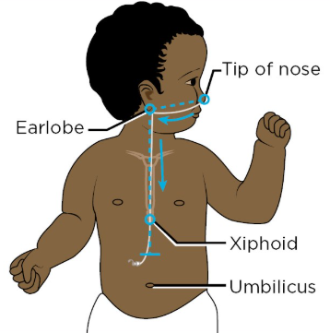

NEMU= Nose-earlobe-midline of umbilicus measurement

8.3.1 Therapeutic holding techniques

Babies, children and young people may require clinical holding to support the process of nasogastric tube insertion (Bray et al., 2019); this should be discussed with the patient and their parent or guardian. The figure below illustrates various therapeutic holding techniques (Hucker, 2022).

Nasogastric tube feeding may be used for short-term nutritional support in young people with eating disorders. When a patient is unable or unwilling to cooperate with NGT insertion, clinical holding or restraint may be necessary. In such cases, staff must follow the East London NHS Foundation Trust (ELFT) Policy on the use of Physical Holding Skills.

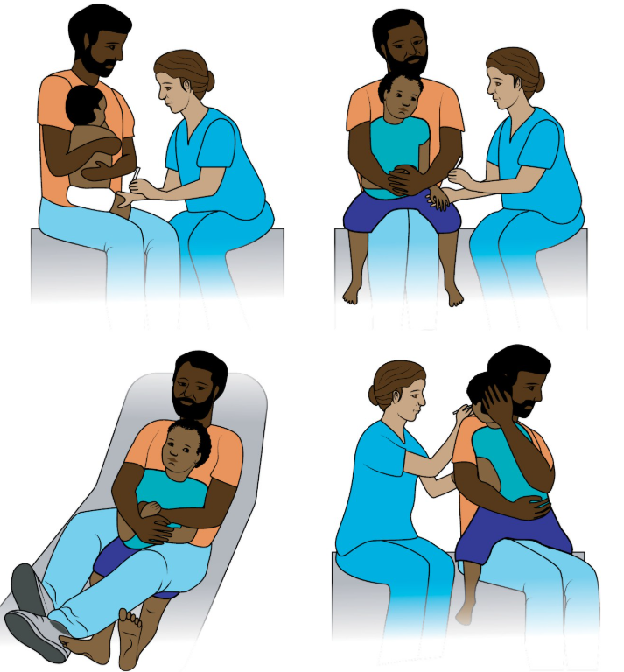
(Hucker, 2022)

8.4 Confirming the position of the nasogastric tube

To ensure safe use of a nasogastric (NG) tube in a child or young person, the tube’s position must be confirmed in the stomach before administering any water, feed, or medication. This is done by aspirating stomach contents and testing the fluid using pH indicator paper.
Only CE-marked pH paper designed specifically for human gastric aspirate should be used (MHRA, 2010; DOH, 2000). A pH reading of 5.5 or below (≤5.5) confirms the tube is in the stomach. Readings above this range (typically pH 7 to 9) may indicate placement in the bronchus or small bowel and are unsafe for use (NPSA, 2005; NHS Improvement, 2016).

To test:
- Aspirate 0.5 ml (for neonates) or 1 ml (for children/young people) using a 20 ml syringe.
- Place the aspirate on the pH strip.
- Wait up to 1 minute, then compare the colour change to the corresponding pH scale.
- Use the tube only if the result is 5.5 or lower.
If the pH is above 5.5 or no aspirate is obtained, do not use the tube. Instead, follow the guidance in Appendix 6: Decision Tree for Nasogastric Tube Placement in Children and Infants.
Note: If the patient is taking a proton pump inhibitor (PPI) such as omeprazole, or an antacid, this may affect the pH of gastric aspirate, potentially leading to consistently higher readings. In such cases, it is essential to document pH results and refer to section 8.7 and appendix 6 for management.

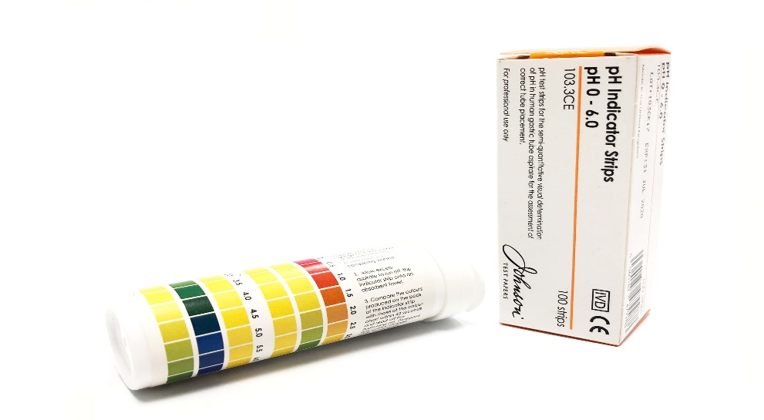

NHS supply code: FWM3043
Enabled Living Healthcare code: F013

8.5 Securing the nasogastric tube

Secure the tube to the patient’s cheek using a suitable fixation, ensuring the external markings of the nasogastric tube are visible. Typically, DuoDerm extra thin is placed on the cheek and Tegaderm film is placed on top to secure the nasogastric tube. Use alternative dressings if these dressings cause redness or irritation.
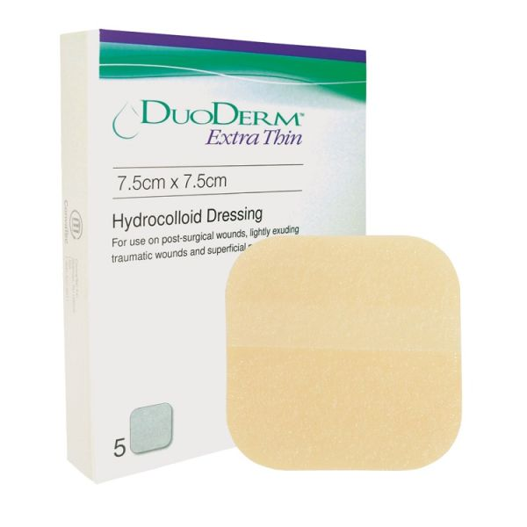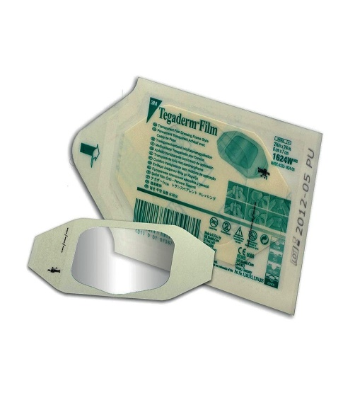
For procedures on commencing a nasogastric tube feed, see appendix 7

8.6 Documentation post nasogastric tube insertion

It is the responsibility of the professional who inserted the nasogastric tube to document the following:
- Date and time inserted
- Which nostril the tube was inserted (i.e. left or right nostril)
- Type and size of tube inserted
- NEMU measurement
- Measurement in cm at the nostril (e.g. 35cm)
- pH of aspirate obtained
- That it is safe/not safe to feed
- Any additional comments, e.g. how well the patient tolerated the procedure, difficulties in insertion, steps taken to obtain an aspirate, etc.

Metheny et al (1990), (1997), (1998), (1999); Metheny, Smith and Stewart (2000); Burns, Carpenter and Truwit (2001); Metheny and Titler (2001) and Hana (2010)

Staff working within East London Foundation Trust can either document the above with the child’s electronic notes or use the nasogastric tube placement checklist in Appendix 8. Within the school setting, School staff must complete the confirmation checklist in Appendix 9.

8.7 X-ray, tube position confirmation and safety guideline

PH testing should be the primary method for confirming nasogastric (NG) tube placement. An x-ray should only be used if aspirate cannot be obtained or if pH indicator strips fail to confirm the tube’s position. If an x-ray is required, the child or young person must be referred to the local hospital’s accident and emergency department. Nursing staff within the East London Foundation Trust are not expected to interpret x-rays.
If there is any indication that the tube has moved or displaced, either:
- The tube should be removed and reinserted, with placement confirmed by pH testing (≤5.5), or
- A second-line x-ray confirmation must be performed.
This decision, along with any risk factors, must be documented in the child’s medical notes for the Coburn Unit and in RIO records for community-based settings.
For children or young people receiving continuous feeds, acid-reducing medication, or frequent medication through the NG tube, obtaining an aspirate with a pH between 1 and 5.5 may not always be possible. Routine x-rays are neither practical nor safe (NPSA, 2011). If the initial placement was confirmed appropriately and there are no signs of displacement (e.g., vomiting, retching, coughing spasms, or unexplained respiratory symptoms), external tube observation may be the only viable method before administering feeds or medication.
In such cases, it must be agreed upon by the healthcare professional and the child’s family that tube placement can be confirmed by ensuring:
- The external tube length remains the same as the initial placement length.
- Facial tapes are secure and unchanged.
- There are no signs of displacement.
- If the child has a safe swallow and is permitted to eat or drink orally, offer a small amount of food or drink. After a few minutes, aspirate the nasogastric tube to check if food or drink is present in the aspirate.
The external tube length must be documented daily and before administering any medication, water, or feeds. This approach should only be used in exceptional circumstances and is not a routine alternative.

  - Continuous overnight feeds via nasogastric tube

Continuous overnight feeds via nasogastric tube is not recommended within the community setting due to high risk of aspiration. Parents must be adequately informed of the risks involved with continuous nasogastric tube feeding. The administration of continuous overnight feed will only be considered in exceptional circumstances. The community dietitian or nurses within Community Children’s Nursing Service must obtain a letter from the hospital consultant confirming their acceptance of responsibility for a child receiving continuous overnight feeds via nasogastric tube against the risks identified in appendix 2. The risk assessment must then be completed, followed by implementation of an action plan to help minimise risks.

Community Children’s Nursing Service must ensure parents/guardians have received resuscitation training if the child or young person is commenced on continuous overnight feeding via a nasogastric tube prior to discharge from hospital.

- Nasojejunal Tubes (NJT)

Some children are unable to tolerate feeding into the stomach and require a nasojejunal tube which bypasses the stomach. These tubes are more difficult to insert in comparison to nasogastric tubes; therefore insertion usually takes place during surgery or in the x-ray department. Confirmation of placement is determined by x-ray, after which the guidewire is removed, and feeding may commence. There are a small number of children in the community who are fed via a nasojejunal tube. The type of nasojejunal tube inserted will be at the discretion of the clinician. Nasojejunal tubes look very similar to nasogastric tubes as they are secured to the child’s check with the same recommended dressings. As there is no acid in the jejunum, pH testing is not required, and confirmation of placement is via x-ray only. If the tube were to become blocked or dislodged (identified by unable to flush, a change in the number at the nostril, loose tapes or vomiting milk), the child or young person must be taken to hospital and the urgent jejunal tube pathway for nasojejunal tubes followed (See appendix 10).

- Gastrostomy devices

For patients who require long-term enteral feeding, a gastrostomy device is the route of choice. A gastrostomy tube is inserted through the abdomen to deliver nutrition directly into the stomach. Benefits include being less likely to be displaced than an NG tube. Displacement of NG tubes will interrupt feeding and replacement can be uncomfortable.

A gastrostomy tube may be placed endoscopically (percutaneous endoscopically placed gastrostomy (PEG) or radiologically (radiologically inserted gastrostomy (RIG) or surgically. They are made from polyurethane or silicone and are therefore suitable for short- or long-term feeding.

10.1 Percutaneous Endoscopic Gastrostomy (PEG)

A gastrostomy tube inserted using endoscopic guidance through the mouth, into the stomach and out through the abdominal wall. For feeding directly into the stomach, or for drainage of stomach contents.

Freka PEG

- Inserted in hospital under general anaesthetic
- Available in two widths (French/Fr)- 9Fr & 15Fr
- Must be advanced and rotated daily from day 28 after insertion
- Clean the tube and stoma site daily
- Ensure the external fixation is 2mm from the skin to avoid over-granulation
- Clamp to be left open when tube is not in use, to avoid flattening and weakening of the tubing.
- Freka tubes should last for more than 18 months, but are kept in place indefinitely as long as they are functioning
- If a new replacement tube has been inserted, advance and rotation can begin from day 1 if no signs of trauma
- If the whole tube needs to be replaced, this must be done in the hospital. The following spare parts are available:

End adaptor External fixator Clamp

See appendix 11 for manufacturers guide on care and maintenance of Freka PEG tubes

Corflo PEG

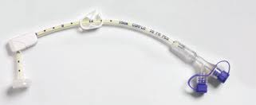

- Inserted in hospital under general anaesthetic
- Available in one width- size 16Fr
- Must be advanced and rotated from day 28 after insertion
- Clean the tube and stoma site daily
- Ensure the external fixation is 2mm from the skin to avoid over-granulation
- Clamp to be left open when tube is not in use, to avoid flattening and weakening of the tubing.
- Corflo tubes should last for more than 18 months, but are kept in place indefinitely as long as they are functioning
- If a new replacement tube has been inserted, advance and rotation ca begin from day 1 if no signs of trauma
- If the whole tube needs to be replaced, this must be done in the hospital. The following spare parts are available from Enabled Living

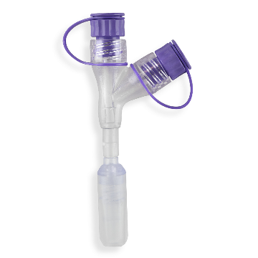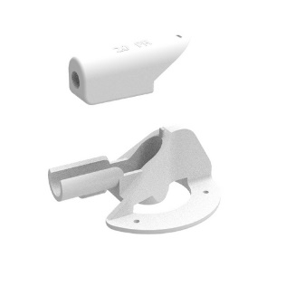
Corflo Y adaptor External fixator clamp

See appendix 12 for manufacturers guide on care and maintenance of the Corflo PEG

10.2 Balloon Gastrostomy

A low-profile balloon-retained gastrostomy tube may be used as a first-line device for patients requiring long-term enteral feeding. The initial insertion and formation of the stoma are carried out in a hospital setting under general anaesthetic. Once established (6 weeks), routine tube changes can be safely performed in the community.
Historically, balloon gastrostomy tubes were only inserted once the stoma tract had fully matured. However, advances in technique now allow for primary placement using a T-fastener gastropexy device. This involves the use of small, T-shaped anchors (T-fasteners) with sutures that temporarily secure the stomach to the abdominal wall, helping to maintain correct positioning and allowing the tract to heal safely.

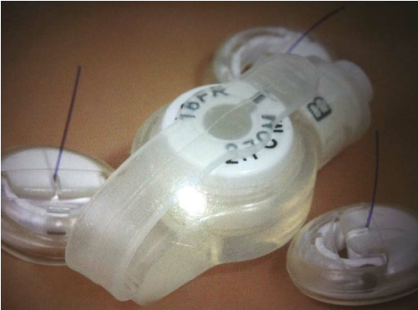

Management of T-Fasteners
- Parents/carers must inspect the site daily for signs of redness, swelling, discharge, or signs of infection.
- The area should be kept clean and dry. The community nursing staff must inform parents of how to clean the site, with cool boiled water for the first two weeks and then tap water thereafter.
- If a dressing is required, it must be a non-occlusive dressing to allow for visual monitoring.
- The sutures and fasteners should not be pulled or put under pressure.
- Monitor for pain or discomfort around the insertion sites. Mild pain is common, but increasing pain should be reported and assessed.
- T-fasteners are designed to fall off naturally once the sutures dissolve—usually within 2 to 4 weeks.
- If T-fasteners are still in place at 6 weeks post-insertion, and the tract is well healed, trained nursing staff may remove them by:
  - Cutting the suture at skin level
  - Gently withdrawing the T-fastener through the skin using clean technique
- Document the removal and condition of the site following the procedure (if required)
- Report any signs of buried fasteners (e.g. inflammation or hard lumps under the skin) and refer to the stoma nurse/surgical team.

Management of the balloon gastrostomy

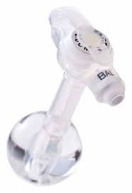

- Can be inserted in the community by appropriately trained staff, parents, or carers.
- Low-profile design improves comfort and reduces visibility under clothing.
- Available in a range of lengths and widths to suit individual patient needs.
- Balloon inflation should be checked every 7 days. The water must be replaced according to the manufacturer’s instructions, using the correct volume.
- Clean and rotate the device and stoma site daily to prevent infection and ensure free movement.
- Ensure the external base is flush with the skin to minimise movement and reduce the risk of over-granulation.
- The device can remain in place for up to 6 months but is routinely replaced every 4–6 months.
- The extension set should be removed when not in use to avoid unnecessary wear or contamination.
- Extension sets can be cleaned and reused for up to two weeks; follow local infection control guidance.
- If there is difficulty inserting the tube, use the introducer/stylet to help guide the device into the stoma.
- The stoma length should be remeasured as needed using a stoma measuring device, especially if leakage or poor fit is suspected.

Extension set Stoma measuring device

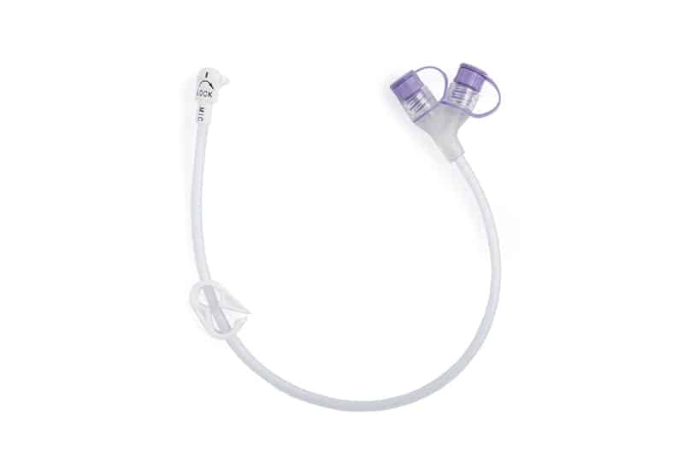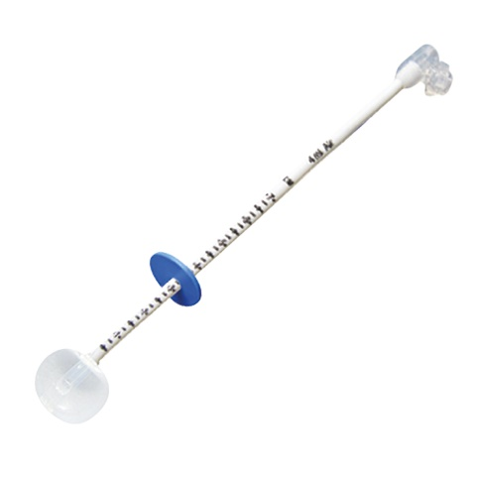

Introducer
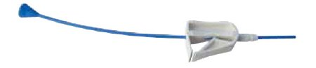

See appendix 13 for introducer user guide

pH Testing Upon Insertion of Balloon Gastrostomy Tube
Following the placement of a new balloon gastrostomy tube, nurses may wish to test the pH of gastric aspirate to support confirmation of correct positioning prior to commencing feeds or medications. Using a 20 mL enteral syringe, an attempt should be made to aspirate gastric contents via the newly inserted tube. If aspirate is obtained, it can be tested immediately using CE-marked pH indicator paper designed for gastric use. A pH reading of 5.5 or below indicates sufficient acidity and is consistent with gastric placement. If the pH is above 5.5, this may suggest non-gastric positioning (e.g. stomach lining) and alternative methods of confirmation, such as radiographic imaging, should be considered before use.

10.3 Other Gastrostomy Tubes

The above gastrostomy tubes are most common amongst children and young people that reside in Newham. There are a range of other gastrostomy tubes available. If you are caring for a child or young person with one of these devices, or if the device is not listed; please follow the manufacturers guide.

Capsule Monarch Gastrostomy Tube

This is a non-balloon retained tube which is used for patients whose balloon retained tubes do not last. It is inserted via an existing stoma and lasts 1-2 years.

Radiologically Inserted Gastrostomy (RIG)

A balloon retained gastrostomy tube inserted using radiological (x-ray) guidance into the stomach directly through the abdominal wall. For feeding directly into the stomach, or for drainage of stomach contents. This method of insertion is used if the endoscopic method is not possible.

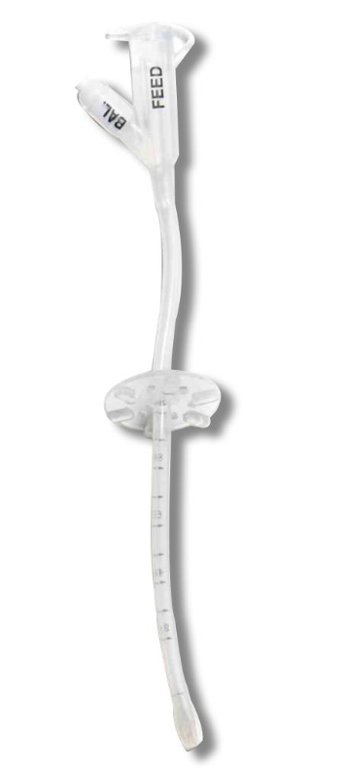

MIC G tube

A balloon retained gastrostomy tube. It has an adjustable external fixator. This low-profile device can be inserted within the community setting like the balloon gastrostomy.

- Gastrostomy/Jejunostomy Devices

A gastrojejunostomy (GJ) feeding device is a combination of a gastrostomy device (placed into the stomach) and a jejunostomy device (placed into the jejunum, the first part of the intestines). The feeding device allows feed to be given directly into the jejunum, bypassing the mouth, throat and stomach. It also allows access to the stomach to draw off excess air, test the contents of the stomach, provide drainage, or possibly give medications directly into the stomach.
All GJ devices have two ‘ports’ – one ends in the jejunum and the other in the stomach. These are clearly labelled, so you will know which is which. The advantage of having two ports is that different fluids and medicines can be given into the stomach and/or the jejunum as directed by the dietitian and pharmacist.

A GJ device is usually suggested after gastrostomy feeding has been unsuccessful. Some children cannot tolerate feeding directly into the stomach, so a GJ device can be helpful as it bypasses the stomach. A GJ device can be helpful for children with gastric motility problems, where food does not pass through the stomach to the intestines as it should.

  - Percutaneous Endoscopic Gastrostomy - Jejunostomy (PEG-J)

Percutaneous Endoscopic Gastrostomy with a Jejunal extension – a 9Fr tube passed through an existing Freka 15Fr PEG under endoscopic guidance, into the jejunum, to allow feeding directly into the jejunum. The gastric port can also be used for administration of fluids, medication or feed, or drainage.

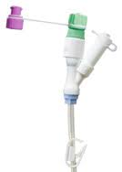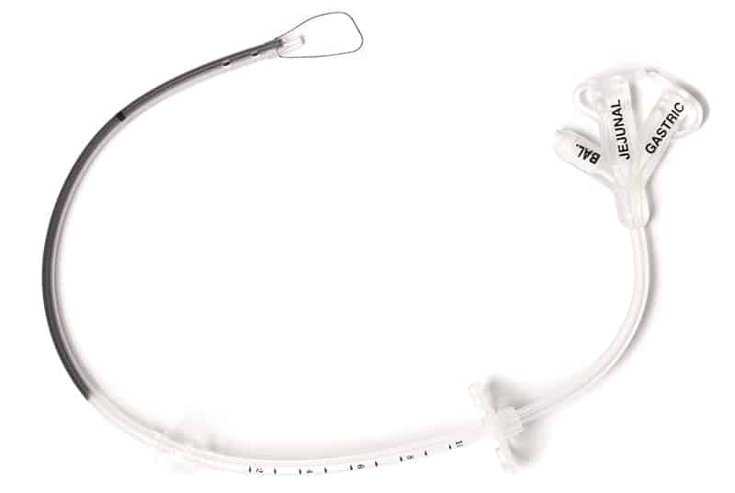

- Inserted and replaced in hospital under general anaesthetic.
- Repaired in hospital under interventional radiology.
- Gastric and jejunal ports clearly labelled or colour coded.
- Cool boiled water to be used for water flushes.
- Reusable syringes can be used, they must be cleaned thoroughly or sterilised (see sections 12.2 and 12.3).
- Gastric port typically used for medication, water flushes, free drainage and aspiration.
- Jujunal port for liquid feed and water flushes.
- Cap, tube and stoma site to be cleaned daily.
- Device should be advanced weekly but must not be rotated as this will cause the jejunal extension to twist and block within the bowel.
- Leave clamps open when tubes are not in use to prevent weakening of the tube.

  - Trans-gastric Jejunal Tubes

A feeding tube placed directly into the stomach and fed through to the jejunum. This device is held in place with a balloon in the stomach. Extension sets are then connected to enable feed, water or medication to be given.
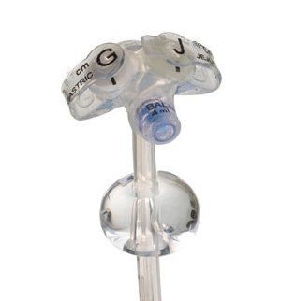

- Initially inserted in hospital under general anaesthetic.
- Replaced in interventional radiology under x-ray while the child is awake
- Replaced every 6 months typically
- Gastric and jejunal ports clearly labelled ‘G’ or ‘J’
- Cool boiled water to be used for water flushes
- Single use syringes to be used with any jejunal device
- Gastric port typically used for medication, water flushes, free drainage and aspiration.
- Jujunal port for liquid feed and water flushes.
- Jejunal tube to be flushed every 6 hours if not in use
- Stoma site to be cleaned daily.
- Never turn or advance the tube as this can cause the tube to migrate out of the jejunum and into the stomach
- The water in the balloon must be changed WEEKLY to prevent the water in the balloon evaporating, which may lead to the device becoming dislodged
- Extension sets can be used for two weeks and can be washed with warm soapy water (ensuring thorough rinsing).

  - Jejunostomy Tubes

A jejunostomy tube is placed through the skin of the abdomen into the midsection of the small intestine to deliver nutrition. A jejunostomy or a jejunal extension to a gastrostomy should be used if a patient has undergone upper GI surgery or has severe delayed gastric emptying. A jejunostomy tube may be placed endoscopically (Percutaneous endoscopically placed jejunostomy (PEJ) or radiologically (radiologically inserted jejunostomy RIJ) or surgically.

- Syringes for Enteral Feeding

Within East London NHS Foundation trust, only ENFIT syringes can be used to administer
medication, enteral feed or water via an enteral feeding device. ENFIT syringes cannot be
connected to intravenous catheters or ports.

Medication or feed should be calculated over a daily requirement. The same syringe can be used to flush before and after a feed.

12.1 Reusable Syringes

The current brand of reusable syringe is Enteral ISO-safe home. These syringes can be used up to 84 times each. Syringe assessment must be carried out to calculate the number of syringes needed per day then multiplied by two to obtain the monthly amount. These can safely be re-used up to six times per day for no more than 14 days (or 84 uses). They must then be discarded and new syringes commenced after 14 days. Extra syringes may be ordered if the child attends school.

12.2 Cleaning Reusable Syringes
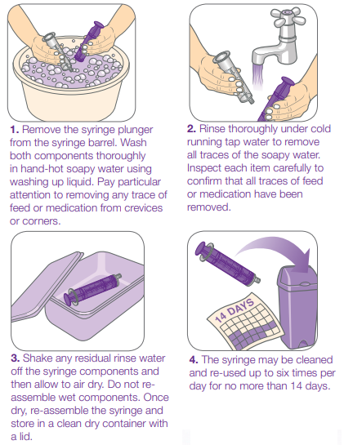

12.3 Single Use Syringes

Single-use syringes will only be provided to children who are immunocompromised, receiving cytotoxic medication, or post-transplant (if requested by the managing hospital). Previously, all children with jejunal devices were given single-use syringes due to the absence of stomach acids, which normally help protect against harmful bacteria. However, with proper cleaning techniques and sterilisation, the risk of contamination can be significantly reduced, making the routine use of single-use syringes unnecessary for most patients.
The current brand of single-use syringes is Entral. The difference in brand between single-use and reusable syringes helps prevent ordering errors.

12.4 Ordering Syringes from Enabled Living

All health professionals working within the trust need to ensure they order the appropriate size syringes for the child’s feeding and medication regime. A table of syringes stocked at Enabled Living along with ordering codes can be found below.

Reusable syringes
Make | Type | Size | NHS supply code | Enabled Living code
Iso-saf Enteral | ENFit/enteral | 1ml | FTA311 | F01A
Iso-saf Enteral | ENFit/enteral | 2.5mls | FTA312 | F02A
Iso-saf Enteral | ENFit/enteral | 5mls | FTA309 | F05A
Iso-saf Enteral | ENFit/enteral | 10mls | FTA179 | F10A
Iso-saf Enteral | ENFit/enteral | 20mls | FTA301 | F20A
Iso-saf Enteral | ENFit/enteral | 60mls | FTA305 | F60

Single use syringes
Make | Type | Size | NHS supply code | Enabled Living  code
EntralTM | ENFit/enteral | 1ml | FTA317 | F1101A
EntralTM | ENFit/enteral | 2.5mls | FTA316 | F1102A
EntralTM | ENFit/enteral | 5mls | FTA313 | F1105A
EntralTM | ENFit/enteral | 10mls | FTA314 | F1110A
EntralTM | ENFit/enteral | 20mls | FTA318 | F1120A
EntralTM | ENFit/enteral | 60mls | FTA346 | F1151A

Enabled Living Healthcare also stock catheter tip syringe for bladder use only as follows:

Size | Enabled Living code
50mls | A150
60mls | F1150

- Emergency EN-Plugs

When a gastrostomy or jejunostomy device is accidentally displaced, there is a risk of the stoma closing; therefore, it is imperative that a suitable device is inserted into the stoma immediately after displacement. EN-Plugs are designed for emergency use to prevent the stoma from healing and to maintain the patency of the tract with minimal risk. Nursing staff, parents, and school staff must receive appropriate training in inserting the EN-Plug to ensure this is done safely and correctly.
Not all children or parents require EN-Plugs at home. For example, if the child has a balloon gastrostomy in situ, they should be provided with a spare balloon gastrostomy device so that, if it is accidentally removed, it can be replaced immediately. Each situation should be assessed on an individual basis.
EN-Plugs are made of medical-grade silicone and are latex- and phthalate-free. There are two types of EN-Plug available. Some packs contain coloured EN-Plugs, while others may include white (translucent) EN-Plugs. The French size is moulded on the top of each EN-Plug.
Colours and sizes (for coloured EN-Plugs): Black – 10F, White – 12F, Green – 14F, Orange – 16F
For the white (translucent) EN-Plugs, the size marking may not be easily visible. To make the size clearer, it may be helpful to carefully trace over the embossed size number with a black permanent marker.
The EN-Plug size inserted must always match the size of the enteral device that was accidentally removed. For example, if the child has a 12 French balloon gastrostomy in place, then the 12F EN-Plug (white) should be inserted in an emergency. The EN-Plug length for gastrostomy and jejunostomy use is 4 cm. A longer length is available but must not be used in children.
If a child or young person with a PEG or PEG-J has accidental device displacement, the correct EN-Plug should be inserted, and the child must attend hospital immediately for replacement. Balloon gastrostomies, however, can be replaced in the community setting.
EN-Plugs are reusable for up to six months.

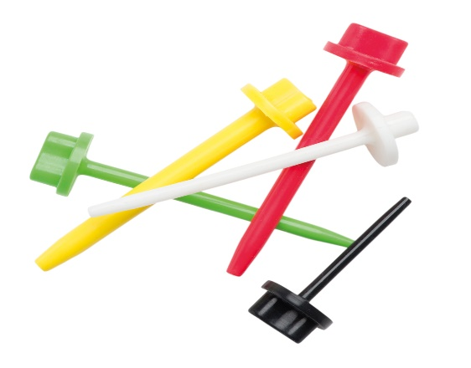 OR 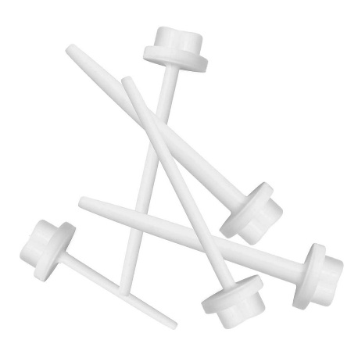

Procedure for inserting the EN-Plug:

- Do Not Panic – it is not life threatening.
- Wash hands and apply suitable fitting gloves.
- Lie the child down or recline them in their chair.
- Wipe the stoma site with gauze and water to ensure the stoma site is visible.
- Open up EN-plug pack.
- Remove the correct size EN-plug from the pack. This should be the same size as the child’s enteral feeding tube
- Insert the EN-plug into the stoma site until it is flush with the abdomen.
- Cover with a first aid dressing or tape to secure the EN-Plug

If unable to insert the correct size EN Plug into the stoma

- Remove the next size down EN-plug from the pack and attempt to insert into the stoma. If successful, cover with first aid dressing
- If unsuccessful, cover with a first aid dressing
- The EN-plug is only temporary, arrange for the enteral device to be reinserted either at home or hospital (depending on device).

- Methods of Feed Delivery

Enteral feeds can be administered through a range of methods. Always follow the method of feeding recommended by the dietitian. This can be found on the feeding regimen. If you feel that a different method would be more appropriate for the patient, please discuss with the dietitian.

14.1 Pump feeding

The feed pump used within East London Foundation Trust for children and young people is the Amika® smart enteral feeding pump manufactured by Fresenius Kabi. The volume and rate of each feed is calculated by the dietitian. Please use the following link to access the Fresenius Kabi website for information on how to use the Amika feed pump and how to troubleshoot. Fresenius Kabi are responsible for servicing the pumps on a yearly basis. Any problems with malfunctioning pumps should be reported directly back to Fresenius Kabi.

https://www.fresenius-kabi.com/gb/resourcehub/patient-nutrition-resources/amika--enteral-nutrition-pump

A pictorial guide can also be accessed using the link above.

The following video is also available:

How to use the Amika enteral feeding pump:
https://www.youtube.com/watch?v=8w1J1WfX_Yw

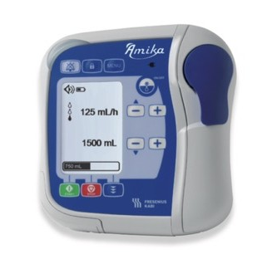

The Amika® pump can be used either on a stationary stand (within the patient’s home) or with the portable rucksack to allow mobility. Fresenius Kabi stock two size rucksacks for ambulatory use with the Amika® feed pump

- Mobility Kit Small (blue) for younger children.
- Mobility Kit Large (black) for older children and adults.

Volume delivery

The volume to be delivered must be set prior to each feed and the previous feed delivered must be cleared before a new feed is started. This will enable the volume infused to be monitored and ensure the child or young person receives the correct amount of feed. Any problems identified with under or over delivery of feed must be reported back to Fresenius Kabi immediately (Medical Device Alert MDA/2011/058).

The Amika® pump will reset volume delivery if the feed is interrupted where the pump is switched off and on again or if there is a power failure. If a feed is interrupted before the volume is delivered, ensure pump is placed on hold by pressing the stop button; this will prevent over delivery of feed to the child or young person. The risk of overfeeding following power failure to the feeding pump must form part of acquisition of competency. Please ensure parents, carers and school staff are aware of the risks of overfeeding outlined in the feed pump risk assessment tool (appendix 3).

  - Giving Sets

Giving sets are required to feed with the pump. There are various giving sets available that can be ordered by the dietitian from Fresenius Kabi. The dietitian will select the most appropriate and safe giving set. Feeding sets are provided for both the stationary stand and mobile rucksacks. Only the Duo lines are interchangeable between stationary and mobile set up. Giving sets with a chamber will not fit within the mobile rucksacks and should not be used as this will lead to problems with kinking and air within the line, causing the pump to alarm.

The giving set needs to be correctly fitted within the pump to prevent any free flow of feed to the child or young person as this poses a potential risk of fatal overfeeding (Medical advice alert MDA/2007/098).

All feeding sets must be primed using the pump and not primed using gravity.

The most common types displayed below

Amika mobile set

This can be used with the drip stand or in the rucksack.

Varoline giving set

For use with an Abbott feed bottle

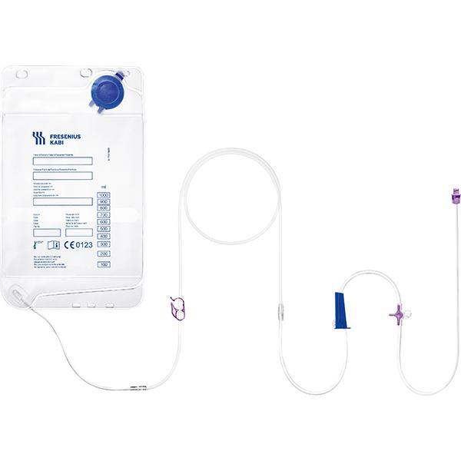
Amika giving set

For mobile use with the rusksack
  - Bolus Feeding

Bolus feeding involves giving the feed in measured doses. This is measured in a syringe and then administered directly into the enteral device, typically over 3-5 minutes.

  - Gravity Feeding

Gravity feeding allows the feed to drip into an enteral device using gravity rather than a feed pump. This is achieved by removing the plunger from a 60ml syringe, connecting it to the enteral device and then adding the feed. The higher the syringe is held above the stomach, the faster the feed enters the stomach. Not all children or young people can tolerate the rate of gravity feeding. Gravity feeding must be initiated within the hospital setting first before the child is discharged home; this allows staff to fully assess their tolerance. The hospital setting must inform the community dietitian of the volume tolerated via gravity.

- Water Flushes

Enteral feeding devices must be flushed regularly with water, before and after medications and feeds are administered. Flushing before will check the patency of the tube whilst flushing afterwards will ensure the tube remains clear of any feed or medication which could potentially block the tube (NICE, 2003).

Enteral feeding tubes that are not being used regularly should be flushed at least 3 times a day to ensure patency of the tube (Huband and Trigg, 2000; Merck Serono, 2009 and Medicina, 2011).

The volume of water is dependent on the child or young person’s needs and will vary depending on hydration requirements. The dietitian will advise the family on how much water to flush and this should be documented within the care plan for the child or young person.

Cool boiled water

- For children under 12 months
- Children or young people receiving enteral feeds into the Jejunum
- Children or young people who are immunocompromised.
- Inflating balloons of balloon retained devices

Freshly drawn tap water – for all other children and young people.
(NICE, 2003; DoH, 2010)

- Types of Feed

16.1 Sterile Commercial Feed

The majority of children and young people will be on these feeds. Feeds should be stored in a clean dry environment, between 5-25 degrees. Check expiry date before use. Do not add anything to the feed. Discard unused open feed after 24 hours. If feeds have been opened, they should be refrigerated below 5 degrees and used within 24 hours. At room temperature, the feed must be used within 4 hours if not given continuously. If the giving set has not been removed, the feed can be used for up to 24 hours.

  - Decanted Sterile Feeds

Feeds which are not ready to hang or require additions must be decanted into a sterile reservoir. The full volume for 24 hours should be decanted using an aseptic no touch technique.

  - Powdered Feeds/Non-Sterile Feeds

Utensils must be sterile, or heat sterilised in a dishwasher. Feeds must be thoroughly mixed using a non-touch technique. Cooled boiled water at home to make up powdered feeds. Modified feeds can be refrigerated below 5 degrees for up to 24 hours. Feeds can hang at room temperature for up to 12 hours at home if the patient is older than 12 months and not immunocompromised.

  - Blended Diet

East London NHS Foundation Trust (ELFT) recognises that there has been a national increase in popularity of blended/liquidised diets via enteral feeding tubes as an alternative to commercially available prescribed enteral feeds in the UK. There is a growing body of new evidence which demonstrates that anecdotal benefits reported by patients and families can be replicated under research conditions. These benefits included:
- Reduced vomiting and retching
- Improved bowel function
- Reduced dependence on medication
- Improved general wellbeing and mood

It is important that when patients or families are considering using a blended diet that they are aware of all the possible risks. A comprehensive, individualised risk assessment should be completed for all (appendix 4), in line with ELFT Blended diet policy. The risk assessment is likely to be completed by the child’s dietitian.

ELFT clinicians will endeavour to support a family’s decision to transition to a blended diet aiming to work collaboratively with the patient/ family and carers to reduce the possible risks. The Dietitian should document and discuss reasons for the request and any alternatives that have been considered

For assessment and commencement of a blended diet, please refer to the ELFT Standard Operating Procedure for Blended Diet in Children via Enteral Feeding Tubes 2025.

- Troubleshooting

  - Management of a blocked tube

The most effect way to prevent tube blockage is through a good flushing technique. If a tube is blocked, please follow these steps.

Step 1
Massage
- Gently massage any visible blockage to attempt to dislodge it.
- Attach a 20ml or larger syringe and attempt aspiration to remove any particles.

- Connect a 20ml syringe filled with warm water.
- Use a gentle push-pull technique to help loosen the blockage
Step 2
Push and Pull

- Connect a 20ml syringe filled with soda water.
- Gently push and pull the plunger to attempt to dislodge the blockage.
- If the blockage begins to clear, allow the soda water to remain in the tube for a few hours before flushing with fresh water.

Step 3
Soda water

- Do not use small syringes as they may split the tube.
- Do not insert guidewires as it can puncture the tube and injure the gastrointestinal mucosa.
- Do not flush with cola or pineapple juice as this may worsen the blockage.
DO NOT

Adapted from PIER Network (2022)

  - Management of a jejunal tube

Any child or young person with a jejunal tube or gastrostomy tube with jejunal extension are advised to attend the Royal London Hospital if any problems arise. Jejunal devices can only be repaired in the interventional radiology department under X-ray. Problems that may arise include:

- A blocked tube
- Child or young person vomiting milk
- Milk aspirated from gastric port of a GJ tube
- Connection is broken and child or young person is unable to feed
- There is a split in the tube
- The whole tube has come out

Parents/carers are encouraged to follow the guidance in Appendix 15 and Appendix 16 and pick a scenario that most fits their child’s tube issue. They must then follow troubleshooting guidance and if unsuccessful, contact the Royal London Hospital.

Important information on who to contact regarding urgent jejunal tube change
1) ‘In hours’ to contact Paediatric Assessment Unit (PAU) 10am-8pm Monday to Friday – Telephone Number: 02035945760
2) ‘Out of hours’ after 8pm and at weekends – attend Royal London A&E department
3) If PAU up to full bed capacity, then to go to A&E
5) Please bring your child’s spare tube and jejunal tube patient passport with you

  - Management of skin redness

Follow these steps to manage redness around the stoma:

Follow section 17.6 if signs of infection are present.
Assess for infection
Clinical signs to look for:
- Spreading redness, warmth, fever, and possible pus
- Visible skin pustules, especially with mouth or groin fungal infections

No evidence of infection

Ensure the following factors have been assessed and managed

Check the gastrostomy is the correct size and is supported properly with a fixation device.
Check for granulation. If present, treat it following the steps in section 17.4
Check for leakage or discharge. If present, follow the steps in 17.5

Management of skin redness

General management
- Avoid irritants, for example: Soaps, Wet wipes, Moisture on the skin.
- Swab if blistering or erosions
- Wash the gastrostomy device and surrounding skin twice a day with warm water only and pat dry.
- Apply a greasy emollient ointment 2-4 times a day (e.g. Vaseline, Cetraben, Epaderm or Zeroderm).

Additional management
Medihoney: This can promote healing and have antimicrobial properties. Apply this instead of emollient; clean first, apply medihoney and cover with gauze or dressing. Apply once a day for up to two weeks.
Eumovate ointment: Apply 20 minutes prior to the emollient, once daily for 2 weeks.
Note: this may need to be repeated for further episodes of redness

  - Management of granulation tissue

When a wound is healing, the body makes new tissue called granulation tissue. This is a mix of new skin cells, blood vessels, and immune cells that help repair the area. Sometimes, the body makes too much of this tissue, this is called over-granulation or a granuloma. It sticks out above the skin, stays moist, and can bleed easily. It’s not dangerous, but it can be troublesome to treat.

Key features of over-granulation tissue:
- Not harmful
- Red, moist, and bleeds on contact
- Exudes a yellow, sticky discharge that dries brown
- May interfere with stoma device fit
- Common within the first 3 months

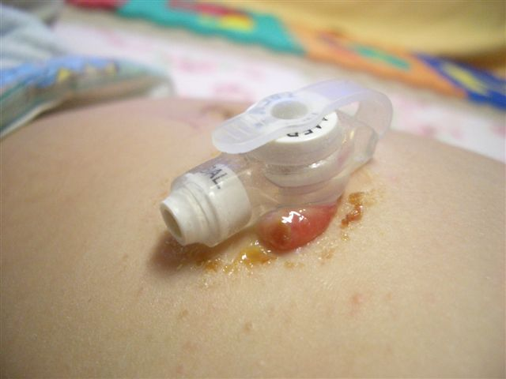

The following steps can be taken before following the granulation pathway:

- Ensure the fixation device is placed correctly 2mm away from the skin. If loose, this can exacerbate or cause over-granulation.
- The tube size should be carefully assessed for signs of pressure, trauma, or friction, and any issues must be addressed.

Pathway for the management of granulation tissue:

Step 1
Introduce Prontosan wound irrigation solution to clean the stoma site daily
Reassess after 2 weeks
Step 2
Salt Treatment
Apply 2 times a day for 2 weeks
Reassess after 2 weeks
Step 3
Hydrocortisone 1% ointment. Twice a day for 2 weeks cover with a foam dressing
Reassess after 2 weeks
Step 4
Maxitrol eye ointment
Rub in 4 times a day to granuloma for 2 weeks,
cover with a foam dressing

Reassess after 2 weeks
Granuloma not resolved, refer to specialist.
Reassess after two weeks
Step 5
75% Silver Nitrate treatment
To be applied by a nurse only
Reassess after 2 weeks

Granuloma resolved, stop treatment.

Adapted from PIER Network (2022)

Salt treatment: step-by-step

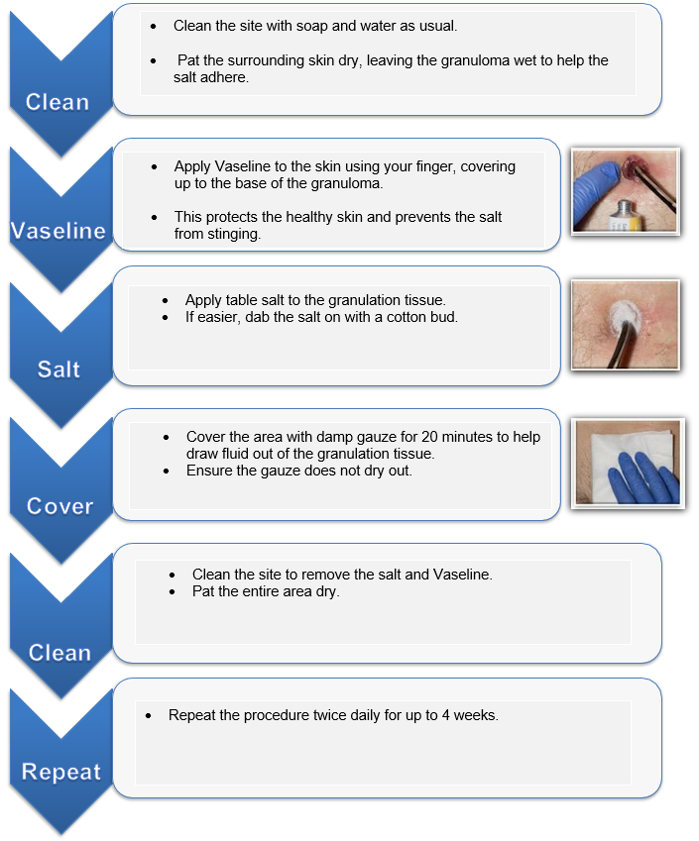
Adapted from PIER Network (2022)

Silver Nitrate Treatment: step-by-step

Ensure the following prior to using silver nitrate:
- Avoid using silver nitrate if the child is sensitive to silver.
- Application can be painful; consider giving pain relief beforehand to keep the child comfortable.
- Always apply Vaseline to protect healthy skin before using silver nitrate on the stoma.
- Do not use saline or antibiotic creams, as they can interfere with the effectiveness of silver nitrate.
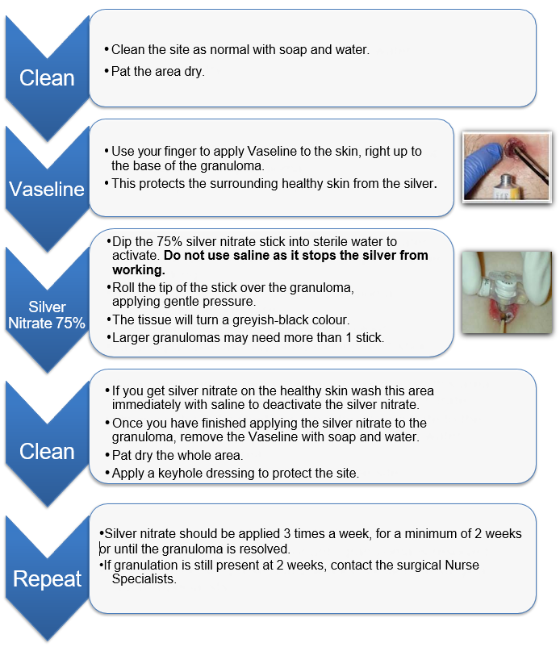Adapted from PIER Network (2022)

  - Management of leaking/discharge

When managing gastrostomy site leakage, it's important to assess and address potential underlying causes systematically to ensure proper function and patient comfort.
- Ensure the fixation device is placed correctly 2mm away from the skin. If loose, this can exacerbate leakage. Ensure the child or young person is positioned correctly when feeding.
- Check the tube for damage, if damaged, repair or replace tube. Or refer to acute setting.
- Check the patient is not suffering with constipation or a chest infection, if so treat the problem.
- Test leakage with pH indicator to determine whether it is stomach acid or a potential infection.
- If pH 5.5 and below, leakage is gastric content. Apply barrier cream and a dressing for 10-14 days at least
- If possible, infection, swab and contact GP
- If still leaking, consider resizing the gastrostomy tube.

17.5(a) Managing discharge from the stoma Adapted from PIER Network (2022)
No
Is the child experiencing a fever and spreading cellulitis (a bacterial skin infection causing redness, swelling, warmth, and pain) around the stoma site?

Yes
DO NOT SWAB
Refer to 17.3 management of skin redness
- Clean site with Prontosan
- Apply barrier film to protect skin
- Apply foam dressing
- Review in 2 weeks
Is there redness / skin irritation?
Refer to 17.5 (b) Management of a leaking gastrostomy stoma
Pathway
Refer to 17.6 management of Infection
Pathway
No
Yes
No
Yes
pH > 5
pH < 5
Is there obvious stomach contents leaking from the stoma site?
What is the pH of the discharge?

17.5(b) Management of a leaking gastrostomy stoma

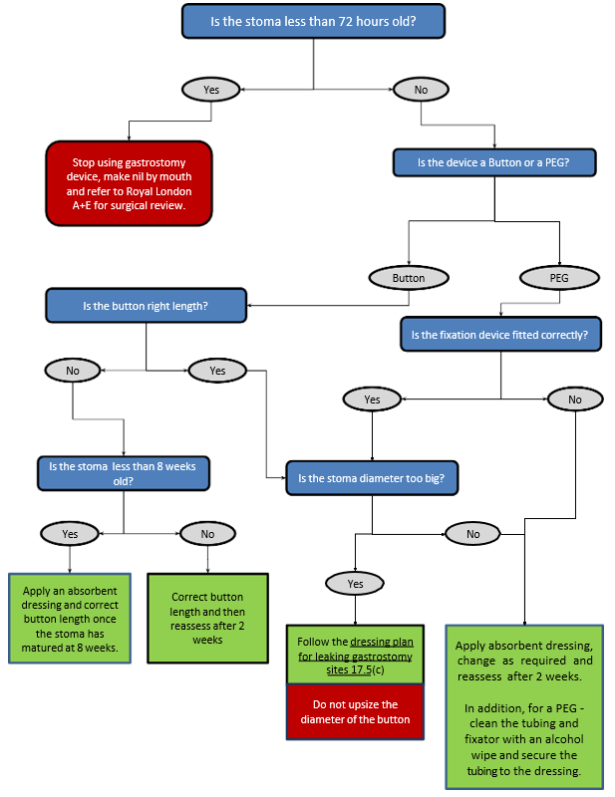

Adapted from PIER Network (2022)
17.5(c) Dressing plan for a leaking stoma

This is a two-person task: one person should hold the PEG/button securely throughout the dressing change, while the other cleans the site and applies the new dressing.

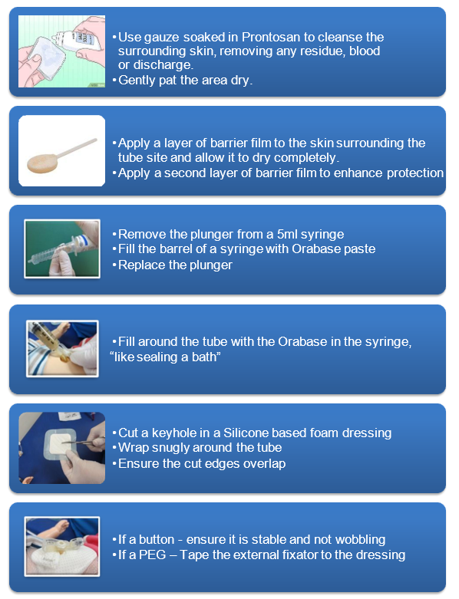
Adapted from PIER Network (2022)
  - Management of infection

Clinical signs of infection may include either spreading cellulitis accompanied by a temperature, with or without pustulent discharge, or the presence of obvious skin pustules in conjunction with an existing oral or perineal fungal infection.

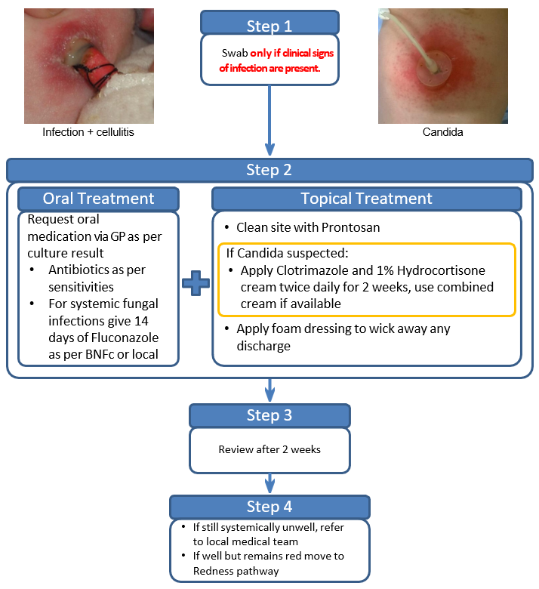

Adapted from PIER Network (2022)

  - Managing a balloon gastrostomy that is difficult to remove

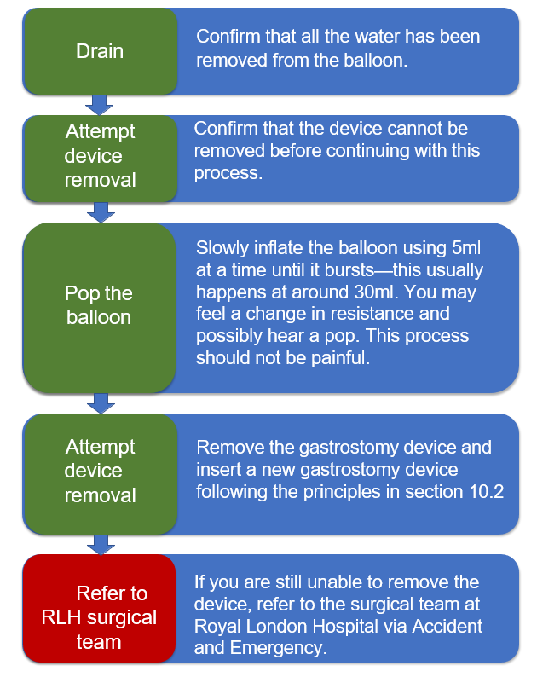

Adapted from PIER Network (2022)

  - Diarrhoea

In many cases, the cause of diarrhoea is not related to the feed. In some instances, diarrhoea may be induced by other causes including:

- Medications e.g. antibiotics
- Infection - a stool sample should be sent to microbiology immediately
- Feed infusion rate
- Fibre content of feed
- Malabsorption
- Clinical condition
If feed is suspected of causing the diarrhoea, contact the home enteral feeding dietitian. The dietitian will consider the amount and type of feed, its composition, osmolarity and the way it is administered. Make sure feed is administered at room temperature.

  - Nausea or Vomiting

Possible causes of nausea and vomiting include medication, infection, constipation and feed infusion too rapid. Follow these steps:
- Check for infection
- Review medications
- Avoid giving the feed too quickly or in too large a volume. Seek advice of the dietitian with regards to rate of feed or frequency of bolus feeds.

- If the patient has a nasogastric tube and if vomiting occurs, check tube position by testing the pH level

  - Constipation

Possible causes include medication, lack of fluid, fibre content of feed and changes in gut motility.

- Ensure patient has an adequate fluid intake and that all prescribed flushes of water are delivered.
- Contact Dietitian to ensure adequate fluids and fibre are prescribed.
- Consider laxatives.
  - Buried Bumper Syndrome

Buried bumper syndrome (BBS) is a serious complication that can occur with devices containing an internal bumper. It occurs when the internal bumper becomes imbedded against the stomach wall and is caused by inadequate advancement and rotation of the gastrostomy tube or insufficient advancement of the PEG-J. BBS may be asymptomatic but can lead to tube leakage, difficulty infusing feeds, abdominal pain, stoma swelling and in severe cases, infection, abscess, bleeding or peritonitis (Cyrany, 2016). Early detection is key to prevent severe complications; the following steps should be taken:
- Attempt to advance and rotate the gastrostomy tube.
- Attempt to advance the PEG-J tube.
- If unsuccessful, consider the possibility of BBS and promptly refer the child or young person to the Royal London Hospital's accident and emergency department.

- Training for parents/carers, staff and schools

Training to manage the enteral feeding device is provided by registered nurses and nurse associates within East London Foundation Trust. Only staff who have received training and have completed either a workbook or a competency are able to teach, supervise and sign off the competency of others. This competency or workbook must be marked or assessed by a registered nurse within the Trust who already holds a valid competency.
The standard of staff training is guided by the competency, and all aspects of the competency must be achieved, where relevant, in order to attain full competency. During training, staff must be made aware of all associated risks, safety considerations and required procedures to ensure that all tasks are carried out in accordance with best practice. This includes ensuring that risk assessments are understood, applied and followed consistently in clinical practice.
Staff managing enteral feeding devices are responsible for delivering training within their own area of practice. For example, children’s nurses will provide training for children’s nurses. In some situations, other ELFT services outside of SCYPS may require train-the-trainer teaching so they can supervise and assess staff within their local area. Where there is no existing competent staff member who is able to teach or assess others locally, services may contact the Practice Development Team for support with train-the-trainer teaching.
Staff must complete the relevant workbook and competency below:
• Enteral Feeding Workbook (Appendix 17)
• Nasogastric Tube Feeding Workbook (Appendix 18)
• Enteral Tube Feeding Competency (Appendix 19)
• Nasogastric Tube Competency (Appendix 20)
To keep up to date with current practice and maintain their competency, staff must attend enteral feeding refresher training every 18 months. Within the Community Children’s Nursing Service, this training is provided by the Practice Development Facilitators. Staff outside of this team must consult their Practice Development Nurse or education lead for training.

Parent/carer training

If the enteral feeding tube was inserted within the acute setting; staff within the acute setting are responsible for ensuring training is delivered and parents/carers are competent to manage their child’s device prior to discharge. Acute staff must sign a competency document to evidence this; which is then given to community staff on discharge.

If no competency document was received upon discharge, community staff must contact the acute setting to obtain a copy. If for any reason, this was not completed and the child or young person has already been discharged; ELFT staff must assess the parent/carer, sign the appropriate competency and upload it to the child’s electronic record.

Training for the Amika feed pump is usually carried out by Fresenius Kabi if the child is in the acute setting. If delivery of feed pump feed training is required within the community setting, this can be completed by a competent registered nurse or nurse associate. ELFT staff must ensure parents/carers are aware of the risks identified in Appendix 3 in relation to pump power failure and over delivery of feed.

Equipment and mannequins can be used to provide parent/carer training, however the final assessment/sign off should be carried out directly on the child with the parent demonstrating they are safe to feed their child or young person.

Parents/carers are only expected to complete the appropriate competency document and not any ELFT workbooks.

If parents/carers are trained to pass the nasogastric tube, their competency must be reassessed every 18 months. This includes demonstrating a correct NEMU measurement, inserting the NGT safely and correct pH testing of aspirates.

The following competency document should be completed for parents/carers based on the individual child’s device

- Enteral Tube Feeding competency (Appendix 19)
- Nasogastric Tube Competency (Appendix 20)

School training

Schools within Newham are invited to attend enteral feeding training if they have a child or young person with an enteral device. This training runs throughout the year and consists of virtual theory training and a practical classroom-based competency session 4 weeks later. The gap between the theory and practical session is to enable school staff to practice feeding the child or young person in school under supervision of another school staff member who is competent. Schools who do not have a competent staff member are supported to gain practical skills by the special school nursing team.

School staff are expected to complete the appropriate ELFT workbook and competency document to be deemed competent. During the classroom-based competency session, school staff are marked against the practical assessment sheet (Appendix 22). If they pass the workbook and practical assessment, they can feed a child or young person independently in school. School staff who fail the practical assessment will receive feedback on areas for improvement and encouraged to gain more practice before returning for reassessment.

By signing the competency document, ELFT staff are confirming that the learner demonstrated safe and competent practice at the time of assessment. School staff also sign the competency to confirm they will carry out the procedure as they have been trained, will not undertake any procedure outside of the competency and will seek additional training if there are any concerns around their competence. School staff must renew their competency every 18 months.

Schools must have a system for documenting administration of enteral feeds. If a child or young person requires nasogastric tube feeds in school; competent school staff must double check pH aspirates and ensure they complete the Nasogastric Tube Position Confirmation Record (Appendix 9).

- Transition to Adult Services

On transition to adult services, the home enteral feeding Dietitian will refer the young person to the adult dietetic team and the named nurse will refer to the adult nutritional nurse. Supplies received from Enabled Living will continue, however be moved over to the adult budget. ELFT staff must inform Enabled Living once a young person has moved over to adult services.

- Audit

Currently, an annual audit takes place to monitor compliance for children and young people receiving nasogastric tube feeds. The table below outlines the standards for audit:

No. | Standard
1 | The nasogastric tube must be radio-opaque with external markings.
2 | The pH strips must measure 0-6 pH and be CE marked.
3 | All nurses who provide care and management for children with nasogastric tubes must have a completed competency or workbook.
4 | Nurses to document the initial placement and confirmation checklist on RIO (including NEMU, NGT size, length inserted, nostril and pH level)
5 | Parents must complete a nasogastric tube feeding competency signed by a registered nurse.
6 | Parents who insert the nasogastric tube must have the ‘passing the nasogastric tube competency’ signed by a registered nurse
7 | School staff who feed via nasogastric tube must complete a nasogastric tube feeding competency signed by a registered nurse.
8 | Children on continuous overnight feeds must have confirmation from a consultant and ELFT risk assessment completed.
9 | All children with nasogastric tubes must have a dietetic care plan.
10 | All children with nasogastric tubes must have a nursing care plan.

The audit cycle must include 20% of caseload. If the number of children and young people with nasogastric tubes in place falls below 20 within caseload at time of audit, all notes should be audited. Audit results are shared with staff within Community Children’s Nursing Service along with recommendations, actions and a planned re-audit date if standards fall below 100%.

- Permanent removal of enteral device

1. Clinical Assessment and Decision-Making
- Multidisciplinary Evaluation: The decision to remove a gastrostomy tube permanently should involve a comprehensive assessment by the multidisciplinary team (MDT), including the dietitian, GP, and relevant specialists.
- Nutritional Intake Assessment: The dietitian must confirm that the patient can meet all nutritional, fluid, and medication needs orally, without reliance on enteral feeding.
- Timing of Removal: Ensure that at least 8 weeks have passed since the initial insertion of the gastrostomy tube to allow for adequate stoma tract maturation.

2. Pre-Removal Preparation
- Anticoagulant Management: Review the patient's medication regimen. If the patient is on anticoagulant therapy, consult with the prescribing physician to determine if adjustments or temporary cessation are necessary to minimize bleeding risks during removal.
- Fasting Protocol: Instruct the patient to remain nil by mouth (no food or drink) for two hours before and after the procedure. Small sips of water may be permitted if the patient is thirsty.
- Stoma Site Evaluation: Assess the stoma site for signs of infection, over-granulation, or other complications. Address any issues prior to proceeding with tube removal.
3. Removal Procedure
- Qualified Personnel: Only healthcare professionals who have received appropriate training and demonstrated competency should perform gastrostomy tube removals.
- Balloon Gastrostomy Tubes: For balloon-retained gastrostomy tubes, the procedure can typically be conducted in the patient’s home:
  - Position the patient comfortably, preferably lying down.
  - Deflate the internal balloon completely.
  - Gently rotate and withdraw the tube.
  - Apply a sterile dressing over the stoma site.
- Non-Balloon or PEG Tubes: Tubes without a balloon retention mechanism, such as PEG tubes, usually require removal in a hospital setting, often via endoscopy or radiology. Arrange for appropriate referrals and appointments.

4. Post-Removal Care
- Dressing Management: Advise the patient to keep the dressing clean and dry. Change the dressing as recommended, typically once daily or if it becomes soiled, until the site has healed.
- Monitoring for Complications: Educate the patient on signs of infection or complications, including redness, swelling, persistent leakage, or pain at the stoma site. Instruct them to contact their GP or healthcare provider if such symptoms occur.

5. Equipment and Service Coordination
- Discontinuation of Supplies: Notify Enabled Living to cease deliveries of enteral feeding supplies and arrange for the collection of any unused equipment.
- Follow-Up Care: If ongoing nutritional support is required, coordinate with the patient’s GP to prescribe oral nutritional supplements as needed. Refer the patient to a community dietitian for continued monitoring and support.

References

akhpub.aboutkidshealth.ca. (2017). AboutKidsHealth. [online] Available at: https://akhpub.aboutkidshealth.ca/Article?contentid=984&language=English [Accessed 27 Jan. 2022].

Bray, L., Ford, K., Dickinson, A., Water, T., Snodin, J. and Carter, B. (2018). A qualitative study of health professionals’ views on the holding of children for clinical procedures: Constructing a balanced approach. Journal of Child Health Care, 23(1), pp.160–171.
‌
Burns, S. M., Carpenter, R. And Truwit, J.D. (2001). Report on the development of a procedure to prevent placement of feeding tubes into the lungs using end-tidal CO2 measurements. Critical Care Medicine. 29(5):936-9

Cyrany, J. (2016). Buried bumper syndrome: A complication of percutaneous endoscopic gastrostomy. World Journal of Gastroenterology, [online] 22(2), p.618.

ECRI Institute. (2017). Implementing the ENFit Initiative for Preventing Enteral Tubing Misconnections. [online] Available at: https://www.ecri.org/components/HDJournal/Pages/ENFit-for-Preventing-Enteral-Tubing-Misconnections.aspx?PF=1%3Fsource=print [Accessed 9 Apr. 2019].

Fresenius Kabi (2019). Amika® - Feeding Pumps. [online] Fresenius-kabi.com. Available at: https://www.fresenius-kabi.com/gb/products/amika [Accessed 9 Jul. 2019].

Huband, S. and Trigg, E. (2000) Practices in Children’s Nursing: Guidelines for Hospital and Community. Churchill Livingstone.

Hucker, J. (2022). Nasogastric tube insertion 1: children and young people | Nursing Times. [online] Nursing Times. Available at: https://www.nursingtimes.net/childrens-nursing/nasogastric-tube-insertion-1-children-and-young-people-25-07-2022/.

International Organization for Standardization (ISO). 2016. Small-bore connectors for liquids and gases in healthcare applications—part 3: connectors for enteral applications. ISO 80369-3:2016. Available at: https://www.iso.org/standard/50731.html [Accessed 23 May 2019].

Irving, S.Y., Rempel, G., Lyman, B., Sevilla, W.M.A., Northington, L. and Guenter, P. (2018). Pediatric Nasogastric Tube Placement and Verification: Best Practice Recommendations From the NOVEL Project. Nutrition in Clinical Practice, 33(6), pp.921–927.

Medicina (2011). Nasogastric feeding tubes and accessories. Medicina, Bolton. Available on line at www.medicina.co.uk/uploads/files/nasogastric_tube_booklet.pdf
Metheny, D., Dettenmeier, P., Hampton, K et al. (1990). Detection of inadvertent respiratory placement of small –bore feeding tubes: a report of 10 cases. Heart Lung 19(6):631-8

Metheny, N.A., Smith, L. and Stewart, B.A. (2000). Development of a reliable and valid bedside test for bilirubin and its utility for improving predication of feeding tube location. Nursing Research. 49(6): 302-9

Metheny, N.A., Stewart, B.A., Smith, L., Yan, H., Diebold, M. And Clouse, R.E. (1997). pH and concentrations of pepsin and trypsin in feeding tube aspirates as predicators of tube placement. Journal of Parental and enteral nutrition. 21(5): 279-85

Metheny, N.A., Stewart, B.A., Smith, L., Yan, H., Diebold, M. And Clouse, R.E. (1999). pH and concentration of bilirubin in feeding tubes aspirates as predictors of tube placement. Nursing Research. 48(4): 189-97

Metheny, N.A. and Titler, M.G. (2001). Assessment of feeding tubes. American Journal of Nursing. 101(5):36-45

Metheny, N.A., Wehrle, MA., Wiersema,L. et al (1998) Testing feeding tube placement: auscultation Vs pH method. American Journal of Nursing. 98(5): 37-42; quiz 42-3

Macqueen, S., Bruce, E. and Gibson, F. (2012). The Great Ormond Street Hospital manual of children’s nursing practices. Chichester, West Sussex; Malden, Ma: Wiley-Blackwell.
‌‌

Nursing and Midwifery council (NMC), 2018. The Code. Professional standards of practice, and behaviour for nurses, midwives and nursing associates. London. 10th October 2018.

PAEDIATRIC INNOVATION, EDUCATION & RESEARCH (PIER) NETWORK. (2022). Paediatric Gastrostomy Toolkit. [online] Available at: https://www.piernetwork.org/gastrostomy.html [Accessed 28 Apr. 2025].

Spalding, K. and McKeever, P. (1998) Mother’s experiences caring for children with disabilities who require a gastrostomy tube. Journal of Paediatric Nursing. 13(4): 234-242

Taylor, S.J., Allan, K., McWilliam, H. and Toher, D. (2014). Nasogastric tube depth: the “NEX” guideline is incorrect. British Journal of Nursing, 23(12), pp.641–644.

