

Guideline for Managing Intoxication on
In-Patient Wards

Version number | 3.0
Consultation Groups | Physical Health Group / Bedford Drug and Alcohol Service / Pharmacy / Resuscitation
Approved by (Sponsor Group) | Physical Health / Resuscitation Committee
Date approved | 13 February 2026
Ratified by | Quality Committee
Date ratified | 25th March 2026
Name and Job Title of author | Director of Nursing  Trust wide Physical Health Lead Nurse
Executive Director Lead | Chief Nurse
Implementation rate | March 2026
Last review date | February 2026
Next review date | February 2029

Services | Applicable to
Trust wide | Yes
Mental Health and LD
Community Health Services
Primary care

Version Control Summary

Version | Date | Author | Status | Comment
1.0
2.0 | June 2022 | Sharon Hawley
3.0 | December 2025 | Bernadette Kinsella  Roberta Contino | FINAL | Updated News 2, Testing ABCDE, Medications  Added Naloxone

Table of Contents

Section |  | Page
 | Introduction  1.1 Executive Summary  1.2 Governance | 4
 | Scope  2.1 Key Principles | 5
 | Acute Intoxication | 5
 | Recognising Acute Intoxication  4.1 Administration and Initial Assessment  4.2 Assessment of Suspected Intoxication | 5
 | Management of Acute Intoxication  5.1 Observation and Vital Signs Monitoring  5.2 Indications for Routine Monitoring  5.3 Identification of the Need for Medical Assistance  5.4 Identification of a Medical Emergency  5.5 ABCDE  5.6 Management and Escalation of the Deteriorating Patient  or Service User | 10
 | Naloxone  6.1 Administration of Naloxone  6.2 Contraindications  6.3 Special Warnings or Precautions and Withdrawal  6.4 Fertility, Pregnancy and Lactation  6.5 Interactions with Other Medical Products | 13
 | Monitoring the Sleeping Patient | 16
 | Managing Prescribed Medication | 16
 | Prescribing During Acute Intoxication | 16
 | Intoxicated Patient in Seclusion | 16
 | Documentation, Communication, and Governance  11.1 Documentation  11.2 Communication and Information Sharing  11.3 Discharge Planning and Harm Reduction  11.4 Liaison and Referral  11.5 Training and Competencies  11.6 Post-Incident Review and Learning | 17
 | References | 18
- Appendices

Appendix 1 | Triple Testing Ordering Kit, includes Nitazenes (via Oracle) | 19
Appendix 2 | Key Terms | 20
Appendix 3 | Naloxone Protocol | 22
Appendix 4 | Flumazenil Protocol | 23
Appendix 5 | Toxbase, Resources for Health Professionals On ELFT Desktop | 24
Appendix 6 | Quick Guide for Wards on Acute Intoxication | 25
 | Equality Impact Assessment | 26

1.0 Introduction

1.1 Executive Summary

This guideline has been produced to support in-patient staff to recognise, assess and provide immediate clinical management to people who are acutely intoxicated with alcohol and illicit substances including New Psychoactive Substances (NPS), previously known as legal highs, and Cannabinoids (including cannabidiol, CBD).

The Purpose is to provide clinicians and ward staff with practical, evidence-informed guidance to assess, monitor, stabilise and escalate care for patients with suspected or confirmed drug intoxication on inpatient mental health wards. This guideline does not replace withdrawal management pathways.

Patients at risk of alcohol, benzodiazepine, or opioid withdrawal must be managed under relevant detoxification protocols.

1.2 Governance

This guideline is approved by the Trust Quality Committee. It will be reviewed every three years or sooner if national guidance changes. Responsibility for implementation rests with Ward Managers and Medical Leads.

All assessments and interventions must comply with the Mental Capacity Act (2005), Mental Health Act (2025), Human Rights Act (1998), and Trust Consent Policy. Where capacity is impaired by intoxication, best-interest decisions must be documented.

Staff must consider safeguarding risks including exploitation, trafficking, domestic abuse, self-neglect, and vulnerability related to substance use.

Concerns must be escalated via Trust Safeguarding Procedures.

All patients presenting with intoxication must receive a documented suicide and self-harm risk assessment once clinically stable. Intentional overdose must trigger urgent psychiatric review.

This guideline should also be read in conjunction with the following ELFT policies and protocols which are available on the intranet:
- Prescribing Guidelines Specialist Addiction Services
- Physical Healthcare Policy
- Deteriorating Patient Policy – National Early Warning Score (NEWS2)
- Sepsis Policy
- Resuscitation Policy
- Admission and Discharge Policy for Mental Health Services
- Rapid Tranquillisation Policy for all ages
- Place of Safety Policy
- In-Patient Alcohol Detoxification Guidelines
- Guidelines for the Inpatient Treatment of Opiate Dependence
- Local Protocol for the Management of S136 MHA 1983
- Trust Safeguarding Adults Policy
- Trust Violence Reduction and De-escalation Policies.

2.0 Scope

This guideline applies to all adults in all directorates admitted to ELFT in-patient wards, and all adult service users brought to the S136 suite for assessment only.

2.1 Key Principles

- Safety first: prioritise ABCDE assessment and basic life support.
- Early recognition: use NEWS2 to detect deterioration.
- Targeted treatment: use specific antidotes when indicated.
- Multidisciplinary response: involve medical/liaison psychiatry, pharmacy, and Accident and Emergency early.

3.0 Acute Intoxication

Acute intoxication can be a transient condition or it can be life threatening. However, it may be life threatening and must never be ignored. Never adopt a “wait until they sober up” approach. A patient may be in overdose, where the respiratory system is in the process of shutting down. A patient may vomit and choke causing an occlusion to the airway.

Acute intoxication may be related to the amount of substances someone has taken. Or, where underlying health conditions produce a disproportionately severe intoxication (like renal or liver impairment).

It is a condition that requires clinical management.

4.0 Recognising Acute Intoxication

4.1 Admission and Initial Assessment

All patients admitted to in-patient mental health units will be assessed for alcohol and substance use as part of the admission process. It is important to take a good history, including history of overdose (accident or intention), and is good practice to include baseline urine drug screening.

Patients with a known history, or disclosed history, of alcohol or substance misuse are to be managed under ELFT Dual Diagnosis Pathways, including alerting community substance misuse teams in good time prior to discharge, and to enable a joined up discharge plan.

Alcohol/drug misuse is always reflected in care plan and risk assessments. This may include the possibility of intoxication whilst an in-patient

For service users who have been known to take drugs or alcohol throughout their admission an ongoing assessment needs to occur. Increased risk maybe indicated when there is suspected drug availability on the ward, visits from friends or family who are suspected to be bringing in drugs or increased periods of leave.

4.2 Assessment of Suspected Intoxication

4.2.1 Alcohol

Figure 1. below shows Quick Checklist for Suspected Alcohol Intoxication.

Quick checklist ALCOHOL
Inpatient Nursing Staff
Are responsible for monitoring CIWA-Ar scores on Rio for signs of Withdrawal.
Signs and symptoms | Behaviours
Smelling of alcohol | Disinhibition
Loss of coordination: stumbling or swaying | Argumentativeness
Flushing of the face | Lability of mood
Bloodshot eyes | Impaired attention
Louder speech than usual | Impaired judgement
Slurred speech | Interference with personal functioning
Damp or clammy skin | Aggression or depression, crying
Drowsiness | Mood swings
Possible Medical Emergency.  - Loss of consciousness  - Shallow breathing  - Blue skin or lips | Overdose outcome:  Alcohol poisoning is caused by drinking large quantities of alcohol in a short period of time. Very high levels of alcohol in the body can shutdown critical areas of the brain that control breathing, heart rate, and body temperature, resulting in death.

4.2.2 Depressants (e.g. heroin, methadone, pain medication, Benzodiazepines)

Figure 2. below shows Quick Checklist for Suspected Opiate/Opioid Intoxication.

Quick checklist OPIATES/OPIOIDS

Signs and symptoms | Behaviours
Drowsiness | Impaired attention
Loss of coordination: stumbling or swaying | Impaired judgement
Pinned pupils | Apathy
Slurred speech | Withdrawn
Slow pulse | Tired
Losing consciousness
Possible Medical Emergency | Overdose outcome
May lead to death  - Shallow breathing  - Blue skin or lips  - Confusion  - Small pupils  - Loss of consciousness  - May need ITU support | Depressants that affect the central nervous system lower blood pressure and body temperature, and slow the heart rate and breathing. When used to excess it lead to respiratory failure, overdose, coma, and death.

Follow Flumazenil process documented in Appendix 4.
Flumazenil should NOT be used routinely in suspected benzodiazepine overdose due to seizure risk in dependent or mixed overdose patients. Use only on specialist advice.
See Section 5.5 for ABCDE Assessment.
Figure 3. below shows Quick Checklist for Suspected Nitazene/Xylazine Intoxication.

Quick Checklist Nitazenes / Xylazine | Use Specific Test Kit to check for this
Signs and symptoms | Behaviours
- All of above  - Symptoms may be more profound  - Onset may be quicker  - Respiration/shallow breathing  - Alert staff that patient may have further symptoms over the next 24 hours. | - All of above & agitation  - Delayed responses are possible  - Person may alternate between drowsy and agitated in presentation  - There can be delayed and repeated presentation up to several hours after ingestion
Medical Emergency

Nitazene suspected overdose
- Use more naloxone. More supplies/kits may be required for overdoses e.g. 4-6 doses for overdose. Higher doses may be required in synthetic opioid (e.g. fentanyl, nitazene) overdoses. Continue ventilation and emergency support.

1-Stay with patient
- Always the first priority is ensuring the patient is not left alone.
2-Ambulance should be called promptly. For City & Hackney call 2222. For other areas call 999.
- Emergency services must be contacted immediately.
- Ask for Resuscitation Trolley or MERT Bag with emergency drugs.
3-Give 2 doses of naloxone (400 microgram) to start for suspected overdose. Additional doses may be required. See Appendix 3
- Begin with naloxone administration as soon as overdose is suspected.
4-Test & Confirm as soon as possible
- Check vital signs (NEWS2 score)
5-Maintain airway if respiration rate below 8 breaths per minute
- Airway management is crucial if respiratory depression is evident.
- Consider using an airway adjunct i.e. OP= oropharyngeal; NP= nasopharyngeal
6-Ventilate using bag valve mask every, squeeze every 5-6 seconds with bag.
- Provide assisted ventilation if breathing is inadequate.
7-Maintain adequate oxygen
- Once the patient regains consciousness or breathing improves, ensure oxygen (SPO2) is maintained at 94-98%.
Please see Section 5.5: ABCDE Assessment and Management and Escalation of the Deteriorating Patient/Service User.

4.2.3 STIMULANTS (e.g. cocaine, crack, some new psychoactive substances)

Figure 4. below shows Quick Checklist for Suspected Stimulant Intoxication.

Quick checklist STIMULANTS

Behaviours | Signs and symptoms
Increased energy and alertness | Increased body temperature
Euphoria | Increased pulse
Paranoia | Increased blood pressure
Panic | Dry mouth
Anxiety | Faster breathing
Feeling indestructible | Large dilated pupils
Pseudo-hallucinations  Agitation | Seizures  Sweating  Flushed skin
Possible Medical Emergency: | Overdose outcome:
- Chest pain or laboured breathing  - Extreme sweating  - Increased blood pressure  - Rapid heart rate or palpitations  - Anger, Confusion  - Paranoia, Delirium  - Blurred vision or vision loss  - Nausea, diarrhoea, or vomiting  - Seizures or convulsions  - Loss of consciousness | Stimulants cause the heart rate to increase, which can result in heart problems. Hypertension common. When used to excess it can result in loss of vital functions, respiratory failure, cardiac arrest, coma, death.
Treatment

Ambulance should be called promptly. For City & Hackney call 2222. For other areas call 999.Stay with the person and keep them calm and safe.
Move to a quiet, low-stimulation environment – reduce noise, light, and crowds.
Monitor airway, breathing, and circulation (ABCs):
- If unconscious but breathing: place in recovery position.
- If not breathing: begin CPR and use AED if trained and available.
Do not leave the person alone – watch for sudden changes in consciousness or seizure activity.
Cool the body if overheating (remove excess clothing, use cool compresses).
Reassure and reorient if the person is confused, paranoid, or panicking.
Do NOT restrain the person forcefully – this can worsen agitation or risk injury.
NOT give food, drink, or other substances – risk of choking or interaction.
If seizure occurs:
- Do not restrain.
- Protect the head and clear surrounding area.
- Time the seizure and report to emergency responders.
See Appendix 3 & 4 for Emergency Drugs
Please see Section 5.5 on ABCDE & Management and Escalation of the Deteriorating Patient/service User

4.24 NEW PSYCHOACTIVE SUBSTANCES (NPS’s) (e.g. spice, synthetic cannabinoids, novel benzodiazepines, and novel stimulants all available easily online).

Figure 5. below shows Quick Checklist for Suspected New Psychoactive Substance Intoxication.

Quick checklist NPS
Signs and symptoms | Behaviours
NPS’s can present like STIMULANTS or DEPRESSANTS.  It depends on the NPS | NPS’s can present like STIMULANTS or DEPRESSANTS.  It depends on the NPS
Possible Medical Emergency: see above  STIMULANTS and DEPRESSANTS | Overdose outcome:  see above STIMULANTS and DEPRESSANTS

4.25 Suspicion and Detection of Use

Observation: change in behaviour, new behaviour, and disinhibited behaviour, ask the patient if they have used in a non-confrontational manner
If the patient says yes, ask
- which drug or alcohol
- how much
- how (oral, injected, smoke)
- what time did they use
- Did they use alone or with someone else.

Safety Measures Isolate the patient from other patients, but do not leave them alone
- If the patient agrees seek clarity
- Take observations using NEWS2 Scoring Resource (Figure 6. in Section 5.3), in addition assess level of confusion, disorientation. See Contact and Non-Contact observations (Appendix 2)

Investigations:
Drug screen, Triple drug testing kit for including fentanyl, nitazene and xylazine (Please see Appendix 1).
Breathalyse for Alcohol,
- Glucose finger prick test,
- Electrocardiogram (ECG,)
- Pregnancy test.
- Bloods: FBC, U&Es, LFTs, CK, toxicology screen. (May take time for results)
- Imaging: CXR, CT head as indicated, Acute Trust

Medication Review
- Check when last medications were given, consider overdose possibilities (e.g. if the patient has used depressants, were they also given depressants on the ward within the last 2hours)
- Inform a senior team member and the duty senior nurse DSN out of hours, Contact the ward doctor or on call doctor to agree an onward management plan
- Onward assessment should include review of medical and psychiatric history to identify additional risk factors that may cause overdose: e.g. liver or renal problems or low tolerance through periods of abstinence
- Review Quick Checklist 4.23 (Alcohol) and 4.24 (New Psychoactive Substances NPS’s) above.
5.0 Management of Acute Intoxication

The primary goal is to ensure the patients safety, and the safety of other patients and staff.

The team need to monitor what is happening and plan for the potential physical health deterioration. The level of intoxication is on a continuum from mild - to - life threatening.

Inform the patient that continued monitoring for their safety and the safety of others is required.

General principles when managing intoxication include:

- Maintain a calm, professional, non-judgemental attitude
- Orientate and establish rapport
- Be aware of the potential physical health deterioration risk and the escalation points.
- Pace the interaction to the level of cognitive impairment
- Stop and go style of interaction whereby you stop positive interaction at the point of unwanted behaviour, inform the patient this behaviour is not acceptable, and then return to the friendly positive interaction.
- Work together. Inform the service user what they need to do, what you need to do, and how you might both get to where you need to be for safety.

5.1 Observation and Vital Signs Monitoring to Include Contact and Non-contact

One to one eyesight observations must commence at point of assessment and should not be reduced until agreed by the medical team. One to one observations need to include life signs observations including vital signs using NEWS2 and Non-Contact observations for any refusals recorded. If from the history taking, observation and testing there are suspicions the patient is intoxicated please see below indications for monitoring.

5.2 Indications for Routine Monitoring

If the baseline total NEWS2. Score is zero initiate physical health monitoring every 15 minutes initially. If physical observations are refused, then one to one observation should continue. Minimum frequency should be increased if clinical concern persists, regardless of NEWS2 score. Please see Figure 6. (Section 5.3) for NEWS2 Scoring Resource and Appendix 2 for contact & non-contact observations.

Levels of acute confusion and disorientation must be assessed and if there is worsening levels this alone would indicate the need for escalation and possible medical intervention.

Consider decreasing the frequency in consultation with the ward or duty doctor when the service user’s observations have been stable for 2 hours.

5.3 Identification of the Need for Medical Assistance

Total NEWS2 score is 1-4 inform a registered nurse who must assess the patient and decide if increased frequency of monitoring, clinical escalation and medical assistance is required. One to one observation must remain or commence until this is done.
Registered nurse to urgently call medical staff (Duty Doctor) and Duty Senior Nurse (DSN) and commence protocol for the Management of Medical Emergencies
If:
- Total NEWS2 score is 5 or more
- NEWS2 score is 3 in any one parameter (red section of the chart)
Consider action to improve the patient’s physical condition including positioning and oxygen.
Figure 6. below shows Royal College of Physicians NEWS2.

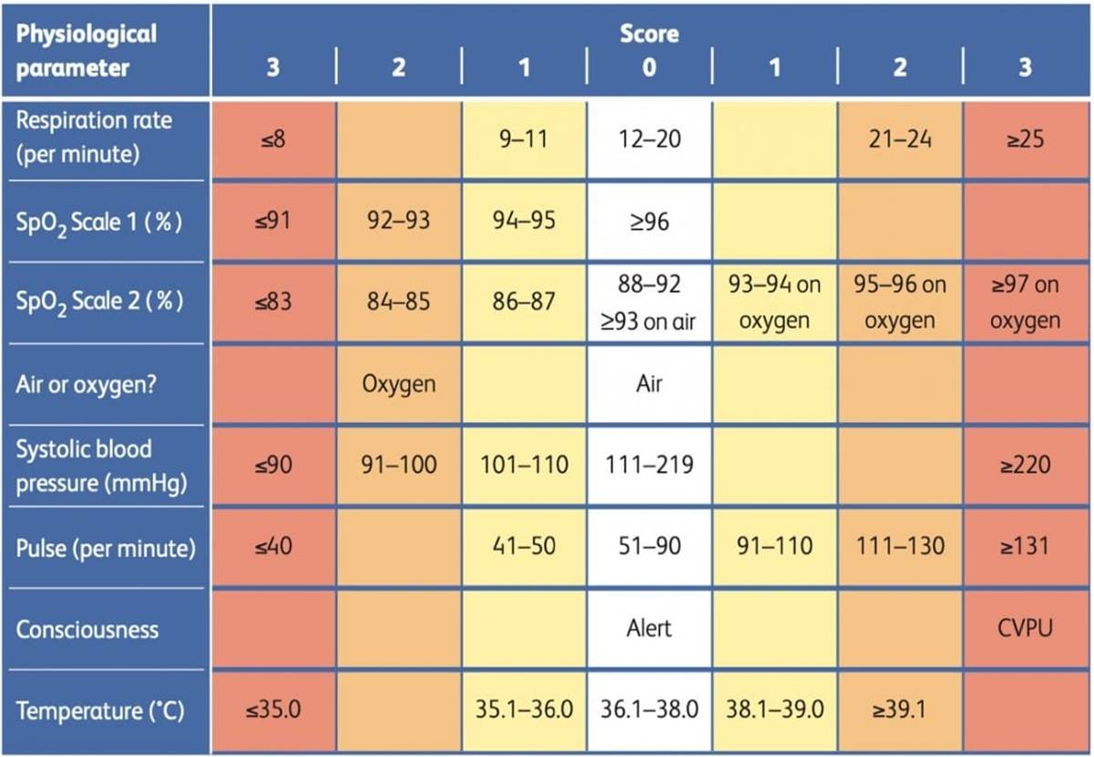

The assessing doctor should complete a physical and mental health assessment, including neurological examination to rule out injuries resulting from intoxication, exclude other underlying medical causes and the complications of chronic alcohol abuse if the service user consents.

The service users care plan must be reviewed and a joint decision between the assessing doctor and the nursing team reached about the continuing management plan, frequency of monitoring arrangements and whether an ambulance should be called. This plan must be documented in the service users RiO progress notes.

5.4 Identification of a Medical Emergency

Immediately follow your local protocol for the Management of Medical Emergencies in the following circumstances:
- The NEWS2 Total score is 7 or more
- Respirations are noisy, shallow or less than 8 breaths per minute
- The level of consciousness as assessed by the NEWS2 indicated the person is unresponsive, (also commonly referred to as unconscious) and service user does not make any eye, voice or motor response to voice or pain.
- The service user is experiencing a seizure
- Initiate continuous monitoring of vital signs
- Consider action to improve the patient’s physical condition such as positioning and oxygen
- Registered nurse to stay with the patient
- Response team including the Dr to prepare for medical emergency
- Call an ambulance 999 or 2222 (City and Hackney centre for mental health only)
5.5 ABCDE

If the patient is deteriorating and a more comprehensive assessment is required, the ABCDE model of assessment should be used to give a rapid, initial assessment of the patient’s condition which will involve assessing the following:

A –  Airway | - Check the patency of the airway and assess for signs of obstruction  - Is the airway clear or is it obstructed?  - If the airway is obstructed, is it a full or partial obstruction? Can air pass through? Can the obstruction be removed?  - Check patency, manage obstruction, and escalate 999 0r 2222 City and Hackney if P or U on ACVPU score.
B – Breathing | - Check the respiratory rate, depth and rhythm  - What are the saturations?  - Is the chest rising and falling equally?  - Is the patient using their accessory muscles to breathe?  - Assess rate, give O₂ as needed, naloxone if opioid toxicity.
C – Circulation | - Check the patient’s pulse rate? Is it fast or slow? Is it regular or irregular? Does it feel bounding or thready?  - Check the blood pressure  - Check capillary refill time  - Check the urine output  - Give fluids if hypotensive.
D – Disability | - Check level of consciousness using ACVPU  - Check blood glucose level  - Check pupil reaction to light stimulus  - Can the patient move all limbs with equal strength and power  - Assess ACVPU score. Glucose, treat seizures.
E – Exposure | - Check the patient’s body to assess for wounds, oedema, discolouration, fractures etc. Check body temperature  - Check temp, skin, signs of injection or injury.

All intoxicated patients must be assessed for head injury, falls, assault-related trauma, and safeguarding concerns.
Low threshold for CT head and Acute Trust referral where indicated.

See Appendix 6 for Summary Guide to Intoxication.

5.6 Management and Escalation of the Deteriorating Patient or Service User

Simple measures can often prevent deterioration of the patient and may even avoid the need for admission into secondary care.
- Full top to toe clinical assessment by an appropriately skilled clinician including a full set of vital signs observations using NEWS2 or MEWS
- Early escalation to a senior clinician (Trust doctor, ACP, GP, ambulance service)
- Appropriate positioning of the patient
- Administration of appropriate medicines
- Administering IV fluids if appropriately trained staff are available to site a cannula and prescribe fluids
- Preparing emergency equipment for a potential cardiac arrest
- It may also be appropriate to give oxygen if required. If oxygen is available and the patient/service user is acutely deteriorating, then oxygen should be administered via a reservoir (non-rebreathe) mask at a rate of 15L/min to aim for oxygen saturations of 94% - 98%. This advice applies to all patients, even if they have risk factors for hypercapnia, until such a time as analysis of blood gas measurements and/or expert assessment is available.

There is no need for a prior prescription to deliver emergency oxygen, however, once the patient’s condition has stabilised, oxygen should be titrated according to patient need and its administration recorded on a medication chart.

6.0 Naloxone

Naloxone is a synthetic opioid antagonist, used in the treatment of opioid overdose.

Naloxone reverses the respiratory depression, induced by opioids such as heroin, morphine, oxycodone, fentanyl, methadone, etc. and it can be life-saving.

Naloxone is a prescription only medication (POM) and would normally require a prescription prior to administration. However changes to Misuse of Drugs Act in 2005 and later in Oct 2015, permit trained individuals to administer naloxone for the purpose of saving life in an emergency. Therefore a registered nurse may administer naloxone in an emergency, without a prescription, as described within this guideline.

If overdose of opioids or any other substances is suspected, local medical emergency procedures should be followed.

Naloxone should only be administered by those suitably trained in recognising the symptoms of overdose and competent to administer naloxone.

6.1 Administration of Naloxone

ELFT recommended route of administration for acute opioid overdose is intramuscularly (IM), available in the emergency bag. Naloxone injection is also licensed for administration by subcutaneous (SC), or intravenous (IV) injection.

The duration of action is dependent on the dose given and route of administration. The IM route provides a more prolonged effect and a dose administered via this route may take longer to take effect (approximately 2-5 minutes).

If a patient has lost consciousness, and you are fairly certain opiates/opioids have been used

- Call 999 (or 2222 at CHCMH) and follow local protocol for the Management of Medical Emergencies
- Commence high flow oxygen
- Consider action to improve the patient’s physical condition including positioning (e.g. recovery position)
- If the respiratory rate is less than 10-12 breaths per minute, administer 400mcg or 0.4ml of Naloxone Injection solution by intramuscular injection into the outer thigh or muscles of the upper arm as part of the resuscitation intervention. The dose of 0.4ml can be repeated every 2-3 minutes in subsequent resuscitation cycles until an effect is noted or the ambulance arrives.
- Repeat dose of 400mcg every 2-3mins up to maximum of 5 doses or until RR>10-12/min.

The patient must always be transferred to Accident and Emergency for medical assessment, even if they respond well to the Naloxone.

Naloxone has a much shorter half-life (1 -1.5 hours) than most opioids such as codeine (approx.3 hrs), methadone (approx.12-24hrs) and morphine (2-4hrs). There is a risk that opioid toxicity will recur as the naloxone wears off while the opioid remains in the blood stream.

Respiratory rate and oxygen saturation should be monitored closely until stable. The length of this period of monitoring will be dependent on the half-life of the opioid causing toxicity. The half-life of morphine and some other opioids is prolonged in renal failure and other metabolic disturbance.

6.2 Contraindications

Naloxone injection should not be given to patients who are known to be hypersensitive to the drug or any of the excipients

6.3 Special Warnings or Precautions and Withdrawal

- It should be administered cautiously to patients who have received large doses of opioids or to those physically dependent on opioids since too rapid reversal of opioid effects by Naloxone Injection may precipitate an acute withdrawal syndrome in such patients.
- Hypertension, cardiac arrhythmias, pulmonary oedema and cardiac arrest have been described
- The signs and symptoms of opioid withdrawal in a patient physically dependent on opioids may include but are not limited to the following: body aches, diarrhoea, tachycardia, fever, runny nose, sneezing, sweating, yawning, nausea, vomiting, nervousness, restlessness, irritability, shivering, trembling, abdominal cramps, weakness and increased blood pressure. In the neonate, opioid withdrawal may also include: convulsions, excessive crying and hyperactive reflexes.
- Patients who have responded satisfactorily to Naloxone Injection should be placed under medical supervision and kept under observation for at least 2 hours. Repeated doses of Naloxone Injection may be necessary since the duration of action of some opioids may exceed that of Naloxone Injection.
- Naloxone Injection is not effective against respiratory depression caused by non-opioid drugs. Reversal of buprenorphine-induced respiratory depression may be incomplete. If an incomplete response occurs, respiration should be mechanically assisted.
- Abrupt postoperative reversal of opioid depression may result in nausea, vomiting, sweating, tremulousness, tachycardia, increased blood pressure, seizures, ventricular tachycardia and fibrillation, pulmonary oedema and cardiac arrest which may result in death.
- Several instances of hypotension, hypertension, ventricular tachycardia and fibrillation, pulmonary oedema and cardiac arrest have been reported in postoperative patients. Death, coma and encephalopathy have been reported as sequel of these events. Although a direct cause and effect relationship has not been established, Naloxone Injection should be used with caution in patients with pre-existing cardiac disease or patients who have received medications with potential adverse cardiovascular effects, such as hypotension, ventricular tachycardia or fibrillation and pulmonary oedema.
- In addition to Naloxone Injection other resuscitative measures such as maintenance of a free airway, artificial ventilation, cardiac massage and vasopressor agents should be available and employed when necessary to counteract acute poisoning.

Renal Insufficiency/Failure: The safety and effectiveness of Naloxone Injection in patients with renal insufficiency/failure have not been established in clinical trials. Caution should be exercised and patients monitored when Naloxone Injection is administered to this patient population.

Liver Disease: The safety and effectiveness of Naloxone Injection in patients with liver disease have not been established in well-controlled clinical trials. In one small study in patients with liver cirrhosis, plasma naloxone concentrations were approximately six times higher than in patients without liver disease. Naloxone administration had a diuretic effect in these patients with cirrhosis. Caution should be exercised when Naloxone Injection is administered to a patient with liver disease

6.4 Fertility, Pregnancy and Lactation

Pregnancy
The safety of this medicinal product for use in human pregnancy has not been established.
Animal studies have shown reproductive toxicity. The potential risk for humans is unknown. The medicinal product should not be used during pregnancy unless clearly necessary. In a pregnant woman who is known or suspected to be opioid-dependent, risk benefit must be considered before Naloxone Injection is administered, since maternal dependence may be accompanied by foetal dependence. In this type of circumstance, the neonate should be monitored for respiratory rate and signs of opioid withdrawal.

Use in Labour and Delivery
Naloxone injection may be administered to mothers during the second stage of labour to correct respiratory depression caused by opioids used to provide obstetrical analgesia.
It is not known if Naloxone affects the duration of labour and/or delivery

Breast-feeding
It is not known whether Naloxone is excreted in human milk. Because many drugs are excreted in human milk caution should be exercised when Naloxone Injection is administered to a nursing mother. Therefore, breast-feeding should be avoided in the first 24 hours after treatment.

6.5 Interactions with Other Medical Products

- The effect of naloxone hydrochloride is due to the interaction with opioids and opioid agonists. When administered to subjects dependent on opioids, in some subjects the administration of naloxone hydrochloride can cause pronounced withdrawal symptoms. Hypertension, cardiac arrhythmias, pulmonary oedema and cardiac arrest have been described.
- With a standard naloxone hydrochloride dose there is no interaction with barbiturates and tranquillizers.
- Data on interaction with alcohol are not unanimous. In patients with multi intoxication as a result of opioids and sedatives or alcohol, depending on the cause of the intoxication, one may possibly observe a less rapid result after administration of naloxone hydrochloride.
- When administering naloxone hydrochloride to patients who have received buprenorphine as an analgesic complete analgesia may be restored. It is thought that this effect is a result of the arch-shaped dose-response curve of buprenorphine with decreasing analgesia in the event of high doses. However, reversal of respiratory depression caused by buprenorphine is limited.
- Severe hypertension has been reported on administration of naloxone hydrochloride in cases of coma due to a clonidine overdose.

7.0 Monitoring the Sleeping Patient

Intoxicated patients who fall asleep are at risk from:

- Changes in respiration going unnoticed
- Risk of aspiration due to vomiting
- A compromised airway can be mistaken for normal snoring
- Responsiveness cannot be checked unless you wake the patient.
- Tell the patient that monitoring their level of consciousness using the Alert,
- New Confusion, Voice, Pain, and Unresponsive (ACVPU) scale is important so that,
- If they go to sleep, they will need to be woken up as dictated by the monitoring requirements agreed.
- The observing nurse must observe breathing throughout and escalate any deviation from normal respiratory rate (respiratory rate of 12-20 breaths per minute). Respiratory challenges can be characterised by snoring and the observing nurse needs to undertake a full assessment of breathing in these cases and escalate any concerns.

8.0 Managing Prescribed Medication

Omit prescribed medication if the service user is intoxicated with alcohol or other substances until the next dose, or until the service user is no longer showing signs and symptoms of acute intoxication.

Seek medical advice if you think that there is a potential contraindication to omitting prescribed medication and consider seeking additional advice from the pharmacy department or on call pharmacist.

Do not stop established carbamazepine, rifampicin or ritonavir treatment in a patient who is prescribed methadone without reviewing the methadone dose with a doctor or pharmacist because these medications lower the levels of methadone and can lead to toxicity if they are withdrawn.

9.0 Prescribing During Acute Intoxication

Non-pharmacological interventions should be explored where possible

If a pharmacological intervention is necessary, follow the ELFT Rapid Tranquillisation Policy for Adults and Older People.

Avoid benzodiazepines which may worsen respiratory depression

10.0 Intoxicated Patient in Seclusion

Where the risk of harm to others is high, seclusion of the intoxicated patient may be required. Where possible this should be avoided as it makes the observation of physical health more challenging.

Where available, physical health should be constantly monitored using the Oxehealth monitoring system. This does not negate the observing staff responsibility to carry out continuous eyesight observations and escalate any cause for concern. Signs of life in relation to movement, breathing, and levels of alertness need to be constantly monitored. Any deviation from the 0 NEWS2 score, or inability to assess signs of life will necessitate for the Rapid Response Team to safely enter and undertake NEWS2 observations or if non-compliant with observations assess breathing and levels of alertness (please refer to the Seclusion Policy). Any concerns must be escalated to the duty senior nurse and Doctor for onward management plan.

11.0 Documentation, Communication, and Governance

11.1 Documentation
- All incidents of suspected or confirmed intoxication must be clearly documented in the patient record, including:
  - Time of ingestion (where known)
  - Assessment findings
  - Vital signs and NEWS2 scores
  - Interventions and treatment provided
  - Escalation and clinical decisions made
  - A Trust Incident Reporting Form must be completed where indicated.
  - The patient’s care and management plan must be reviewed and updated following the incident.

11.2 Communication and Information Sharing
- Next of kin must be informed in line with Trust policy where appropriate.
- Information sharing must comply with GDPR and Trust Information Governance policies.
- Only relevant information should be shared on a need-to-know basis.
- Clear handover must be provided between shifts and services to ensure continuity of care.

11.3 Discharge Planning and Harm Reduction
- Discharge planning must begin early and include:
  - Harm reduction advice
  - Overdose prevention education
  - Take-home naloxone where appropriate
  - Referral to substance misuse services
  - Follow the ELFT Dual Diagnosis Policy to ensure robust follow-up by drug and alcohol services. If naloxone was used on the ward, the patient must be provided with a naloxone kit on discharge and instructed in its use.

11.4 Liaison and Referral
- Maintain and use an up-to-date contact list for:
  - Emergency Department
  - Toxicology services
  - Pharmacy
  - Wound care teams
  - Infection team services
  - Ensure timely referral and liaison with relevant services when clinically indicated.

11.5 Training and Competencies
- All relevant staff must complete annual training in:
  - Intoxication and overdose management
  - Naloxone administration
  - Airway management
  - Escalation pathways
  - Intermediate Life Support (ILS) training is required in line with Trust policy.

11.6 Post-Incident Review and Learning
  - All serious intoxication incidents must be reviewed through clinical debrief and governance processes.
  - Learning outcomes must be shared with teams to support service improvement and risk reduction.

12.0 References

- Advisory Council on the Misuse of Drugs (ACMD) (2023) Report on Nitazenes: Assessment of Harm and Response Recommendations. London: Home Office.
- European Monitoring Centre for Drugs and Drug Addiction (EMCDDA) (2024) European Drug Report 2024: Trends and Developments. Luxembourg: Publications Office of the European Union.
- National Early Warning Score (NEWS2) (2017, updated 2023) Royal College of Physicians: NEWS2 Implementation Guidance. London: RCP.
- National Institute for Health and Care Excellence (NICE) (2023) NG64: Drug Misuse Management in Over 16s: Clinical Guidelines. London: NICE.
- Office for National Statistics (ONS) (2024) Deaths Related to Drug Poisoning in England and Wales: 2023 Registrations. Newport: ONS.
- Public Health England (PHE) / NHS England (2023) Naloxone Implementation and Opioid Overdose Response Guidance for Healthcare Settings. London: NHS England.
- Public Health Scotland (2024) Scottish Drug Deaths Taskforce: Emerging Substances Report. Edinburgh: PHS.
- World Health Organization (WHO) (2022) Community Management of Opioid Overdose. 2nd edn. Geneva: WHO.

13.0 Appendices

Appendix 1: Triple Testing Ordering Kit, includes Nitazenes (via Oracle)

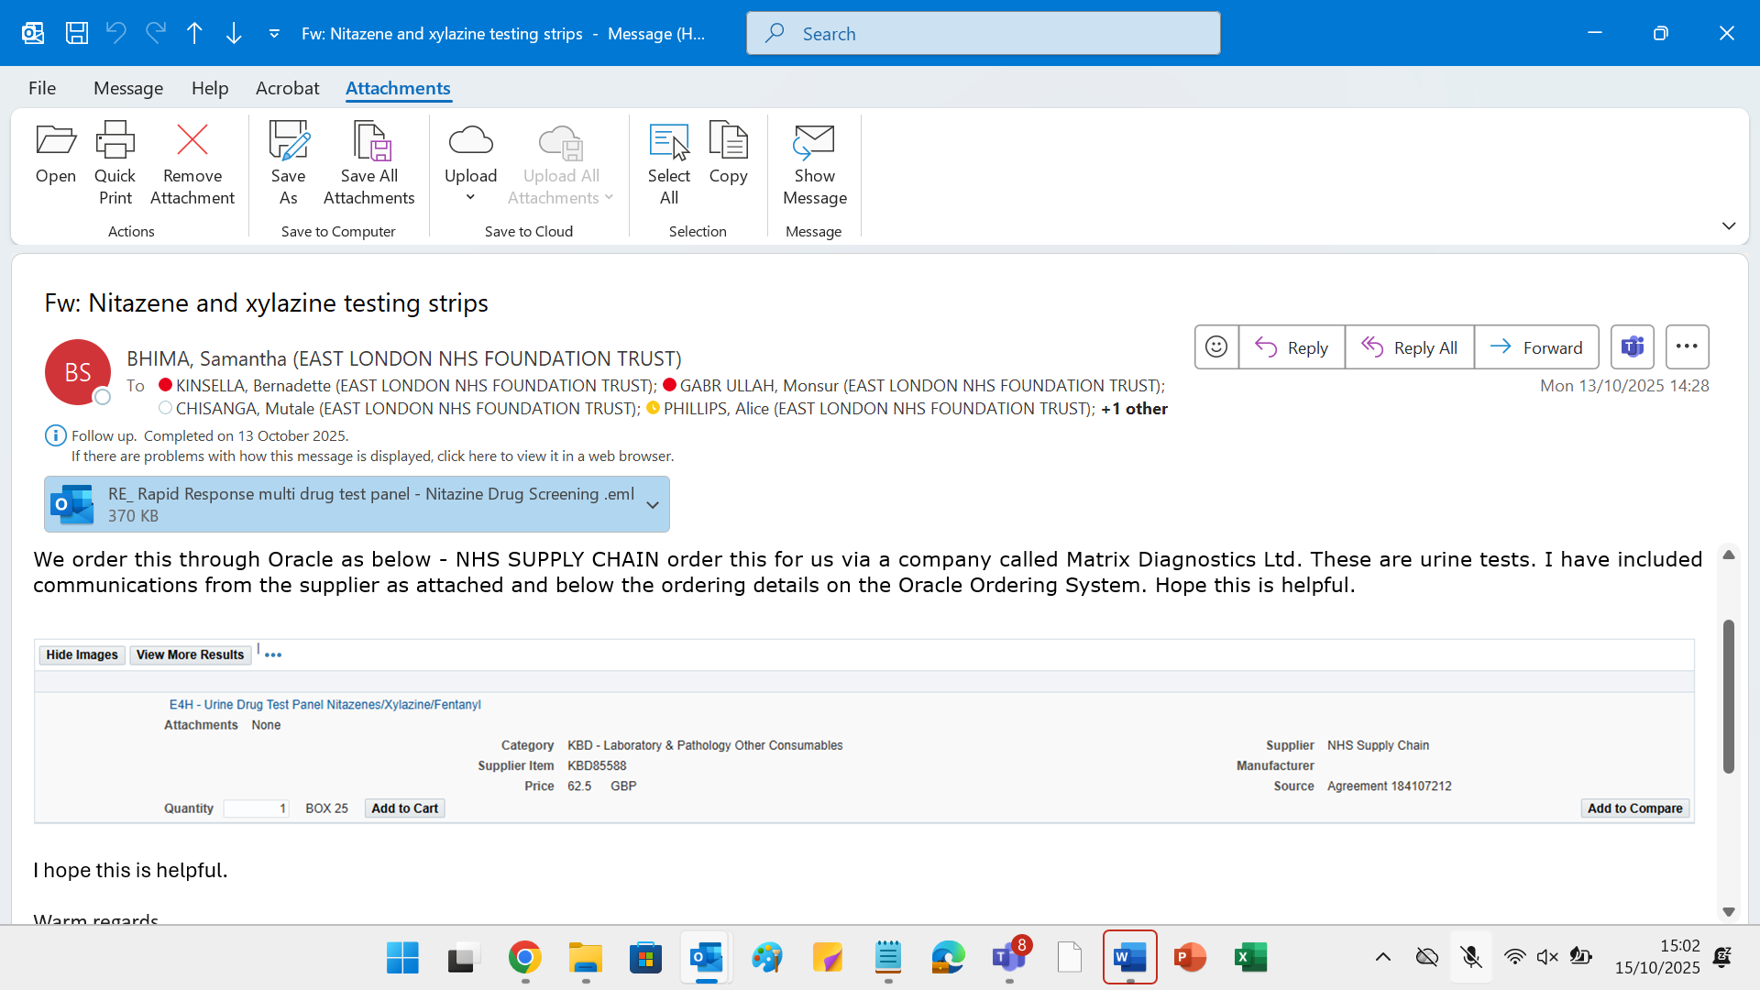

Appendix 2: Key Terms

Naloxone Injection temporarily reverses the effect of opioid drugs such as; heroin, methadone, fentanyl, tramadol, oxycodone and buprenorphine. Naloxone works by displacing opioid drug molecules from the receptors in the brain and body.

NEWS2 - ELFT expects staff within mental health settings to use the National Early Warning Score (NEWS2) tool, as recommended by NHSE.
https://www.rcp.ac.uk/improving-care/resources/national-early-warning-score-news-2/
https://vimeo.com/402507826
Staff should be confident in and understand the use of NEWS2 to record the service user’s vital signs, how the early warning system works, and when to escalate swiftly to a senior clinician when needed. Staff are expected to upload physical health measurements at point of care and ensure safe and timely interventions as required.
An electronic version of NEWS2 is accessible on RiO. Any use of hard copy NEWS2 forms should be uploaded onto RiO after completion.
NEWS2 should be used as an aid to clinical assessment. It is not a substitute for clinical judgment or from the need to escalate concerns if needed. Concerns about a service user’s clinical condition should prompt a clinical review, irrespective of the NEWS2 score.

MEWS - NEWS2 as an early warning tool is not designed for use with service users who are pregnant, because the physiological response to acute illness can be modified in pregnancy and post-partum.
The Maternity Early Warning Score (MEWS) tool can be used from day one of pregnancy. The Scottish safety programme recommends using MEWS up to six weeks after giving birth. Although NEWS2 can be used up to about week 18 of pregnancy, it should not be used after this time or for up to six weeks after giving birth.
If staff are unclear about the use of MEWS, or other aspects of the management of pregnant service users, advice should be sought from the medical team and, if appropriate, from perinatal services.
As for NEWS2, MEWS should be used as an aid to clinical assessment. It is not a substitute for clinical judgment or from the need to escalate concerns if needed. Concerns about a service user’s clinical condition should prompt a clinical review, irrespective of the MEWS score.

Vital Signs - This policy uses the term vital signs throughout, rather than observations, to avoid any confusion with mental health supportive observations.
A set of vital signs would normally include measuring respiratory rate, pulse, blood pressure, and temperature. Oxygen saturation would usually also be taken at the same time. Additional vital signs include blood sugar level and hydration status. Other vital signs include: weight, height and body mass index. The presence or absence of pain is also sometimes described as a vital sign, and staff should certainly always take pain into consideration when assessing physical health.

Taking vital signs should also always go hand in hand with considering the service user’s overall physical presentation and, where possible, considering any information from carers, friends and family.
Although staff are encouraged to be confident in taking a manual pulse or measuring blood pressure using a sphygmomanometer and stethoscope, the use of electronic vital signs monitors is standard in all inpatient areas in the Trust, and their use is perfectly acceptable. The Trust’s Medical Devices Policy sets out expectations for maintenance and calibration of these monitors.
This policy adopts the use of the terms ‘contact’ and ‘non-contact’ vital signs. It is not acceptable for no vital signs monitoring to take place due to a service user’s non-cooperation. Non-contact vital signs can still be recorded.

Contact Vital Signs
These rely on the consent and cooperation of the service user. Temperature, pulse, blood pressure, oxygen saturation, height and weight are considered contact vital signs.

Non-contact Vital Signs
Non-contact vital signs do not rely on the consent or cooperation of the service user. Respiration rate, level of consciousness using ACVPU (Alert, Confusion (new), Voice, Pain, Unresponsive) and hydration status are considered non-contact vital signs. A set of non-contact vital signs should be taken even when service users are non-cooperative with contact vital signs.

ECG - Electrocardiograms (ECGs) support the identification of baseline cardiac arrhythmias, acute cardiac problems and potential iatrogenic changes. QT intervals are crucial measurements in ECGs as abnormalities can indicate potential heart problems e.g. interval changes with antipsychotic medication.
Guidance for the use of ECGs with psychotropic medications can be found in the relevant policy, e.g. Standards for physical health monitoring of patients on antipsychotic treatment.

SBARD - SBARD is a communication tool used to facilitate clear concise information sharing. It stands for Situation, Background, Assessment, Recommendation, and Decision.
Clinical staff are encouraged to use SBARD when reporting or escalating a physical health or other concern. The agreed course of action or decision taken following discussion about a significant concern should always be documented in the service user’s notes.

Appendix 3: Naloxone Protocol

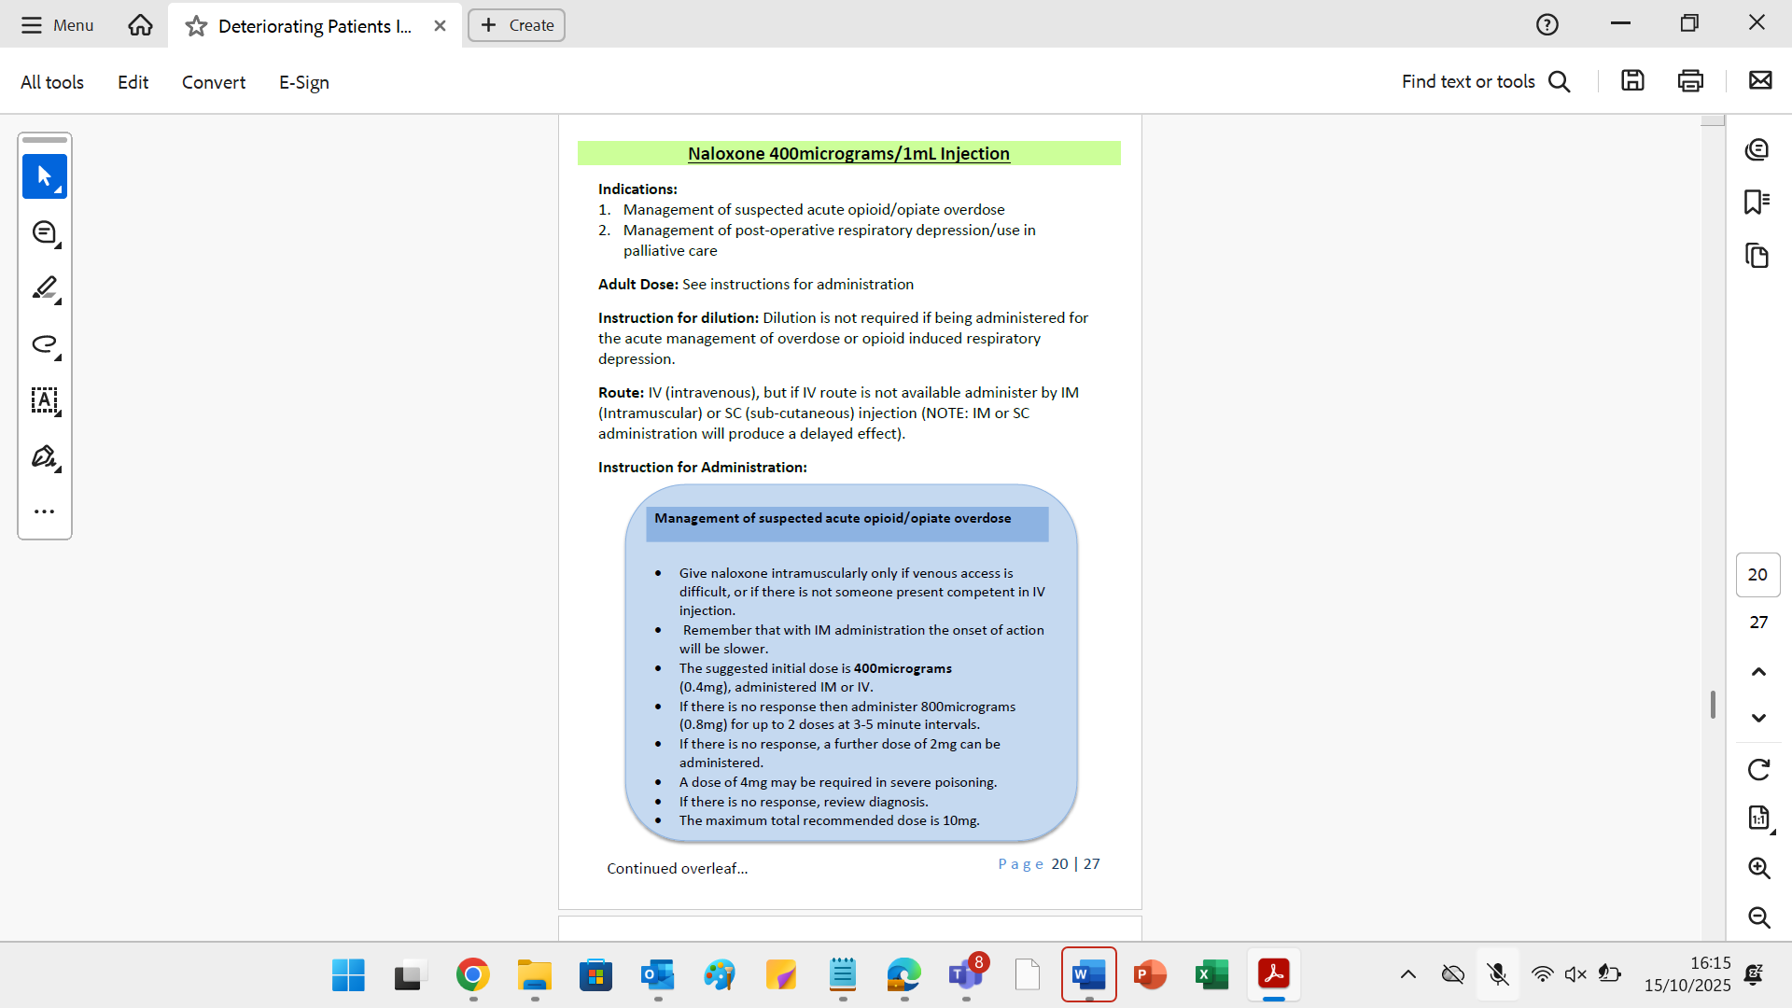

Naloxone IM Adults

• 400 micrograms or 0.4ml of Naloxone solution by intramuscular injection into the outer thigh or muscles of the upper arm as part of the resuscitation intervention. The dose of 0.4ml can be repeated every 2-3 minutes in subsequent resuscitation cycles until the contents of a syringe are used up.
• N.B. The duration of action of certain opioids can outlast that of an IV bolus of Naloxone, e.g. dextropropoxyphene, dihydrocodeine and methadone. In situations where one of these opioids is known or suspected it is recommended that an infusion of Naloxone be used to produce sustained antagonism to the opioid without repeated injection.

Children
• The Naloxone Injection presentation is not intended to be used for children in the home setting other than by an appropriately trained healthcare professional.
• In the event of a child being given or taking an opioid inappropriately an ambulance should be called and resuscitation started if required.

Appendix 4: Flumazenil Protocol
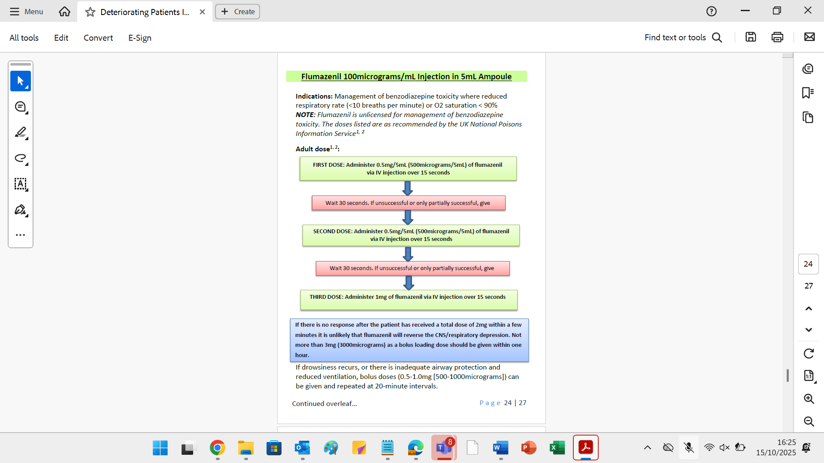
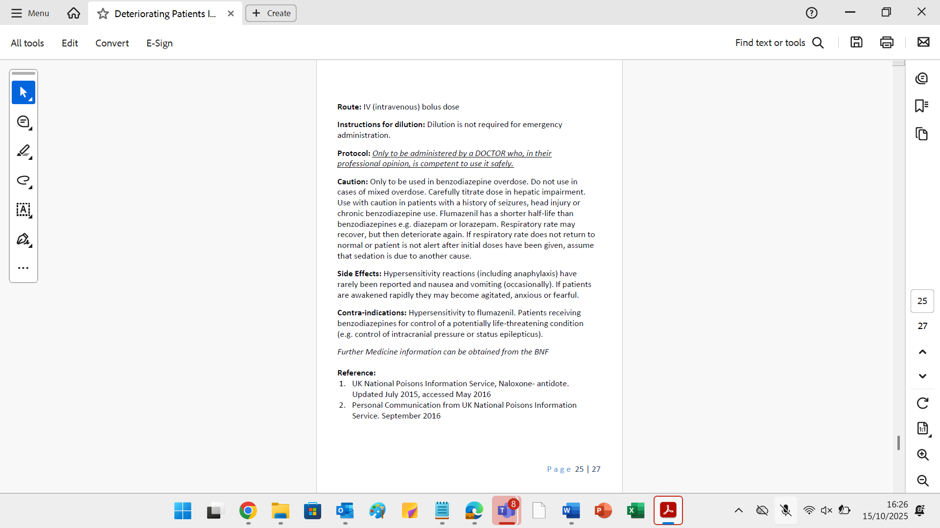

Flumazenil should NOT be used routinely in suspected benzodiazepine overdose due to seizure risk in dependent or mixed overdose patients. Use only on specialist advice.

Appendix 5: Toxbase, Resources for Health Professional
On ELFT desktop

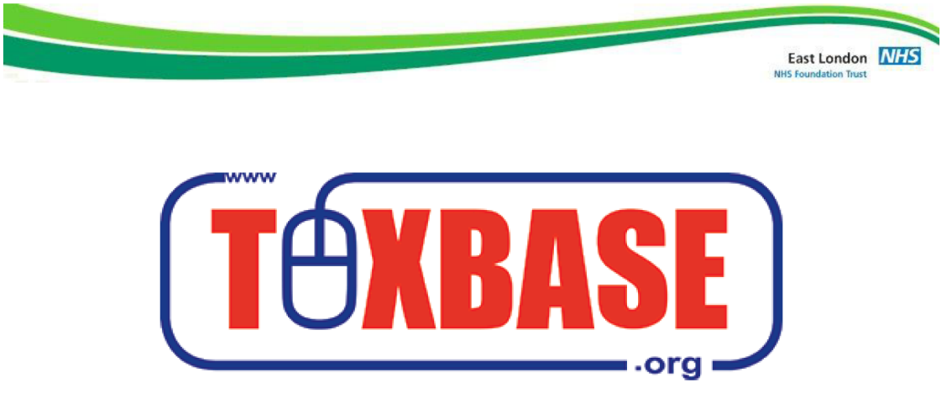
https://www.toxbase.org/

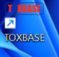

Appendix 6: Quick Guide for Wards on Acute Intoxication
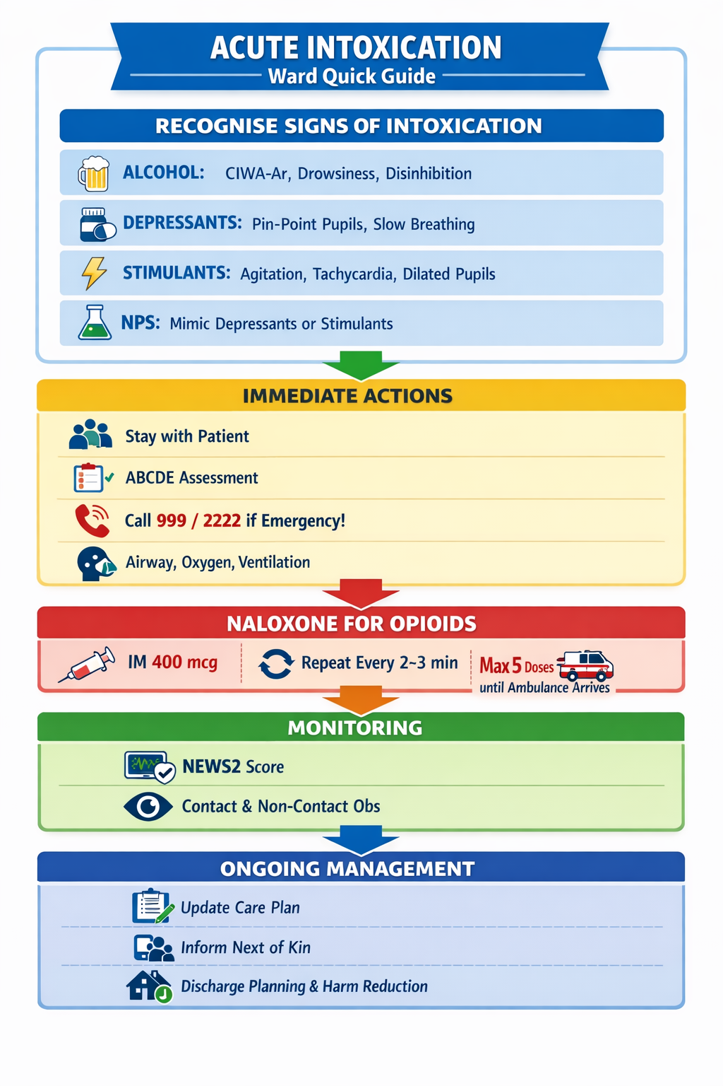

14.0 Equality Impact Assessment

Name of service, function or policy | Guideline for Managing Intoxication on In-Patient Wards
Brief description of service, function or policy (purpose) | For ELFT In-patient Wards
Is the service, function or policy | ☒ Existing | ☐ New |  |  |  |  | ☐ Under review
Directorate  (If all groups are impacted, please state ‘Trust-wide’) | Trust-wide
Who is completing the EIA?  (name/role) | Bernadette Kinsella – Trust-wide Lead Physical Health Nurse
Which Trusts Strategies are supported by the service? | Population Health |  |  |  |  |  | ☒
Which Trusts Strategies are supported by the service? | The Experience of Care |  |  |  |  |  | ☒
Which Trusts Strategies are supported by the service? | Staff Experience |  |  |  |  |  | ☒
Which Trusts Strategies are supported by the service? | Improved Value |  |  |  |  |  | ☒
Which Trusts Strategies are supported by the service? | None |  |  |  |  |  | ☐
Who will benefit from the service, function or policy? | ☐ Workforce |  |  | ☒ Patients, Service Users, and Carers
How will the service, function, or policy be implemented to:  - Ensure access  - Meet health needs  - Provide a safe and positive experience for everyone? | The Policy will be published on the Trust Intranet and promoted via the Communications Team.  Borough Lead Nurses, Medical Directors, Managers & Medical Leads will be responsible for cascading the policy and any training requirements for local teams.  Key aspects of the policy will be included in local induction programmes and discussed during supervision/appraisals.
How will the service, function or policy be implemented? | Approval at Physical Health Committee, Trust-wide Physical Health in Mental Health Group, Chair’s Action by Chief Nurse and Quality and Medicines Committee.
What are the intended outcomes by delivering the activity? | To ensure safe practice in line with quality care.
How will these outcomes be measured? | Reflections on incidents in line with Trust incident management and quality care.
Who are the key stakeholders for this activity and how have they been involved? | Pharmacy  Resuscitation  Bedford Drug & Alcohol Service
Does this service, function or policy impact other existing policies? | ☒ Yes |  |  | ☐ No
 | As listed above on Section 1.2
Is there any data available that  influences, affects, or shapes this Equality Impact Assessment? | ☐ Yes |  |  |  | ☒ No
Are there gaps in information?  Consider groups that you have not directly engaged with, or existing data that does not provide then full picture. | ☐ Yes |  |  | ☒ No
Does the service, function or policy have a negative impact on any particular group? | Protected Characteristic |  |  |  |  | Yes |  | No | Unclear
 | Age |  |  |  |  | ☐ |  | ☒ | ☐
 | Disability |  |  |  |  | ☐ |  | ☒ | ☐
 | Race |  |  |  |  | ☐ |  | ☒ | ☐
 | Marriage and Civil Partnership |  |  |  |  | ☐ |  | ☒ | ☐
 | Pregnancy and Maternity |  |  |  |  | ☐ |  | ☒ | ☐
 | Gender re-assignment |  |  |  |  | ☐ |  | ☒ | ☐
 | Religion or belief |  |  |  |  | ☐ |  | ☒ | ☐
 | Sex |  |  |  |  | ☐ |  | ☒ | ☐
 | Sexual Orientation |  |  |  |  | ☐ |  | ☒ | ☐
Could the way the service, function, or policy is implemented have an adverse impact on equality of opportunity or good relations between different groups? | ☐ Yes |  |  |  | ☒ No
 | N/A
Where a negative impact has been identified, can changes be made to minimise it? | N/A
Is the service, function, or policy indirectly discriminatory, and can it be justified? | ☐ Yes |  | ☒ No
 | N/A
Is the service, function, or policy intended to increase equality of opportunity by permitting Positive Action or Reasonable Adjustment? | ☐ Yes |  | ☒ No
 | N/A

Please select one option
☐ | This EIA indicates that there is insufficient evidence to judge whether there is differential impact.
☒ | This EIA shows that the service/function has a differential impact which is not negative.
☐ | This EIA reveals a differential impact which amounts to a negative impact.

Submit the completed Initial Equality Impact Assessment to Project Lead/Sponsor and EDI Team elft.edi-team@nhs.net for review.

EDI Team sign-off:

Reviewed by EDI Team | ☐ Yes | ☐ No
Date

Project Lead/Sponsor sign-off:

Has a negative or potential negative impact been identified? | ☐ Yes | ☐ No
Name
Role
Date

