


Code of Practice: Mental Health Act 1983


Easy Read version

What is in this booklet
About this booklet
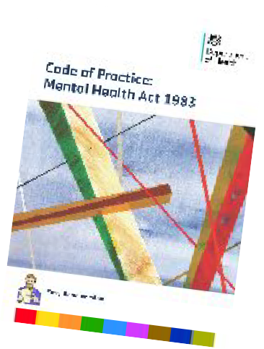
About the Mental Health Act About the Code of Practice

Why the Code of Practice needs to change How we worked on the changes
- Using the Mental Health Act
Guiding Principles


- Patient’s Rights Information Nearest relative IMHAs
Attorneys and deputies Privacy, safety and dignity
Saying what you want before you are ill Keeping your personal information confidential Visiting patients in hospital
The Tribunal

page
1

3

4

6

7

9

10

16

16

18

19

20

22

24

25

27

29






What is in this booklet page
- Getting the right care in the right place 31
The Mental Capacity Act 2005 32
Detaining (holding) a person in a hospital 35
- Specific groups of patients 39
People with learning disabilities or autism 40


People who are involved with the police or courts 42
- Safe care and treatment in hospital 45
Medical treatment 46
Safe ways to respond to behaviour that is 47
difficult or dangerous
- Leaving hospital 54
Community treatment orders (CTOs) 55
Guardianship 57
- Professional responsibilities 59
Hospital managers’ discharge power 59
Information for victims 63
What do the words mean? 64


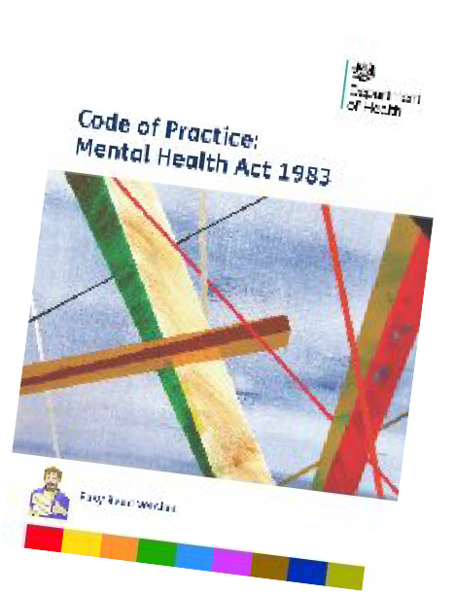
About this booklet

The Department of Health wrote this booklet.



It is about the new Code of Practice that tells people about the Mental Health Act.
Code of
Practice


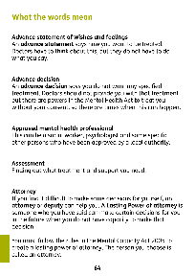
Some difficult words are in bold text.

There is a list at the end of the booklet to explain these words.








We have put the information about the Code into 7 different parts.

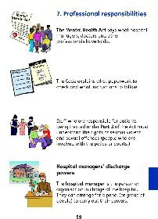
Each part is a different colour to help you find things more easily.



This booklet covers those parts we think you will be most interested in.



There is more information in the long version of the Code of Practice.


You can read this at: www.gov.uk/government/publications/co de-of-practice-mental-health-act-1983


The longer version has the same 7 parts as this booklet.




About the Mental Health Act
The Mental Health Act is a law about detaining (holding) and treating people with a mental disorder in England and Wales.




Under the Mental Health Act people can be made to stay in hospital.

This means they are detained there and are not free to leave even if they want to.



They can also stay at home with certain rules about what they must do.




This booklet is about the revised Code of Practice that says how to use the Act in
Code of
Practice



- England.
✓
Code of

Wales has its own Code.
Practice

3




About the Code of Practice
Code of
Practice
The Code of Practice explains the law and tells people and services what they must do.



It helps patients get the right treatment, care and support when they are treated under the Mental Health Act.


The Code of Practice is for:

  - people who work with patients with mental health problems



  - people who are being treated under the Mental Health Act in hospital or in the community



  - the families and friends of people with mental health problems

  - hospital managers



  - other people like the police or ambulance staff.



It will also help the Care Quality Commission (CQC) and other organisations that check mental health services are being provided properly.
✓




The Code of Practice tells people about the rights of patients and their carers. It makes sure patients are treated equally and fairly.
Code of
Practice



It helps people:

  - understand the Mental Health Act and use it properly




  - make decisions about how to care for people with mental health problems



  - give the best care to people with mental health problems.



Why the Code of Practice needed to change
The Code of Practice needed to be stronger and clearer because:


  - it was last written in 2008 and laws and health services have changed since then
Code of
Practice







  - it will only work if it is up to date and people understand how to use it properly
Code of
Practice

  - patients get poor or unsafe care when services do not understand or do not use the Code properly.
Code of
Practice




How we worked on the changes
Code of
Practice
In 2014 we asked lots of different people and organisations about a new Code.


A group of Experts by Experience worked with us from the very beginning.



They are people who know what it is like when someone is treated under the Mental Health Act.


They told us the new Code should:

  - make sure patients can speak up


  - stop poor or dangerous care



  - make sure all staff get the same, good training


  - be clear and easy for everyone to understand.



Using the Mental Health Act

The Mental Health Act says:


  - when you can be given treatment, even if you do not want it


  - when you can be held in hospital for assessment or for treatment for your mental disorder

  - what your rights are.




The Code helps services treat patients fairly and equally when they use the Mental Health Act.
Code of
Practice



The Code explains the 5 guiding principles. These are things everyone must think about when they use the Mental Health Act.
5
Guiding
1.
Principles 3.
2.
✓
4.
5.






Give treatment in the least restrictive way and help people to be as independent as possible
g 2.
es 3.
4.
5.
5
Guidin
11.
Principl
✓

This means:

  - only use the Act and keep people in hospital if they really need to



  - keep people in hospital for the shortest time possible



  - avoid any rules that apply to all patients. This means treat patients as individuals and do not just have the same rules for everyone



  - help patients get well and be as independent as possible.


Involve patients
5
Guiding
Principles 3.
22.
1.
✓
4.
5.


  - involve patients as much as possible in planning their treatment and care




  - think about what patients have said before about what was important to them

  - write down the patient’s views



  - give patients information and support to be involved in decisions

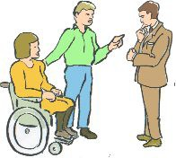
  - tell patients how an advocate could support them to be involved


  - involve family or carers if the patient wants them to be.


Respect patients, families, carers and friends
5
Principles 33.
Guiding
1.
2.
✓
4.
5.


  - respect, understand and listen to them


  - understand that every patient is different. Think about what this means for their treatment and care.


Help people get well
5
Guiding
1.
Principles 3.
2.
✓
414.
5.



  - use the Act to give people the treatment they need



  - treat people in places that are safe and help them get well


  - plan the right services and support for patients in hospital and when they leave

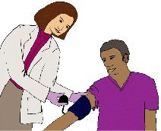
  - think about patient’s physical health as well as their mental health.




Making fair and efficient decisions
✓
✓
5
Guiding
1.
Principles 3.
2.
55.
4.

  - mental health is as important as physical health


  - work together to keep patients in hospital for as short a time as possible



  - make sure staff understand how to use the mental health act to support all their patients safely




  - work together to give you good safe mental health services and the right support when you leave hospital.



Services must stick to laws about treating people equally and fairly.



They must make sure that everyone has the same chance to get good treatment and care.


Services must make reasonable adjustments or changes so people with a disability are treated equally.



For example, having information in EasyRead or staff who can communicate in sign language.




Patients’ Rights
Code of
Practice




The Code says patients should have a say in their care and be treated with dignity and respect.




Families and carers must know about the Code and understand their rights
Code of
Practice

The Code says what people should do to keep patients safe.
P
Code of
ractice



Information
Give patients clear information about how the Mental Health Act applies to them and their rights.


Tell them this information, give it in writing and communicate it in a way that they understand it.



Tell patients when they can refuse treatment and when it can be given even if they do not want it.




Tell the patient what information will be shared with their nearest relative under the Act and talk about what the patient is happy to share.

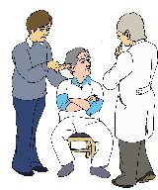
Give patients the support they need if they speak another language or have a disability that affects their communication.

Tell patients how Independent mental health advocates (IMHAs) can help them understand their treatment and rights.


Tell patients and carers how to complain if they are not happy with their treatment or care.



Nearest relative
Your nearest relative is given certain information and involved in certain decisions about your treatment and care.



The Mental Health Act says who your nearest relative is. This might not be the same as your ‘next of kin’ or the person you feel closest to.


The nearest relative can ask someone else to take on their role.


If you have no close family, a court can choose a nearest relative for you. This might be the local authority.

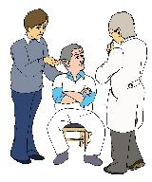
IMHAs
Independent mental health advocates (IMHAs) help patients understand their rights and be involved in decisions.

They are only there to support you.




Anyone who is held in hospital or under a community treatment order under the Mental Health Act can have support from an IMHA.

The person treating you must tell you about IMHAs and how to get support.



The advocates are specially trained to understand the Mental Health Act.



They are independent which means they are nothing to do with any person or service that is giving you treatment or care.


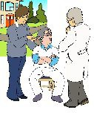
The local authority must plan advocacy services to meet different people’s needs.

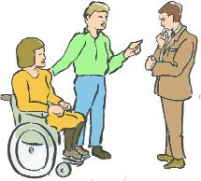
Attorneys and deputies
If you do not have capacity to make a decision for yourself, an attorney or deputy can make it for you if you have one.



A Lasting Power of attorney is someone who you have said can make certain decisions for you in the future if you do not have capacity to make that decision yourself.



You need to follow the things the law says you must do to create a lasting power of attorney. The person you choose is called an attorney.


A deputy is someone who the court of protection has said can make decision for you because you do not have capacity to make that decision.



If you are treated under the Mental Health Act and do not have capacity, your attorney or deputy can make some decisions for you.



In some cases consent (agreement) is not needed, for example, for some medical treatment under the Act.



Privacy, safety and dignity
People who treat you must make sure they respect your privacy and dignity when they try to keep you safe.



They should think about your privacy when you:

- undress or wash



- read or send letters or emails


- use the telephone



- meet your advocate, family or friends.



Staff should treat patients as individuals and decide what is safe for them, not just have the same rules for everyone.





There should be separate places for men and women to sleep, wash and go to the toilet and a room for just women to go to during the day.


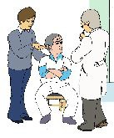
Sometimes patients need to be somewhere that is more secure. Your responsible clinician will make this decision.


This should only take away your freedom if it keeps you or other people safe.


Saying what you want before you are ill


Patients who are treated under the Mental Health Act cannot decide what treatment they want.

Doctors have to think about what the patient said in the past and what they know is important to them.



When you are well you can write a statement about what you want to happen if you don’t have capacity at some time in the future, for example, because your mental illness gets worse.



An advance statement of wishes and feelings says how you want to be treated.



Doctors have to think about this when they decide what is in your best interests, but they do not have to do what you say in the statement.



An advance decision: The Mental Capacity Act says that people who have capacity and are at least 18 years old can make a decision that they do not want a particular treatment.




Doctors should not give that treatment to them unless they are using powers in the Mental Health Act where they do not need your consent to give you that treatment.



Your confidential information


The law about confidential information is the same for patients who are treated under the Mental Health Act as for other people, except where the Act says otherwise.

Sometimes, your confidential information can be shared without your agreement.






Sometimes they need to share information with other services like housing. They should usually ask if you agree to this.

But the Act says there are some times when services can share information, even if you do not agree.



This is usually where the law says it can be shared.

People must write down who they share the confidential information with and why they did this.

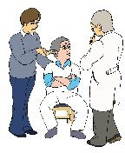

An IMHA can help a patient understand how their confidential information is being used.



Visiting patients in hospital
All patients have the right to see their family and friends while they are held in hospital.



You also have the right to see people like your advocate in private.



The hospital has to make sure the patient and visitors are safe.


There are some times where hospital managers may restrict visitors, refuse to let them in or ask them to leave. Managers should have a policy (plan) for the times when they can limit visits to patients.



This should be clearly displayed on the ward so staff and patients can read it.
Policy



They have to write down why they stopped the visitor coming and show there is a good reason for this.


Hospitals cannot have rules for everyone that say things like no visitors for the first 4 weeks.



Hospital managers must check when staff are stopping visitors. They should have a policy on when visits are not allowed.


The Tribunal
The Mental Health Tribunal is an independent group.



They review (look again at) cases where a patient is held in hospital or subject to a community treatment order or to guardianship.



For example, The Tribunal can decide that a person should not be held in hospital.



If this happens, doctors have to tell the Tribunal why the patient should be held in hospital and why they they are doing what the Act says they must do.





Hospital managers must tell patients about the Tribunal and how to ask them to look at their case.

You can get free help and advice from a solicitor to help you with this.


The Tribunal usually meets in the hospital and the patient usually goes to the meeting with someone who can speak for them.


The hospital manager must make sure the patient and their family can be involved and understand what is happening.



Getting the right care in the right place

People must use the Mental Health Act to give patients the treatment they need.



The Code says:



  - how doctors must ask for a person to be held in hospital under the Mental Health Act

  - how patients should be taken to hospital.




Sometimes the police need to take someone away from a public place to keep them or other people safe.

They should only use a police station as a safe place if there is nowhere else to take the person.


The Mental Capacity Act
People who make decisions, including doctors, must understand the Mental Capacity Act and how to support people who do not understand how to make decisions about their treatment or care. This is called lacking capacity.

There are 5 important things people must do and think about when they use the Mental Capacity Act:
5
Important 2.
1.
✓
Things
✓
3.
4.
5.


- Start off by thinking that everyone has
✓
capacity to make their own decisions


- Give the person all the support they can to help them make decisions


- No-one should be stopped from making a decision just because someone else thinks it is wrong or bad


- If everyone agrees that a person lacks capacity, another person can make a decision for them, but it must be the right thing for the person.




This is called a best interests decision. The Mental Capacity Act says how people must do this.


- When they do something or decide something for another person, they must involve the person.


For example, a decision can be made under the Mental Capacity Act about:
✓

  - whether to take certain medicines or not




  - whether to stay in a hospital or care home or not.
✓

The Deprivation of Liberty Safeguards are part of the Mental Capacity Act.




Services have to think about these safeguards if they give you any care or treatment that deprives (takes away) a person’s liberty.

This means where you are not free to leave and where you may be watched or controlled all the time.



They must tell the local authority (council) and the Care Quality Commission (CQC) if they use the Deprivation of Liberty Safeguards so they can check what they are doing.



Sometimes people have to decide whether to keep a person in hospital under the Mental Health Act or the Deprivation of Liberty Safeguards. Both cannot be used at the same time.



Asking for a person to be detained in hospital
A person can be held in hospital for assessment to find out what treatment and care they need if:


  - they have a mental disorder which needs them to be held in hospital for assessment

  - they need to be held in hospital for their own health or safety or to keep other people safe.




A person can be detained in hospital for treatment if:

  - they have a mental disorder which means it is right for them to be treated in hospital


  - it is needed for their own health or safety or to protect other people and the treatment can only be given if the person is held in hospital for treatment and



  - the right medical treatment is available.


The patient’s nearest relative or an approved mental health professional (AMHP) can ask for a person to be detained in hospital under the Mental Health Act.



Approved mental health professionals can be social workers, psychologists and some specific other persons who have been approved by a local authority.


2 doctors must give a medical recommendation saying that the criteria for detention are met.

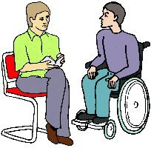
Before making an application, the Approved Mental Health Professional must think about:

  - how to support the patient to communicate and understand the assessment


  - what the patient wants now or said they wanted in the past



  - whether keeping them in hospital is the only way to treat the patient


  - how it will affect the patient and their family if they are taken into hospital.



The NHS must make sure that local authorities (councils) know where there are hospital beds for patients who need them urgently.


The NHS should try to place patients as close as is reasonably possible to their home.

If it is difficult for the patient’s carer or family to visit a patient because of the distance they need to travel, then the NHS should think about what support they can provide.



Specific groups of patients

The Mental Health Act protects patients but says there are special things to think about for some people.


The Code has extra information about treatment and care for:

  - children and young people under 18 years old



  - people with learning disabilities or autism


  - people with a type of mental illness called a personality disorder

  - people who have been involved with the police or courts.



People with learning disabilities or autism
A person cannot be detained and treated under the Mental Health Act just because they have a learning disability or autism.




The Act defines a learning disability (says what it is). If a person’s mental disorder is a learning disability, then the Act can only be used if the rules for detention are met and the learning disability is linked with:

  - very (unusually) aggressive or


  - seriously irresponsible conduct (for example, behaving in a way that is dangerous to them or other people.)

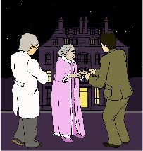
This is not the same as bizarre or unusual behaviour.


The person might be angry or frustrated because they cannot say or do what they want.




It is important to think about why the person is behaving like this to make sure that their behaviour is not caused by something they need that they are not getting that could be solved.

The definition of mental disorder in the Act includes autistic spectrum disorders.



People with autism can find changes difficult or upsetting. Being kept in hospital can be difficult for them so they need support from staff who understand autism.


The staff should listen to carers and other people who know the person well and can say if they understand the decision.


People who are involved with the police or courts
People should not usually be sent to prison, held at a police station or immigration removal centre if they need treatment for their mental health.



The police or courts must ask for an assessment if they think someone needs treatment for their mental health.




Liaison and Diversion services support people at risk to get the services they need.

People at risk include:

- children and young people


- people with mental health problems


- people with learning disabilities

- people with autism.



A doctor will assess the person and say if they should go to hospital instead of prison.

Doctors write reports to tell the court what is best for the patient.


This might be:

- treatment they must have in hospital


- going to prison

- treatment they must have in the community.



A hospital order is not for a set time like a prison sentence. You have to stay in hospital until you do not need to be treated there any more.



A hospital direction has a time limit like a prison sentence. The patient can be moved to a prison when the hospital cannot treat them any more.



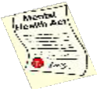
Safe care and treatment in hospital
Code of
Practice

The Code says all patients must get the right treatment in a place that is safe for them.


Doctors should think about the patient’s wishes when they plan their treatment and care.



Medical treatment

Treatments with special rules
There are special rules for some treatments that the patient has to consent or agree to or a second doctor has to say they need.



Doctors must think carefully about whether the patient needs this treatment.

They should tell the CQC how they will keep to the rules about consent and second doctors.



Community treatment orders
If you have been in hospital under the Mental Health Act the doctor in charge of your care can put you on a community treatment order (CTO) if it meets certain rules.


If you are under a Community Treatment Order you must go for medical examinations for some things if you are asked to.


You can also have other rules which will:
✓

- make sure you get medical treatment for your mental disorder


- stop you being a danger to your own health and safety and protect other people.


Except in an emergency, physical force cannot be used to make you have medical treatment for your mental health problems when you are under a Community Treatment Order.



A patient on a community treatment order can be recalled (called back to) to hospital.




Patients who cannot agree to treatment
✓
If you are held under the Mental Health Act, you can be treated without your consent, but people must follow the rules in the Act.

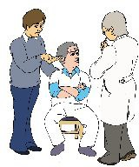
An IMHA can help you understand what this means for your treatment.



For example, the Mental Health Act says you can be given treatment during the 3 months when you are first detained (although there are special rules for some treatments).

3 months





Even if they can treat you against your wishes, doctors should still ask if you agree to the treatment and write down if you refuse.




Your IMHA can help you to understand if any special rules apply to the treatment you are getting.

The Mental Health Act sometimes says doctors must decide:


- whether you have capacity to agree to or refuse the treatment


- whether you do agree to it.




If you need to agree to some treatment, the Mental Capacity Act will apply if you are 16 or over.

There are different rules for children.

Treatment plans


A treatment plan is an important part of treatment under the Mental Health Act. It should say:



- what treatment you need

- how you will be treated


- why you are having that treatment and how it will help your mental illness.
✓


You should have the chance to be involved in talking about your treatment plan. An advocate can help you with this.




If your family will be caring for you while you have the treatment, it is important to involve them in the treatment plan.



The Mental Health Act and Mental Capacity Act


If you have to consent to treatment under the Mental Health Act and doctors find that a patient aged 16 or over does not have the capacity to agree to it, then they must use the Mental Capacity Act.

In certain cases the Court of Protection may have a power to order that doctors must not give the treatment.




Safe ways of dealing with behaviour that can be difficult or dangerous
Code of
Practice
The Code says services should give good, safe care to people who have difficult behaviour and might hurt themselves or others.


Hospitals and community services should:

- assess patients to see if their behaviour might be dangerous or difficult when they first go into hospital



- have rules and training about how to stop people doing dangerous things



- understand and think about human rights



- care for patients in safe places that are not noisy or upsetting



- know what can upset the patient. Have plans about how to stop things before their behaviour gets dangerous



- only use restrictive interventions (things like physical restraint or holding people physically) for as long as necessary to stop the patient harming themself or others.

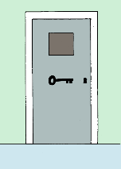
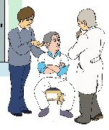
This must be a proportionate response to the possible harm the patient could do.

It should take away as little freedom as possible. Your IMHA can help you understand if this happens to you.



- have clear information about keeping patients away from other people to keep them or others safe. Do this for as short a time as possible


- write down if how and why they restrain a patient or keep them away from other people


- talk to the patient afterwards about what happened, why they were restrained and what they thought about


- tell patients and their families how to complain if they are not happy about the restraint


- think about physical healthcare and not just mental health.



Leaving hospital

When patients leave hospital it might be:



  - for a short break called leave of absence

  - to have their treatment in the community.




  - because they are discharged or sent home.

Local authorities and clinical commissioning groups must make sure patients get the right care in the community after they have been kept in hospital for treatment.

This is called after-care and the Mental Health Act says what this means.


Community treatment orders


A Community treatment order means a person can stop being held in hospital for treatment and can be treated in the community.




It is a way to be more independent and get back to normal life at home or with your family.

A CTO is not right for everyone.






There are rules to make sure you carry on with the treatment and your doctor can bring you back to hospital if they need to.

✓

Your doctor has to make sure they keep to the rules in the Act.




You do not have to agree to a CTO but you should be involved in planning your treatment.


You should get clear information about your treatment and have the right to support from an IMHA.
✓



Your doctor will check how things are going and can decide to change your treatment or bring you back into hospital for treatment if you do not keep to certain rules.



Your doctor must end your CTO if it does not meet the rules any more or if you have been held in hospital for more than 72 hours.


Guardianship
Guardianship is a way for patients to get care outside a hospital.


You can be put under guardianship if you are 16 or over, have a mental disorder and doctors need to protect you or other people.




The guardian is the local authority or someone that the local authority has approved.


Guardians can:

  - say where you have to live



  - say that you have to go for treatment, work or training at a set time and place. But they cannot use force to take you there


  - say that a doctor or approved mental health professional must be able to visit you where you live.



Guardianship can be used to keep you safe and make sure you get the treatment you need. It must not have rules that take away your freedoms.



The rules should not mean you are watched and controlled all the time. They should not stop you leaving the place where you live.




Doctors must think about whether this is the best way to give you the care you need or whether it can be done another way.



If you lack capacity to make some or all decisions about your treatment and care, your doctor should think about whether to use the Mental Capacity Act instead.



Professional responsibilities


The Mental Health Act says what hospital managers, doctors and other professionals have to do.



The Code explains what paperwork to check and what instructions to follow.
Code of
Practice



Staff who are responsible for patients being treated under Part 3 of the Act must understand the rights of serious violent and sexual offenders (people who are involved with the police or courts.)


Hospital managers’ discharge powers
The hospital manager is the person or organisation in charge of the hospital. They can arrange for a panel (or group of people) to carry out their powers.



When doctors agree a detained patient can leave hospital or no longer be on a CTO this is called being discharged.


Hospital managers cannot discharge some patients, including those who are on a hospital order.




Hospital managers should think about whether a patient is ready for discharge when:

- they think it needs to be done



- the patient’s doctor gives them a report to renew detention (hold them for longer)



- the patient asks them


- the nearest relative wants the patient to leave hospital but doctors want to stop this and give the hospital managers a barring order to stop them leaving.



Hospital managers need to think about the following if a person is detained for treatment:
?

- does the patient still have a mental disorder?



- if so, is it the type or serious enough to make treatment in hospital the right treatment?
?



- is detention necessary to protect the patient’s health or safety or to protect others?


- is the right medical treatment available?
?




- have they thought about whether the Mental Capacity Act could be used to treat the patient safely?
?

Hospital managers should tell patients about their decision and the reason for them.


Information for victims
Some victims of serious crimes by someone being treated under the Mental Health Act have rights:
- people should listen to what the victim thinks when they decide about things like treatment, community leave and discharge



- the victim has a right to know what is happening with the patient. For example, if they are moving back into the community

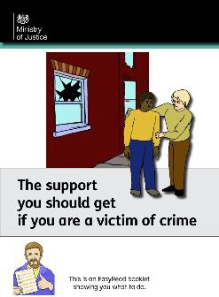
- victims should get support to deal with how the crime has affected them. The Victims’ Code says what support you can get.



The Mental Health Act Code says who should give victims information and what information they can give.
Code of
Practice

What the words mean

Advance decision
An advance decision says you do not want any specified treatment. Doctors should not provide you with that treatment but there are powers in the Mental Health Act to treat you without your consent, so there are times when this can happen.

Advance statement of wishes and feelings
An advance statement says how you want to be treated. Doctors have to think about this, but they do not have to do what you say.

Approved mental health professional
This can be a social worker, psychologist and some specific other persons who have been approved by a local authority.

Assessment
Finding out what treatment and support you need.

Attorney
If you find it difficult to make some decisions for yourself, an attorney or deputy can help you. A Lasting Power of attorney is someone who you have said can make certain decisions for you in the future when you do not have capacity to make that decision.

You must follow the rules in the Mental Capacity Act 2005 to create a lasting power of attorney. The person you choose is called an attorney.

Best interests
When doctors make a decision about treatment they have to think about whether it is in the patient’s best interests. This means thinking about what is important to the patient, whether this is the best treatment to help the patient, and consider what other people think.

Capacity
Being able to understand and make a decision for yourself at the time the decision needs to be made. If you cannot do this you lack capacity.

Care Quality Commission (CQC)
An independent organisation that checks health and social care services, including hospitals that detain and treat people under the Mental Health Act.

Clinical commissioning group
The NHS organisation that plans and pays for local health services.

Code of Practice
The Code explains the Mental Health Act and tells people and services how to use it properly to give safe care.

Community treatment order (CTO)
The doctor in charge of your care can put you on a community treatment order if specific requirements in the Mental Health Act are met.

This means you are discharged from hospital but can be recalled. There will be conditions attached to the order, including to make sure that you allow a doctor to examine you for specific purposes.

Consent
Give permission or agree to something.

Court of protection
A special court that set up under the Mental Capacity Act to deal with issues relating to people who lack capacity to make decisions for themselves.

Definition or define
To say what something means.

Deprivation of Liberty Safeguards (DOLs)
Safeguards in the Mental Capacity Act for people who lack capacity are deprived of their liberty. Services have to think about these safeguards if they give you any care or treatment that takes away your freedom.

Deputy
A deputy is someone who the court of protection says can make a decision for you because you lack capacity to make that decision.

Detain
To hold or keep someone in hospital even if they do not want to be there.

Discharge
When you leave hospital or you are no longer on a CTO stops or subject to guardianship.

Experts by Experience
People who know what it is like to use a service. For example, being treated under the Mental Health Act.

Guardianship
A guardian is appointed to help and supervise a patient in the community.

The guardian is the local authority or someone that they choose.

Guiding principles
Important things that everyone must think about when they use the Mental Health Act.

Hospital direction
When a court send you to hospital for a time limit like a prison sentence. You can be moved to a prison when the hospital cannot treat you any more.

Hospital manager
The person or organisation who is responsible for the Mental Health Act in a hospital.

Hospital order
When a court says you are detained in hospital until you do not need to be treated there any more.

Immigration removal centre
A place to hold people from other countries while the court decides if they can stay in this country or not.

Liaison and diversion services
When people who might be at risk get involved with the police or courts these services help them get the support and services they need.

Mental Capacity Act 2005
The law that protects people aged 16 or over who do not have capacity to make decisions for themselves.

Mental disorder
This is sometimes called a mental illness. It means the person thinks, behaves or sees things differently and this makes everyday things difficult for them.

Mental Health Act 1983
This is the law about treating people with a mental disorder in England and Wales.

Mental Health Tribunal (also called the First Tier Tribunal (Mental Health).

An independent organisation that has the power to discharge patients from detention, community treatment orders and guardianship.

Nearest relative Your nearest relative is given information and involved in decisions about your treatment and care. The Mental Health Act says who your nearest relative is.

Part 3 of the Mental Health Act
You can be kept in hospital for treatment under Part 3 of the Act. You might need the treatment for your health, your safety or to keep other people safe.

Personality disorder
We each have different traits or things that make us the type of person we are and the way we act with other people. For example, we might be anxious or confident, quiet or full of energy.

If any of these things develop in ways that make it very difficult for you to live your life or be with other people, doctors might decide this is a personality disorder.

Reasonable adjustments
Changes to help a person with a disability. The NHS is required to take reasonable steps to avoid putting a person with a disability at a substantial disadvantage compared with people who are not disabled.

Responsible clinician
The doctor in charge of your care and treatment under the Mental Health Act.

Restrictive interventions (Restraint)
This includes holding a person physically, or using a device like a wheelchair strap, or putting them somewhere and not letting them leave (also called seclusion).

Victims’ Code
This says what rights you have if you are the victim of a serious violent and sexual offence.

Credits

This paper has been designed and produced for the Department of Health by the EasyRead service at Inspired Services Publishing Ltd.
Ref ISL 201/14. March 2015.


www.inspiredservices.org.uk
It meets the European EasyRead Standard.


It has been user-checked by the Making It Easier Group of people with learning disabilities.


Artwork includes material from the Inspired EasyRead Collection
and cannot be used anywhere else without written permission from Inspired Services.

www.inspired.pics
72

