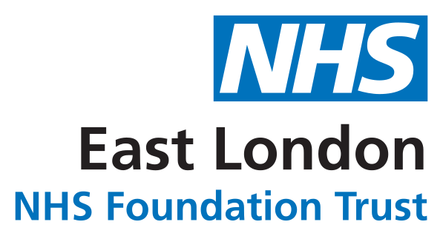

The Deprivation of Liberty Safeguards For Patients, Families and Carers


We promise to work together creatively to: learn ‘what matters’ to everyone, achieve a better quality of life and continuously improve our services.

What are the Deprivation of Liberty Safeguards?
The Deprivation of Liberty Safeguards (DoLS), which apply only in England and Wales, are an amendment to the Mental Capacity Act 2005. The DoLS under the MCA allows restraint and restrictions that amount to a deprivation of liberty to be used in hospitals and care homes – but only if they are in a person’s best interests.

They are a law which makes sure that an independent assessment takes place to see whether depriving a person of their liberty in the hospital or care home is the only way to keep them healthy and safe.

When do the Deprivation of Liberty Safeguards apply?

They will apply when a person is over the age of 18 and lacks the mental capacity (or ability) to make their own decision about whether to stay in the hospital or care home. The Managing Authority (hospital or care home) will complete a capacity assessment in relation to this decision, to establish if a DoLS application is required and, in the person’s best interest. The Managing Authority complete an application (Form 1) and submit this to the relevant Local Authority (Supervisory Body) to arrange assessments.

When wouldn’t the Deprivation of Liberty Safeguards apply?

They do not apply when a person is detained under the Mental Health Act. Or if they have been deemed to have capacity.

How do the Deprivation of Liberty Safeguards work?

They work through a number of assessments carried out on behalf of the Local Authority which take place before permission is granted to deprive a person of their liberty.

The responsible Local Authority (Supervisory Body) is dependent on where the person is ordinarily resident.



Why are the Deprivation of Liberty Safeguards important?

They are important because special assessors come to see the person to make sure that they are being cared for in a way which is in their best interests.
The person is also given a Relevant Person’s Representative (RPR) to support them (usually a family member or friend).

What happens if the assessment conditions are met?

If the assessment conditions are met the Local Authority will authorise the deprivation of liberty and inform the person and the hospital or care home in writing.

What happens if the assessment conditions are not met?

If the assessment conditions are not met the hospital or care home will not be granted authority to deprive a person of their liberty and they have to find a less restrictive way of caring for the person.

What training do staff have?

The hospital and care home staff are trained to understand when a person might be deprived of their liberty and how to take action so that a person is assessed quickly.



How long may deprivation of liberty be authorised for?

Deprivation of liberty may be authorised for a maximum of one year at a time. Prior to the end of an existing authorisation, if a DoLS is still required the hospital/care home can submit a renewal application.

Can the authorisation be reviewed?

Authorisation may be reviewed at any time on request by the person, the RPR, or the place where the person is being cared for. The review is carried out on behalf of the local authority.
Staff can provide more information on how to apply to the local authority for a review.

Could a Mental Health Act assessment take place instead?

Staff may believe that is more appropriate for a person to be assessed under the Mental Health Act rather than the Deprivation of Liberty Safeguards. Staff are able to provide more information on this if that is the case.





Contact us
Trust HQ
9 Alie Street London
E1 8DE

Email: elft.mentalcapacity@nhs.net Web: elft.nhs.uk

EastLondonNHSFoundationTrust

@NHS_ELFT

east-london-nhs-foundation-trust

NHSELFT

