
Valproate Policy
Management and review of Valproate in all patients

Version number | 3.1
Consultation Groups | Medicines Committee
Approved by (Sponsor Group) | Medicines Committee
Date approved | 11 March 2026
Ratified by: | Chair’s action Chief Medical Officer
Date ratified: | 15 April 2026
Name and Job Title of last author: | Medication Safety Officers  Chief Pharmacist
Executive Director lead | Chief Medical Officer
Implementation Date | April 2026
Last Review Date | April 2025 (interim update April 2026)
Next Review date: | May 2028

Services | Applicable to
Trust wide | √
Mental Health and LD

Community Health Services

Version control summary
Version | Date | Author | Status | Comment
10.0 | May 2021 | Indreet Anand  Toby Baldwin | Ratified by Medicines Committee | ARCHIVED DOCUMENT:  Protocol for Using Valproate  in Women of Childbearing Potential and Girls
1.0 | March 2024 | Indreet Anand  Rajesh Jethwa | Ratified by Medicines Committee | NEW DOCUMENT:  Valproate Prescribing Policy  - Policy fully reviewed and re-titled to reflect recent national updates by the MHRA and National Patient Safety Alert (Nov 23), applicable to Males and Females.
2.0 | November  2024 | Indreet Anand | Ratified by Medicines Committee | Amendments  - POLICY NAME CHANGE; from ‘Valproate Prescribing Policy’ to ‘Valproate Policy Management and Review of Valproate in all patients’ to reflect this is a multidisciplinary policy.  - 2.0/6.0 – Females > 55 years old - complete RAF if risk of pregnancy exists.  - 5.0 Valproate Prescribing Checklist – removed prescribing of folic acid 5mg for women of childbearing potential, as this was a historical requirement/precaution.  - 6.0 – clarified all patients who’ve had a 1 month break in treatment are considered new initiations.  - 6.3 – Complete the electronic RAF at least once for females with a permanent absence of pregnancy risk, who only have a paper based RAF on the system.  - New section 8.0 – to include MHRA Drug Safety Update Sept 2024 and a new appendix inserted in relation to advice HCPs should provide.  https://www.gov.uk/government/publications/drug-safety-update-monthly-newsletter  - Pre-menarche section updated to reflect the required section of the RAF to be completed.  - Risk Acknowledgment Form section updated to remove use of paper form and implement electronic form  - New sub section inserted: ‘’Neurology Diagnosis and Valproate Prescribing’’  - Contraception Advice section updated with regards to patients not on a highly effective contraception.  - ‘’Emergency use of Valproate’’ section updated to extend time frame to complete RAF to one week  - Mental Health Law Team have amended the definition of Responsible Person within the Glossary and amended section ‘Patients who are assessed to lack capacity’  - Added Inpatient Nursing staff role and responsibilities to section ‘Actions/Roles and Responsibilities of Healthcare Professionals’
3.0 | May 2025 | Indreet Anand | Ratified by Chairs action | Amendments  - Glossary updated to include non-medical prescribers working as Approved Clinicians/Responsible Clinicians in the list of specialist prescribers and second specialist signatories.  - Specified male patients under 55 years old started on Valproate before January 2024 (before implementation of national regulation) are not required to have a review by two specialists and consequently the RAF is not a mandatory requirement to complete but would be considered good practice  - MHRA Drug Safety Update (February 2025): Valproate Use in Men – new information incorporated into the Policy  - Appendix 3 infographics/flowcharts to clarify in which situations a review by two specialist may be required  - Appendix 1 updated re advice/counselling to be provided for ALL male patients  - Appendix 2 updated to clarify location of the electronic RAF on RIO and additional amendments to clarify the process of completing the form via RIO  - Roles and Responsibilities of ELFT Community Epilepsy Nurses added  - Clinical pharmacists’ role and responsibilities updated to clarify particulars of the RAF should be checked to ensure compliance with national regulation and policy is satisfied.
3.1 | March 2026 | Stuart Banham  Indreet Anand | Ratified by Medicines Committee  Chairs Action | Section 14: Emergency Use of Valproate (Inpatient Setting). When emergency treatment commenced the Risk Acknowledgement Form (RAF) must be completed within 2 weeks (14 days). Previous version of policy specified completion within 7 days  Section 8: Implementation of digital RIO ‘Valproate Male Counselling Checklist. Clarification to acknowledge where a male RAF is completed, counselling points are considered documented and do not require additional completion of the checklist.  Appendix 1 updated to account for the new digital male counselling checklist.  Section 13: Clarified that, in patients lacking capacity, valproate avoidance applies to males at risk of fathering a child and females at risk of pregnancy, and that RAF completion and PREVENT (PPP) requirements apply only if mandated or clinically relevant.  Section 14: added completion of the Risk Acknowledgement Form is required prior to patient transfer to another ward or healthcare setting.

Table of contents
Section | Topic | Page number
 | GLOSSARY | 6
1.0 | Background | 7
2.0 | National Safety / Regulatory Measures | 7
3.0 | Safety and Education Materials | 8
4.0 | PREVENT (Pregnancy Prevention Programme) | 9
5.0 | Valproate Prescribing Checklist | 10
6.0 | Prescribing Valproate: Second Specialist Signatory Requirement | 11
6.0 | 6.1 Initiation FEMALES AND MALES: | 11
6.0 | 6.2 Annual Review FEMALES | 11
6.0 | 6.3 Second Specialist Signatory Omission – Acceptable Circumstances | 12
7.0 | Prescribing Valproate: ELFT Second Specialist Signatory Criteria | 12
8.0 | General Prescribing Advice for Males | 13
9.0 | Community Service Users under the care of ELFT | 14
10.0 | Risk Acknowledgement Form | 14
11.0 | Pregnancy Test | 14
12.0 | Contraception Advice for females of childbearing potential | 15
13.0 | Patients who are assessed to lack capacity | 16
14.0 | Emergency Use of Valproate: Inpatient Setting Only | 17
15.0 | Specific Patient Groups | 17
 | 15.1 FEMALES: Permanent absence of pregnancy risk e.g. post- menopausal or post-hysterectomy | 17
 | 15.2 MALES: Risk of infertility and testicular toxicity not applicable e.g. permanent infertility | 18
 | 15.3 Pre-Menarche | 18
 | 15.4 Transgender and Non-binary People | 18
 | 15.5 Neurology Diagnosis and Valproate Prescribing | 19
16.0 | Actions / Roles and Responsibilities of Health Care Professionals  - General Practitioners  - Specialist Prescribers  - Pharmacists  - Inpatient Nursing Staff  - Community Based Epilepsy Nurses BCHS | 19
17.0 | ELFT Clinical Pharmacist Screening and Authorisation of Supply | 21
18.0 | Original Full Pack Dispensing of Valproate Containing Medicines | 21
19.0 | Incident Reporting | 23
20.0 | Resources | 24
A1 | Appendix 1 - Advice and Counselling to be provided to Male Patients | 26
A2 | Appendix 2 - New RiO Valproate Risk Acknowledgement Form guide | 27
A3 | Appendix 3 – Infographic 1 - 3 to clarify in which situations review by two specialists may be required | 30-32

Glossary
New valproate prescription | Refers to individuals being commenced on valproate for the first time, or when there has been more than 1 month’s break in therapy.
Specialist Prescriber  Primary Prescriber  Experienced Specialist | For the purpose of this policy, a ‘specialist prescriber’ within ELFT is defined as, registered medical practitioners who are:  - working at consultant grade consultant  OR  - have attained the MRCPsych qualification  OR  - are approved under Section 12(2) of the Mental Health Act.  OR  - a non-medical prescriber working as an Approved Clinician/ Responsible Clinician
Second Specialist Signatory | Is the second specialist to countersign the Risk Acknowledgement form after independently considering and documenting on the Risk Acknowledgment Form that there is no other effective or tolerated treatment, or there are compelling reasons that the reproductive risks do not apply.  The second specialist must be a  - Doctor working at consultant level who does not have a line management or supervisory function in relation to the primary prescriber.  OR  - A non-medical prescriber working as an Approved Clinician/Responsible Clinician, who does not have a line management or supervisor/supervisee relationship to the primary prescriber.  Note: In all cases, at least one of the two specialists must be a registered medical practitioner working at consultant grade.
Risk Acknowledgment Form | These forms are used to support and record the prescriber decision and the discussion of associated risk(s) with patient and/or their responsible person. The form used for females also outlines conditions of PREVENT: Pregnancy Prevention Programme.  Annual Risk Acknowledgement Form, used for female patients starting valproate and at their annual review.  Risk Acknowledgement Form for Male patients, used for male patients starting valproate.
Responsible Person | Person capable of giving consent on behalf of patients without the capacity/competence to make an informed decision i.e. parent/legal guardian for minors and donee of Lasting Power of Attorney (LPA) or court nominated deputy for adults. If no one is legally capable of giving consent on behalf of the patient (i.e. no LPA, no deputy) then the prescriber, as decision maker, will be expected to acknowledge that the treatment is in the best interests of the patient.
Existing male patient  Newly initiated male patient | Male patients under 55 years old who are already taking Valproate (started on Valproate before January 2024; before the national regulation was introduced) are not required to have a review by two specialists and consequently there is not a mandatory requirement to complete the RAF – see Appendix 3, Infographic 2  *NOTE: If there has been a break in treatment of more than one month and valproate is re-started, the patient should be considered a ‘new’ patient, and completion of the RAF is mandatory.  Male patients under 55, newly started on Valproate after January 2024 (after implementation of the national regulation) are required to have a RAF completed – see Appendix 3, Infographic 2

1.0 Background
Valproate is approved in the UK to treat epilepsy and bipolar disorder. It is available in three formulations in the UK: sodium valproate, valproic acid and semisodium valproate. Brands used in the UK include Epilim, Depakote, Convulex, Episenta, Epival, Syonell, Belvo & Dyzantil. It is also sometimes used outside of licence (‘off label’) to treat other conditions

Females
Since 2018, valproate has been contraindicated in women of childbearing potential unless the conditions of the Pregnancy Prevention Programme (PPP) are followed. This is designed to make sure patients are fully aware of the risks and the need to avoid becoming pregnant.

In women who take valproate while pregnant, around 1 in 9 babies (11%) will have a birth defect. Birth defects seen when mothers take valproate during pregnancy include:

-spina bifida (where the bones of the spine do not develop properly)
- facial and skull malformations (including cleft lip and palate)
- malformations of the limbs, heart, kidney, urinary tract and sexual organs

In women who take valproate while pregnant, about 30-40% of children may have neuro developmental problems, and these disorders can be seriously debilitating and permanent.
The effects on development can include:

-being late in learning to walk and talk
-lower intelligence than other children of the same age
-poor speech and language skills
- memory problems.

Children exposed to valproate in the womb are more likely to have autism (approximately 5 fold) or autistic spectrum disorders (approximately 3 fold) when compared to an unexposed population. There is also some evidence children may be more likely to be at risk of developing attention deficit hyperactivity disorder (ADHD)

Males
Valproate administration may also impair fertility in men. The MHRA Drug Safety Update (August 2023), suggests an increased risk of neurodevelopmental disorders in children whose fathers took valproate in the 3 months before conception. As a precaution, it has been advised by the MHRA that male patients who are planning a family within the next year, should discuss treatment options with a healthcare professional. Further MHRA drug safety updates were issued in September 2024 and February 2025 – please subsection ‘General prescribing advice for males - see Appendix 1.

2.0 National Safety/Regulatory Measures

The MHRA have published safety and educational materials to support the new regulatory measures announced in the National Patient Safety Alert (NatPSA/2023/013/MHRA) [issued 28th November 2023]. Due to the known significant risk of serious harm to a baby after exposure to valproate in pregnancy, these measures aim to ensure valproate is only used if other treatments are ineffective or not tolerated, and that any use of valproate in women of childbearing potential who cannot be treated with other medicines is in accordance with the Pregnancy Prevention Programme (PPP). Given these and other risks of valproate, these measures also aim to reduce initiation of valproate in patients for whom no other therapeutic options are suitable.
The regulatory change in January 2024, for oral valproate medicines, means that:
A. Valproate must not be started in new patients (male or female) younger than 55 years, unless TWO SPECIALISTS independently consider and document that there is no other effective or tolerated treatment, or there are compelling reasons that the reproductive risks do not apply.
B. At their next annual specialist review, women of childbearing potential and girls should be reviewed using a revised valproate Risk Acknowledgement Form, which will include the need for a second specialist signature if the patient is to continue with valproate and subsequent annual reviews with ONE SPECIALIST unless the patient’s situation changes.
Note:
See Appendix 3 for infographic/flowcharts to clarify in which situations review by two specialists may be required:
  - for female patients under 55 years old (infographic/flow chart 1)
  - for male patients under 55 years old (infographic/flow chart 2)
  - for male and female patients 55 years and older (infographic/flow chart 3)
- Females 55 years old and over:
As per national regulatory requirements, these patients are exempt from completing the annual RAF. However, if there is reason to believe the risk of pregnancy remains, the form should be continued until that risk ceases.’’
- Males
- EXISTING male patients under 55 years old who are already taking Valproate (started on Valproate before January 2024; before the national regulation was introduced) are not required to have a review by two specialists and consequently there is not a mandatory requirement to complete the RAF – see Appendix 3, Infographic 2
*NOTE: If there has been a break in treatment of more than one month and valproate is re-started, the patient should be considered a ‘new’ patient, and completion of the RAF is mandatory.
- NEW Male patients under 55, newly started on Valproate after January 2024 (after implementation of the national regulation) are required to have a RAF completed – see Appendix 3, Infographic 2
- ALL male patients, irrespective of age and regardless of whether the patient is deemed an ‘existing’ or ‘new’ patient on Valproate, there is a requirement to counsel all male patients (of any age) who may father children of the risk and precautions; see subsection ‘General prescribing advice for males’ in this document.
Hence, it would be good practice to complete the RAF for existing male patients prescribed Valproate who may father children, although this is not a regulatory requirement.

3.0 Safety and Education Materials (Males and Females)

PREVENT (Pregnancy Prevention Programme, PPP) is supported by the following safety and educational materials available from the MHRA online. These are a collection of information and guidance for healthcare professionals and patients on the reproductive risks of valproate and new safety measures introduced to reduce these risks.
Healthcare professional MUST access and utilise these appropriately in the process of prescribing and reviewing patients on Valproate and also to ensure compliance with PREVENT (PPP).
MHRA Valproate safety measures. Available at https://www.gov.uk/government/collections/valproate-safety-measures#full-publication-update-history [Last updated 5th September 2024].
Patient guide: Provides those taking valproate (or their parent, caregiver, or responsible person) with information on the risks of valproate in pregnancy and the risks to male patients and what they need to do.
Healthcare Professional Guide: Provides updated information for healthcare professionals on the risks of valproate in pregnancy and the risks for male patients, the new conditions for valproate prescribing and key points for patient discussions.
Annual Risk Acknowledgement Form (FEMALES): For female patients starting valproate and at annual review. Used to support and record the discussion between the patient and specialist prescriber on the risks associated with valproate in pregnancy and to record the decision of the countersigning specialist. At subsequent annual reviews only ONE SPECIALIST is required.
Risk Acknowledgement Form for male patients starting valproate (MALES): Used to support and record the discussion between the patient and specialist prescriber of the risks associated with valproate in males and to record the decision of the countersigning specialist. This is only to be completed at initiation of valproate.
Patient card: Provides key information for female patients receiving valproate on contraception and pregnancy prevention.
Pharmacy poster: Provides important actions for pharmacists dispensing valproate to female patients.
Warning stickers: To be added to packaging of medicine in exceptional circumstances where the original pack cannot be dispensed.
Product Information for valproate medicines (Summary of Product Characteristics, SPC), including the Patient Information Leaflet
No one should stop taking valproate without advice from a specialist. This is because epilepsy or bipolar disorder may become worse without treatment, which can be harmful.

4.0 PREVENT: Pregnancy Prevention Programme (PPP)

All Healthcare professionals (Specialist prescribers, General Practitioners and Pharmacists) MUST read the Valproate Health Care Professional Guide to ensure they have a comprehensive understanding of the PREVENT; Pregnancy Prevention Programme (PPP) and their individual roles and responsibilities to ensure compliance and patient safety.
Valproate medicines must NOT be used in women of childbearing potential unless the PREVENT: Pregnancy Prevention Programme (PPP) is in place. The conditions of the PPP must be met even for female patients who are not sexually active unless the prescriber considers that there are compelling reasons to indicate that there is no risk of pregnancy. Please see section ‘Specific Patient Groups’ within this policy which addresses examples of female patients where conditions of the PPP do not need to be fulfilled.
Ensure all women and girls of child bearing potential (and their parent, caregiver, or responsible person, if necessary) are fully informed of the risks and the need to avoid exposure to valproate medicines in pregnancy.
  - The PPP is a system of ensuring all female patients of childbearing potential taking valproate medicines:
  - Have been told about, and understand the risks of use in pregnancy and have signed a Risk Acknowledgement Form.
  - Are on effective contraception.
    - As detailed within PREVENT: PPP, at least one effective method of contraception, preferably a highly effective user independent form such as an intra-uterine device or implant or two complementary forms of contraception including a barrier method should be used.
  - See their specialist at least once a year.
  - The PPP incorporates use of the safety and education materials as detailed in the previous section, when valproate is prescribed for a girl (of any age) or women of childbearing potential:
  - In addition, further national measures have been implemented to support from a safety perspective;
  - smaller medication pack sizes to encourage monthly prescribing
  - a pictogram/warning image on valproate labelling
  - legislation introduced in 2023 to ensure all patients receive a original pack of valproate with the warnings on the box with exceptions allowed where a risk assessment has been carried out to confirm smaller supplies are appropriate.

5.0 Valproate Prescribing Checklist
Specialist prescribers making recommendations for treatment, must always carefully balance the benefits of valproate treatment against the risks. Valproate should only be used when other treatment options have been ineffective, have not been tolerated or would not be tolerated, as judged by an experienced specialist.

The following actions must be completed by anyone who prescribes valproate, or who makes a recommendation for valproate to be prescribed, for a particular patient:

- Access ‘Safety and Education Materials’ (sub-section in this policy) provided by the MHRA online.
- Read the ‘Healthcare Professional Guide’
- Provide the patient with the ‘Patient Guide’
- Complete the ‘Risk Acknowledgment Form’ via RIO
- Onwards distribution of Risk acknowledgement form to the Patient’s GP
(clear understanding of when a Second Specialist Signatory is required)

- Second Specialist Signatory
- To check if a Second Specialist Signatory is required to sign the Risk Acknowledgment Form, i.e. that this is a new prescription for valproate in a male or female patient under 55 years of age.
- Review information provided by the primary prescriber and agree, in their professional opinion that other treatment options have been ineffective, have not been tolerated or would not be tolerated.

- Assess capacity
  - Assess the patient’s capacity to consent to treatment with valproate and document the outcome of this assessment in the patient’s notes
  - Refer to sub-section ‘Patients who are assessed to lack Capacity’ in this policy

- Perform serum pregnancy test
- Perform serum pregnancy test at least 14 days after last possible date on which patient had, or could have had, unprotected sex.
- For further details refer to sub section of this policy ‘Pregnancy Testing’
- Note: Valproate is contraindicated for women with bipolar disorder who are pregnant; it must not be prescribed for this group of patients.

- Contraception Arrangements
- The prescriber must arrange for effective contraception (as defined within the PREVENT: PPP; see the Health Care Professional Guide) for women of childbearing potential before the first prescription is issued. There may be temporary exceptions to this whilst the patient is in an INPATIENT setting, whereby there are safeguards to mitigate against the risk of pregnancy. However, females of child bearing potential must be on effective contraception before being discharged on Valproate.
- Refer to sub-section ‘Contraception Advice’ within this policy
- Resources:
- It is the prescriber’s responsibility to access most recent version of relevant resources to support prescribing of Valproate.
- Refer to sub-section ‘Resources’ within this policy for potential resources

6.0 Prescribing Valproate: Second Specialist Signatory Requirement
See Appendix 3 for infographic/flowcharts to clarify in which situations review by two specialists may be required:
  - for female patients under 55 years old (infographic/flow chart 1)
  - for male patients under 55 years old (infographic/flow chart 2)
  - for male and female patients 55 years and older (infographic/flow chart 3)
6.1 Initiation Males and Females:
Males: Valproate should not be started in male patients aged under 55 years unless two specialists consider and document that there is no other effective or tolerated treatment or the risk of infertility or potential risk of testicular toxicity do not apply.
Females: Valproate should not be used in female patients aged under 55 years* unless two specialists (specialist prescriber and countersigning specialist) independently consider and document, in the Risk Acknowledgment Form that there is no other effective or tolerated treatment and the conditions of the PREVENT (Pregnancy Prevention Programme) are fulfilled or there are compelling reasons that the reproductive risks do not apply.*
*All patients 55 and over are exempt from completing the RAF (but for females if there is reason to believe the risk of pregnancy remains, the form should be continued until that risk ceases.
Discontinued /break in treatment: For male and female patients who have previously been discontinued and/or had a break in treatment, if more than a month has elapsed and Valproate is re-started, this will be considered a new initiation; the Risk Acknowledgement Form will have to be completed with a second specialist signatory for applicable patients, as specified by the national regulatory requirements (see section ‘’National Safety/Regulatory Measures’’). In the case of females, this is also to ensure compliance with the PREVENT (PPP) is re-checked.

- RISK ACKNOWLEDGEMENT FORM must be completed (separate form: males and females)
- A SECOND SPECIALIST SIGNATORY is required to counter sign Risk Acknowledgment Form.

6.2 Annual Review FEMALES
If an existing patient does NOT already have a previous documented Annual Risk Acknowledgement Form that has been signed by two specialists independently, then the risk acknowledgment form MUST be completed with a Second Specialist Signatory
If the patient already has a documented Annual Risk Acknowledgement Form signed by two specialists independently, then subsequent annual reviews do not require the countersigning specialist unless the patient’s circumstances have changed.

6.3 Second Specialist Signatory Omission – Acceptable Circumstances
Other than in emergency situations (as described in subsection ‘Emergency Use of Valproate: Inpatient Setting Only’ of this policy), there are a very limited number of scenarios in which Valproate can be prescribed despite a second specialist signature not being in place, when one would usually be required. These are:
FEMALES
Patients who have a permanent reason that they do not have the potential to get pregnant (e.g., post-menopausal patients, post hysterectomy, transgender male to female) do not need to complete the Risk Acknowledgement Form, RAF beyond Step 1.
Step 1 of the form is completed by the specialist prescriber if they consider PREVENT (Pregnancy Prevention Programme) is not needed. Consequently the second specialist signatory is not required. This form can be used to support documentation in the medical notes that PREVENT (Pregnancy Prevention Programme) does not apply to this patient.
If there is a permanent absence of pregnancy risk the RAF only needs to be completed once and an annual completion is not required. However, for patients who have had a paper based RAF completed in the past, a new electronic RAF must be completed at least once, so that these patients do not appear as ‘non-compliant’ as audits results will be based on completion of an electronic form.
MALES
If the risk of infertility and the potential risk of testicular toxicity does NOT apply (e.g., the patient is permanently infertile), the Second Specialist Signatory is not required, and the specialist prescriber should use the Risk Acknowledgement Form to document the reason and record in the patients notes.

Prescribing Valproate: ELFT Second Specialist Signatory Criteria

The Primary Prescriber: must be a Specialist Prescriber (see Glossary)

The Second Specialist Signatory: - see Glossary for requirements of a second specialist signatory

Disagreements: In cases, where the Second Specialist Signatory is in disagreement with the primary prescriber, then an opinion from a different Consultant Psychiatrist from another directorate should be obtained. A full review of the patient’s circumstances would be needed.
Second Specialist Signatory: Pre-requisite Information
It is the responsibility of the Primary Specialist Prescriber to provide sufficient information for the Second Specialist to reach a decision as to the appropriateness of valproate therapy. Provided information should include:
- Patient demographic details, age, current diagnosis, any relevant co-morbid diagnoses.
- Details of all relevant previous psychotropic therapies prescribed during current and previous episodes of mental illness. Information should include drug, dose, length of time (at relevant dose levels), assessment of response and adverse effects seen.
- If valproate risks are not considered appropriate due to individual fertility circumstances, then these should be clearly stated.
- Concise statement as to why the Primary Prescriber considers valproate to be the only reasonable option for the individual at this point in their care.

- General Prescribing Advice for Males – see Appendix 1

As per national regulatory requirements, for males, the RAF only needs to be completed when Valproate is being NEWLY initiated for men under 55 years old.

However, regardless of age and regardless of whether the patient is an existing or new patient on Valproate, there is a requirement to counsel ALL male patients (of any age) who may father children of the risk(s) and precautions in relation to Valproate.

This counselling should be provided at treatment initiation and at their regular treatment review.

- This advice MUST be documented using the digital RIO ‘Valproate Male Counselling Checklist’ located within the ‘Medicines’ folder in the patient’s RIO record. The checklist covers all counselling points and advice that must be provided to the male patient. If a RAF has been completed, completion of the ‘Valproate Male Counselling Checklist’ is not required, as the counselling points are captured within the RAF form.

- Please see Appendix 1 for more information – advice/counselling to be provided to Males.

In addition, it would be good practice to complete the RAF for existing (see glossary) male patients prescribed Valproate who may father children, although this is not a regulatory requirement – see subsection ‘’National Safety/Regulatory Measures’’; clarification of which patients require a review by two specialists.

The MHRA issued a drug safety update in September 2024, which stipulates the counselling/advice that should be provided to men on Valproate (and their partners):
MHRA Drug Safety Update September 2024 – ‘’Valproate use in men: as a precaution, men and their partners should use effective contraception.’’ Full Drug Safety Update, available at
https://www.gov.uk/government/publications/drug-safety-update-monthly-newsletter

An additional MHRA drug safety update in February 2025, strengthens consolidates the counselling/advice that should be provided to men on Valproate (and their partners):
MHRA Drug Safety Update February 2025 – ‘’Valproate use in men - review by two specialists is required for initiating valproate but not for male patients already taking valproate’’, Full Drug Safety Update, available at
https://www.gov.uk/government/publications/drug-safety-update-monthly-newsletter

9.0 Community Service Users under the care of ELFT

The information contained within this policy, and the required steps outlined, apply equally to those patients attending outpatient appointments. Prescribing of Valproate would need to be planned in advance to ensure a Second Specialist Signatory can be consulted before and the necessary steps are completed before valproate is prescribed.

For patients in primary care who have been ‘discharged’ from the mental health service or are otherwise prescribed valproate for a mental health condition, ELFT community teams MUST accept referrals back into the service for female patients under 55 years (also those >55 years where the risk of pregnancy still exists) who require a yearly review and completion of the Risk Acknowledgement Form.

10.0 Risk Acknowledgement Form (RAF)

RIO Electronic Risk Acknowledgement Form – see Appendix 2.
ACCESS: The form can be accessed from the patient’s ‘Case Record Menu’ under the ‘Medicines’ folder.
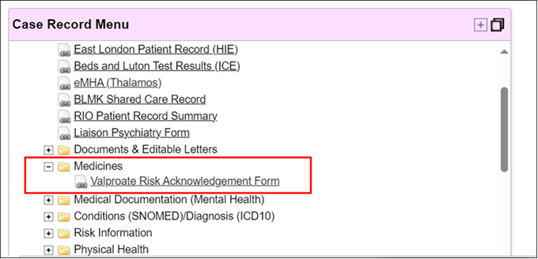
The Risk Acknowledgement Form is to be completed electronically on RIO.
The paper forms are no longer to be utilised as there is an electronic provision in the Trust.

The Risk Acknowledgement Form is used to support and record:
For Females: the prescribing decision and, where applicable, discussion with the patient or their responsible person of the risks associated with the use of valproate during pregnancy and the measures needed to minimise the risks in female patients.
For Males: the discussion of risks with male patients aged under 55 years starting treatment with valproate or their responsible person or parents/care givers (if applicable).

11.0 Pregnancy Testing
* Pregnancy testing information obtained from: Bastian LA and Brown HL. Clinical manifestations and diagnosis of early pregnancy. From “UpToDate®” clinical resource (Wolters Kluwer), Topic 440, Version 32.0. Topic last updated: 16th March 2023.
- As with all teratogenic medicines, pregnancy should be excluded before initiation on valproate medicines by a negative plasma pregnancy test, confirmed by a healthcare professional.

- The aim of pregnancy testing is to provide as much certainty as possible that the service user is not pregnant, before prescribing valproate.

- Pregnancy testing relies on detection of human chorionic gonadotropin (hCG), which is released after a fertilised egg has implanted into the uterus wall.

- Implantation normally occurs 6 to 12 days after ovulation. As hCG will not be released until after implantation, there is a delay between the time of fertilisation of an egg and the time at which a pregnancy is detectable.

- In the early stages after implantation, an hCG serum assay more sensitively detects pregnancy than an hCG urine dip test.

- Therefore, if there is any possibility that the patient has recently been sexually active, valproate should not be prescribed until:

  - 14 days have elapsed since the last possible day on which the patient could have had unprotected sex (for example, this could be 14 days from the point of admission, or 14 days from the last day on which the patient was given unescorted leave from the ward),

AND

  - A negative hCG serum assay has been obtained after this 14 day period has elapsed.

Suspected Pregnancy or risk of unprotected sex having occurred:
- For patients who have been admitted and who are already prescribed valproate for mood stabilisation in the community, if there is any possibility that the patient has recently had unprotected sex, valproate should be STOPPED. If clinically appropriate, the drug can be restarted provided that a negative serum hCG test has been obtained a minimum of 14 days after the last possible day on which the patient could have had unprotected sex.

- For patients who have been admitted and who are already prescribed valproate in the community for the treatment of epilepsy, if there is any possibility that the patient has recently had unprotected sex, the patient’s neurology team must be consulted before stopping the valproate. This consultation should be considered extremely urgent and should occur at the earliest possible opportunity after the patient is admitted. The consultation should involve a thorough discussion about the risks posed by either continuing the valproate or stopping it.

Contraception Advice for females of childbearing potential

- All healthcare professionals MUST consult the current guidance as outlined in the Valproate Healthcare Professional Guide.
https://www.gov.uk/government/collections/valproate-safety-measures#full-publication-update-history

- The prescriber must ensure the patient is counselled regarding contraception, and that the patient is capable of complying with the need to use effective contraception, without interruption during the entire duration of treatment with valproate.

- These patients must be provided with comprehensive information on pregnancy prevention and should be referred for contraceptive advice if they are not using effective contraception.

- As detailed within PREVENT (Pregnancy Prevention Programme), at least one effective method of contraception, preferably a highly effective user independent form such as an intra-uterine device or implant or two complementary forms of contraception including a barrier method should be used.

- Individual circumstances should be evaluated in each case when choosing the contraception method with the patient, involving the patient in the discussion to support her engagement and compliance with the chosen measures. Even if she has amenorrhea, she must follow all the advice on effective contraception.

- If the patient chooses to use a method of contraception that is not highly effective, i.e. one of the user-dependent methods (condom, cap, diaphragm, combined oral contraceptive pill, progestogen-only contraceptive pill, or fertility awareness based methods), they should be advised to undertake more frequent pregnancy testing. Oral contraceptive pill methods should be used together with a barrier method of contraception, with frequent pregnancy testing. If they suspect any reason to suggest lack of effectiveness of contraception, or believe they may be pregnant, they should be advised to report this to their GP immediately, and undertake a pregnancy test.

- NOTE: For patients being discharged into community settings, prescribers MUST ensure effective contraception is prescribed and supplied or effective contraception is in place before proceeding to prescribe and supply Valproate for use in community.

13.0 Patients who are assessed to lack capacity

- For patients who are assessed to lack capacity/competence to consent to treatment, prescribing of valproate should be avoided in male patients where there is a risk of fathering a child and in female patients where there is a risk of pregnancy, in line with national regulatory requirements. However, if use of valproate is considered to be unavoidable then the following steps must be undertaken:
  - If there is a Responsible Person¹, all information related to valproate prescribing must be shared with them including risks of starting Valproate treatment so they can make an informed decision. The Risk Acknowledgement Form must be used to support and document the discussion. For female patients provide the information and advice on highly effective methods of contraception and on the use of valproate during pregnancy to their Responsible Person and make sure they clearly understand the content.
  - If there is no Responsible Person who can make a decision on behalf of the patient, then what is in the patient’s best interest must be determined in line with the ELFT Mental Capacity Act Policy. This might involve holding a best interest meeting. Please refer to the ELFT MCA policy for details of how to determine what is in someone’s best interest

For minors the Responsible Person will be the parent/legal guardian. For adults, the Responsible Person will be the person capable of giving consent on behalf of the patient i.e. the donee of a Lasting Power of Attorney (LPA) or the court-appointed Deputy – if there is no LPA and no court appointed Deputy, there will be no Responsible Person and the prescriber (decision maker) will be responsible for following the best interest determination process (and for acknowledging the decision made is in the patient’s best interest).
- For female patients, the patient’s mental capacity needs to be assessed repeatedly to permit discussions with the patient or carer according to the Pregnancy Prevention Programme as soon as her mental state has sufficiently improved. This may not be possible for those patients who permanently lack mental capacity.

- If, after thorough consideration of the risks, it is concluded that prescribing Valproate is in the patient’s best interest then:

  - a clear risk-minimisation plan should be put in place and clearly documented in the patient’s RIO notes.
  - The Risk Acknowledgement Form (where mandated) must be completed by two specialists (primary prescriber and second specialist signatory)
  - The Risk Acknowledgement Form should be used to support and record the prescribing decision and discussion with the patient’s responsible person (if there is one).
  - For female patients, where relevant,the conditions of PREVENT (PPP) should be fulfilled or if there are compelling reasons that there is no risk of pregnancy, then this MUST be documented on the Risk Acknowledgement Form.

14.0 Emergency Use of Valproate: Inpatient Setting Only

NOTE: Prescribing without a Pregnancy Prevention Programme in place is contraindicated and represents an unlicensed use of the drug; the MHRA regulation clearly states valproate must no longer be used in any women or girl able to have children unless she has a pregnancy prevention programme in place.

In a pregnant woman with a mental disorder detained under the Mental Health Act, Valproate should not be initiated.

There may be situations deemed as an ‘emergency’ on inpatient wards where prescribing of Valproate is required before it is practically feasible to complete a Risk Acknowledgment Form countersigned by a Second Specialist Signatory. An example of where this might occur would be admission of a patient with acute or severe mania occurring outside of normal working hours or at a weekend.

In such emergency situations the prescriber is permitted to prescribe Valproate on an INPATIENT setting and the following steps should also be taken:
- Documentation within the patient’s RIO notes to reflect why Valproate has been prescribed and the nature of the emergency. The prescriber should also document on RIO a plan/timeline for completing the Risk Acknowledgement Form
(the Risk Acknowledgement Form MUST be completed within 2 weeks, 14 days).
- If such prescribing is outside of working hours, then the on-call pharmacist should be contacted, so they can advise on where to obtain a supply of medication, as Valproate should not be kept as stock medication on any ward. The on-call pharmacist MUST also handover to the directorate pharmacy team to follow up the patient with the clinical team to ensure completion of the Risk Acknowledgment Form.
- The Risk Acknowledgement Form must be completed fully before a patient is discharged on Valproate, authorised short term leave on Valproate, or transferred to another ward or healthcare setting. Given that Valproate is being used for emergency use in severely ill service users, section 17 leave is highly unlikely to be appropriate in any case.

15.0 Specific Patient Groups

15.1 FEMALES under 55 years: Permanent absence of pregnancy risk

e.g. post-menopausal or post-hysterectomy

- Patients who have a permanent reason that they do not have the potential to get pregnant (e.g., post-menopausal patients, post hysterectomy, transgender male to female) do not need to complete the Risk Acknowledgement Form (RAF) beyond Step 1 and consequently the second specialist signatory is not required.
- If there is a permanent absence of pregnancy risk, then the RAF only needs to be completed once and an annual completion of the RAF is not required. However, for patients who have had a paper based RAF completed in the past, a new electronic RAF must be completed at least once, so that these patients do not appear as ‘non-compliant’; audits results will be based on completion of an electronic form.
- This Risk Acknowledgment Form can be used to support documentation in the medical notes that PREVENT (Pregnancy Prevention Programme) does not apply to this patient.
- It is the responsibility of the clinical team/consultant to definitively confirm a diagnosis of ‘menopause’ and document this clearly within the patient’s RIO notes and also on Step 1 of the risk acknowledgement form.
- It should not be assumed that the patient has reached menopause based solely on age, due to individual variation.
- It is important to bear in mind women can experience menopausal symptoms with irregular periods during the peri-menopausal stage, which can last several years. There is still a risk of pregnancy during the premenopausal stage.
- Please access the most up to date NICE guidelines for reference:
NICE guidelines Menopause: diagnosis and management, NICE guideline [NG23] Published date: November 2015, Last updated December 2019
[Accessed January 2024]

15.2 MALES: Risk of infertility and testicular toxicity not applicable e.g. permanent infertility

If the risk of infertility and the potential risk of testicular toxicity does NOT apply (e.g., the patient is permanently infertile), the second specialist signatory is not required, and the specialist prescriber should use this form to document the reason and record in the patients notes.

15.3 Pre-Menarche
- Females who have not yet reached menarche (not started her periods) DO NOT need to fulfil the conditions of PREVENT (Pregnancy Prevention Programme), but they and their responsible person need to be aware of the risks relating to exposure to valproate during pregnancy. Document this counselling has taken place in the medical RIO notes.
- You should provide a copy of the Patient Guide and remind the responsible person that they MUST contact their GP once the patient using valproate experiences their first period. Their GP MUST refer the patient back to the specialist prescriber.
- The reasons why PREVENT does not apply to the patient should be documented on the Annual Risk Acknowledgment Form and in the patient’s medical notes.
- Step 1 and Step 2 of the Risk Acknowledgement Form needs to be completed.
- Step 3 and Step 4 to be completed where possible, so that the patient and/or their responsible person is aware of the risks if their situation were to change in the future.
- The Risk Acknowledgement MUST still be completed annually.

15.4 Transgender and Non-binary People

Guidance within this section has been provided following consultation with transgender and non-binary network representatives from the Trust.

A transgender individual is someone whose gender identity is not congruent with the sex they were assigned at birth. A transgender woman is someone who was assigned the sex of male, but is a woman. A transgender man is someone who was assigned the sex of female, but is a man. The term transgender is often shortened to ‘trans’. The term non binary describes any gender identity which does not fit the male and female binary.

Currently there is no specific advice available from the MHRA with regards to valproate prescribing within this cohort of patients, although there are particular challenges associated. The appropriate pathway for individual prescribing decisions (male v female) will depend upon the biological sex assigned at birth and the stage of medical gender transition which has been reached.

Patients who present as male but have an intact uterus should be treated as if they were presenting as female for the purposes of pregnancy prevention.

Patients who present as female but have the ability to father a child should be treated as if they were presenting as male for the purposes of pregnancy prevention.

Prescribers will be required to have individual discussions with patients who have transitioned or are transitioning, or who are non-binary. It is important that prescribers have these discussions, ensuring they respect the patient’s gender identity and their autonomy to make decisions about their own healthcare. For example, ensuring you use the correct name and pronouns. In addition, it may be a difficult experience for those who have transitioned or are transitioning; additional empathy and compassion may be required.

Prescribers are advised to read the following resource:
- Sexual the FSRH CEU Statement: Contraceptive Choices and Sexual Health for Transgender and Non-Binary People, The Faculty of Sexual and Reproductive Healthcare (FSRH) of the Royal College of Obstetricians Gynaecologists, Clinical Effectiveness Unit (CEU), Last Published 1st October 2017. Available at:
https://www.fsrh.org/Public/Public/Documents/fsrh-ceu-statement-contraceptive-choices-and-sexual-health-for-non-binary-people.aspx
https://www.fsrh.org/Common/Uploaded%20files/documents/contraceptive-choices-and-sexual-health-for-transgender-non-binary-people-oct-2017.pdf
[Accessed November 2024]
- The ELFT Transgender Policy, Last updated April 2021. Available via ELFT intranet.
- Inclusive care of trans and non-binary patients, BMA, British Medical Association. Last updated March 2022. Available at:
https://www.bma.org.uk/advice-and-support/equality-and-diversity-guidance/lgbtplus-equality-in-medicine/inclusive-care-of-trans-and-non-binary-patients
[Accessed March 2024]

15.5 Neurology Diagnosis and Valproate Prescribing

In circumstances where ELFT prescribers are required to continue Valproate prescribing for a neurology indication e.g. an inpatient with epilepsy, then it wouldn’t be appropriate for you to complete the RAF (competition is required by initiating specialist). However, you should ensure that the patient is highlighted to both the relevant specialist and the GP as a matter of urgency. The individual patients should be assessed with regards to a pregnancy risk and consideration to whether any further actions are required. If you have an immediate concern regard a patient prescribed Valproate for EPILPESY, (including circumstances where you think a patient is pregnant), you should not stop their medication, instead consult with the patient’s neurology team as a matter of urgency. This consultation should be considered extremely urgent (within days) and should occur at the earliest possible opportunity after they are admitted. The consultation should involve a thorough discussion about the risks posed by either continuing the valproate or stopping it.

In the rare circumstance that valproate is being used for a dual indication across psychiatry and neurology, contact should be made with the other specialist and an agreement made as to how annual reviews will be conducted. Where possible, a patient should be reviewed jointly and if a RAF is required, this should be done as a single form and agreed with both specialists. The requirement for the completion of the annual review and RAF form remains the responsibility of the initiating specialist.

16.0 Actions / Roles and Responsibilities of Healthcare Professionals

- General Practitioners
- Specialist Prescribers
- Pharmacists
The above Healthcare Professionals MUST read and refer to the Valproate Healthcare Professional Guide. This guideline clearly outlines the roles and responsibilities of each healthcare professional under ‘Actions for HCPs’ within the Healthcare Professional Guide.
Please access the Healthcare Professional Guide online via the MHRA’s webpage
https://www.gov.uk/government/collections/valproate-safety-measures#full-publication-update-history [Last update 22 January 2024].
- Inpatient Nursing Staff
- To familiarise themselves with this policy and the national regulatory requirements in relation to prescribing of Valproate and the risk(s) associated with this medication.
- For those patients prescribed Valproate, check that a RAF has been completed within the patient’s RIO records (for applicable patients who require a completed RAF as per national regulatory requirements). If you cannot locate a completed RAF, contact the clinical team or ward pharmacist for further advice.
- In order to strengthen the Trust’s compliance with national regulations, Valproate has been removed from ward stock. Supply must requested via pharmacy on a named patient basis and stock should not be borrowed from another patient’s supply. If a medication supply is required out of hours, contact the Duty Senior Nurse (DSN) who can contact the on-call pharmacist.
- Incident reporting – see Incident reporting section.
- Discharge Medication –see section ‘ELFT Discharge Medication’
- In cases where original full pack dispensing is not appropriate for discharge, an individualised risk assessment needs to be completed by the Nurse, Pharmacist or Doctor with the Service user (SU)/Service user’s representative.
- See relevant section ‘ELFT Discharge Medication’ for more information

- ELFT Community Based Epilepsy Nurses
Valproate can also be prescribed for Epilepsy. Therefore Community Based Epilepsy Nurses should ensure the following points below are adhered to or confirmed:
- To familiarise themselves with this policy and the national regulatory requirements in relation to prescribing of Valproate and the risk(s) associated with this medication.
- For patients prescribed Valproate for the indication of Epilepsy, check that an up to date RAF has been completed within the patient’s GP record e.g. Systm1 (for applicable patients who require a completed RAF as per national regulatory requirements). If you cannot locate a completed RAF, contact the relevant neurology department to request a copy of the completed RAF (for GP records).
- If Valproate is prescribed for Epilepsy, the neurologist within a secondary or tertiary hospital must complete the initial RAF and yearly RAF (yearly RAF is only required for females of childbearing potential) and ensure this is forwarded on to the GP, so that the GP can safely continue prescribing repeat prescriptions of Valproate in the community. .
- When Valproate is first prescribed in secondary care, the initial medication supply should be provided by the hospital in line with their policy.

- Patients who have a diagnosis of Epilepsy, but have been prescribed Valproate for a mental health indication:
- If the patient is under a mental health team, then contact the team to request a copy of the completed RAF or in situations where a RAF has not been completed, the mental health team will need to co-ordinate a patient review in order to complete the RAF.
- If the patient is not under a mental health team, inform the GP, so that the GP can complete a referral to the mental health team to review the patient. If the GP in the interim of a specialist review continues to supply the Valproate medication in the absence of a Risk Acknowledgement Form (based on their clinical judgement of risk benefit), then they must ensure the patient is aware and counselled on the risks and for females of child bearing potential, they MUST have effective contraception arrangements in place.

17.0 ELFT Clinical Pharmacist Screening and Authorisation of Supply

- Directorate Lead Pharmacists
- Co-ordinate checks, to ensure Valproate containing medicines are not kept by any inpatient ward as ‘ward stock’. Co-ordinate reviews of their wards ‘B-LISTs’ to ensure Valproate containing medicines are not listed as a ‘ward stock’ item.
- Co-ordinate checks to ensure Valproate containing medicines are stocked in the Emergency Drug Cupboard (EDR) for out of hours use, which can be accessed by the Duty Senior Nurse (DSN).
- Ensure the pharmacy team/ward pharmacists action the weekly PowerBI Valproate report sent to the pharmacy email inbox. This report identifies patients under 55 year who do not have a valid Valproate Risk Acknowledgement Form on the RIO system. Pharmacists must follow up these patients with the clinical team before authorising Valproate medication supply.

- Clinical Pharmacists
- All Pharmacist MUST be well versed with the Valproate Healthcare Professional Guide. This guideline clearly outlines their roles and responsibilities under ‘Actions for HCPs’.
- Pharmacists should NOT clinically screen and authorise the supply of Valproate until they have checked the particulars of the Risk Acknowledgment Form (where one is required to be completed) and are satisfied that prescribing is in compliance with national regulation and this policy.
- If the form has not been completed (or has been completed incorrectly), the clinical team/prescriber should be contacted to complete the form before the pharmacist clinically screens and authorises the medication supply.
- Exceptions to completion of the RAF would include any emergency prescribing, see the section ‘Emergency Use of Valproate: Inpatient Setting Only’
- In such emergency circumstances, the pharmacist should check the clinical team have documented emergency use on the patient’s record. The pharmacist should also document on the patient’s record and authorise a maximum 4 day supply of medication. The pharmacist should follow up with the clinical team within the one week time frame to check the form has been completed.
- If there are issues with non-compliance in completing the Risk Acknowledgment Form as per policy, then a medication incident should be submitted via the Trust’s Incident Reporting System INPHASE and the Directorate Clinical Director should be assigned as the manger to investigate. The Medicines Safety Officer should be informed of the incident reference number.

- Clinical Pharmacists and Pharmacy Technicians

- Valproate containing medicines must not be kept by any inpatient ward as ‘ward stock’.
- Preferably, supply of valproate containing medicines MUST only be on a named patient basis.
- However, on occasions where there are multiple patients on the ward prescribed the same Valproate containing medicine and there is limited medication storage, the ward pharmacist/technician may opt to supply Valproate as a ‘non-stock’ item for this period of time.
- Stock should regularly be reviewed by ward technicians and any old/unwanted Valproate medication on wards must be returned to pharmacy, including ‘non-stock’ supplies if there are no longer multiple patients on the ward prescribed Valproate.

18.0 Original Full Pack Dispensing of Valproate Containing Medicines

Following a change in regulation, from 11th October 2023, Valproate-containing medicines must be dispensed in the manufacturer’s original full pack. This legislative change has been made to ensure that patients always receive specific safety warnings and pictograms, including a patient card and the Patient Information Leaflet, which are contained in the manufacturer’s original full pack. These materials form a key part of the safety messaging and alert patients to the risks to the unborn baby if valproate-containing medicines are used in pregnancy.
18.1 ELFT Inpatient Medication
Supply during Inpatient stay can be in either original packaging/smaller boxes. However, it is the responsibility of the Clinician and Pharmacy team to ensure that correct supply has been authorised at the point of discharge (see information below).
18.2 ELFT Short Term Leave Medication
Supply for short term leave (STL) is exempt from original full pack dispensing. ELFT Inpatient dispensary are to supply the exact quantity that has been requested on the STL request. An individual risk assessment does not need to be completed for STL medication dispensed outside of original packaging.
In terms of risk mitigation, pharmacy dispensary staff must ensure that Patient Information Leaflets (PILs), Valproate warning stickers with a pictogram (figure 1) and MHRA valproate patient safety cards are provided for all patients, regardless of gender when valproate-containing products are not dispensed in original packs.
18.3 ELFT Discharge Medication
Discharge Medication must be supplied in the manufacturer’s original full pack, unless there are exceptional circumstances.
18.4 Exceptional circumstances to ELFT Discharge medication:
- There may be exceptional circumstances where original full pack dispensing is not appropriate and the prescriber may wish to deviate from original full pack dispensing. For Example:
- Risk to Self-Harm Suicide
- Monitored dosage systems (MDS)

- In such circumstances, an individualised risk assessment needs to be completed:
The ‘’Valproate pre-dispensing risk assessments form’’ must be completed alongside the Service user (SU)/Service user’s representative on RIO by the Nurse, Pharmacist or Doctor.
Note: ‘’The Valproate pre-dispensing risk assessment form’’ is for internal purposes and is independent of Annual Risk Acknowledgement Form (ARAF)
The form can be accessed from the Case record menu > Risk Information > Valproate Pre dispensing Risk Assessment Form.
- The Pharmacist/Technician ordering the supply from ELFT Pharmacy must check that the ‘Valproate pre-dispensing risk assessments form’ has been completed on RIO if they are NOT requesting an order for an original full pack e.g. MDS. They MUST then annotate the Prescription Tracking System with a note that states ‘Exceptional Circumstance’.
18.5 ELFT Inpatient Dispensary
All pharmacy staff involved in the dispensing process of Valproate containing medicines need to read this Policy and be aware of the requirement to dispense discharge medication in original full packs unless it is a STL medication request or exceptional circumstance for discharge medication. In such circumstances, where valproate-containing products are not dispensed in original packs, the pharmacy dispensary staff must ensure that Patient Information Leaflets (PILs), Valproate warning stickers with a pictogram (figure 1) and MHRA valproate patient safety cards are provided for all patients, regardless of gender.
Figure 1: Valproate Warning Stickers
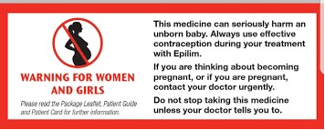
If there is any discrepancy or concern regarding the ‘exceptional circumstance’ status of a discharge medication request or quantity requested, then the screening pharmacist MUST be contacted to clarify the intention.

19.0 Incident Reporting

Any errors associated with Valproate prescribing/supply/administration must be reported via the Trust’s incident reporting system INPHASE. This includes instances where the Risk Acknowledgement Form has not been completed correctly and medication is supplied without completion of the form in line with this policy.
Incidents associated with incompletion of the Risk Acknowledgement Form should be assigned to the clinical director of that service on the Trust’s Incident Reporting System.

20.0 Resources

It is the prescriber’s responsibility to ensure that they are accessing the most recently updated version of any resource document accessed below. This is not fully exhaustive list of relevant resources.

- MHRA Resources

Valproate Safety Measures, MHRA, Last updated 22nd January 2024
https://www.gov.uk/government/collections/valproate-safety-measures
[Accessed November 2024]

National Patient Safety Alert: Valproate: organisations to prepare for new regulatory measures for oversight of prescribing to new patients and existing female patients (NatPSA/2023/013/MHRA), MHRA, Published 28th November 2023
https://www.gov.uk/drug-device-alerts/national-patient-safety-alert-valproate-organisations-to-prepare-for-new-regulatory-measures-for-oversight-of-prescribing-to-new-patients-and-existing-female-patients-natpsa-slash-2023-slash-013-slash-mhra
[Accessed November 2024]

MHRA Drug Safety Update, Valproate: re-analysis of study on risks in children of men taking valproate, MHRA, Published 30th August 2023
https://www.gov.uk/drug-safety-update/valproate-re-analysis-of-study-on-risks-in-children-of-men-taking-valproate#re-analysis-of-study-examining-risk-in-children-of-men-taking-valproate
[Accessed November 2024]

Valproate: review of safety data and expert advice on management of risks, Public Assessment Report, MHRA, Published November 2023 https://assets.publishing.service.gov.uk/media/65660310312f400013e5d508/Valproate-report-review-and-expert-advice.pdf
[Accessed November 2024]

MHRA Drug Safety Update, Valproate use in men: as a precaution, men and their partners should use effective contraception, MHRA, Published 2nd September 2024.
https://www.gov.uk/government/publications/drug-safety-update-monthly-newsletter
[Accessed November 2024]

MHRA Drug Safety Update, Valproate use in men: Valproate (Belvo, Convulex, Depakote, Dyzantil, Epilim, Epilim Chrono or Chronosphere, Episenta, Epival, and Syonell▼): review by two specialists is required for initiating valproate but not for male patients already taking valproate, MHRA, Published 13th February 2025.
https://www.gov.uk/government/publications/drug-safety-update-monthly-newsletter
[Accessed March 2025]

- Prescribing valproate to female patients under 18 years of age, British Paediatric Neurology Association and Royal of Paediatrics of Paediatrics and Child Health, Last updated 15th April 2019.
[https://www.rcpch.ac.uk/resources/valproate-use-women-girls-childbearing-years-guidance]
[Accessed January 2024]

- Guidance Document on Valproate Use in Women and Girls of Childbearing Years On behalf of the Royal College of General Practitioners and Association of British Neurologists and Royal College of Physicians, Version 2, December 9th 2020. Accessed via Royal College of Paediatrics and Child Health.
[https://www.rcpch.ac.uk/resources/valproate-use-women-girls-childbearing-years-guidance]
[Accessed January 2024]

- FSRH CEU Statement: Contraception for women using known teratogenic drugs or drugs with potential teratogenic effects, Faculty of Sexual and Reproductive Health of the Royal College of Obstetric and Gynaecology, Last updated 14 February 2018.
https://www.fsrh.org/Public/Public/Documents/fsrh-ceu-statement-contraception-for-women-using-known-teratogenic-drugs.aspx

https://www.fsrh.org/Common/Uploaded%20files/documents/teratogenic-medication-and-contraception-fsrh-ceu-statement-february-2018.pdf
[Accessed November 2024]

- Withdrawal of, and alternatives to, valproate-containing medicines in girls and women of childbearing potential who have a psychiatric illness. Position Statement, Royal College of Psychiatrists. Last Updated December 2018.
https://www.rcpsych.ac.uk/docs/default-source/improving-care/better-mh-policy/position-statements/ps04_18.pdf?sfvrsn=799e58b4_2
https://www.bap.org.uk/docdetails.php?docID=122
[Accessed November 2024]

- Sexual the FSRH CEU Statement: Contraceptive Choices and Sexual Health for Transgender and Non-Binary People, The Faculty of Sexual and Reproductive Healthcare (FSRH) of the Royal College of Obstetricians Gynaecologists, Clinical Effectiveness Unit (CEU), Last Published 1st October 2017.
https://www.fsrh.org/Public/Public/Documents/fsrh-ceu-statement-contraceptive-choices-and-sexual-health-for-non-binary-people.aspx
https://www.fsrh.org/Common/Uploaded%20files/documents/contraceptive-choices-and-sexual-health-for-transgender-non-binary-people-oct-2017.pdf
[Accessed November 2024]

- Withdrawal of, and alternatives to, valproate-containing medicines in girls and women of childbearing potential who have a psychiatric illness. Position Statement, Last updated December 2018. PS04/18 RCPsych 2018. Royal College of Psychiatrists.
https://www.rcpsych.ac.uk/docs/default-source/improving-care/better-mh-policy/position-statements/ps04_18.pdf?sfvrsn=799e58b4_2
[Accessed November 2024]

Appendix 1 – Advice and counselling to be provided to Male Patients

See subsection of the Policy ‘’General Prescribing Advice for Males’’

ACCESS TO ‘Valproate Male Counselling Checklist’: The form can be accessed from the patient’s ‘Case Record Menu’ under the ‘Medicines’ folder
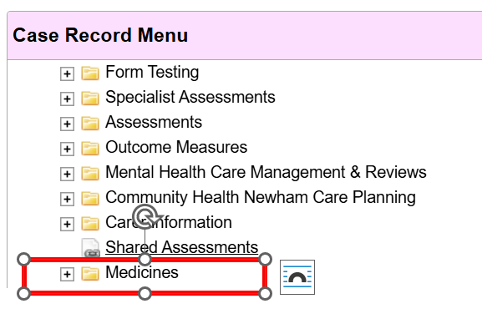

Instructions at the start of the form
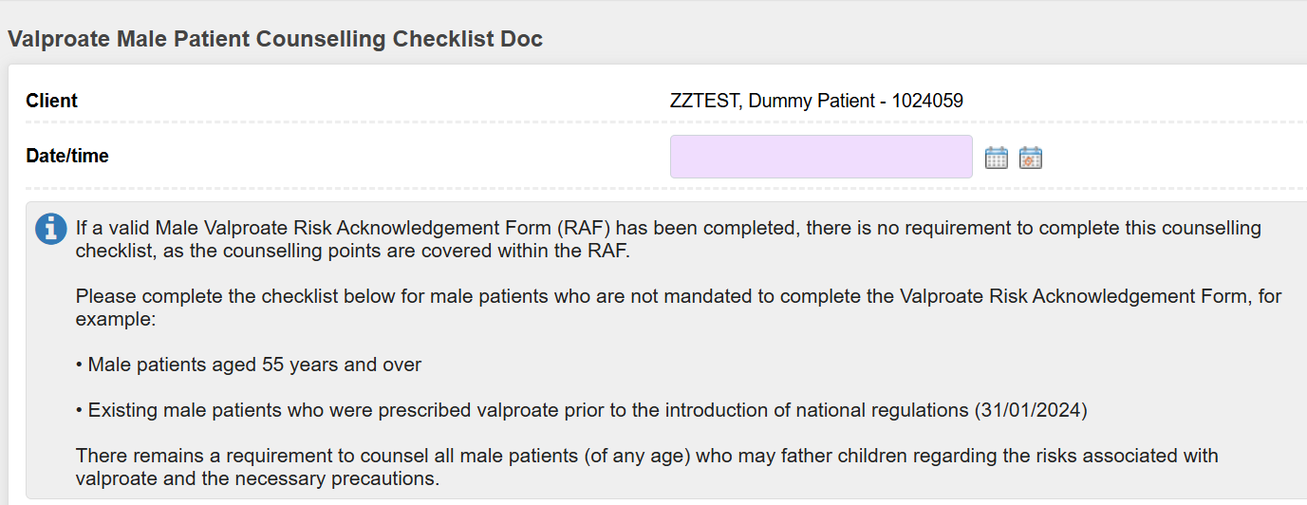

The RIO Valproate Male Counselling Checklist documents that the specialist prescriber has discussed the benefits and risks of valproate with the patient (or responsible person), including the potential impact on male fertility, possible risks to children fathered during treatment, and relevant safety information. It confirms that all required counselling points have been covered and acknowledged by the patient.

For further information:
- MHRA Drug Safety Update (Sept 2024): ‘’ Valproate use in men: as a precaution, men and their partners should use effective contraception’’
- MHRA Drug Safety Update (Feb 2025): ‘’Valproate use in men: review by two specialists is required for initiating valproate but not for male patients already taking valproate’’
Full Drug Safety Updates available at:
https://www.gov.uk/government/publications/drug-safety-update-monthly-newsletter

Appendix 2 - New RiO Valproate Risk Acknowledgement Form guide
The MHRA guidance on the risk counselling of patients prescribed Valproate and related compounds changed in 2024. The changes are detailed in the Valproate policy.
In line with this change the old VRAF in RiO has been retired (made read only so previous forms can be viewed but no new forms completed) and a new VRAF has been developed. This document/appendix lays out the key steps that must be taken in completing the new VRAF.
The two most key changes from the point of view of completing the new VRAF are:
- It is now required that a Valproate Risk Acknowledgement Form (VRAF) be completed for both men and women prescribed valproate.
- It is now required that the VRAF be countersigned by an independent specialist.

ACCESS TO RAF: The form can be accessed from the patient’s ‘Case Record Menu’ under the ‘Medicines’ folder (see below)

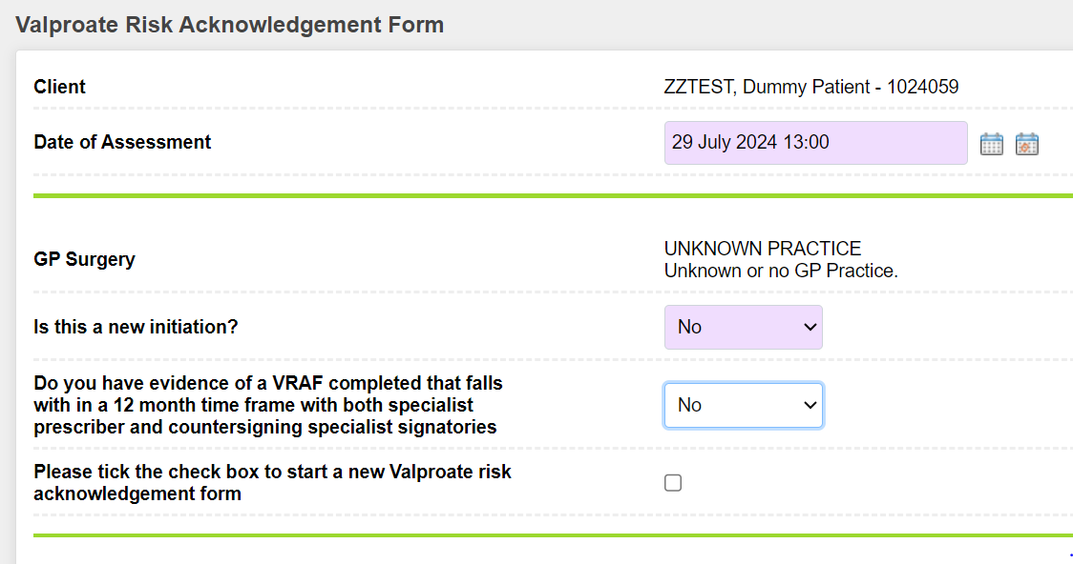
The start of the form asks a number of key questions that determine which subsequent questions will be displayed when completing the form. You will be asked:
- Whether this is a new initiation of valproate or whether the form is being completed for an existing valproate prescription.
- Whether a compliant VRAF has been completed in the last 12 months (perhaps on paper). In this case the VRAF should be scanned and uploaded to RiO as an attached document using code “VALP” and it is not required to complete the new form in full. However, from January 2025 ELFT has mandated completion of the electronic RAF via RIO (paper RAFs are no longer to be utilised).
- Whether you are completing the form for a male or female patient. In certain cases it may be clinically appropriate to complete a form for a different gender than that which the patient is registered under in RiO – see subsection ‘Transgender and Non-binary People’
Once these initial questions have been answered, the form will guide the clinician through the key items that must be discussed with the patient.
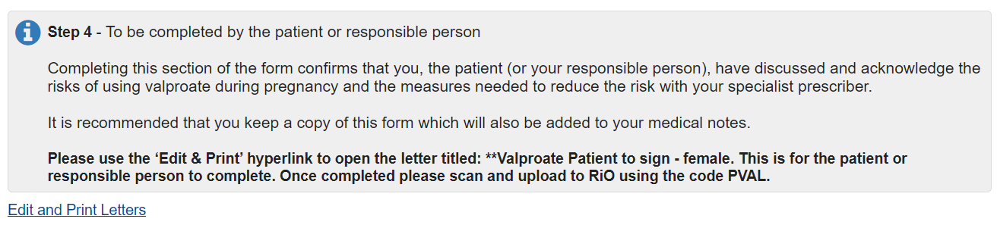
PATIENT SIGNATURE and upload signed form: Once this has been done an editable letter for the patient (or their responsible person) to sign to acknowledge that the risks have been explained to them needs to be printed and completed as explained in the above screenshot. There are two versions of this letter, one for female patients and one for male patients:
- **Valproate Patient to sign – female
- **Valproate Patient to sign - female
Once the appropriate version has been completed and signed, it should be scanned and uploaded as an attached document in RiO using the code “PVAL”.
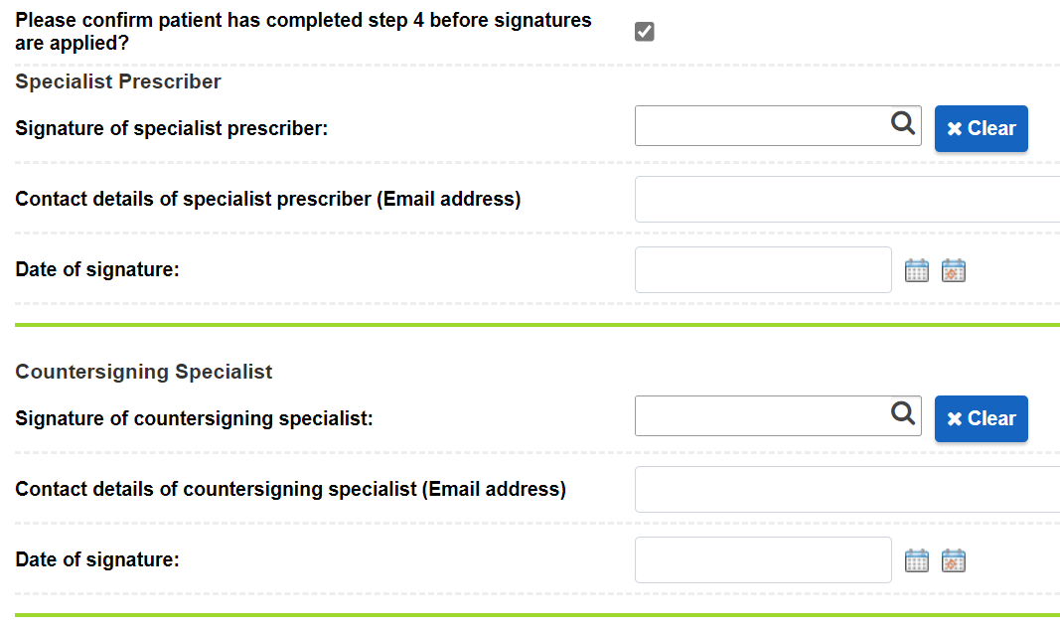
The signatures section of the form then needs to be completed, including the section that needs to be completed by the countersigning specialist.
GP LETTER VIA DROPZONE: The final step is to generate a second editable letter that captures the VRAF. Again, there are two versions of this letter, one for female patients and one for male patients:
- **Valproate GP RAF – female
- **Valproate GP RAF – male

This letter should be sent electronically to the GP using the “Send to GP” feature in DropZone when the letter is generated. It should be stored as an attached document in RiO using the code “VALP”. A copy should also be printed and given to the patient or their responsible person.
DROP ZONE FUNCTIONALITY: If the drop zone function is not appearing for the user in Word when generating the Valproate letter to send to the GP, then they will need to log a request to the IT service desk portal to have this functionality installed on their device. The screen shot below is what the user should be seeing if they edit the word document and then select the drop zone tab, then click ‘send to Rio’ button.
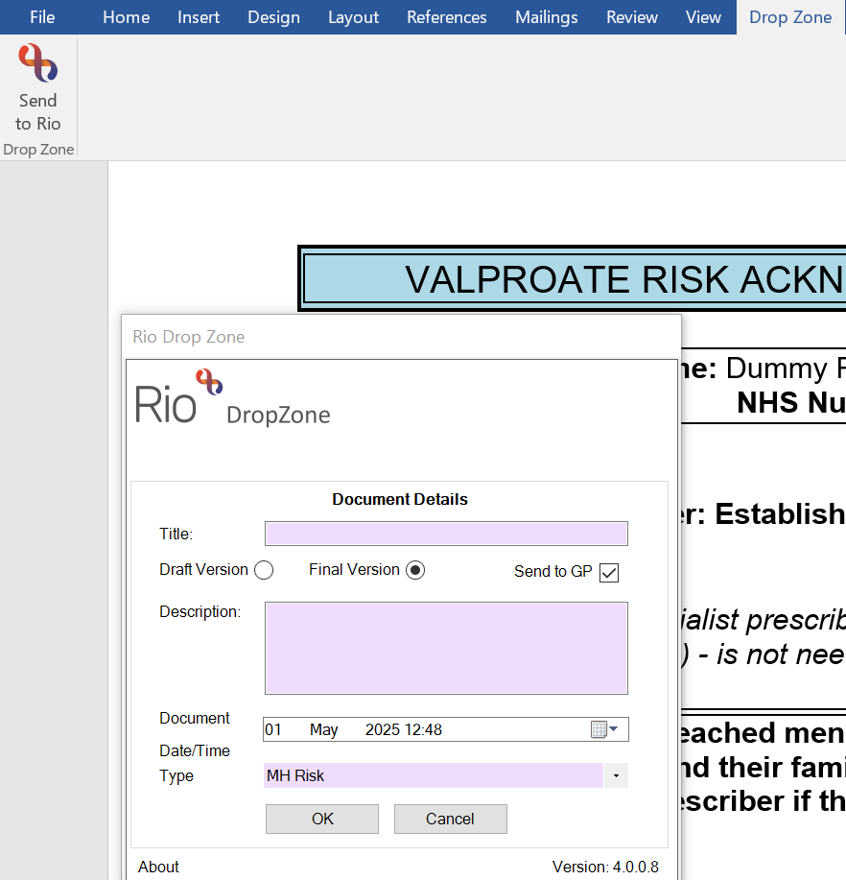

Appendix 3
Infographic 1 - to clarify in which situations review by two specialists may be required: FEMALES UNDER 55 years old
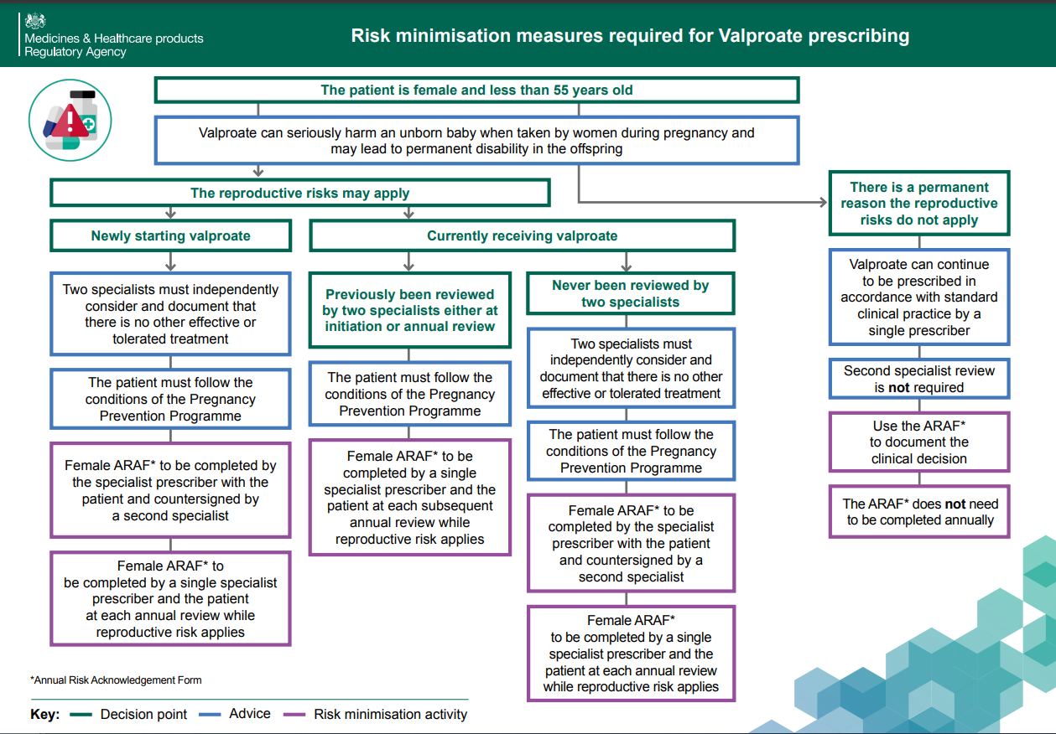
Click here for link:

Infographic 2 - to clarify in which situations review by two specialists may be required: MALES UNDER 55 years old
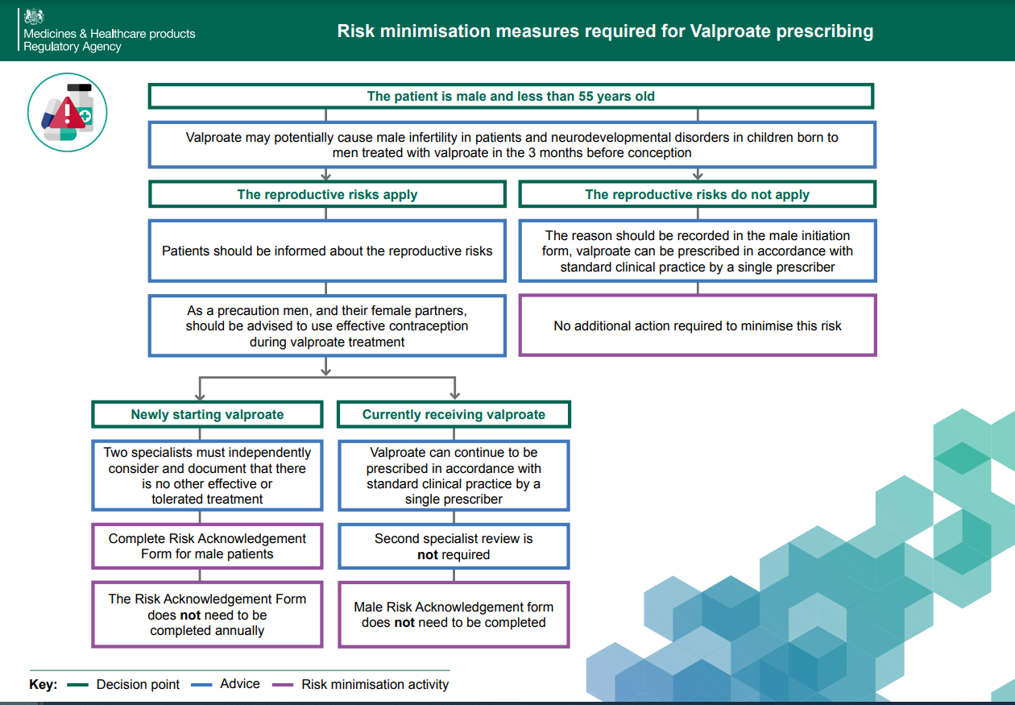
Click here for link:

Infographic 3 to clarify in which situations review by two specialists may be required: MALES & FEMALES OVER 55 years older
Click here for link:
