Patient Information and Noticeboards

Scan the QR code to find a listing of information to be displayed in areas of the Trust. This tells you who to contact if you want to add key information for your service users or if you want to refresh tatty items.
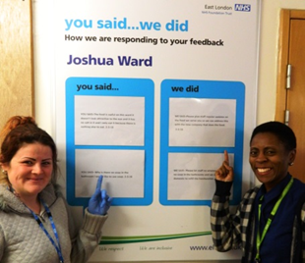
Displaying Information Safely
Notices need to be displayed behind safety glass on a notice board, or be plastic-coated so they can be wiped clean to reduce dust accumulating causing an infection risk. Laminating should be used with caution if the sharp edges could present a risk to the client group. Foam board posters are long-lasting and cleanable.
Noticeboards can be purchased via the stationery company (clares)
You will need to contact your Estates Helpdesk to get these installed.
Keeping it Real and Relevant
Some of the information listed in this document is optional depending on its relevance to your service. E means the item is essential and should be displayed.

Loving Your Noticeboard
It is good idea to allocate the management of noticeboards to someone in your team to remove information when it is out of date, ensure no information is added which does not fit in with the Trust’s values, and keep noticeboards fresh and interesting.
Make your noticeboard an event. Highlight health awareness weeks, local community events and fascinating facts about your service, speciality or staff.

Make Sure All Information Displayed is Accurate, Appropriate and Neutral
It is important that all information is accurate and validated by a reliable source such as the Royal College of Physicians, Psychiatry, Nursing, NICE, NHS England or recognised voluntary sector organisations such as Age UK, Alzheimers, MIND, Citizens Advice, etc.
Local information displayed must be unbiased, non-judgemental and non-discriminatory. There should be no information advertising on behalf of a second party. Eg. No advertising of commercial legal services, financial services, spiritual healers, religious event, etc.
Ensure Information Displayed is Impartial – Remove Any Inappropriate Items Pinned up by Others
It is important that information displayed is non-political and non-religious. The NHS is a politically neutral and secular (non-religious) organisation. (Information issued by affiliated unions is permitted.)
These restrictions apply to information displayed in non-patient areas too. Noticeboards and offices must only display information that is business-specific, health or science-based. Our walls should not advertise events, campaigns or sporting preferences (football teams, etc) which could be biased or cause offence.
If you are not sure if an item is appropriate to be added to your noticeboard, get advice from the ward manager or centre manager, who can make a decision or seek guidance from the communications team or legal team.

Poster | Page | Poster | Page
Trust Board  Zero Tolerance Poster  Welcome in Multiple Languages  The Local Senior Team  EHIC Posters  Lester Tool  Ward Team Photoboards  PALS Posters  PALS leaflets  Complaints Posters  Complaints leaflets  CQC Tell Us poster  Your Records and You leaflets  Your Records and You posters  Understanding the Mental Capacity Act leaflet  Understanding the Deprivation of Liberty Safeguards  24 Hour National Domestic Abuse Helpline poster  10 Points for Staff  Complaining about use of MHA | 3  3  4  5  5  6  6  7  7  7  7  7  7  7  8  8  8  9  9 | Safeguarding Adults posters  Carers Information  Use of Force leaflet  PSIRF leaflet  Staffing Levels wipe boards  Printed Information about Medication  Printed Information about Mental Health Conditions  Printed Information about Physical Health Condition  General Information from specialist charities and organisations  Improvement Noticeboard Section  Service leaflet  Welcome Packs  ‘Hotel’ Information  Patient Feedback/Quality Improvement posters or displays  Freedom to Speak Up Poster  CQC Ratings Boards | 9  9  10  10  10  10  11  11  11  11  11  12  12  12  13  13

Many of the items listed can be downloaded from the intranet here. Go to the Noticeboard section on the CQC intranet page person for the specific item will be indicated.

Item | Summary of Item | Essential/Optional | Who to contact to obtain item | Link to Item
Trust Board | Names and photos of the Trust Board Directors | E  Reception and Ward areas | Can be downloaded from the website: https://www.elft.nhs.uk/information-about-elft/our-board | 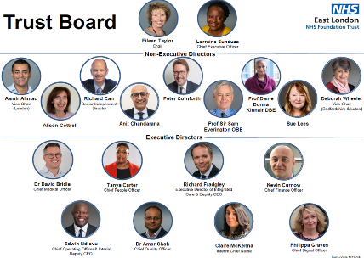
Zero Tolerance Poster | Joint poster with police stating our expectations of patients and visitors behaviour.  Three versions: a London version a Bedfordshire and Luton MH version and a Beds and CCST version | E  Receptions and Wards | Issued by the Safety team. Contact Richard Harwin  richard.harwin@nhs.net | 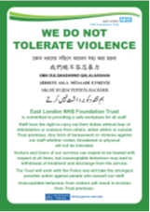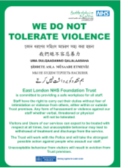
Welcome  In English and other languages | For entrances and reception areas.  These can be ordered direct from Apogee, ELFT’s designated print company. Select a size suitable for the space available in your service. | O | Apogee is the Trust primary print and design company.  https://www.elft.nhs.uk/intranet/digital/our-staff-and-digital/print-services | 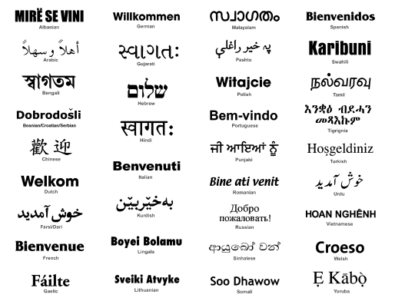
The Senior Team  Photograph showing the Directorate Management team at entrance of inpatient units inc PP leads | A board showing the photographs of the senior team for the directorate and their job title | At entrance to inpatient units | To be arranged by the local DMT | 
ELFT Strategy foamboard poster | The A3 landscape foamboard poster is available to any service or team. Useful at recruitment events and to explain the Trust’s priorities.  *Currently being distributed Trustwide | E | Contact the Communications team: elft.communcations@nhs.net | 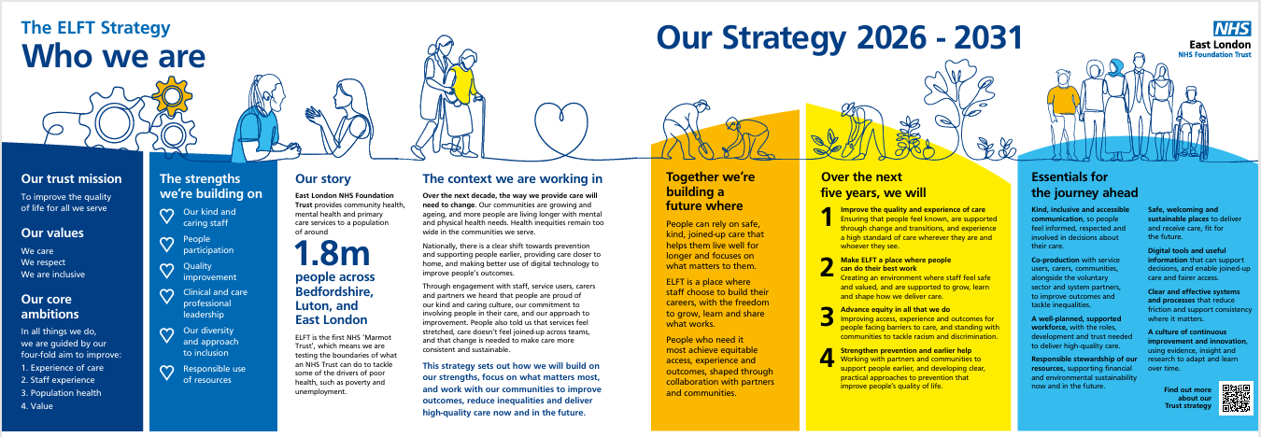
EHIC Posters  European Health Identity Card | A poster to be visible at all access points to ELFT services stating that European visitors should show a valid EHIC (European Health Insurance Card), otherwise they may have to pay for healthcare | E  To be displayed all Reception areas in the Trust | Issued by the Overseas Visitor Team on 020 7655 4179/07535 695 075  Or email:  cyril.okolocha@nhs.net | 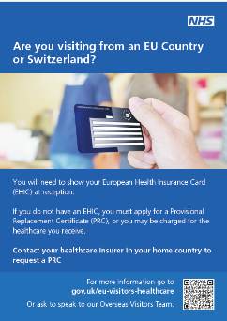
Lester Tool | This is a CQUIN requirement for all consulting rooms where people with mental health issues are seen. The Lester Tool poster should be displayed to assist in the management of the patient’s physical health care – “Don’t just screen – intervene for all people in the red zone.” 2023 version | E  In all mental health  consulting rooms | Contact your Service Director for these or download here | 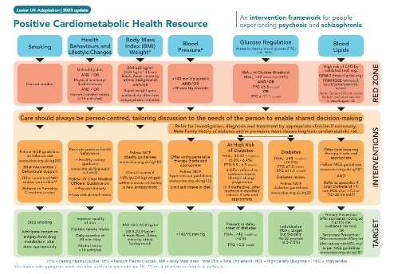
Ward Team Photoboards | A board showing the photographs of the ward team and their job titles.  Can be displayed creatively using cartoons, trees, etc. | E  All wards | To be determined by service manager/lead nurse/ward manager
PALS posters and leaflets | A poster and leaflet explaining the steps to take if an individual or family not happy with what is happening with their care. The PALS team can intervene and nip issues in the bud.  Two versions: a London version and a Bedfordshire and Luton version | E  In all areas | Issued by the PALS team. Contact: elft.pals@nhs.net | 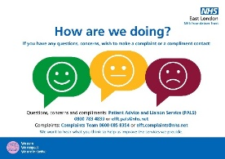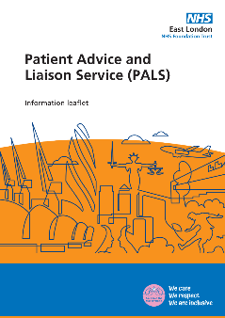
Complaints and PALS posters and leaflet | Assets explaining how to make a complaint and provide feedback to the Trust about care and treatment.  Two versions: a London version and a Bedfordshire and Luton version | E  In all areas | Issued by Complaints team  Contact: elft.complaints@nhs.net | 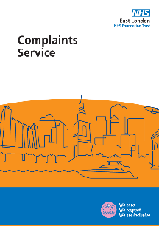
CQC Tell us poster | Details for the public on how they can raise concerns with the CQC | E  In all areas | CQC Tell us now here | 
Your Records and You leaflets and posters | A booklet and poster explaining why the Trust gathers information about patients, safeguards around confidentiality and how they can access their own records. | E  In all areas | Issued by Information Governance team. Available on the intranet here  Contact: elft.information.governance@nhs.net
Understanding the Mental Capacity Act leaflet  Understanding the Deprivation of Liberty Safeguards | A guide for service users, their families and carers. Explains what the Mental Health Capacity Act is, how someone is assessed, what this means and how this can be challenged.  Simple explanation of the criteria, assessment, what it means in practice, how it is reviewed and when DoLs doesn’t apply. | E | Contact Dominique Merlande, Associate Director of Mental Health Law  dominique.merlande1@nhs.net | 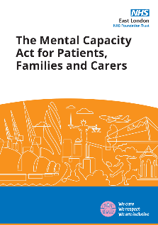  
24 Hour Domestic Abuse Helpline | The national helpline for people seeking help with domestic abuse | E | 24 hour Domestic Abuse Helpline poster | 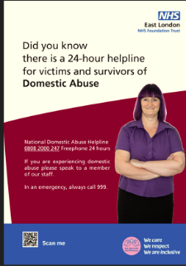
Complaining about the use of the MHA | Two versions that can be displayed for patients to reference | E | Contact Dominique Merlande, Associate Director of Mental Health Law  dominique.merlande1@nhs.net  Download here:  ELFT MHA poster  CQC MHA poster | 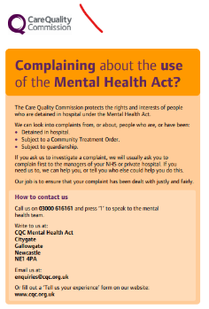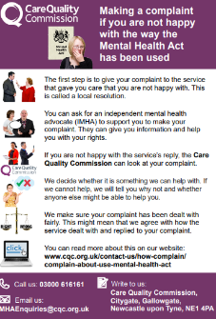
Mental Capacity Act  10 Points for Staff | A flyer to remind staff of key principles: presume patients can make a decision for themselves unless you have shown otherwise, support them to make their own decision, they have the right to make an unwise decision and always act in your patient’s best interests applying least restrictive effective option. | E  In mental health care settings | Contact Dominique Merlande, Associate Director of Mental Health Law  dominique.merlande1@nhs.net | 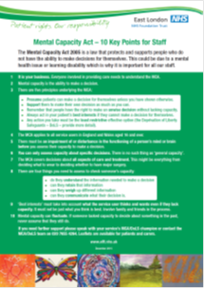
Safeguarding Adults posters | A simple poster to say staff are trained to help if someone is upset or worried about something that has happened to them.  Local authority reporting number for each borough is included.  A version for each area showing the local authority contact number | E  All health care settings | Contact the Safeguarding Adults lead for your service | 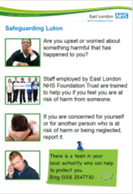
Carers Information | Contact the Carers lead for you area to access local information for carers:  https://www.elft.nhs.uk/contact-us/contact-carers-leads | E  In all health care settings | Contact the carers lead for your area | 
Use of Force leaflets and poster | It is a requirement under the Mental Health Units (Use of Force) Act 2018 and statutory guidance for all trusts to have a written policy to clearly set out the measures which are needed to both reduce the use of force and ensure accountability and transparency about the use of force in mental health settings. | E | Can be downloaded from the ELFT website:  https://www.elft.nhs.uk/mental-health-units-use-force-act-2018 | 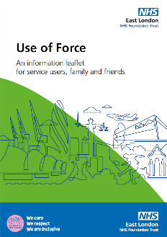
PSIRF leaflet | The Patient Safety Incident Response Framework (PSIRF) is the process whereby the Trust will investigate incidents and spread learning. This leaflet explains this to patients and to the public. | E | Can be downloaded from the ELFT website:  https://www.elft.nhs.uk/sites/default/files/2024-01/PSIRF%20SU%20leaflet%20v2.pdf | 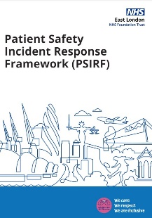
Staffing Levels wipe boards | A display which is updated at every shift change to indicate how many staff are on the ward. | E  On all wards | Contact John Peers, Lead Nurse on 07941 375 089 or email:  john.peers2@nhs.net | 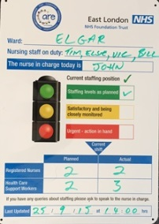
Printed Information about Medication | The Trust has produced resources in a range of languages for patients. These can be accessed via the icon on all Trust desktops. | Print off  information as required for individual patients | Print as required for individual patients | 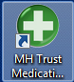
Printed Information about Mental Health Conditions | The Trust signposts people to the Royal College of Psychiatrists website as they have a range of good quality information that can be accessed online by patients or can be printed off for them. | Print off the leaflet/  information as required for individual patients | Print as required for individual patients | https://www.rcpsych.ac.uk/mental-health
Printed Information about Physical Health Conditions | The NHS Choices website has good quality medically validated information that can be accessed online by patients. Information can also be printed off for them by staff. | Print off the leaflet/  information as required for individual patients | Print as required for individual patients | NHS Choices website  And available on RiO
General Information from specialist charities and organisations | Teams may wish to purchase and display specialist information to provide patients and carers with useful national or local information. | Optional | To be determined by service manager/lead nurse/ward manager
Service leaflet | Information about the service stating what the service does, reasons for referral, assessment process, support offered and contact details to reinforce discussion between professional and patient/family/carer | All services | Send draft leaflet content to the Communications team for advice on wording.  They can get a quote and arrange the design and print
Welcome Packs | The People Participation team have developed Welcome Packs for London Inpatient Wards stating what patients can expect and useful information. | All inpatient services | Local People Participation lead
‘Hotel’ Information | A template to go on the back of every bedroom door to convey key information useful to patients during their stay. Reinforcing some of the information in the Welcome Packs | Optional  To go on bedroom door of all rooms | Template to be completed by named health care worker.  Needs to be customised for each ward.
Patient Feedback/Quality Improvement posters or displays | Information about PREMS, PROMS, You said, we did …  Any relevant data or facts about improvements to the service, awards, accreditations, prizes, etc. Can be displayed creatively | To be displayed on wards or in waiting areas in community centres | To be determined by the service manager/team lead.  To order You Said We Did boards, complete an order form and make an order on Oracle. | 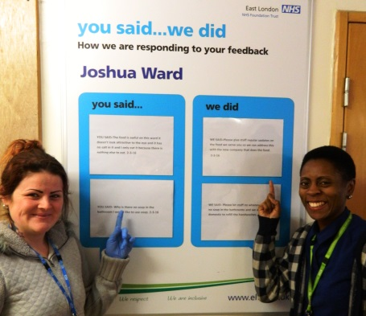  Can also be displayed creatively by the team: speech bubbles, graphs, charts, leaves, etc.
Freedom to Speak Up Poster | Information about ELFT’s Freedom to Speak Up Guardian and how to raise a concern | E  To be displayed in all areas | Contact: Anita Hynes  Freedom to Speak up Guardian.  Email: anita.hynes@nhs.net | 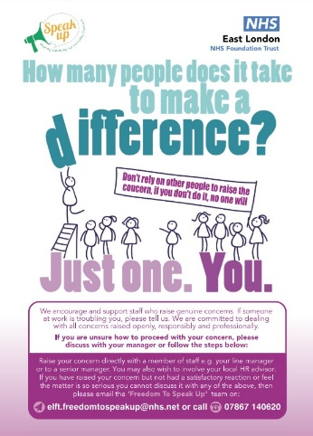
CQC Ratings Board | This sets out the rating each team or service received in the last CQC assessment. It shows visitors the calibre of service they are visiting. Check yours is up to date – it should be dated June 2023. | E | Contact the Comms team: elft.communication@nhs.net | 