Q1 Antimicrobials Prescribing Audit Report 2026/27
Introduction:
This audit report summarises the key findings of the antimicrobials prescribing audit conducted in June 2026 and it is used to monitor antimicrobials prescribing trends and quality indicators as part of the Trust wide Antimicrobial Stewardship initiatives
Method and Standards:
The ELFT pharmacy team collect data across all sites every quarter during a two weeks period. For each antimicrobial prescription found during the audit period, the clinical notes and medication charts are reviewed and compared against antimicrobial guidelines and/or microbiology advice provided. For each prescription, compliance is measured against standards, which are derived from the ELFT Antimicrobial Stewardship Policy. This policy defines the processes, which ensure that antimicrobial prescribing within ELFT is safe, effective and appropriate. The audit standards are as follows:
- Appropriate treatment choice: All antimicrobials prescribed should be in accordance with the recommendations in the relevant local or national guidelines or microbiology advice.
- Completion of the allergy box: 100% of antimicrobial prescriptions should also have a clearly documented allergy status for the patient on the prescription chart.
- Documentation: All antimicrobial prescriptions should have the clinical indication clearly documented in the patient medical record or on the prescription chart
- Course length: All antimicrobial prescriptions should have a clearly documented duration (or review date) which is appropriate for the indication and is in accordance with recommendations in the relevant local or national guideline or microbiology advice.

The RAG rating parameters are set as follows:
RAG Rating | Required parameter
Red – Poor Compliance | Below 50% total compliance
Amber – Good Compliance, improvement needed | Total compliance between 50%- 89%
Green – Excellent Compliance | Above 90% total compliance (100% for allergy status documentation)
No colour | Insufficient forms to RAG rate

Key Findings
A total of 523 prescriptions were audited across all sites in June 2026, of which 30 were prescribed antibiotics. Findings for Q1 are summarised in table 1 below.
Site | n | Completion of Allergy Status | Appropriate Treatment Choice | Documentation in RIO progress notes and medication chart
 |  |  |  | Indication | Dose | Course Length | Stop/Review Date
Bedfordshire & Luton | 3 | 100% | 100% | 100% | 100% | 100% | 100%
Tower Hamlets | 4 | 100% | 100% | 100% | 100% | 100% | 100&
Newham | 7 | 100% | 100% | 100% | 100% | 100% | 71.43%
City & Hackney | 3 | 100% | 100% | 66.67% | 100% | 100% | 100%
CAMHS | 2 | 100% | 100% | 100% | 100% | 100% | 100%
Forensics | 11 | 100% | 90.91% | 100% | 90.91% | 81.82% | 54.55%
TOTAL | 30 | 100% (30/30) | 96.67% (30/29) | 96.67% (30/29) | 100% (30/30) | 93.34%  28/30 | 73.34%  22/30
Table 1: Compliance scores Q1 from InPhase Audit Portal

Tower Hamlets, Bedfordshire & Luton, CAMHS: Overall results showed excellent compliance with audit standards.
City & Hackney, Forensics & Newham: This service has demonstrated good compliance with few audit standards for this quarter. Compliance with the appropriate treatment choice, indication and stop/review date (recorded on the medication chart) in Q1 need improvements.

Comparison Data: 12-month trend
A comparison chart was developed for Jun ’25, Oct ’25, Feb ’26 and Jun ‘26 in table 2 below:
Table 2: Compliance scores summary
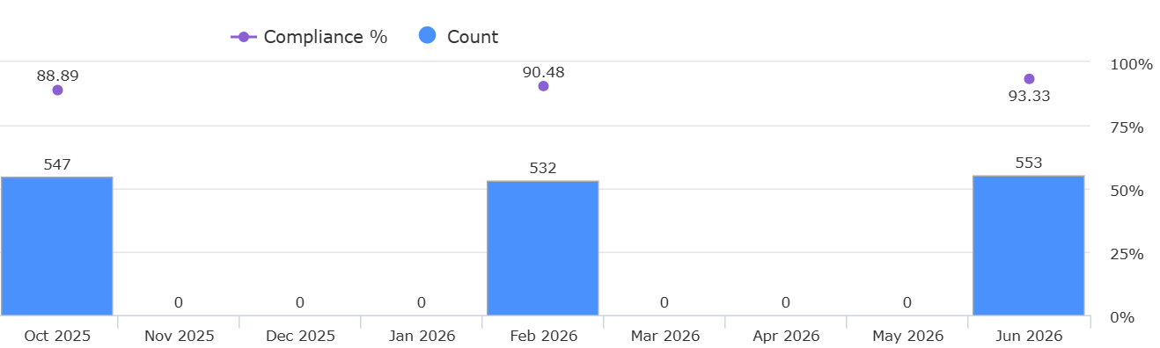
Month | June 2025 | October 2025 | February 2026 | June 2026
Count | 566 | 547 | 532 | 553
Compliance | 84.62% | 88.89% | 90.48% | 93.33%

Top TEN Wards Prescribing Antimicrobials – From Power BI
As per attached graphic, the top 10 wards prescribing Antimicrobials for Q1 2026/27 were:
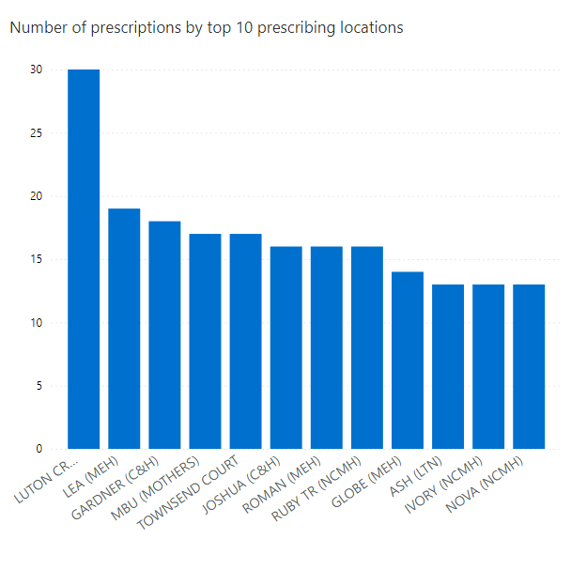
Prescribing Location | No of Prescriptions (Antimicrobials)
LUTON CRYSTAL | 30
LEA (MEH) | 19
GARDNER (C&H) | 18
MBU (Mothers) | 17
TOWNSEND COURT | 17
JOSHUA (C&H) | 16
ROMAN (MEH) | 16
RUBY TR (NCMH) | 16
GLOBE (MEH) | 14
ASH (LTN) ` | 13
IVORY (NCMH) | 13
NOVE (NCMH) | 13

Top TEN Antimicrobials Prescribed - From Power BI
As per attached graphic, the top 10 Antimicrobials Prescribed for Q1 2026/27 were:
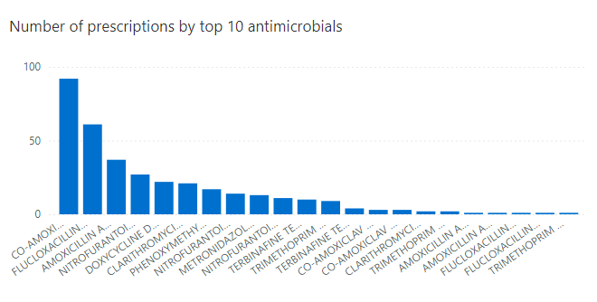
Drug | No of Prescriptions (Antimicrobials)
Co-Amoxiclav 500mg/125mg tabs | 92
Flucloxacillin 500mg caps | 61
Amoxicillin 500mg caps | 37
Nitrofurantoin 100mg M/R caps | 27
Doxycicline 100mg caps | 22
Clarithromycin 500mg film coated tabs | 21
Phenoxymethylpenicillin 250mg tabs | 17
Nitrofurantoin 50mg caps | 14
Metronidazole 400mg tabs | 13
Nitrofurantoin 100mg caps | 11
Terbinafine 1% cream | 10
Trimethoprim 200mg tabs | 9
Terbinafine 250mg tabs | 4
Co-Amoxiclav 250mg/125 tabs  Co-Amoxiclav 250mg+62.5mg/5ml suspension | 3
Clarithromycin 250mg tabs  Trimethoprim 100mg tabs | 2
Amoxicillin 250mg/5ml SF suspension  Amoxicillin 500mg injection  Flucloxacillin 250mg caps  Flucloxacillin 250mg/5ml SF liquid  Trimethoprim 50mg/5ml suspension | 1

Number of Antimicrobials Prescribed from April 2025 to June 2026
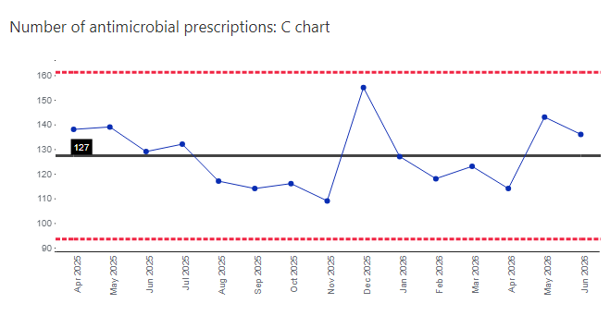

Month/Year | No of Prescriptions (Antimicrobials)
Apr 2025 | 138
May 2025 | 139
Jun 2025 | 129
July 2025 | 132
Aug 2025 | 117
Sep 2025 | 114
Oct 2025 | 116
Nov 2025 | 109
Dec 2025 | 155
Jan 2026 | 127
Feb 2026 | 118
Mar 2026 | 123
Apr 2026 | 114
May 2026 | 143
Jun 2026 | 136

Benchmark between London MH Trusts last 12 months
(from July 2025 to June 2026)
From Define Rx
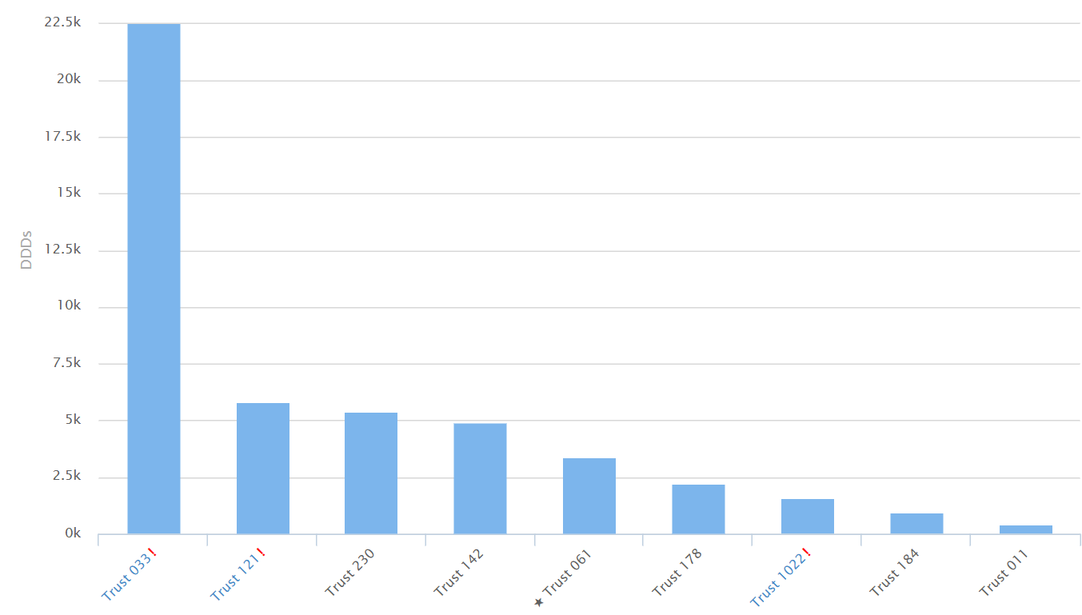
Trust 033: CNWL NHS (22,542)
Trust 121: North East London NHS (5,818)
Trust 142: Oxleas NHS (4,893)
Trust 061: East London NHS (3,399)

Action Plan
The following action plan has been formulated to address areas of non-compliance and concern as well as some overarching antimicrobial stewardship objectives in order to improve use of antimicrobials.
Action No | Action | By When
1 | Circulate report to all Pharmacists, Prescribers, and Clinical Directors to discuss at respective quality and governance meetings. Present findings of the audit to each divisional IPC subgroup and IPC Committee. | July 2026
2 | Services with good to poor compliance (RAG rated as amber or red) will be asked to develop local action plans to improve antimicrobial prescribing. This will involve close working between local prescribers, pharmacy teams and the antimicrobial pharmacist. | July 2026
3 | Monitor vs the ELFT ACT NOW priorities 2026/27 and the Antimicrobial Resistance Action Plan 2026–2029 | Ongoing

