Managing Patient eCorrespondence Preferences (EMIS Opt-Out Process)

Document Control

Version: | 2.1
Ratified by: | XXX Clinical Systems Training Standardisation Group
Date ratified:
Name of originator/author:
Name of responsible committee: | XXX Clinical Systems Training Standardisation Group
Circulated to: | Trust wide
Date issued:
Date reviewed: | XXX
Next review date: | XXX
Target audience: | IAPTUS Users

  - Version Control Summary

Version | Date | Author/Review | Status | Comment
1.1 | 05/06.2026 | Kyle Buffong | Active

Contents

Accessing a Patient Record and Opting a Patient Out of Digital Correspondence 3
Locating the client demographic page 6

Entering an eCorrespondence Opt-Out Preference on the Patient Clinical Record
- Patients may request not to receive correspondence electronically via email or other digital communication methods. In these circumstances, you can update the patient’s communication preferences within EMIS to opt them out of digital correspondence and ensure future communications are delivered by post.
- This crib sheet will show you how to record patients’ communication preference within EMIS and confirm that future correspondence is sent through the appropriate postal delivery method via Hybrid Mail.

  - Click on Active tab drop down icon, you should see this on the top half of your screen when on EMIS. This will allow you to see the patients address, contact information, and patient information alongside any additional warnings.


2. Click on ‘Edit patient details’
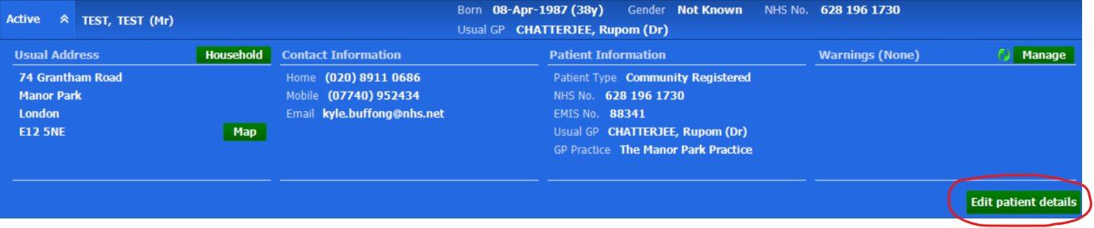

4. Here under ‘Patient Details’ you will be able to update the personal details of the patient. Adding the Patients address correspondence and email, phone number and preferred communication method to email are the key steps in getting the patients account updated.
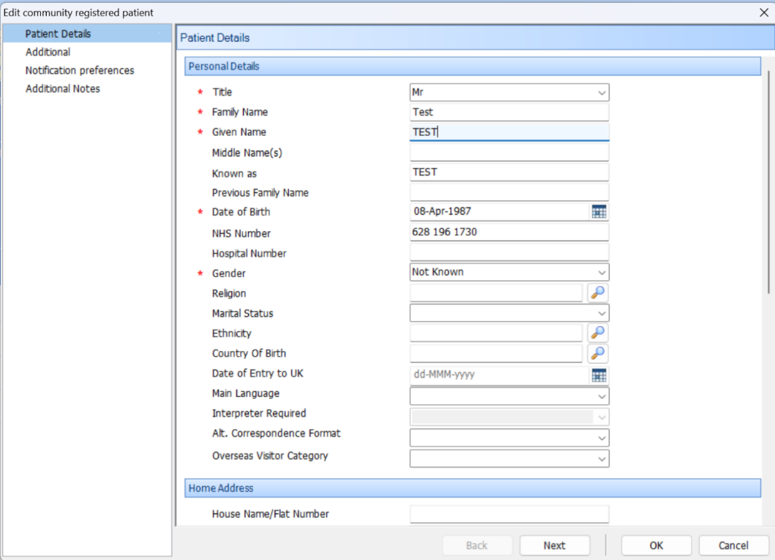

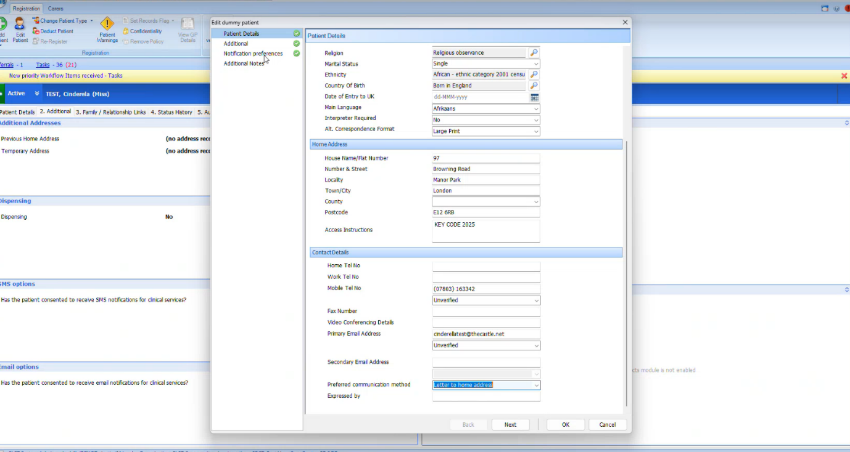
5. Update the Preferred Communication Method to 'Letter to Home Address', once completed, please select ‘Ok’ to save what you have input

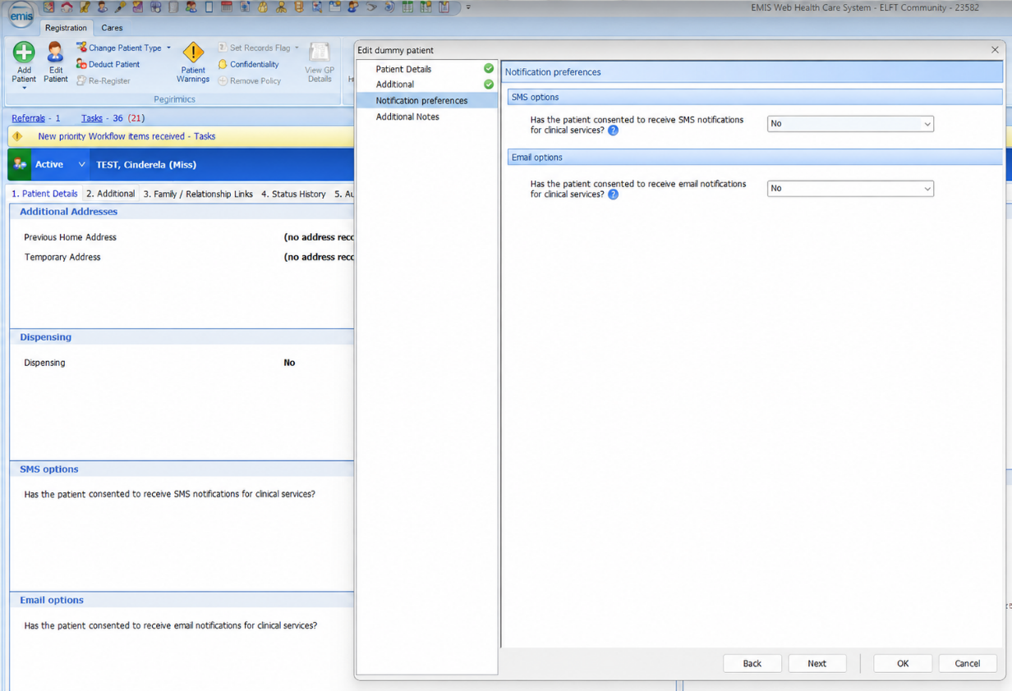
6. Update the Email Notifications preference in line with the patient's request to opt out of digital correspondence. Both SMS and EMAIL options are set to ‘No’ as shown below.

7. Once the patient's communication preferences have been updated, future correspondence generated for the patient will follow the selected postal communication route. Outcome: The patient has been successfully opted out of digital correspondence and future communications will be sent via post, subject to local service processes and configuration.
