
FAQ – Hybrid Mail – Digital Opt-Out
Recording, viewing and applying patient communication preferences in RiO and EMIS
★ KEY POINT: Patient choice must always be respected. Digital by default does not remove a patient's ability to choose how they receive their correspondence. Good data quality is essential to ensure correspondence is sent safely, accurately and through the patient's preferred communication method.

1. Key Points for Staff
Key points staff should always remember about recording communication preferences.
- Ask and record the patient's communication preference upon first contact.
- Ensure the patient's email address, mobile number and postal address are accurate and up to date.
- Clearly record where a patient has opted out of a particular communication method, such as email, SMS or post.
- Review communication preferences throughout the clinical pathway and update the clinical system whenever a patient's preference changes.
- Never assume a patient's preferred communication method based on the contact information available on their record.
- Patient choice must always be respected. Digital by default does not remove a patient's ability to choose how they receive their correspondence.
- Good data quality is essential to ensure correspondence is sent safely, accurately and through the patient's preferred communication method.
2. Communication Preference – How to Opt Out & Opt In (RiO)
Patient Preference 1: Send me SMS and do not send email and post to home address (POST only)
This means the patient wishes to receive SMS/text messages only and does not want to receive correspondence by Email or Post.
Additional step: Complete the additional step displayed in red on RiO. A correspondence address must be added to the patient's demographic record stating "do not send letters to home address" using postcode ZZ99 3CZ. This is required to prevent RiO letters from being sent to the patient's home address in error.
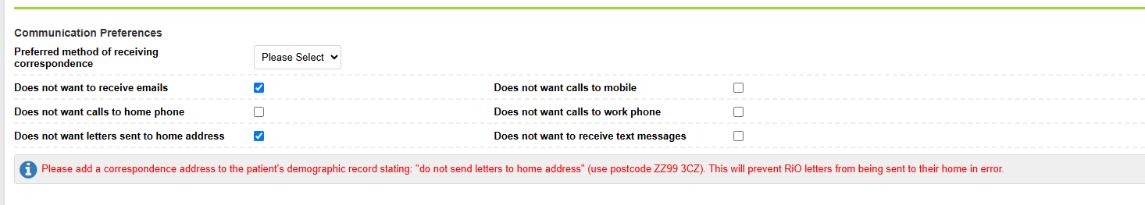
System View – Preference 1: SMS only (Complete Opt Out)
⚠ IMPORTANT: If the letter needs to go to any other correspondence address for the patient if it is clinically imperative, then the staff must select ‘Post only’ template in Hybrid Mail to send by post.

Patient Preference 2: Do not send SMS, Email or Post to home address —(POST only)
This means the patient does not wish to receive correspondence by SMS/text message, email or post — this is a Complete Opt Out.
Once these preferences have been selected, RiO displays two red instructions. Staff must complete both additional steps to ensure the patient's preferences are fully respected:
1. Prevent letters being sent to the home address. Add a correspondence address to the patient's demographic record stating "do not send letters to home address", using postcode ZZ99 3CZ. This will prevent RiO letters from being sent to the patient's home address in error.
2. Prevent automated text messages being sent. Add the alert "Communications - do not send text messages" to the patient's record. This will prevent automated SMS/text messages from being sent.
⚠ IMPORTANT: Simply ticking the three communication preference boxes is not sufficient. Staff must also complete both red steps displayed by RiO to ensure the patient's Complete Opt Out is correctly applied.
If the letter needs to go to any other correspondence address for the patient if it is clinically imperative, then the staff must select ‘Post only’ template in Hybrid Mail to send by post.

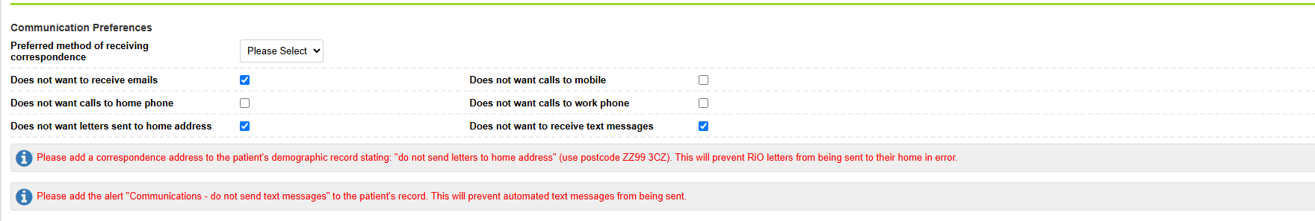
System View – Preference 2: Complete Opt Out
Patient Preference 3: Send me email and do not send SMS and Post to home address — (POST only)
This means the patient wishes to receive correspondence by email only and does not want to receive communications by SMS/text message or Post.
Once these preferences have been selected, RiO displays two red instructions. Staff must complete both additional steps:
1. Prevent letters being sent to the home address. Add a correspondence address to the patient's demographic record stating "do not send letters to home address", using postcode ZZ99 3CZ. This will prevent RiO letters from being sent to their home address in error.
2. Prevent automated text messages being sent. Add the alert "Communications - do not send text messages" to the patient's record. This will prevent automated SMS/text messages from being sent.
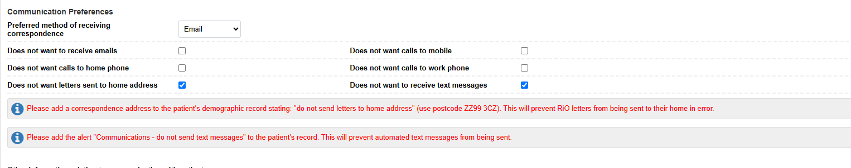
System View – Preference 3: Email only (Complete Opt Out)
⚠ IMPORTANT: If the letter needs to go to any other correspondence address for the patient if it is clinically imperative, then the staff must select ‘Post only’ template in Hybrid Mail to send by post.

Patient Preference 4: Send me SMS and EMAIL, do not send post — (Digital Only)
Where a patient wishes to receive communications digitally by Email and SMS/text message, but does not want to receive correspondence by post, this should be recorded as follows:
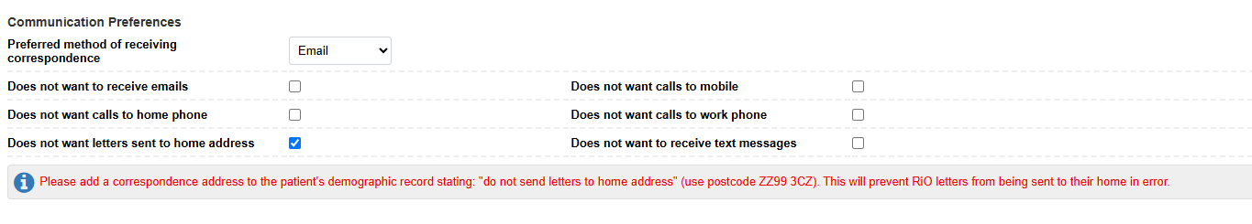
System View – Preference 4: Digital Only (Email + SMS)
Prevent letters being sent to the home address. Add a correspondence address to the patient's demographic record stating "do not send letters to home address", using postcode ZZ99 3CZ. This will prevent RiO letters from being sent to the patient's home address in error.
⚠ IMPORTANT: Ticking "Does not want letters sent to home address" alone is not sufficient. The red step displayed within RiO must also be completed to ensure the patient's preference is correctly applied.

Patient Preference 5: "Send me SMS or EMAIL or POST" (no opt-out selected) (Digital Only)
The patient has not opted out of any communication method. Their preferred method of receiving correspondence is Email by default, and they can also receive SMS/text messages or post.
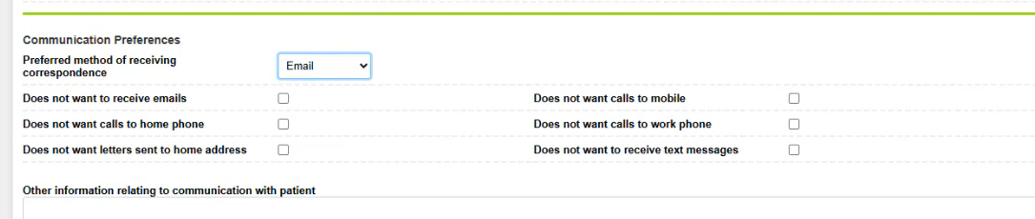
System View – Preference 5: No opt-out selected (Digital Only by default)
Patient Preference 6: Send me Email and Post but not SMS — (Post Only)
The patient wants email and post but not SMS, and hence the letter must go via post only, as the digital letter PIN cannot be sent via messages. This should be recorded as follows:
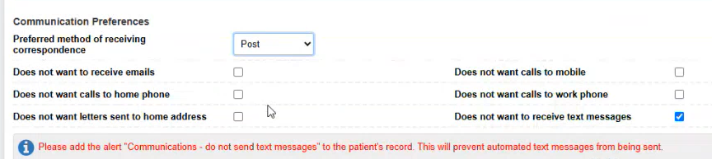
System View – Preference 6: Email + Post, no SMS (Post Only)
Patient Preference 7: Send me Post only — (Post Only)
The patient has opted out of receiving emails and SMS/text messages. Their preferred method of receiving correspondence is Post, and letters should continue to be sent by post. This should be recorded as follows:
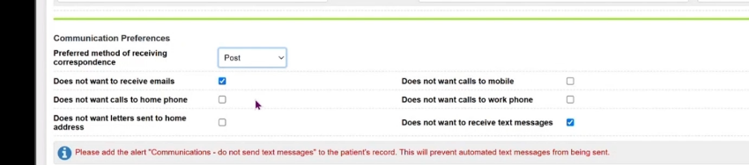
System View – Preference 7: Post only
Patient Preference 8: Send me Post and SMS but do not send Email — how do I record this? (Post Only)
The patient has opted out of receiving emails but is happy to receive correspondence by post and communications via SMS/text message. This should be recorded as follows:
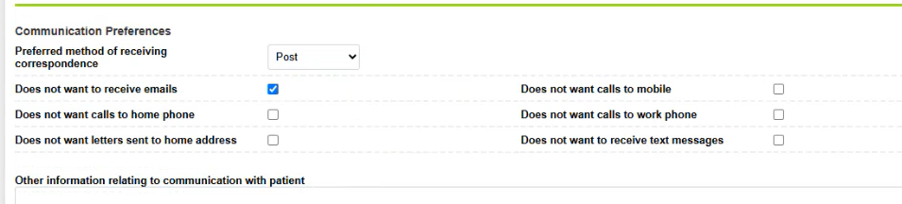
System View – Preference 8: Post + SMS, no Email (Post Only)
3. EMIS EPR – How to Opt Out of Digital Correspondence
Q. How do I opt a patient out of digital correspondence in EMIS?
A. Where a patient has chosen to opt out of receiving correspondence digitally and wishes to receive their correspondence by post, their communication preferences must be updated correctly in EMIS, using the four steps below.
Step 1 – Open the patient's details
- Open the patient's record in EMIS.
- Select Edit patient details.
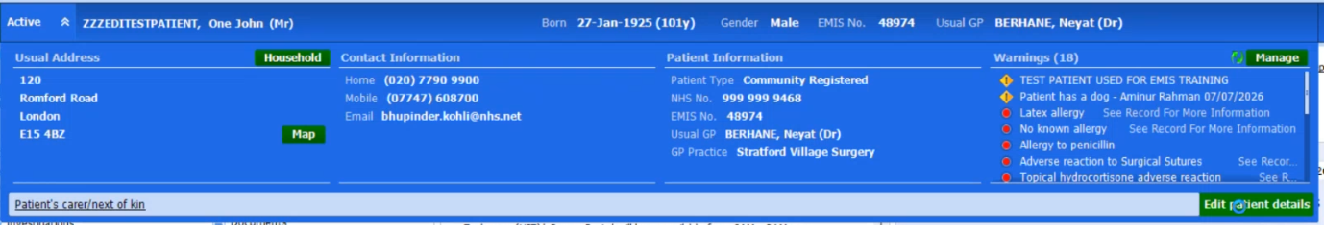
Select ‘Edit patient details’
Step 2 – Update the Preferred Communication Method
- Within Patient Details, review the patient's contact information and ensure their details are accurate and up to date.
- Locate Preferred communication method.
- Change the selection to "Letter to home address".
- This records that the patient's preferred method for receiving correspondence is post.
Step 3 – Update Notification Preferences
- From the menu on the left-hand side, select Notification preferences.
- Under Email and SMS options, locate: "Has the patient consented to receive email notifications for clinical services?" / "Has the patient consented to receive SMS notifications for clinical services?"
- Change this option to "No".
⚠ IMPORTANT: If only one of these options is set to "No" this will still Opt Out the patient. To Opt a patient back in, select "Yes" for both options and update "Preferred communication method" to “Email addess” under "Patient Details".

Step 4 – Save and confirm
- Save the changes to the patient's record.
- Confirm that "Letter to home address" is recorded as the preferred communication method and that Email notifications are set to "No".
Q. What do the other EMIS opt-out variation screens look like?
A. These screens show alternative combinations of the Preferred Communication Method and Notification Preferences fields as they appear once updated in EMIS.
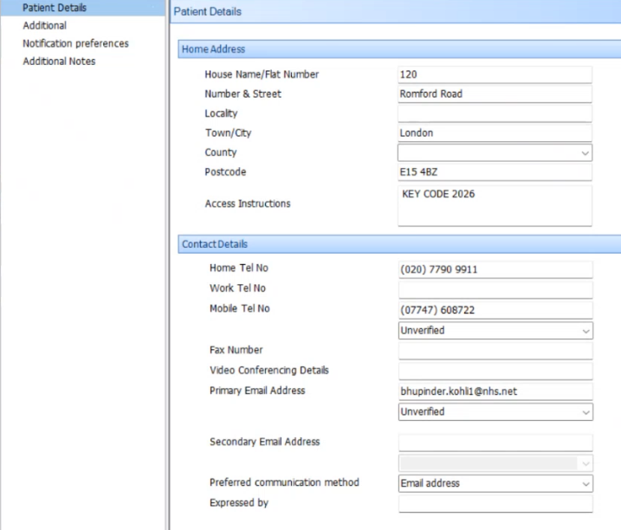
EMIS – Other opt-out variations (1)
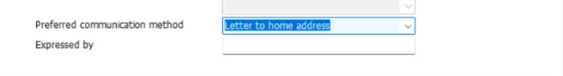
EMIS – Other opt-out variations (2)
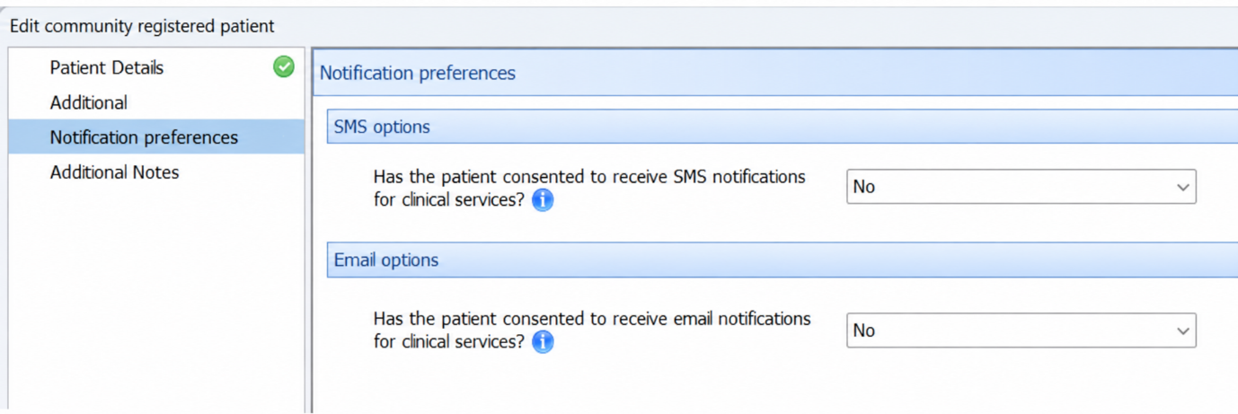
EMIS – Other opt-out variations (3)
4. How to View a Patient's Communication Preference
Q. How do I quickly check a patient's recorded communication preference in RiO?
- A. Open the patient's record in RiO.
- From the Clinical Portal – Client's View, look at the Demographics section on the right-hand side of the screen.
- Under Communication Preferences, you will see any preferences or opt-outs currently recorded for the patient, for example:
- Does not want to receive emails
- Does not want to receive text messages
- Other recorded communication restrictions
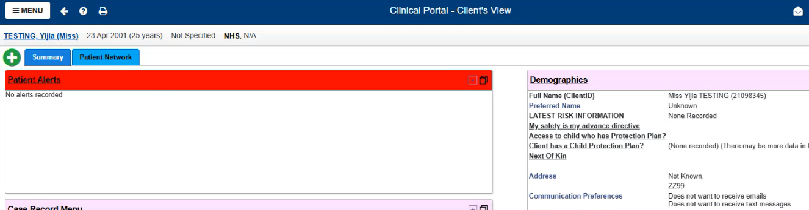
RiO – Communication Preferences under Demographics
⚠ IMPORTANT: Staff should check the patient's communication preferences before sending correspondence and ensure these remain accurate and up to date throughout the patient's clinical pathway.

Q. How do I check a patient's communication preference in EMIS?
A. A patient's communication preference in EMIS can be viewed within Patient Details and Notification Preferences. Both areas should be checked together to understand the patient's currently recorded preference.
Step 1 – Locate the patient
- Log into EMIS Web and select the Patient Find icon.
- Search for the patient using the appropriate patient identifiers.
- Select the correct patient from the search results and open their record.
Step 2 – Open Patient Details
- Once the patient's record has loaded, select the drop-down arrow on the blue patient information ribbon at the top of the screen.
- This will expand the patient's information.
- Select Edit patient details on the bottom right-hand side.
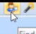
Step 3 – Check the Preferred Communication Method
- Within Patient Details, review the patient's contact information and ensure their details are accurate and up to date.
- Locate Preferred communication method.
- This field shows the patient's recorded preferred method of communication, for example: Email, or Letter to home address.
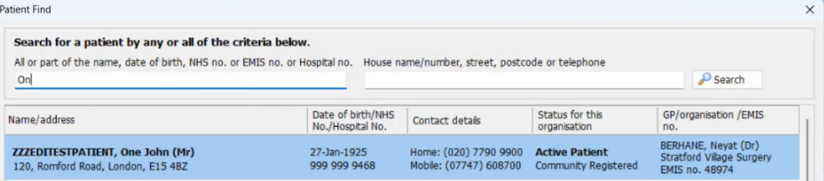
EMIS – Preferred communication method field
Step 4 – Check Notification Preferences
- From the menu on the left-hand side, select Notification preferences.
- Review the patient's Email and SMS notification preferences.
- These settings should be checked alongside the Preferred communication method to confirm the patient's overall communication preference.
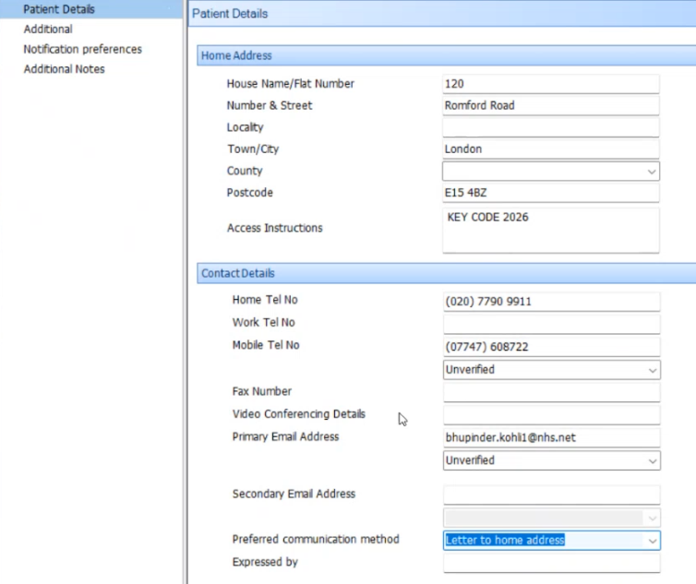
EMIS – Notification preferences screen
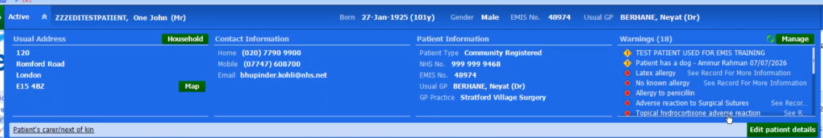
EMIS – Email and SMS notification options
★ KEY POINT: Check Both Areas. The Preferred communication method and Notification preferences should reflect the patient's recorded choice.

For the Hybrid Mail Digital Opt-Out process:
- Digital preference: Preferred communication method should be recorded as “Email address”, with both Email and SMS notification preferences set to "Yes".
- Postal preference / Digital Opt-Out: Preferred communication method should be recorded as Letter to home address. The relevant notification preference(s) should be set to "No" in line with the agreed opt-out process.
- If either Email or SMS is set to "No", this will result in the patient being treated as opted out of digital correspondence.
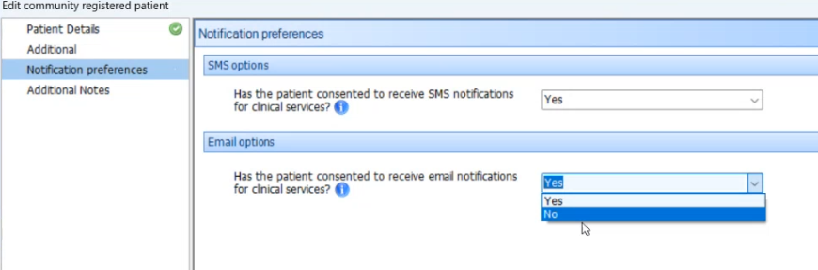
EMIS – Digital opt-out preference summary
⚠ IMPORTANT: If the information recorded across these areas does not match, the patient's preference should be confirmed and the EMIS record updated accordingly.

5. Safeguarding Alerts
Q. How do I view or add a patient safeguarding alert in EMIS?
A. Patient Warnings are separate from a patient’s communication preference and should not be used to record their Digital/Post choice.
Warnings should be checked as part of the wider clinical process as they may contain information affecting how or where correspondence can safely be sent.
If a warning conflicts with the recorded communication preference, the preference should be reviewed and updated where appropriate.
To view Patient Warnings:
- Log into EMIS Web and locate/open the relevant patient record.
- Once the patient record has loaded, the patient's blue information ribbon will appear at the top of the screen. (Patient Warnings will pop up automatically, if any, once you select a patient record.)
- Select the drop-down arrow on the blue ribbon to expand the patient's information.
- On the right-hand side, locate the Warnings section. This will display any warnings currently recorded against the patient.
- Review the existing warnings and check for any safeguarding or communication information that may affect how correspondence should be sent to the patient.
To add, edit or remove a Patient Warning:
- Select Manage next to the Warnings section.
- The Manage Patient Warnings screen will open, displaying the warnings currently recorded for the patient.
- From this screen, staff can: add a new warning, edit an existing warning, or delete a warning where appropriate.
- When adding or updating a warning, ensure the information recorded is clear and accurately reflects the patient's safeguarding or communication requirements.
- Save the changes once complete.
⚠ IMPORTANT: Patient Warnings should be reviewed alongside the patient's recorded communication preference. A safeguarding warning may contain additional instructions that affect whether correspondence can safely be sent digitally or by post, including restrictions relating to where patient correspondence should be sent.

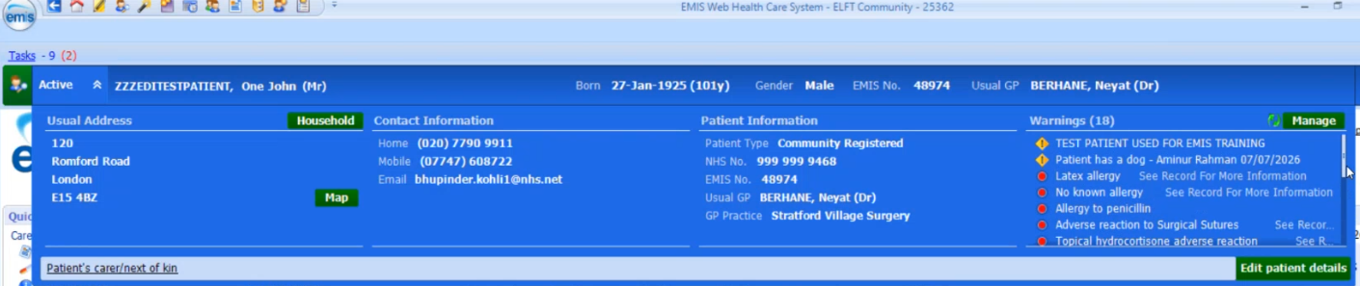
EMIS – Patient Warnings section
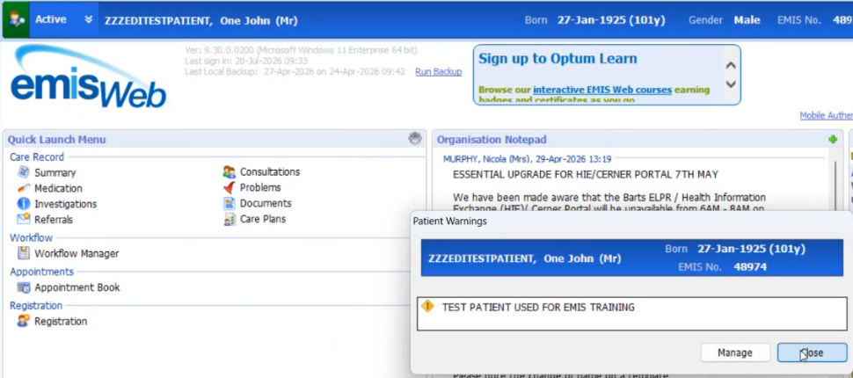
EMIS – Manage Patient Warnings screen
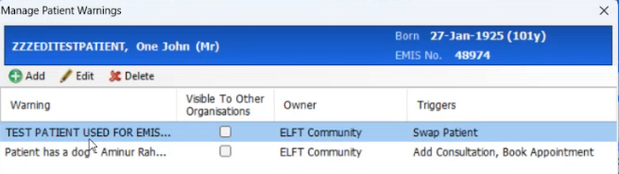
EMIS – Example recorded warning
Q. How do I view or add a patient safeguarding alert in RiO?
A. Patient Alerts are separate from a patient’s communication preference and should not be used to record their Digital/Post choice.
Alerts should be checked as part of the wider clinical process as they may contain information affecting how or where correspondence can safely be sent.
If an alert conflicts with the recorded communication preference, the preference should be reviewed and updated where appropriate.
To view Patient Alerts:
- Log into RiO and open the relevant patient record.
- On the patient record, locate Patient Alerts. This can be accessed by either: selecting the "Patient Alerts" hyperlink shown in red; or selecting the red warning triangle containing an "!" to access/view the patient's existing alerts.
- Review the alerts currently recorded for the patient and check for any information that may affect correspondence or communication with them.
To add a new Patient Alert:
- From the Patient Alerts screen, select the option to add a new alert.
- Select the appropriate Alert Type from the drop-down list. For example, where relevant, RiO includes the alert: "Do not send correspondence to home address."
- Enter the Alert Date and add any relevant information within the Comment field, where required.
- Ensure "This is a significant Alert" is ticked where the alert needs to be clearly highlighted on the patient's record.
- Select Save to record the alert.
⚠ IMPORTANT: Patient Alerts should be reviewed alongside the patient's recorded communication preference. Where an alert indicates that correspondence should not be sent to a particular address or by a particular method, staff should ensure this is considered before correspondence is issued.

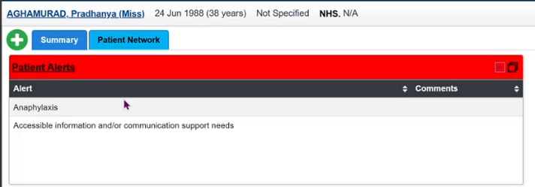
RiO – Patient Alerts hyperlink / warning triangle
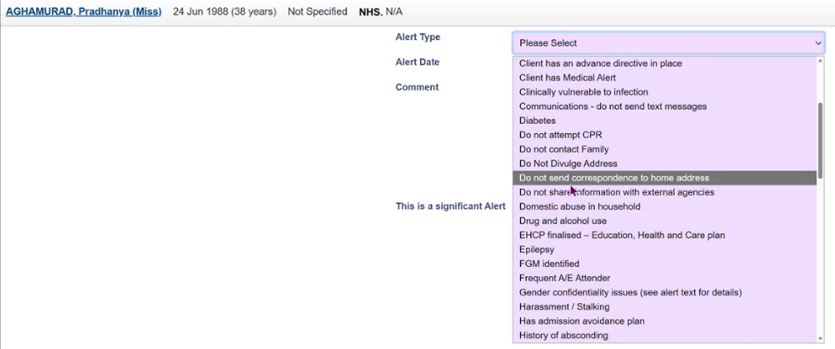
RiO – Add a new Patient Alert
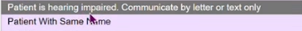
RiO – Example alert entry
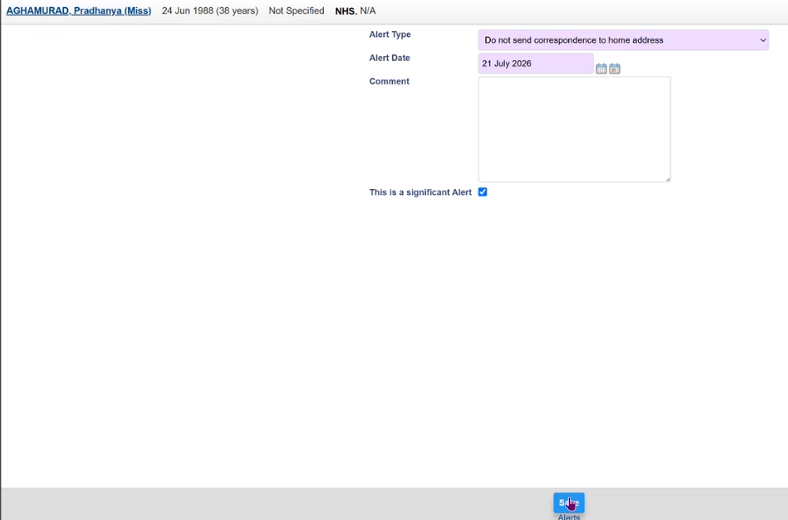
RiO – Alert Type drop-down list
RiO – Significant Alert confirmation
6. Next of Kin / Carer
Q. How do I add or view a Next of Kin or Carer in EMIS?
- A. Log into EMIS Web and locate/open the relevant patient record.
- Once the patient record has loaded, the patient's blue information ribbon will appear at the top of the screen.
- Select the 'Registration' icon at the top of the screen and select '3. Family Relationship Links' to view relationships such as carers or next of kin.
★ KEY POINT: The 'MC' to the left of the column indicates who the Main Carer is.

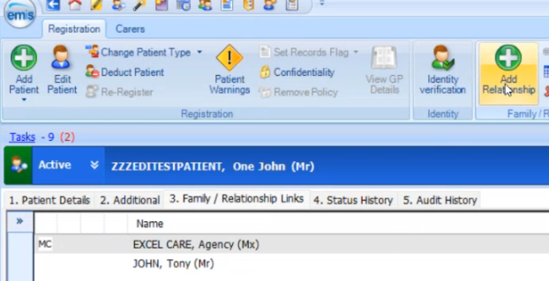
EMIS – Family Relationship Links screen
- To add a new Carer or Next of Kin, select the 'Add Relationship' icon. Complete the personal details of this relationship in full if you wish for them to be contactable on behalf of the patient, whether via email or post.
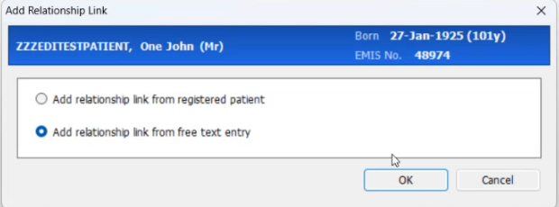
EMIS – Add Relationship screen
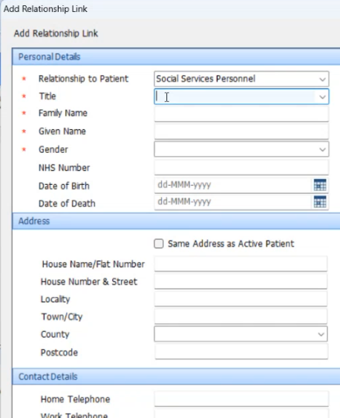
EMIS – Relationship details entry
Q. How do I add or view a Next of Kin or Carer in RiO?
- A. Log into RiO and open the relevant patient record.
- Select 'Full Name (ClientID)' under Demographics on the right-hand side.
- At the bottom of the screen select 'Client Personal Contacts' — here you can view current personal contacts or, if needed, 'Add New Contact'. Input the personal demographics of the contact including telephone/email/preferred method of communication and address in case of any future correspondence. Additionally, mark the carer as Rank 1 to be the main carer; use the arrow functions to reorder contacts.
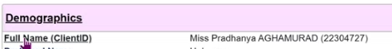
RiO – Client Personal Contacts
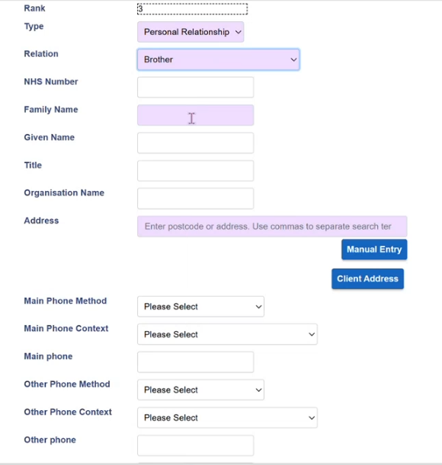
RiO – Add New Contact screen
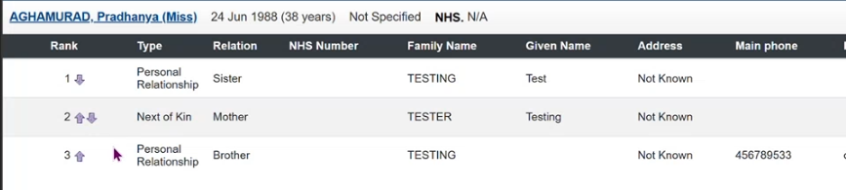
RiO – Contact rank and ordering
Q. How should I record a carer who is receiving an electronic copy of correspondence?
A. Where a carer is authorised to receive an electronic copy of the patient's correspondence, they should be clearly identified as a CCE recipient. The entry should make it clear who the individual is and their relationship to the patient.
★ KEY POINT: Example: CCE: Jane Smith (Patient's Carer) – jane.smith@email.com. This helps distinguish the carer from the main recipient and makes it clear that they are intended to receive an electronic copy of the correspondence.

Before including a carer, staff should ensure that:
- The carer is authorised to receive the patient's correspondence.
- The correct carer and contact details have been selected/recorded.
- The patient's relevant consent and information-sharing requirements have been followed.
- The carer is clearly identified as the CCE recipient rather than the main recipient or a postal CC recipient.
- The correspondence is appropriate to share with the carer.
⚠ IMPORTANT: Always check the patient's record for any relevant safeguarding alerts, communication preferences or restrictions before sending correspondence to another individual.

7. Hybrid Mail – Correctly Addressing CC, CCE Correspondence and GP via eCorrespondence
Q. Why does the format of the address matter for Hybrid Mail?
A. When creating correspondence for Hybrid Mail, it is important that the main recipient, CCE recipient and any CC postal recipients are clearly identified and formatted correctly.
⚠ IMPORTANT: Incorrectly adding additional addresses to a letter can cause Hybrid Mail to identify multiple addresses and may result in correspondence being sent incorrectly.

The guidance below explains how correspondence should be structured for the three most common scenarios.
Q. Scenario 1: Letter to GP with Patient CCE and CC Postal — when and how should this be used?
A. When should I use this? Use this format when:
- The GP is the main recipient of the letter.
- The patient is receiving an electronic copy (CCE).
- An additional person or organisation also needs to receive a postal copy (CC).
How should this appear? The GP should remain the main recipient of the correspondence. The patient electronic copy should be clearly identified using CCE. Any recipient who requires a physical/postal copy should be identified separately using CC: followed by their full postal address.
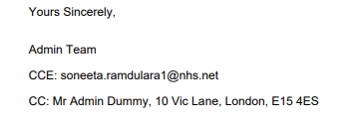
Example format – GP main recipient, patient CCE, CC postal
★ KEY POINT: CCE and CC are not interchangeable. CCE identifies an electronic copy recipient. CC should be used where an additional postal recipient/address needs to be included. Where CC: is used for a postal recipient, the relevant postal address must follow it.

Q. Scenario 2: Letter to Referrer with GP CC Postal — when and how should this be used?
A. When should I use this? Use this format when:
- The referrer is the main recipient of the letter; and
- The patient's GP also needs to receive a copy by post.
How should this appear? The referrer's details should remain the primary/main address for the letter.
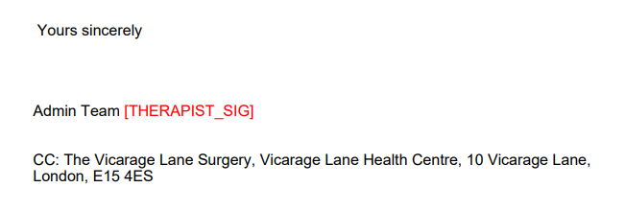
Example format – Referrer main recipient, GP CC postal
The GP postal copy should then be clearly identified separately using CC: followed by the GP Practice name and full postal address.
★ KEY POINT: Example: Main recipient: Referrer Name, Referrer Address. CC: The Vicarage Lane Surgery, Vicarage Lane Health Centre, 10 Vicarage Lane, London, E15 4ES.

⚠ IMPORTANT: Do not place the GP address into the main recipient/address area when the letter is intended for the referrer. The CC: clearly tells Hybrid Mail that the additional address relates to a copied recipient rather than replacing the main recipient.

Q. Scenario 3: Letter to Patient with GP CC — when and how should this be used?
A. When should I use this? Use this format when:
- The patient is the main recipient of the letter; and
- Their GP also needs to receive a copy.
How should this appear? The patient's details should remain the main recipient/address of the correspondence. The GP should then be clearly identified as the copied recipient. Where the GP is being copied using the GP details held within the system, this may appear as:
★ KEY POINT: CC: Dr [GP_NAME], Vicarage Lane Health Centre, 10 Vicarage Lane, London, E15 4ES

Q. Scenario 4: GP via eCorrespondence — what is the common mistake to avoid?
A. Where GP via eCorrespondence is being used as the letter code/routing instruction, do not automatically add "CC:" directly before "GP via eCorrespondence."
⚠ IMPORTANT: Common Issue: Additional text has been added after the letter code "GP via e-correspondence" within a template. This is incorrect and creates a risk of letters being sent to the wrong address, which constitutes an IG breach.

INCORRECT
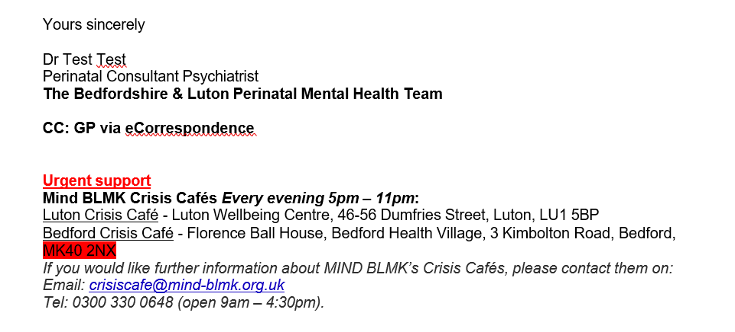
INCORRECT – CC: added before ‘GP via eCorrespondence’
If you're sending a letter to a 'GP via eCorrespondence', do not put the CC: before it (please refer to the screenshots). However, the screenshot above is relevant if you wish to CC a postal address — put 'CC:' before 'GP via eCorrespondence' and the address must follow.
CORRECT
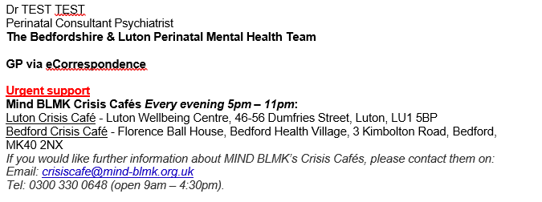
CORRECT – GP via eCorrespondence formatted correctly
Q. What does the "Multiple addresses detected" warning mean, and what should I do?
A. Hybrid Mail has a safety feature which attempts to identify when more than one postal address appears within a document. If Hybrid Mail identifies multiple addresses, you may receive a "Multiple addresses detected" warning.
Option 1 – When using Hybrid Mail via Quick Post
'Multiple addresses detected' pop-up – this is a safety feature to inform the user that multiple addresses have been detected when sending a letter via Quick Post.
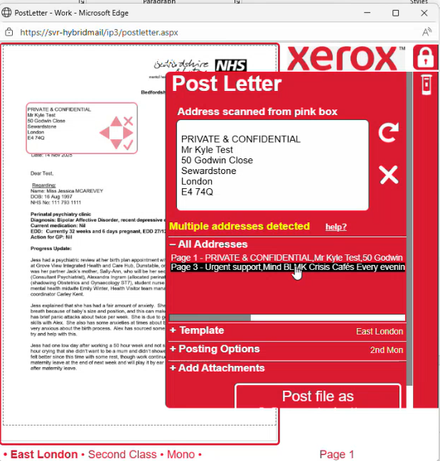
‘Multiple addresses detected’ pop-up (Quick Post)
Review the letter and confirm:
- Who is the main recipient?
- Is another address intentionally included as a CC postal recipient?
- Has CC: been used correctly?
- Is an address appearing elsewhere in the letter that Hybrid Mail may incorrectly interpret as a recipient address?
⚠ IMPORTANT: Only continue once you are satisfied that the correct recipient/address has been identified.

Option 2 – Printing a letter via the Print Client
When sending through: File → Print → Hybrid Mail, the Print Client may also identify additional addresses. Where multiple addresses are detected, the system can provide options to:
- Split the letter where it contains correspondence for different recipients; or
- Confirm that the letter is for a single recipient.
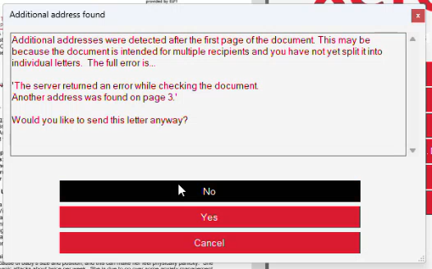
Print Client – multiple address options
⚠ IMPORTANT: Always review the warning and the document before selecting the appropriate option.

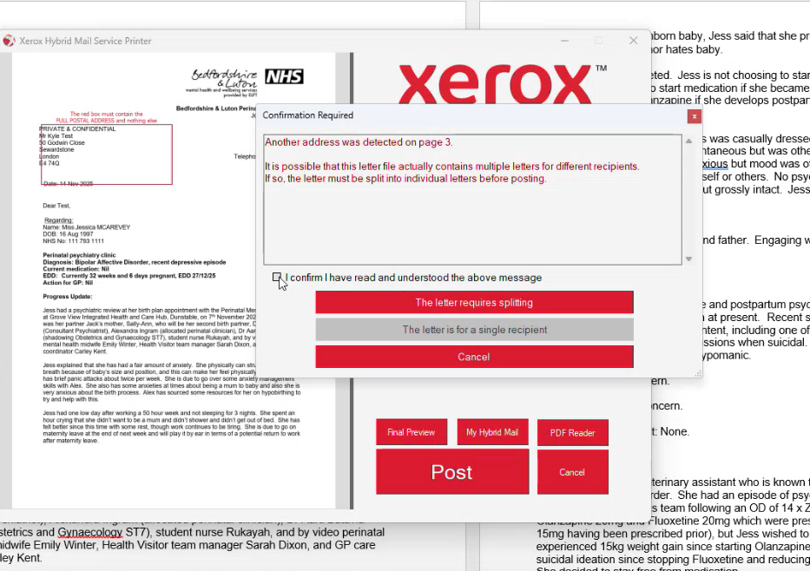
Print Client – example warning screen (1)
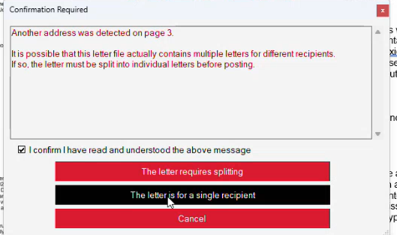
Print Client – example warning screen (2)

8. Hybrid Mail – Correctly Addressing CCE Process in more detail:
What is CCE?
CCE (Carbon Copy Electronic) is used when an electronic copy of a letter needs to be sent to an additional recipient, such as a patient, carer or referrer.
CCE can be used across all letter templates where an electronic copy of the correspondence needs to be sent to an appropriate recipient, such as a patient, carer or referrer.
The CCE details can be manually typed into the letter using the following format:
CCE: <carer email address>; <carer mobile number>
CCE: <patient email address>;<patient mobile number>
CCE: <referrer email address>;<patient mobile number>
Example:
Carer:
CCE: jane.smith@example.com; 07700 900123
Patient:
CCE: john.smith@example.com; 07700 900456
Referrer:
CCE: sarah.jones@example.com; 07700 900789
Important
Always include a semicolon ( ; ) between the email address and mobile number. This is required as part of the CCE format.
Before sending the correspondence, ensure the correct recipient email address and mobile number have been entered and check the details against the patient's record.
Opt out from Digital – functionality from Opt-out from digital using lookup CSV file. The name of the csv file used is in particular link is D:\HM_OptOut_MPI\HybridMail_OptOut.csv. Ignore the white text code when the new digital system Opt Out is switched live.
If CC: or CCE present in the letter, then send to the postal address or email address following the CC: or CCE coding.

9. Hybrid Mail – Rejection Process:
If a letter cannot be delivered digitally because the patient's email address or mobile number is invalid, Hybrid Mail will automatically move the correspondence to the Rejected Mail queue.
What happens next?
There is no need to resend the letter manually. Hybrid Mail will automatically redirect the rejected digital correspondence to Print & Post on the following day:
- First Class: Rejected items are processed at approximately 11:45am, before the standard 12:00pm First Class run.
- Second Class: Rejected items are processed at approximately 5:45pm, before the standard Second Class run.
How does the process work?
Hybrid Mail automatically:
- Identifies correspondence that could not be delivered digitally due to an invalid email address or mobile number.
- Redirects the rejected item from Digital to Print & Post.
- Adds a tracking field to show that the letter has been redirected.
- Produces a daily report listing the items that have been redirected to Print & Post.
Important
Although the letter is automatically redirected to post, staff should ensure that any invalid email address or mobile number is reviewed and updated within the patient's EPR where appropriate. This helps improve data quality and reduces future digital delivery failures.
9. Hybrid Mail – Do Not Send to Patient Process:
There may be occasions where a clinician determines that a specific piece of correspondence should not be sent to the patient, regardless of the patient's recorded communication preference.
What should I do?
When submitting this type of correspondence through Hybrid Mail, select the:
“DO NOT SEND TO PATIENT” template
This tells Hybrid Mail that the correspondence must not be sent to the patient.

What happens to the letter?
Hybrid Mail will:
- Recognise the Do Not Send to Patient template.
- Prevent that specific letter from being emailed to the patient, regardless of their recorded communication preference.
- Send the correspondence by post to the primary recipient/address displayed at the top of the letter only.
- Apply this rule irrespective of whether the patient's NHS Number appears elsewhere within the letter.
Example
This may be required where correspondence is intended from one healthcare professional/clinician to another and the clinician has determined that the specific letter should not be sent to the patient.
Important
The Do Not Send to Patient template applies to the specific correspondence being processed. It does not change the patient's overall communication preference.
Always ensure the correct primary recipient and address are displayed at the top of the letter before submitting it through Hybrid Mail.

