Deteriorating Patient (Physical Health) Policy

Version Number | 1.0
Consultation Groups | Physical Health Committee 17th July and Resuscitation Committee 21st July 2026
Approved By (Sponsor Group) | Trust Physical Health group
Date Approved | 17 July 2026
Ratified By | Quality Committee
Date Ratified | 02 September 2026
Name of Originator/Author | Lead Nurse Practice Education
Executive Director Lead | Ruth Bradley
Implementation Date | August 2026
Last Review Date | June 2026
Next Review Date: | August 2029

Services | Applicable
Trustwide | X
Mental Health and LD
Community Health Services

Version Control Summary
Version | Date | Author | Status | Comment
1 | July 2026 | Lead Nurse Practice Education /Trust Lead Physical Health Amended | Approved | The new policy reflects evidenced practice aligned with NEWS2, the ABCDE approach, neurological assessment principles, stroke recognition, delirium assessment and medication-related neurological emergencies, and includes a neurological escalation pathway, appendices, governance structure, monitoring framework and clinical escalation standards.

Executive Summary
This policy sets out East London NHS Foundation Trust’s (ELFT) requirements for the early recognition, assessment and escalation of physical deterioration in patients and service users. It establishes a consistent Trust-wide approach to monitoring physical health, using recognised tools such as NEWS2 and MEWS alongside professional clinical judgement.
The policy supports the early identification of deterioration to enable timely intervention, reduce avoidable harm, and improve patient safety and outcomes. It applies to all clinical staff involved in the assessment, monitoring and management of deteriorating patients across Trust services and outlines their responsibilities for escalation, documentation and emergency response.
Through implementation of this policy, ELFT aims to ensure safe, effective and equitable care, compliance with national guidance and regulatory standards, and a culture in which concerns about deterioration are recognised and acted upon promptly.

Table of Contents

Paragraph |  | Page
 | Introduction | 5
 | Purpose | 5
 | Scope | 6
 | Duties and Responsibilities | 7
 | Recognition and Assessment  5.1 Baseline Observations  5.2 NEWS2  5.3 Medical Assistance  5.4 Medical Emergency  5.5 Maternity Early Warning System (MEWS)  5.6 ABCDE Assessment  5.7 Non-contact Observations  5.8 Documentation  5.9 Mental Capacity | 8  8  8  9  10  10  11  12  12
 | Sepsis  6.1 Blood Investigations  6.2 Darker Skin Tones  6.3 Soft Signs  6.4 Delirium  6.5 Neurological Deterioration, Assessment and Escalation  6.6 Medication-Related and Substance-Related Causes of  Neurological Deterioration | 12  13  13  14  14  15  15
 | 7.7 Neurological Assessment Framework  7.1 Level of Consciousness  7.2 Glasgow Coma Scale (GCS)  7.3 Pupil Assessment  7.4 Motor Function  7.5 Cranial Nerve Assessment  7.6 Documentation Requirements | 16  16  16  17  17  17  17
 | Management and Escalation of The Deteriorating Patient or Service User  8.1 Immediate Clinical Response  8.2 Escalation Pathway  8.3 Emergency Escalation  8.4 Supportive Clinical Management  8.5 Ongoing Monitoring and Communication  8.6 Transfer and Safety-Netting | 17  17  17  17  17  18  19  19
 | Training | 20
 | Monitoring, Audit and Learning | 20
 | References | 21
12.0 Appendices

Appendix 1 | NEWS2 Observation Chart | 22
Appendix 2 | NEWS2 Physiological Parameters | 23
Appendix 3 | NEWS2 Clinical Response | 23
Appendix 4 | MEWS Observation Chart | 24
Appendix 5 | MEWS Physiological Parameters & Clinical Response | 25
Appendix 6 | SBARD | 26
Appendix 7 | FAST Assessment for Suspected Stroke | 27
Appendix 8 | Neurological Deterioration – Escalation Flow | 29
Appendix 9 | Seizure Management Flowchart | 30
Appendix 10 | Neurological Observation Assessment Chart | 31
Appendix 11 | Definitions | 33
 | Equality Impact Assessment | 34
1.0 Introduction
Recognising when a patient’s physical health condition is deteriorating is a key aspect of patient safety. Use of early warning scoring tools are integral to this, and it is vital that these are used to identify early signs of deterioration allowing for escalation and prompt treatment.
The National Institute for Clinical Excellence (NICE) identify those patients who become acutely unwell in hospital may receive suboptimal care which may be due to the fact that their deterioration is not recognised, not appreciated or not acted upon with sufficient rapidity¹. To help prevent this, physiological track and trigger systems (NEWS2 and MEWS) are recommended for use in both the monitoring of patients and also in those whose physical health is deteriorating. These tools should be used in conjunction with a full clinical assessment which should be carried out by an appropriately qualified and skilled clinical practitioner.
The goal is to prevent harm, to reduce the incidence of cardiac arrest and to reduce mortality rates through early recognition and treatment as evidence shows that patient deterioration or cardiac arrest are often preceded by physiological abnormalities which are potentially treatable.^{2,3}Patients presenting with chest pain suggestive of acute coronary syndrome, new arrhythmia, syncope, or unexplained cardiovascular instability should receive urgent clinical assessment and emergency transfer where appropriate.
Early warning scores support but do not replace clinical judgement. Staff must escalate concerns whenever they believe a patient/service user is deteriorating, regardless of NEWS2 or MEWS score.
The Trust is committed to ensuring that all patients/service users receive equitable, safe and timely assessment and escalation of deterioration irrespective of age, disability, ethnicity, communication need, mental health status or protected characteristic.

2.0 Purpose
The purpose of this policy is to ensure that all staff involved in the measuring of, recording of and responding to vital signs observations are aware of how to recognise patient/service user deterioration and how to escalate concerns regarding a deterioration in physical health.
This Trust uses a standardised Trust-wide approach to the recognition, assessment and escalation of physical deterioration
- Support early intervention and timely escalation to reduce avoidable harm
- Promote safe, effective and person-centred care
- Ensure staff understand their responsibilities regarding NEWS2/MEWS monitoring and escalation
- Support compliance with NICE guidance, NHS England NEWS2 guidance, CQC Regulation 12 and professional standards
- Promote equitable assessment and reasonable adjustments for patients/service users who may present atypically or experience barriers to care.
- Patients, carers and families should be encouraged to raise concerns where they believe a patient/service user’s condition is deteriorating. Staff should respond promptly and appropriately to concerns raised. This aligns with NHS England’s Martha’s Rule patient safety initiative.
This policy is not appropriate for use with patients/service users where a multi-disciplinary decision has been made and documented, not to escalate treatment, or for those who are on an end of life or palliative care pathway. This decision must be documented in the notes with the relevant DNACPR forms completed and the treatment plan also documented in the patients notes. Where treatment limitations or ceilings of care have been agreed, these should be clearly documented and reviewed regularly. A DNACPR decision does not mean other active treatment should be withheld.

3.0 Scope
This policy applies to all permanent, temporary, bank, agency and honorary clinical staff employed by ELFT who are involved in the assessment, monitoring, escalation or treatment of deteriorating patients/service users.
This policy applies across all inpatient, community, crisis, rehabilitation, learning disability and specialist forensic services. This policy applies to adults aged 16 years and over, including pregnant and recently pregnant patients/service users.
The policy is intended for use in both clinical inpatient settings as well as in community settings i.e., in a patients’ own home or place of residence.
The policy also applies to those patients/service users who are pregnant. This policy should be used alongside local emergency response procedures, resuscitation guidance and clinical escalation pathways.
Professional interpreters, translation services and accessible communication methods (including Easy Read, hearing support and communication aids) must be used where required to support safe assessment and escalation. Family members should not routinely be used as interpreters except in emergency situations. Consider the use of hospital passports, health action plans, communication passports and carer input when assessing deterioration.
This policy does not apply to children and young people under the age of 16 years. Staff caring for patients under 16 must refer to the relevant children's deterioration policy and escalation procedures.
This policy should be used in conjunction with other relevant Trust policies and guidelines including:
- Dignity in Care at the End-of-Life Policy
- Physical Health Policy
- Rapid Tranquilisation Policy
- Resuscitation Policy
- Sepsis Policy
- Transfer Policy (For mental health patients detained under the Mental Health Act, please see local policy)
- Mental Capacity Policy
- In-Patient Alcohol Detoxification Guidelines
- Venous Thromboembolism Policy

4.0 Duties and Responsibilities
Role | Responsibilities
Chief Executive | The Chief Executive has overall responsibility for ensuring that all Trust policies comply with legal, statutory and good practice requirements
Directors of Nursing/Medical Director/Clinical Directors | Ensuring governance, patient safety and assurance systems in place  Ensuring that this guidance is disseminated to all clinical staff  Ensuring that all relevant staff access education as per the training and support requirements of this policy
Clinical Leads/Lead Nurses | Ensuring that any relevant resources needed to support the implementation of this policy are secured  Ensuring that all staff within their areas comply with the policy  Ensuring that all staff within their areas have undertaken relevant training.  Undertake neurological observations (including AVCPU, GCS, pupil assessment and limb assessment) where clinically indicated, provided they have completed the required Trust training and competency assessment.
Ward Managers/Team Leaders | Ensuring that they and their staff are made aware of their responsibilities under this policy and other relevant and associated policies  Ensuring that all staff within their areas have undertaken relevant training  Ensuring that all staff within their areas (including students and bank/agency staff are aware of the procedure to be undertaken when recognising or caring for a deteriorating patient.  Ensure local escalation pathways and emergency contact numbers are available to staff.  Monitor compliance with training, NEWS2 completion and escalation procedures
Clinicians and Registered Nurses | Ensuring that they are aware of their responsibilities under this policy and other relevant and associated policies  Respond to all NEWS2 or MEOWS scores, prioritising those which trigger escalations and may indicate a patient is deteriorating  Ensuring a prompt medical or senior nursing review where there is concern that a patient’s condition may be deteriorating  Ensure that they are up to date with all relevant training,  Ensure all assessments, escalation decisions, interventions and reviews are documented contemporaneously within the electronic patient record.  Escalate concerns regarding deterioration regardless of NEWS2 score where clinical concern exists.  Take concerns raised by carers, families or advocates seriously and escalate appropriately.  Consider Mental Capacity Act principles where a patient/service user refuses assessment, treatment or transfer.  Neurological deterioration: Registered Mental Health Nurses (RMNs) and Registered Physical Health Nurses (RPHNs) are responsible for recognising signs of neurological deterioration, undertaking an immediate ABCDE assessment and recording observations within their scope of practice, including NEWS2, AVCPU and other neurological observations for which they have been trained and deemed competent. Any concerns must be escalated promptly to the medical team using the Trust escalation process.  Junior medical staff are responsible for undertaking a comprehensive neurological assessment where indicated, determining the frequency and duration of ongoing neurological observations, documenting the management plan and escalating to senior medical staff where clinically required.
Health Care Support Workers | Ensuring that they are aware of their responsibilities under this policy and other relevant and associated policies  Utilising the NEWS2 or MEOWS assessment tool to recognise that a patient or service users’ condition has deteriorated  Ensuring escalation to support prompt review by a registered practitioner
The assessment and management of deteriorating patients may require joint working between mental health, community and acute healthcare teams. Clinical responsibility should be clearly communicated during referral, transfer and handover.

5.0 Recognition and Assessment

5.1 Baseline Observations
An initial baseline assessment of physical health vital signs should be undertaken in line with the Standard Operating Procedures (SOP)/policies for each of the relevant services. This should be done at the time of initial assessment or on admission to an inpatient area and should be repeated where clinically indicated or where it has been identified as part of the treatment plan. Observation frequency should be decided upon by the registered practitioner and the multidisciplinary team where relevant, depending on the patient/service user’s diagnosis, their condition, the agreed treatment plan, the type of medications prescribed and the risk of change to the patient/service users vital signs.
Observation frequency must be clearly documented within the care plan or clinical record and reviewed following any deterioration, intervention or escalation. Where physiological observations cannot be completed, the reason must be documented and escalated to the nurse in charge or senior clinician. Staff should consider any significant change from the patient's usual physical, cognitive or behavioural baseline as a potential indicator of deterioration and undertake an appropriate physical health assessment. Assessment should be adapted to the patient's communication, cognitive and support needs, including the use of reasonable adjustments where required. Information from carers, communication passports, hospital passports and other supporting documentation should be considered where available.

5.2 NEWS2 (Refer to Appendices 1, 2 & 3)

Clinical judgement and concerns about the patient’s condition should override the NEWS2 if a healthcare professional feels that it is necessary to escalate. (RCP, 2017)

The NEWS2 assessment can be accessed via RIO, EMIS or System One and consists of seven parameters (six physiological parameters and a weighted score for supplemental oxygen). The physiological parameters routinely recorded are:
- Respiratory rate (RR)
- Oxygen saturation (SpO2)
- Systolic Blood Pressure (BP)
- Heart Rate (HR)
- Consciousness (utilising ACVPU A=Alert, C=new Confusion, V=Voice, P=Pain, U=Unconscious)
- Temperature (T)
A weighted score of 2 is added for any patient who is receiving supplemental oxygen.
Once all of the vital signs have been recorded, a score is allocated to each parameter (Appendix 1) and the score is aggregated to generate a response. The NEWS2 score should be recorded within the relevant documentation used by their service. NEWS2 must be used alongside clinical judgement. A patient may be clinically deteriorating even when their NEWS2 score does not meet an escalation threshold. Staff should escalate concerns based on the patient's overall clinical presentation and any significant change from their usual baseline

5.3 Medical Assistance
Any concerns regarding a patient/service user's physical health must be escalated immediately to the registered nurse responsible for their care. The registered nurse must undertake a clinical assessment, ensure a NEWS2 assessment has been completed where appropriate, and escalate in accordance with the Trust NEWS2 Clinical Escalation Flowchart (Appendix 3). All assessments, NEWS2 scores, clinical decisions and escalation must be documented contemporaneously in RiO, EMIS or SystmOne. Clinical judgement must always take precedence over NEWS2. Staff must escalate concerns whenever they believe a patient/service user is deteriorating, regardless of the NEWS2 score.
The following escalation principles apply:
- NEWS2 score 1–4: Inform the registered nurse, who must assess the patient/service user and determine the frequency of observations, whether medical review is required, and whether escalation is necessary. Enhanced observation, including one-to-one observation where clinically indicated, should continue until assessment has been completed and an appropriate management plan is in place.
- NEWS2 score of 5 or above, or a score of 3 in any individual parameter: Urgent review by an appropriately registered and skilled clinician is required.
- NEWS2 score of 7 or above: Emergency clinical review is required with consideration of immediate transfer to acute medical services in accordance with the Trust escalation pathway. Where there is concern that a patient/service user is experiencing acute deterioration or a medical emergency, staff must immediately activate the Trust Medical Emergencies protocol and contact the Duty Doctor and Duty Senior Nurse (DSN) without delay.
If an appropriately registered and skilled clinician is unavailable, or the response is delayed, concerns must be escalated through the next appropriate level of seniority, which may include the Duty Senior Nurse, on-call consultant, GP, NHS 111, ambulance service or emergency department, according to the patient's clinical condition. Escalation must never be delayed while awaiting review if there is concern about ongoing deterioration.

5.4 Medical Emergency
Immediately follow your local protocol for the Management of Medical Emergencies in the following circumstances:
- The NEWS2 Total score is 7 or more
- Respirations are noisy, shallow or less than 8 breaths per minute
- The level of consciousness as assessed by the NEWS2 indicated the person is unresponsive, (also commonly referred to as unconscious) and service user does not make any eye, voice or motor response to voice or pain.
- The service user is experiencing a seizure
- Initiate continuous monitoring of vital signs
- Consider action to improve the patient’s physical condition such as positioning and oxygen
- Registered nurse to stay with the patient
- Response team including the Dr to prepare for medical emergency
- Call an ambulance 999 or 2222 (City and Hackney centre for mental health only.

5.5 Maternity Early Warning System (MEWS) (Refer to Appendix 4)

NEWS2 is not designed for use in patients/service users who are pregnant, because the physiological response to acute illness can be modified in pregnancy and in the post-partum period (6 weeks after giving birth)

The Trust supports the use of the Maternity Early Warning System (MEWS) to help in the timely recognition, treatment and referral of women who have or are developing an acute illness. As with NEWS2, MEWS should be used as an aid to clinical assessment, not as a substitute for competent clinical judgement. Any concern about a patients/service user’s clinical condition should prompt an urgent review, irrespective of the MEWS score. Staff should seek additional advice from the Perinatal Service, the ward medical team, or the Duty Doctor about physical health monitoring of pregnant patients/service users and if they are concerned that the physical health condition is deteriorating.
Pregnant or recently pregnant patients/service users may deteriorate rapidly and present atypically. Staff should maintain a high index of suspicion where clinical concern exists.
Please see below re non-contact observations for Recording in patient records. Non-contact observations must not replace full physiological observations where these can be safely undertaken. Non-contact observations do not replace full physical assessment and should only be used temporarily until standard observations can safely be obtained.”
Where a patient/service user refuses observations, staff must consider underlying physical health causes, mental capacity, risks associated with non-assessment and whether escalation is required.

5.6 ABCDE
If the patient is deteriorating and a more comprehensive assessment is required, the ABCDE model of assessment should be used to give a rapid, initial assessment of the patient’s condition which will involve assessing the following:
A - Airway | Check the patency of the airway and assess for signs of obstruction  Is the airway clear or is it obstructed?  If the airway is obstructed, is it a full or partial obstruction? Can air pass through? Can the obstruction be removed?
B – Breathing | Check the respiratory rate, depth and rhythm  What are the saturations?  Is the chest rising and falling equally?  Is the patient using their accessory muscles to breathe?
C – Circulation | Check the patient’s heart rate. Is it fast or slow? Is it regular or irregular? Does it feel bounding or thready?  Check the blood pressure.  Check capillary refill time.  Assess urine output and hydration status where clinically appropriate, as reduced urine output may indicate dehydration, sepsis, shock or acute kidney injury.  Consider blood investigations where clinically indicated, particularly in suspected sepsis, dehydration, acute kidney injury, medication toxicity or metabolic disturbance
D – Disability | Check level of consciousness using ACVPU  Check blood glucose level  Check pupil reaction to light stimulus  Can the patient move all limbs with equal strength and power?
E – Exposure | Check the patient’s body to assess for wounds, oedema, discolouration, fractures etc. Check body temperature
The ABCDE assessment should be repeated following any intervention or deterioration in condition

5.7 Non-contact Observations

Non-contact vital signs do not rely on the consent or cooperation of the patient/service user and can be safely carried out by visual observation from a distance greater than arm’s length. They should be used in situations where contact vital signs are not possible either because the patient/service user does not consent or because it is not felt safe to get close enough to the patient/service user to carry them out. They must also be carried out and recorded every 15 minutes after the administration of rapid tranquilisation or if there is a significant risk of violence.
At the minimum, non-contact vital signs should consist of monitoring, measuring and recording of respiratory rate, level of consciousness (using ACVPU) and hydration. However, there are other observations which can be made that may indicate a patient’s condition is deteriorating, including but not limited to:
- Listening for abnormal airway sounds
- Observing for chest expansion during breathing
- Observing for use of accessory muscles
- Listening for additional breath sounds
- Observing for pallor, cyanosis or flushed skin (see 6.2 for advice regarding patients/service users with darker skin tones)
- Observing for excessive sweating
- Observing for dystonia or an inability to mobilise
- Wounds or breaks to the skin
- Unexpected or offensive smells

Particular attention should be paid to airway compromise, respiratory depression, over-sedation airway obstruction and aspiration risk and reduced consciousness following rapid tranquillisation as key complications requiring immediate escalation.

5.8 Documentation
The following must be documented contemporaneously within the electronic patient record:
- Vital signs and NEWS2/MEWS score
- Clinical concerns and assessment findings
- Escalation actions taken
- Time senior clinician contacted
- Advice received
- Interventions commenced
- Response to treatment/intervention
- Discussions with family/carers
- Mental capacity assessments where relevant
- Transfer arrangements
- Rationale for non-escalation where applicable
- Time of symptom onset or last known well time (for suspected stroke) must always be documented
NEWS2 limitations can occur in some patient groups and should always be interpreted alongside clinical assessment and judgement.
- This is important for: learning disability, autism, frailty, chronic respiratory disease, neurological conditions and baseline abnormal physiology.
- Patients/service users with learning disabilities, autism, cognitive impairment or communication needs may present atypically when unwell. Staff must consider behavioural change, withdrawal or distress as potential indicators of deterioration. Reasonable adjustments must be made where required and appropriate
- Frailty may increase the risk of deterioration, atypical presentation and poorer outcomes. Staff should consider frailty when assessing deterioration, particularly in older adults.
- Restrictive interventions should be minimised wherever possible. Physical deterioration should not be assumed to be behavioural in origin without appropriate assessment.
- The service users care plan must be reviewed and a joint decision between the assessing doctor and the nursing team reached about the continuing management plan, frequency of monitoring arrangements and whether an ambulance should be called. This plan must be documented in the service users RiO progress notes.

5.9 Mental Capacity
Where a patient/service user refuses assessment, treatment or escalation, staff must consider the Mental Capacity Act (2005) and complete a mental capacity assessment where appropriate.
Where a patient/service user lacks capacity, decisions must be made in their best interests in line with Trust policy and legal frameworks. This needs to be considered on refusal of observations, refusal of transfer, fluctuating capacity and best interests’ decisions as required and appropriate. Where patients are detained under the Mental Health Act, staff should refer to local MHA transfer procedures.

6.0 Sepsis
It is important that staff are encouraged to ‘Think Sepsis’ in any deteriorating patient who has a confirmed or suspected infection, as successful management of sepsis relies on the early recognition of the signs and symptoms. This policy should be used in conjunction with the Trust’s Sepsis Policy.
In acute mental health settings, staff should observe for the following;
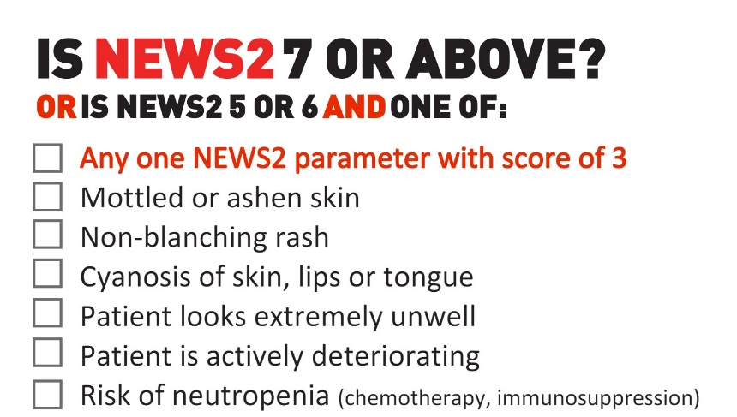

In community health settings and in pregnancy or up to 4 weeks post-partum, staff should observe for the following:
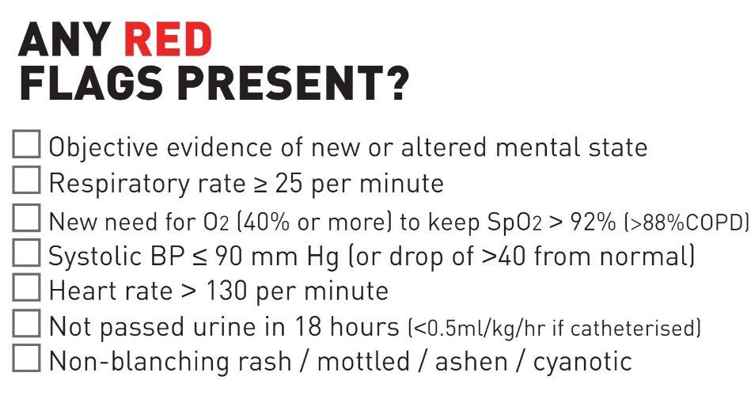

6.1 Blood Investigations
Blood investigations may support the assessment and management of a deteriorating patient/service user and should be considered alongside clinical assessment, NEWS2/ME0WS scores and the ABCDE approach. The need for blood tests should be determined by the clinical presentation and advice from the reviewing clinician. Examples may include:
- Full Blood Count (FBC)
- Urea and Electrolytes (U&Es)
- Liver Function Tests (LFTs)
- C-Reactive Protein (CRP)
- Blood cultures (where sepsis is suspected and local protocols permit)
- Venous or arterial blood gas analysis where clinically indicated
- Blood glucose testing
- Medication-specific monitoring (e.g., lithium levels, clozapine monitoring)
- Consider acute kidney injury in patients with dehydration, sepsis, reduced oral intake, hypotension or reduced urine output.
Blood investigations should not delay escalation, transfer or emergency treatment where urgent medical intervention is required. Where blood tests are requested, the time samples were taken, results received and actions taken must be documented in the clinical record. If blood samples cannot be obtained and there is ongoing concern regarding deterioration, this must be escalated to the responsible clinician and documented appropriately’

6.2 Darker Skin Tones
Extra care should be taken when assessing patients/service users with darker skin tones as some of the most common changes to the skin i.e., pallor, cyanosis, jaundice, redness/erythema are not as easy to distinguish as in those patients with lighter skin tones⁵.
Patients/service users must be assessed in areas with appropriate lighting i.e., ambient or natural lighting and health care professionals should look for areas of skin which may be showing a change in colour to the rest of the skin. It is important to note that in people who have darker skins tones: -
- inflammation or erythema, may appear as hyperpigmentation or the skin in the affected area may be slightly to significantly darker than the surrounding skin
- cyanosis in the lips, tongue and mucous membranes may appear as greyish or white whereas the palms, nail beds, soles of the feet and conjunctiva may have a bluish tinge
- pallor may present as paleness or greyness in the conjunctiva and mucosa around the mouth. In people with brown skin, the skin may appear yellow-brown and in those with dark brown or black skin, the skin may appear ash grey
- the blanching response is rare. Check paler areas such as the palms of the hands, soles of the feet, mucous membranes or conjunctiva for erythema, rash or mottled skin
As well as assessing for changes in colour of the skin, the skin can be assessed for changes in localised temperature, pain/discomfort or induration (texture).

6.3 Soft Signs
Some patients/service users may exhibit ‘soft signs’ of deterioration before the more overt signs become obvious. Understanding and identifying these, can help to support early recognition of deterioration for people in community settings, i.e., community-based patients/service users who are in their own homes, service users living in nursing or residential care home or patients/service users with learning disabilities⁶.
It is important to understand what is usual for the person. Often families, friends and carers will pick up on changes in a person’s behaviour, manner or appearance and this may be an early indicator that the person is becoming unwell. It is therefore very important to take these concerns seriously, even if the patient/service user looks well to you.
Soft signs will be different for different people and may depend on the person and the way that they usually are. Examples of ‘soft signs may include:
- New or increased confusion, agitation, anxiety or pain
- Changes to usual level of alertness or consciousness
- Sleeping more or less, or extreme tiredness or dizziness
- Increased breathlessness, chestiness or a cough or sputum production
- Change in usual drinking or dietary habits
- Can’t urinate, no urine, a change in the appearance of the urine or excessive urinating (polyuria) or excessive urinating at night (nocturia)
- Diarrhoea, vomiting or dehydration
- Reduced mobility – ‘off their legs’, less co-ordinated or experiencing muscle pain.
If you or the patient/services user’s friends, family or carers answer yes to one of more of these triggers, then undertake a set of vital signs, calculate the NEWS 2 score and escalate your concerns to a senior clinician.

6.4 Delirium
New onset of confusion is a sign of potential for clinical deterioration in patients/service users, especially those in whom sepsis is suspected or confirmed. This is considered of such importance, that new confusion results in a score of 3 on the NEWS2 tool identifying that the patient should be assessed as a matter of urgency. Delirium can often be missed and is associated with increased mortality, reduction in independence and cognitive decline particularly in elderly patients. Delirium screening tools such as the 4AT may be considered where clinically appropriate. Older adults and patients/service users with dementia, frailty or cognitive impairment are at increased risk of delirium and deterioration. Assessment may include blood glucose, FBC, U&Es, CRP, liver function tests and other investigations as clinically indicated as below. If a patient/service user is showing signs of new confusion or delirium, then they must be assessed for a physical health cause, which may include (but is not limited to):
- An infection or sepsis
- Hypoxia (low oxygen levels)
- Dehydration
- Constipation
- Renal (kidney) or hepatic (liver) impairment
- Side effects of medication
- Brain injury
- Hypoglycaemia
- Hyperglycaemia
- Diabetic ketoacidosis (DKA)
- Hyperosmolar Hyperglycaemic State (HHS)

6.5 Neurological Deterioration, Assessment and Escalation

Purpose
Neurological deterioration is a medical emergency requiring prompt recognition, assessment and escalation. Patients receiving mental health care may develop acute neurological illness, medication-related complications, or neurological manifestations of physical illness. Early recognition and timely intervention are essential to reduce avoidable harm, disability and mortality. This section defines the minimum standards for neurological assessment and documentation for all adult inpatient mental health services within ELFT.
Principles
Neurological deterioration must be considered where there is any acute change in:
• Level of consciousness or responsiveness
• Cognition or behaviour
• Motor or sensory function
• Speech, vision or coordination
• Sudden headache or collapse
• Suspected neurological event (e.g., stroke, seizure, TIA, head injury
All findings must be considered in relation to the patient’s documented neurological and cognitive baseline. Any notable change from the patient’s usual physical, cognitive or behavioural presentation should be treated as a potential indicator of deterioration and trigger an appropriate physical health assessment. Where indicated, investigations should be undertaken to exclude metabolic, infectious or medication-related causes. Clinical concern should always take precedence over physiological scoring systems.

6.6 Medication-Related and Substance-Related Causes of Neurological Deterioration
Staff must consider medication-related and substance-related causes when assessing neurological deterioration. Potential causes include:
• Neuroleptic Malignant Syndrome (NMS)
• Acute dystonic reactions
• Extrapyramidal side effects (EPSEs)
• Lithium toxicity
• Clozapine-related complications
• Sedative or antipsychotic over-sedation
• Drug or alcohol intoxication
• Drug or alcohol withdrawal
These conditions may present with altered consciousness, confusion, rigidity, tremor, seizures, abnormal movements, autonomic instability or behavioural change and may mimic stroke, seizure activity, sepsis or acute neurological injury.

7.0 Neurological Assessment Framework

7.1 Level of Consciousness
Assess and document: AVCPU status and any deviation from the patient’s baseline level of consciousness:
AVCPU Assessment
As part of the assessment of any patient with suspected or actual clinical deterioration, staff must assess and document the patient's level of consciousness using the AVCPU scale. The assessment should be performed on initial review, repeated according to the patient's condition and monitoring frequency, and whenever there is a change in clinical status.
The AVCPU scale is defined as:
- A – Alert: The patient is awake, alert, and responds appropriately.
- V – Voice: The patient responds only to verbal stimuli.
- C – Confusion: The patient is awake but confused or disoriented compared with their normal mental state.
- P – Pain: The patient responds only to painful stimuli.
- U – Unresponsive: The patient does not respond to verbal or painful stimuli.
Any deterioration in AVCPU score, including a reduction in responsiveness or new-onset confusion, must prompt immediate clinical review and escalation in accordance with the Trust deteriorating patient escalation pathway or rapid response system.

7.2 Glasgow Coma Scale (GCS)
The Glasgow Coma Scale (GCS) is a standardised tool used to assess level of consciousness following neurological injury or acute illness. In mental health inpatient settings, neurological assessment is a shared multidisciplinary responsibility. Registered nurses are responsible for recognising deterioration, initiating immediate assessment and escalating concerns. Where neurological deterioration or suspected head injury is identified, a medical review should be requested promptly. The attending doctor will undertake a comprehensive neurological assessment, determine the ongoing management plan and prescribe the required frequency of neurological observations.
Neurological observations form part of ongoing patient monitoring where clinically indicated and may only be undertaken by staff who have received appropriate training and have been assessed as competent. All members of the multidisciplinary team should remain vigilant for signs of deterioration and escalate concerns promptly in accordance with the Trust's patient deterioration and neurological escalation pathways.

Please see the the Neurological Observation Assessment Chart (Appendix 10) for use in patients with:
- Reduced consciousness
- Suspected stroke or TIA
- Head injury
- Seizure
- Overdose or intoxication
- Unexplained neurological deterioration

A fall in GCS, GCS less than 15, or any progressive deterioration requires immediate escalation in accordance with Appendix 10.
.7.3 Pupil Assessment
Assess and document pupil size and reaction using the Neurological Observation Assessment Chart (Appendix 10). Assess pupil equality and shape where clinically indicated.
7.4 Motor Function
Limb motor function should be documented using the Neurological Observation Assessment Chart (Appendix 10). Where clinically indicated, assess facial asymmetry, arm drift, sensation, coordination and gait.

7.5 Cranial Nerve Assessment
Where clinically indicated, assess speech, swallowing, vision, facial movement and hearing, and document any abnormalities.

7.6 Documentation Requirements
Where neurological deterioration is suspected, document:
- Neurological observations using the Neurological Observation Assessment Chart (Appendix 10)
- NEWS2 or MEWS observations
- Blood glucose
- FAST assessment (where indicated)
- Clinical concerns
- Escalation actions and outcome
Neurological deterioration should be assessed in accordance with the relevant appendices as required and appropriate. Refer to:
• Appendix 7 – FAST Assessment for Suspected Stroke
• Appendix 8 – Neurological Deterioration Flowchart
• Appendix 9 – Seizure Management Flowchart
• Appendix 10 – Neurological Observation Assessment Chart

8.0 Management and Escalation of The Deteriorating Patient or Service User
Simple and early intervention can prevent further deterioration and may reduce the need for admission to secondary care. All staff must act promptly when deterioration is suspected, using clinical judgement alongside early warning scores. Patients/service users who are deteriorating require a structured clinical response.

8.1 Immediate Clinical Response
When deterioration is suspected:
• Undertake a full head -to-toe clinical assessment by an appropriately skilled clinician
• Complete a full set of NEWS2 or MEWS observations as appropriate
• Escalate promptly to a senior clinician (Trust doctor, ACP, GP or ambulance service as appropriate)
• Position the patient/service user to support airway, breathing and circulation
• Administer prescribed or emergency medicines where clinically indicated
• Administer oxygen therapy where indicated (see BTS Oxygen Guidelines)
• Administer IV fluids where appropriately trained staff are available and authorised to do so
• Prepare emergency equipment where further deterioration is anticipated
• Use SBARD communication for all urgent clinical escalation
• Initiate continuous monitoring where severe deterioration is suspected

8.2 Escalation Pathway
Escalation must occur immediately when:
• Clinical concern exists regarding deterioration, regardless of NEWS2 or MEWS score
• NEWS2 or MEWS escalation thresholds are met
• ABCDE assessment identifies significant abnormal findings
• The patient/service user develops acute illness, injury or physiological instability
• There is concern regarding sepsis, reduced consciousness, respiratory compromise, chest pain, neurological deterioration or any other medical emergency.
Concerns raised by patients, families, carers or staff regarding deterioration must be listened to, taken seriously and escalated appropriately in accordance with Trust escalation processes.
Immediate actions:
• Inform the Nurse in Charge
• Seek urgent senior clinical review
• Initiate SBARD communication
• Increase observation frequency as clinically indicated
• Continue monitoring and reassessment
• Prepare for emergency transfer where required

8.3 Emergency Escalation (999 / 2222 where applicable)
Emergency services must be contacted immediately where there is:
• Airway compromise
• Severe respiratory distress or respiratory failure
• Persistent hypoxia despite intervention
• Cardiac arrest or peri-arrest condition
• Suspected sepsis with severe deterioration
• Suspected stroke or transient ischaemic attack requiring emergency transfer
• Persistent or prolonged seizure activity
• Reduced or deteriorating level of consciousness
• Major trauma or significant head injury
• Any life-threatening medical emergency requiring urgent hospital assessment.

8.4 Supportive Clinical Management
Oxygen Therapy
• Administer oxygen where clinically indicated
• Use a reservoir (non-rebreathe) mask during acute deterioration unless contraindicated
• Titrate oxygen in accordance with current British Thoracic Society (BTS) guidance
• Emergency oxygen may be administered without a prescription in an emergency situation
• Once stabilised, oxygen therapy must be prescribed and documented on the medication chart.

8.5 Ongoing Monitoring and Communication.
Patients requiring ongoing neurological assessment or monitoring should, following clinical assessment, normally be transferred to an acute hospital where this can be provided safely. Where transfer is delayed, any deterioration or inability to provide the required level of monitoring must be escalated immediately in accordance with the Trust's patient deterioration and escalation pathways.
Where there is ongoing neurological deterioration or a significant head injury is suspected, registered nurses must escalate concerns promptly in accordance with the Trust Deteriorating Patient Policy.
The responsible medical practitioner will determine:
- The frequency and duration of ongoing neurological observations.
- The need for acute hospital transfer.
- The need for neuroimaging (e.g., CT scan) in accordance with local clinical pathways.
Where patients require assessment or treatment beyond the capability of the mental health service, staff should work collaboratively with acute hospital colleagues to ensure timely assessment, transfer, investigation and ongoing management.
Registered nurses should:
- Use SBARD for all urgent escalation and handover communications.
- Continue ABCDE, NEWS2 (or MEWS, where applicable), and neurological observations at the frequency determined by the patient's clinical condition and medical advice.
- Escalate immediately if neurological observations cannot be maintained at the required frequency or if the patient's condition deteriorates further.
- Do not leave the patient/service user unattended where this would compromise their safety.
- Prepare all relevant documentation, observation charts, and medication records for transfer or medical review.
- Document all assessments, neurological findings, escalation decisions, interventions, and patient outcomes contemporaneously.

8.6 Transfer and Safety-Netting
Where immediate transfer is not required, or the patient/service user remains in the community, clear safety-netting advice must be provided to the patient/service user, carers, family members or care staff. Consideration needs to be given to Community deterioration principles
- Lone worker safety
- When to call 999 directly
- Escalation to GP
- Escalation to Urgent Community Response services

Safety-netting after home assessment; This must include:
• Warning signs of deterioration
• When and how to seek urgent help
• Emergency contact routes
• Planned follow-up arrangements.
Community staff must follow local escalation pathways, which may include:
• Same-day GP review
• Urgent Treatment Centre referral
• Ambulance transfer (999)
• Emergency Department attendance
Clinical response should follow the principles of: Assessment → Escalation → Treatment → Monitoring → Transfer

9.0 Training
All relevant clinical staff must complete training appropriate to their role which may include:
- Recognition of deterioration
- NEWS2/MEWS
- ABCDE assessment
- Sepsis awareness
- Neurological deterioration.
- SBARD communication
- Rapid tranquilisation monitoring
- Emergency oxygen administration
- Mental capacity and escalation
- Training compliance will be monitored through the Trust Learning Management System. Bank, agency and temporary staff must complete an appropriate local induction before undertaking clinical duties, including local arrangements for recognising and escalating deterioration.
- All clinical staff involved in the assessment, monitoring or care of patients must complete education and competency assessment appropriate to their role in recognising and responding to the deteriorating patient. This includes recognition of physical and neurological deterioration, use of NEWS2 where applicable, escalation procedures, communication and documentation requirements.
- Registered nurses and healthcare support workers undertaking clinical observations must do so only within their scope of practice and following completion of the required training and competency assessment. Neurological observations must only be undertaken by staff who have been trained, assessed as competent and authorised to perform these observations within their role.
- The Trust's Physical Health Training Programme provides education in recognising and responding to the deteriorating patient through a range of learning methods, including formal taught programmes, e-learning, simulation, practical skills training and local induction. The programme includes training appropriate to the staff member's role and clinical responsibilities.
- The content of the training programme, competency assessment process, maintenance of competency records and governance arrangements will be managed through the Trust's Physical Health Training Programme and associated implementation plan. Training requirements will be reviewed regularly to ensure they remain aligned with national guidance, best practice and organisational learning.
Staff Group | Training | Frequency
Registered Nurses | Recognition and management of the deteriorating patient, including NEWS2. Additional competency-based training where role-specific skills (e.g. neurological observations) are undertaken within scope of practice. | Every 2 years
Healthcare Support Workers | Recognition of deterioration, NEWS2 awareness, escalation procedures and competency for delegated observations within scope of practice. | Every 2 years
Medical staff | Recognition, assessment and management of the deteriorating patient, including escalation procedures. | Annual
Bank, agency and temporary staff | Local induction, including recognition of deterioration, local escalation procedures and emergency response arrangements. | Before commencing clinical duties

10.0 Monitoring, Audit and Learning
All incidents involving delayed recognition or escalation of deterioration must be reported in accordance with Trust incident reporting procedures. These are reviewed at daily huddles which include physical health Rio ward electronic patient records reports. Repeated refusal of observations should trigger senior clinical review and consideration of physical health deterioration, delirium, capacity and risk. Themes and learning from incidents involving deterioration will be reviewed through appropriate local governance structures. Incidents involving deterioration should be reviewed where indicated using a systems-based approach to identify opportunities for learning across mental health, community and acute services.

Audit can include:
- completion of NEWS2 observations
- timeliness of escalation
- documentation quality
- transfer arrangements
- training compliance
- sepsis recognition
- rapid tranquilisation monitoring compliance
Audit findings, themes, incidents and learning will be reported through relevant governance and quality committees with action plans monitored to completion.

11.0 References
- National Institute for Health and Care Excellence (2007) Acutely ill adults in hospital: recognising and responding to deterioration (CG50). London: NICE. Available at: NICE CG50 Guidance (Accessed: 18 June 2024).
- McQuillan P, Pilkington S and Allan A (1998) ‘Confidential inquiry into quality of care before admission to intensive care’, British Medical Journal, 316, pp. 1853–1858.
- National Confidential Enquiry into Patient Outcome and Death (2005) An acute problem? A report of the National Confidential Enquiry into Patient Outcome and Death. London: NCEPOD.
- Royal College of Physicians (2017) National Early Warning Score (NEWS) 2: Standardising the assessment of acute-illness severity in the NHS. Updated report of a working party. London: RCP.
- Pusey-Reid E, Quinn L, Samost M and Reidy P (2023) ‘Skin assessment in patients with dark skin tone’, American Journal of Nursing, 123(3), pp. 36–43.
- Health Innovation Wessex (2022) Managing deterioration: Using soft signs to identify early indications of physical deterioration. Available at: Health Innovation Wessex Soft Signs Guidance (Accessed: 25 March 2025).
- O’Driscoll B, Howard L, Earis J and Mak V (2017) ‘British Thoracic Society guideline for oxygen use in adults in healthcare and emergency settings’, BMJ Open Respiratory Research, 4(1).
- Care Quality Commission (2024) Regulation 12: Safe care and treatment. Available at: CQC Regulation 12 (Accessed: 28 May 2026).
- Mental Capacity Act 2005 (2007) Mental Capacity Act 2005 Code of Practice. London: The Stationery Office.
- NHS England (2023) National Early Warning Score (NEWS2) guidance. Available at: NHS England NEWS2 Guidance (Accessed: 28 May 2026).
- National Institute for Health and Care Excellence (2023) Delirium: prevention, diagnosis and management (NG103). London: NICE. Available at: NICE Delirium Guidance NG103 (Accessed: 28 May 2026).
- NHS England (2023) Martha’s Rule. Available at: NHS England Martha's Rule (Accessed: 28 May 2026).
- Department of Health and Social Care (2016) Accessible Information Standard. Available at: Accessible Information Standard (Accessed: 28 May 2026).
- Equality Act 2010 (2010) Equality Act 2010. London: The Stationery Office.
- National Institute for Health and Care Excellence (2024) Sepsis: recognition, diagnosis and early management (NG51). London: NICE. Available at: NICE Sepsis Guidance NG51 (Accessed: 28 May 2026).
- Health Services Safety Investigations Body (HSSIB) (2026) Mental health: investigating under the Patient Safety Incident Response Framework (PSIRF): Second investigation report. Available at: Second investigation report (Accessed: 3 August 2026). (HSSIB)

Appendix 1 – NEWS2 Observation Chart
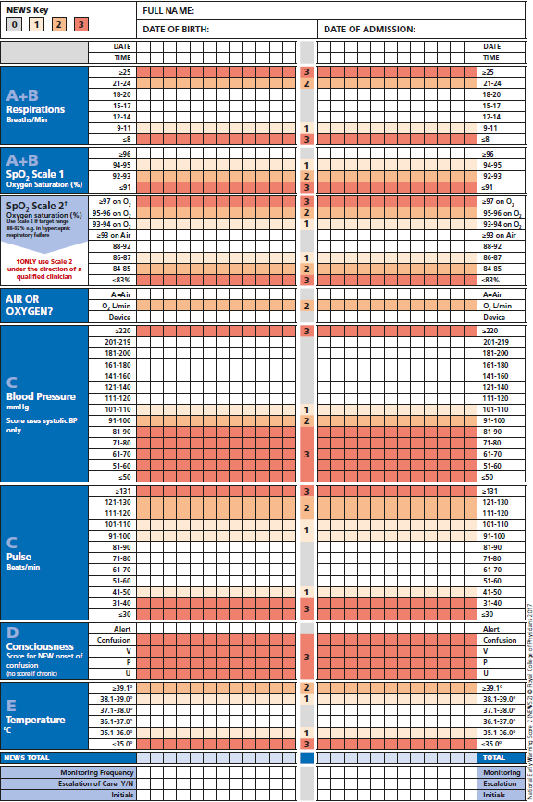

Appendix 2 – NEWS2 Physiological Parameters
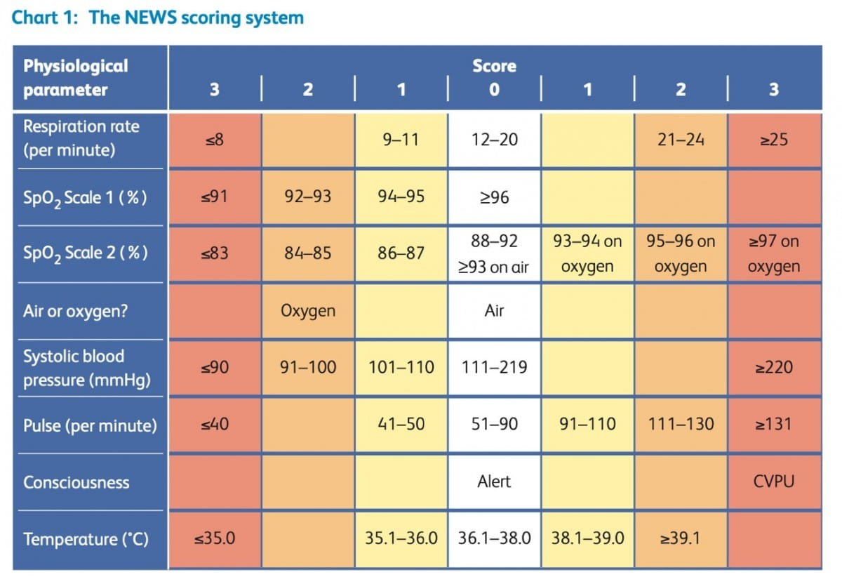

Appendix 3 – NEWS2 Clinical Response
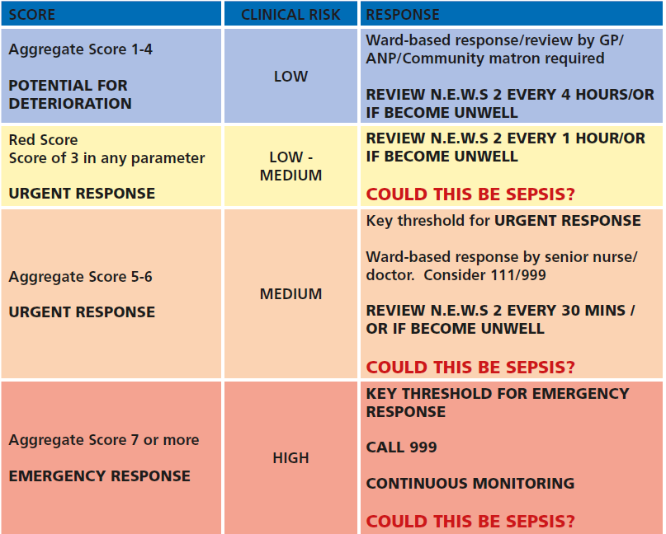

Appendix 4 – MEWS Observation Chart
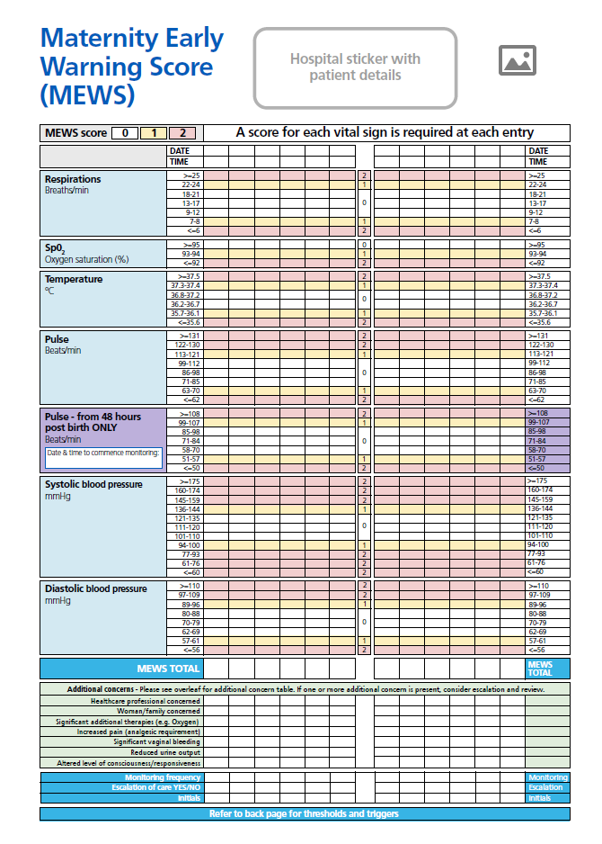

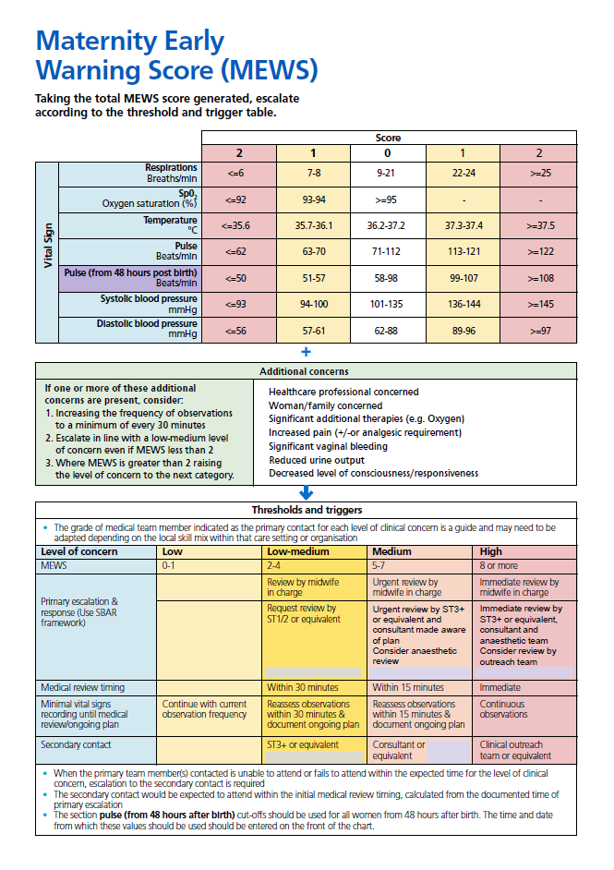
Appendix 5 – MEWS Physiological Parameters & Clinical Response

Appendix 6 – SBARD

All physical and neurological escalation must be communicated using SBARD.

Appendix 7 – FAST Assessment for Suspected Stroke

🚨 Fast Assessment for Suspected Stroke

All staff should use the FAST assessment

🔴 F – FACE

Ask the patient to smile.

Look for:
- Has the face fallen on one side?
- Is the smile uneven?
- Is there facial droop or weakness?

🟠 A – ARMS

Ask the patient to raise both arms and keep them raised.

Look for:
- Can both arms be lifted?
- Does one arm drift downwards?
- Is there weakness or loss of movement on one side?

🟡 S – SPEECH

Ask the patient to repeat a simple sentence, e.g. "Today is a sunny day."
Look for:
- Is speech slurred?
- Are words difficult to understand?
- Is the patient unable to speak?
- Are they using incorrect words or unable to find words?

🔵 T – TIME
Record the exact time symptoms commenced. If the onset time is unknown: Record when the patient was last known to be well. Document the time clearly in the clinical record.
🚑 IMMEDIATE ACTION, If ANY FAST sign is present:
✅ Record the exact symptom onset time or last known well time
✅ Inform the Nurse in Charge immediately
✅ Document all findings and actions
✅ Continue NEWS2 and neurological observations
🔴 CALL 999 or 2222 In patient Homerton IMMEDIATELY FOR SUSPECTED STROKE, TIME LOST IS BRAIN LOST as Early recognition and rapid escalation can significantly improve patient outcomes.

Appendix 8 – Neurological Deterioration – Escalation Flow

PATIENT / SERVICE USER SHOWS ACUTE CHANGE OR CONCERN
(e.g. confusion, collapse, weakness, seizure, reduced responsiveness)
│
▼
IMMEDIATE ASSESSMENT
- ABCDE assessment
- NEWS2 score
- AVCPU
- GCS (if indicated)
- Blood glucose
│
▼
ARE ANY NEUROLOGICAL RED FLAGS PRESENT?
(see list below)
│
┌───────────┴───────────┐
│ │
NO YES
│ │
▼ ▼
CONTINUE MONITORING IMMEDIATE ESCALATION
AND REASSESS (DO NOT DELAY)
│ │
│ ▼
│ INITIATE SBARD COMMUNICATION
│ │
│ ▼
│ URGENT MEDICAL REVIEW / RESPONSE
│ │
│ ▼
│ CONSIDER 999 / EMERGENCY TRANSFER IF:
│ - Stroke suspected
│ - Seizure > 5 min
│ - Reduced consciousness
│ - Rapid deterioration
│ │
▼ ▼
DOCUMENT AND CONTINUE CONTINUOUS MONITORING
OBSERVATION UNTIL HANDOVER COMPLETE.

NEUROLOGICAL RED FLAGS
Escalate immediately if ANY are present
Consciousness / Cognition
- AVCPU deterioration
- GCS < 15 or fall ≥ 2 points
- Sudden reduced consciousness
- New or rapidly worsening confusion
Stroke / Focal Neurological Deficit
- Facial droop
- Unilateral limb weakness
- Speech disturbance
- Suspected stroke or TIA
Seizures
- First seizure
- Recurrent seizures
- Seizure lasting > 5 minutes
- Repeated seizures without recovery
Acute Neurological Symptoms
- Severe sudden headache
- Persistent vomiting with neurological signs
- Signs of raised intracranial pressure
Other Critical Signs
- Unequal or fixed pupils
- Head injury with altered consciousness
- Suspected meningitis.

Ongoing neurological observations must be undertaken by appropriately trained and competency-assessed staff at the frequency determined by the clinical management plan.

Appendix 9 – Seizure Management Flowchart

1. Recognition
- Sudden collapse or convulsive activity
- Loss of awareness / abnormal movements
2. Immediate Safety
- Protect patient from injury
- Remove hazards
- DO NOT restrain patient
- DO NOT place anything in mouth
- Position safely post-event
3. During Seizure
- Monitor airway and breathing
- Record start time and duration
- Observe seizure characteristics
4. Post-Seizure
- AVCPU / GCS assessment
- Blood glucose
- Oxygen saturation
- Full neurological assessment
5. Escalation Triggers
- First seizure
- Seizure > 5 minutes
- Repeated seizures without recovery
- Respiratory compromise
- Injury
- Delayed recovery or persistent reduced consciousness
6. Emergency Response
- Inform Nurse in Charge
- Activate emergency response
- Call 999 if indicated
- Administer prescribed emergency medication

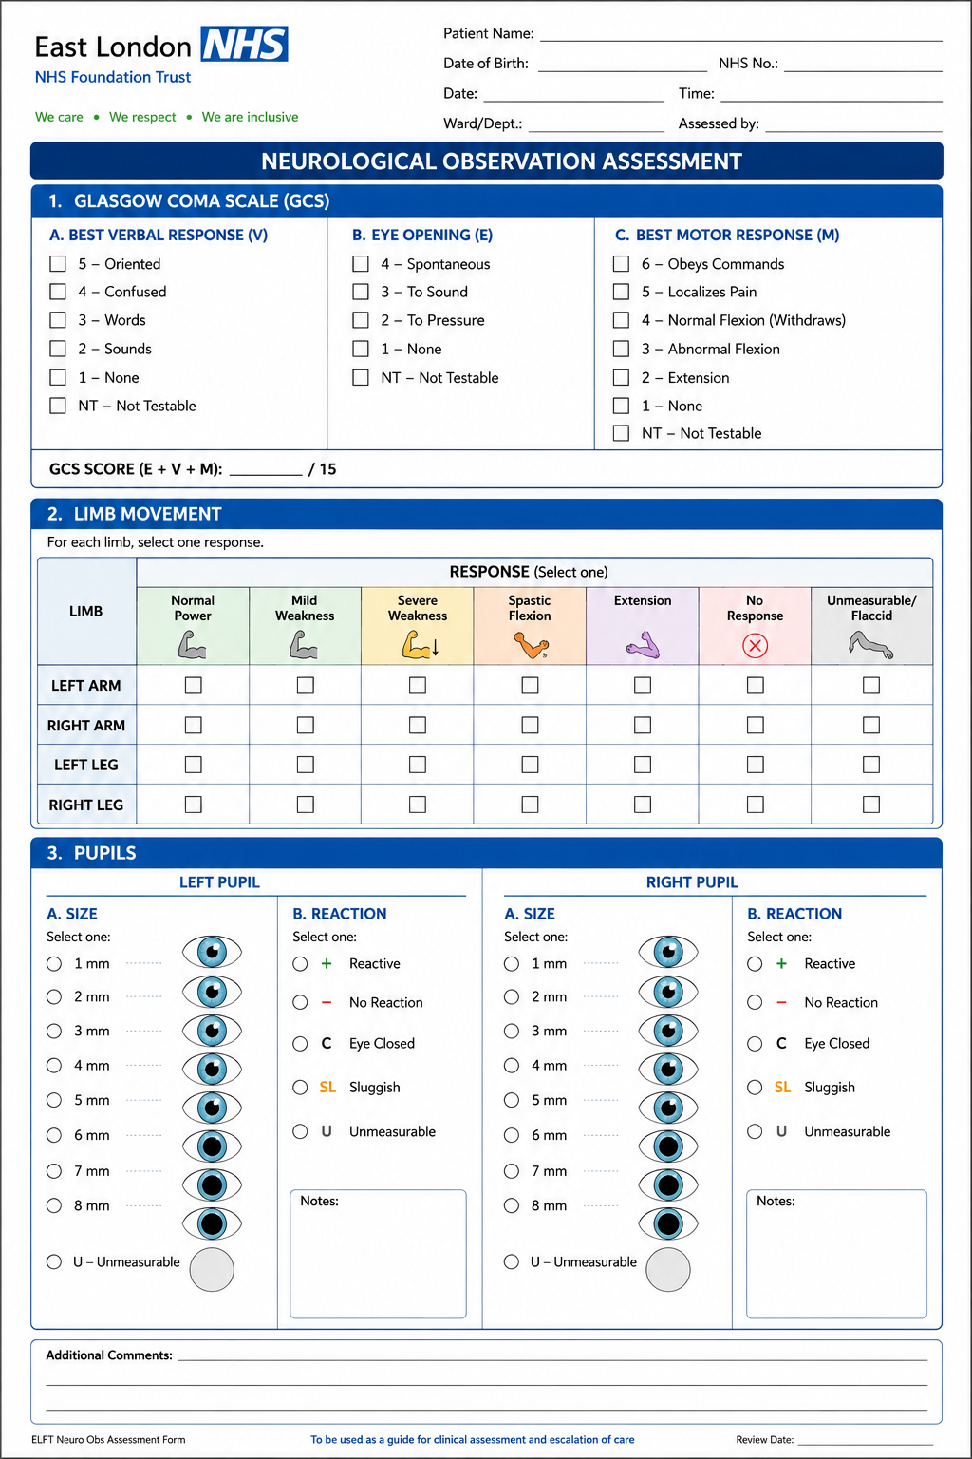
Appendix 10 – Neurological Observation Assessment Chart (Form Physical Health Lead TH)

Appendix 12 – Definitions

ABCDE Airway, Breathing, Circulation, Disability, Exposure
Acute Dystonic Reaction A sudden involuntary muscle spasm or abnormal posture, often occurring as a side effect of antipsychotic medication.
Ataxia Impaired balance, coordination or control of voluntary movements caused by dysfunction of the nervous system.
AVCPU A tool used to assess level of consciousness: Alert, responds to Voice, new Confusion, responds to Pain, Unresponsive.
Baseline Neurological Status A patient's usual level of consciousness, cognition, neurological function and behaviour against which changes or deterioration can be compared.
Contact Vital Signs Physical observations (vital signs) that rely on the consent and co-operation of the service user and necessitate a level of contact or proximity between staff and the service user, which may include the use of items of equipment for the purposes of measurement.
Cranial Nerves Twelve pairs of nerves arising directly from the brain that control functions including vision, hearing, facial movement, swallowing and speech.
Delirium An acute disturbance in attention, awareness and cognition that develops over a short period of time and may fluctuate.
Deterioration The development of abnormal signs and symptoms in response to an acute illness or an exacerbation of an underlying condition.
Extrapyramidal Side Effects (EPSEs) Movement disorders associated with antipsychotic medications, including tremor, rigidity, restlessness and abnormal muscle movements.
Facial Asymmetry Unequal appearance or movement of the two sides of the face, which may indicate neurological dysfunction such as stroke.
FAST Assessment A stroke recognition tool assessing Face drooping, Arm weakness, Speech difficulties and Time to call emergency services.
Focal Neurological Deficit Loss of neurological function affecting a specific area of the body, such as weakness, numbness, facial droop or speech disturbance.
Glasgow Coma Scale (GCS) A neurological assessment tool used to measure a person's level of consciousness by assessing eye opening, verbal response and motor response. Scores range from 3 to 15.
Lithium Toxicity Harmful effects resulting from excessive lithium levels, which may cause tremor, confusion, ataxia, seizures and impaired consciousness.
MEWS Modified Early Warning Score – a scoring tool used during pregnancy to track a patient's vital signs and to trigger a response when vital signs are abnormal.
Motor Assessment Assessment of muscle strength, movement, coordination and sensation to identify neurological impairment.
Neurological Deterioration A worsening of neurological function, consciousness, cognition or physical neurological signs that may indicate acute illness, injury or a medical emergency.
Neuroleptic Malignant Syndrome (NMS) A rare but potentially life-threatening reaction to antipsychotic medication characterised by fever, muscle rigidity, altered mental state and autonomic instability.
NEWS2 National Early Warning Score (2nd version) – a scoring tool used to track a patient's vital signs and to trigger a response when vital signs are abnormal.
Non-contact Vital Signs Physical observations (vital signs) that do not rely on the consent or cooperation of the service user and can be safely carried out by eyesight from a distance greater than arm's length, including respiratory rate (RR), level of consciousness using AVCPU and hydration status.
Pupil Assessment: Assessment of pupil size, equality, shape and reaction to light to identify potential neurological abnormalities.
Raised Intracranial Pressure (ICP) Increased pressure within the skull caused by swelling, bleeding or other conditions affecting the brain, which can be life-threatening.
Reasonable Adjustments Changes made to reduce barriers experienced by disabled people or those with communication needs.
SBARD Situation, Background, Assessment, Recommendation, Decision – a tool which can be used to effectively escalate a clinical problem.
Seizure A transient episode of abnormal electrical activity in the brain resulting in altered awareness, movement, sensation or behaviour.
Sepsis A life-threatening condition caused by the body's dysregulated response to infection, leading to organ dysfunction.
Soft Signs Subtle changes in behaviour, cognition, function or appearance which may indicate early deterioration.
Transient Ischaemic Attack (TIA) A temporary interruption of blood supply to part of the brain causing stroke-like symptoms that resolve completely within 24 hours. Often referred to as a "mini-stroke".
Vital Signs Physiological measurements of organ function including respiratory rate, oxygen saturations, blood pressure, heart rate and temperature.

13.0 Equality Impact Assessment

Name of service, function or policy | Deteriorating Patient Policy
Brief description of service, function or policy (purpose) | The policy will support the aims of the Trust in delivering high standards of effective care adopting current evidence-based procedures.
Is the service, function or policy | ☐ Existing | ☒ New |  |  |  |  | ☐ Under review
Directorate  (If all groups are impacted, please state ‘Trust-wide’) | Trust-wide
Who is completing the EIA?  (name/role) | Trust Lead Physical Health  Bernadette Kinsella
Which Trusts Strategies are supported by the service? | Population Health |  |  |  |  |  | ☒
Which Trusts Strategies are supported by the service? | The Experience of Care |  |  |  |  |  | ☒
Which Trusts Strategies are supported by the service? | Staff Experience |  |  |  |  |  | ☒
Which Trusts Strategies are supported by the service? | Improved Value |  |  |  |  |  | ☒
Which Trusts Strategies are supported by the service? | None |  |  |  |  |  | ☐
Who will benefit from the service, function or policy? | ☒ Workforce |  |  | ☒ Patients, Service Users, and Carers
How will the service, function, or policy be implemented to:  - Ensure access  - Meet health needs  - Provide a safe and positive experience for everyone? | The policy will be published on the Trust intranet and will be incorporated into physical health training on the deteriorating patient
How will the service, function or policy be implemented? | Approval at Physical Health Committee, Trust-wide Physical Health in Mental Health Group, Chair’s Action by Chief Nurse and Quality Committee
What are the intended outcomes by delivering the activity? | The intended outcome is that any patient or service user whose physical health condition is, or is at risk of, deteriorating, has their condition recognised and escalated to the appropriate personnel in a timely manner
How will these outcomes be measured? | Discussion at regular huddles of patient’s physical health with a view to prevention deteriorations and responding appropriately in a timely manner in line with quality care. Monitored by Trust systems including incident reporting learning from reviews
Who are the key stakeholders for this activity and how have they been involved? | Physical Health leads, Community Nurses, Medical staff for monitoring patients at risk of deteriorating and responding appropriately in line with National guidance and evidence-based practice for ELFT Service users Patients.  Consultation as part of Trust groups and Committees
Does this service, function or policy impact other existing policies? | ☒ Yes |  |  | ☐ No
 | Physical health in mental health, DNACPR, End of Life, Sepsis
Is there any data available that influences, affects, or shapes this Equality Impact Assessment? | ☐ Yes |  |  |  | ☒ No
 | Professional interpreters and accessible communication methods should be used where required as diverse population
Are there gaps in information?  Consider groups that you have not directly engaged with, or existing data that does not provide then full picture. | ☒ Yes |  |  | ☒ No
Certain groups may be at increased risk of delayed recognition of deterioration including:
- people with darker skin tones
- people with learning disabilities
- autistic people
- people with cognitive impairment or delirium
- older adults
- people requiring interpreters
- pregnant or recently pregnant people
This policy seeks to reduce inequalities through:
- guidance on assessment in darker skin tones
- recognition of soft signs
- reasonable adjustments
- accessible communication
- support for escalation based on clinical concern and not solely NEWS2 score
- recognition of atypical presentations
Does the service, function or policy have a negative impact on any particular group? | Protected Characteristic |  |  |  |  | Yes |  | No | Unclear
 | Age |  |  |  |  | ☐ |  | ☒ | ☐
 | Disability |  |  |  |  | ☐ |  | ☒ | ☐
 | Race |  |  |  |  | ☐ |  | ☒ | ☐
 | Marriage and Civil Partnership |  |  |  |  | ☐ |  | ☒ | ☐
 | Pregnancy and Maternity |  |  |  |  | ☐ |  | ☒ | ☐
 | Gender re-assignment |  |  |  |  | ☐ |  | ☒ | ☐
 | Religion or belief |  |  |  |  | ☐ |  | ☒ | ☐
 | Sex |  |  |  |  | ☐ |  | ☒ | ☐
 | Sexual Orientation |  |  |  |  | ☐ |  | ☒ | ☐
Could the way the service, function, or policy is implemented have an adverse impact on equality of opportunity or good relations between different groups? | ☐ Yes |  |  |  | ☒ No
NEWS2 has limitations in some patient groups and should always be interpreted alongside clinical assessment and judgement.
- This is important for: learning disability, autism, frailty, chronic respiratory disease, neurological conditions and baseline abnormal physiology.
- Patients/service users with learning disabilities, autism, cognitive impairment or communication needs may present atypically when unwell. Staff must consider behavioural change, withdrawal or distress as potential indicators of deterioration. Reasonable adjustments must be made where required and appropriate
Frailty may increase the risk of deterioration, atypical presentation and poorer outcomes. Staff should consider frailty when assessing deterioration, particularly in older adults
Where a negative impact has been identified, can changes be made to minimise it? | To be aware of Limitations of tools in certain patient groups. Policy reflects current NICE guidance and evidenced practice based on NEWS2, the ABCDE approach, neurological assessment principles, stroke recognition, delirium assessment, and medication-related neurological emergencies.
Is the service, function, or policy indirectly discriminatory, and can it be justified? | ☐ Yes |  | ☒ No
 | N/A
Is the service, function, or policy intended to increase equality of opportunity by permitting Positive Action or Reasonable Adjustment? | ☒ Yes |  | ☐ No
• reasonable adjustments
• accessible communication
• darker skin tone assessment
• atypical presentations
• interpreter use
• delirium recognition
• pregnancy adjustments

