Parking Policy

Version: | 1.0
Consultation Groups | Non-Pay Workstream  Operations Meeting  Borough Directors  Exec Team  Car Parking Implementation Group  Staffside
Approved By | Estates Optimisation/JSC Policy Sub-Group
Date approved | 9 June 2026
Ratified By: | Joint Staff Committee
Date ratified: | 15 July 2026
Name and Job Title of author: | GFGT Programme Manager
Executive Director Lead: | Chief Finance Officer
Implementation Date: | August 2026
Last Review Date: | June 2026
Next Review Date | December 2028

Services | Applicable
Trust wide
Mental Health and LD
Community Health Services

Version Control Summary

Version | Date | Author | Status | Comment
1.0 | June 2026 | GFGT Programme Manager |  | New Policy

- Introduction

  - Efficient and fair management of parking facilities is essential to maintaining safety, accessibility, and convenience for all users. This Car Parking Policy sets out the principles, rules, and responsibilities that govern the use of designated parking areas. Its purpose is to ensure that parking spaces are allocated and used in a way that supports operational needs, promotes equitable access, and minimises disruption to the surrounding environment.

  - The Health Technical Memorandum 07-03 sets out the rules for Trusts providing parking and ensures that parking provision contributes positively to patient experience, staff wellbeing, and the wider community.

- Purpose

  - The purpose of this policy is to establish principles and procedures that promote fairness, safety, and sustainability. It applies to all users of the Trust’s managed car parks, including service users and visitors attending appointments, staff members employed by the Trust, contractors and suppliers, and emergency services. By setting out clear expectations, the policy aims to support patient care by prioritising accessible parking, balance the needs of staff and visitors, maintain safe movement of vehicles and pedestrians, encourage sustainable travel choices, and ensure compliance with NHS guidance and local regulations.

- Scope

  - This policy sets out details for the management of parking at sites within the East London NHS Foundation Trust and applies to staff, students, visitors, contractors and any other users of the car parks including emergency vehicles.

- Policy Statement

  - The Trust is committed to providing a high quality and fair car parking service and demonstrates its commitment through a professional customer focused responsive service.

  - The Trust is partnering with an external car park provider who will enforce the parking terms and conditions for all sites that are managed by the Trust. They will use clear, concise and adequately placed signage and monitor via either Automatic Number Plate Recognition (ANPR) cameras, Closed Circuit Television (CCTV), manned Warden Operative patrols or a combination of the above. See Appendix 1 for a list of Trust managed car park sites.

  - The Trust is committed to ensuring that none of its policies, procedures and guidelines discriminates against individuals directly or indirectly.

  - While the Trust aims to support access where possible, it is not obliged to provide car parking for staff, service users, visitors, or contractors. Any parking spaces available on Trust premises are provided on a discretionary basis.
The Trust may, where necessary, review, amend, restrict, or withdraw parking arrangements at its discretion.

- Responsibilities of Users

  - All individuals driving to Trust premises are required to comply fully with the Trust’s car parking regulations and any instructions displayed on site signage.

  - In addition to signage conveying local rules, the following is strictly forbidden and will be subject to enforcement action:

- Vehicles not registered (with either a permanent or temporary 24-hour permit)
- Parking on double yellow lines or other markings, a crosshatch area or other markings indicating a road or area that requires to be free from parked vehicles
- Parking not entirely within a designated parking bay
- Parking in a disabled bay without displaying a valid disabled badge
- Parking in an area reserved for emergency vehicles without the vehicle being of the type allowed.
- Parking in a manner so as to cause obstruction or inconvenience to others
- Parking on a grass verge or kerb stone
- Parking in an unauthorised or restricted area without authority to be there
- Parking so as to cause site safety risk or restrict emergency access.

  - Individuals choosing to drive to Trust premises remain responsible for making suitable arrangements should parking not be available. The Trust accepts no liability for inconvenience caused by a lack of parking provision.

- Permit Management

  - ELFT Staff (see Appendix 2 for staff permanent parking permit process map)

  - All ELFT staff must apply for a permit through the approved permit app account by scanning the QR code or link provided by the car park administrator elft.parking@nhs.net and create an account for application. In order to create an account and submit an application, staff must provide the provider (via the approved permit app) with the below information:

- Work email address
- Title
- First Name
- Last Name
- Mobile Number
- Department
- Job Title
- Staff Number
- Address information
- You must select the location you are require a permit for

  - Once the application is submitted, the car park administrator (elft.parking@nhs.net) will review and either accept or reject the application following approval from the site lead. within 5 working days. It is imperative the application is submitted at least 5 working days prior to the site go-live date, this will be communicated by the provider via internal communication from the Trust.

  - The driver must renew their permit every 12 months. The driver will receive a reminder email to do this before the permit account expiry but the onus is on the driver to remember to do this.

  - If a member of staff is authorised to have parking across multiple ELFT locations, they must contact the car park administrator (elft.parking@nhs.net) who will add the driver to a special “all sites” list. The provider will provide an alternative QR code link to ensure the driver is assigned the correct Permit Type, which will enable parking across all ELFT locations. (See Appendix 4 for multiple site permit process map

  - Contractors and other regular attending vehicle owners or motorists (see Appendix 3 temporary 24 hour parking permit process map)

  - Each location will be provided with a client portal login or QR code to manage permanent and temporary exemptions from the parking management site rules and enforcement. The vehicle must be registered on the client portal in advance or within 10-minutes of arrival.

  - Service users & other ad-hoc visitors (ANPR or CCTV managed locations) (see Appendix 3 for temporary 24 hour parking permit process map)

  - All provider signage installed on ANPR or CCTV locations state “This is a camera-controlled car park” on the very top of the signage wording. Vehicle owners or drivers who are not registered with an ELFT staff permit or contractor exemption (i.e. service users, visitors of service users, carers, contractors) must register their vehicle on the Tablet Kiosks installed by the provider within 10-minutes of arrival. These will be located at the entrance / reception area of the buildings. Where reception area is staffed, the staff are responsible for reminding drivers to register their vehicle on the Kiosks provided.

  - To register a vehicle on the Tablet Kiosk, drivers must:

- Enter their full and correct vehicle registration number
- Click done

  - Following the entry of a vehicle registration, the driver will be registered with a temporary 24-hour permit for that site only.

  - Service users & other ad-hoc visitors (Warden Operative managed locations) (see Appendix 3 for temporary 24 hour parking permit process map)

  - If the provider’s signage does not state “This is a camera-controlled car park” at the stop of the signage wording, the location is managed by Warden Operatives. Drivers who are not registered with an ELFT staff permit or contractor exemption (i.e. service users, visitors of service users, carers or contractors) must register their vehicle on using the QR code posters provided on tablets at site entrances or speak to site staff. Drivers will be required to add their vehicle within 10-minutes of arrival:

- Email address
- Vehicle registration number

  - An email will be sent to drivers confirming the QR code exemption has been applied. Each entry provides vehicle owners or drivers with a 24-hour permit.

- Allocation of Spaces

  - Parking is provided strictly on a first-come, first-served basis. The Trust does not guarantee the availability of parking spaces at any time. Parking is not a contractual entitlement.

  - Access to Trust car parks does not constitute a contractual right or entitlement. The Trust reserves the right to withdraw, restrict, or amend parking arrangements at its discretion.

- Disabled Parking and Accessibility
  - Where a site can accommodate disabled parking bays, these spaces are reserved exclusively for Blue Badge holders and must remain available at all times.
  - At locations where the physical design or spatial constraints prevent the installation of dedicated disabled bays, the Trust will where possible implement reasonable alternative arrangements such as accessible drop-off points, priority short-stay areas, or pre-arranged support to ensure equitable access for people with mobility needs.
  - Any unauthorised use of spaces designated for accessibility purposes will be managed in accordance with Trust parking enforcement procedures.
Sites with constrained layouts will be kept under periodic review to identify opportunities for future accessibility improvements

- Charges

  - Parking permits (both permanent and temporary 24-hour permits) will be issued to staff, service users, contractors, and visitors. In instances where parking breaches occur, applicable parking charge notices (PCNs) may be issued. Parking rules and applicable charges will be clearly communicated in signage around the Trust parking sites, prominently displayed, and the rules will be applied with transparency. Any concessions will be administered fairly and consistently.

- On-Call Spaces

  - The Trust does not offer on call spaces for authorised staff. All parking facilities and space are offered on a first come, first served basis.

- Visitors / Contractors

  - Trust visitors and contractors may park in the staff parking areas, providing they register their car on the Tablet Kiosk on site on arrival.

- Appeals

  - Drivers need to follow the process outlined on the PCN. If there are extenuating circumstances that the car parking company have not taken into account the driver may refer to the car park administrator (elft.parking@nhs.net) who will liaise with both the car park management company and the Service Director to investigate if there is a valid case to appeal the PCN. However, it must be noted that even if you are a staff member, if you do not have a permit the charge will be valid.

- Disclaimer

  - The Trust cannot accept responsibility for any vehicles left on Trust premises. All vehicles and contents are left entirely at their owner's own risk and under no circumstances will claims of compensation be considered.

- Customer Service

  - The car park remains under the control of the locality directorate team, any issues relating to availability or staff travel plans etc should be addressed to the local leadership team.

  - Any Estates issues or safety concerns should be logged on the Estates helpdesk in the usual way.

  - Issues regarding the vehicle permit, permit process or permit system etc should be reported to the Trust car park administrator (elft.parking@nhs.net).

  - Car parking attendants will patrol sites to monitor parked vehicles and ensure each vehicle complies with the policy. Formal complaints arising from parking attendant activities should be addressed to the car park administrator (elft.parking@nhs.net).

- Verbal and Physical Abuse

  - Verbal or physical abuse from any patient, visitor or staff in connection with the enforcement of this policy will not be tolerated and will be subject to the Trust's Violence & Aggression Policy and may result in the police being informed.

- Sustainable Travel

  - Staff, service users, and visitors are encouraged to consider alternative means of travel, including public transport, cycling, walking, or car-sharing, as part of the Trust’s commitment to sustainability and reducing congestion.

- On Street Parking

  - The Trust discourages staff where possible, service users and visitors from parking their vehicles on residential side streets to avoid bringing the Trust into disrepute with its neighbours where spaces are provided by the Trust.

- Communication

  - This policy will be published on the Trust’s internet, and staff will be briefed through internal communications to ensure awareness and compliance.

  - It remains the responsibility of the vehicle owner to review and comply with the signage in place.

- Review

  - The Trust may change its policy from time to time, including in circumstances where the law changes. The policy will be subject to review as defined by the Trust's policy for policies document.
Appendix 1

Trust Managed Car Parking Sites

Fountains Court (Bedfordshire)
Oakley Court (Bedfordshire)
Townsend Court and The Poplars (Bedfordshire)
Twinwoods (Bedford)

Beech Close Resource Centre (Dunstable)

Crombie House (Leighton Buzzard)
Whichellos Wharf (Leighton Buzzard)

Alma Street (Luton)
Calnwood Court (Luton)
Charter House (Luton)

Donald Winnicot Centre (Hackney)
City & Hackney Centre for Mental Health, 15 Homerton Row (Hackney)
John Howard Centre (Hackney)
The Lodge, (Hackney)
Primrose Centre (Hackney)
Wolfson House (Hackney)

Appleby Centre, (Newham)
115 - 121 Balaam St (Newham)
East Ham Care Centre and Shrewsbury Health Centre (Newham)
Passmore Edwards (Newham)

The Green (Tower Hamlets)

Appendix 2
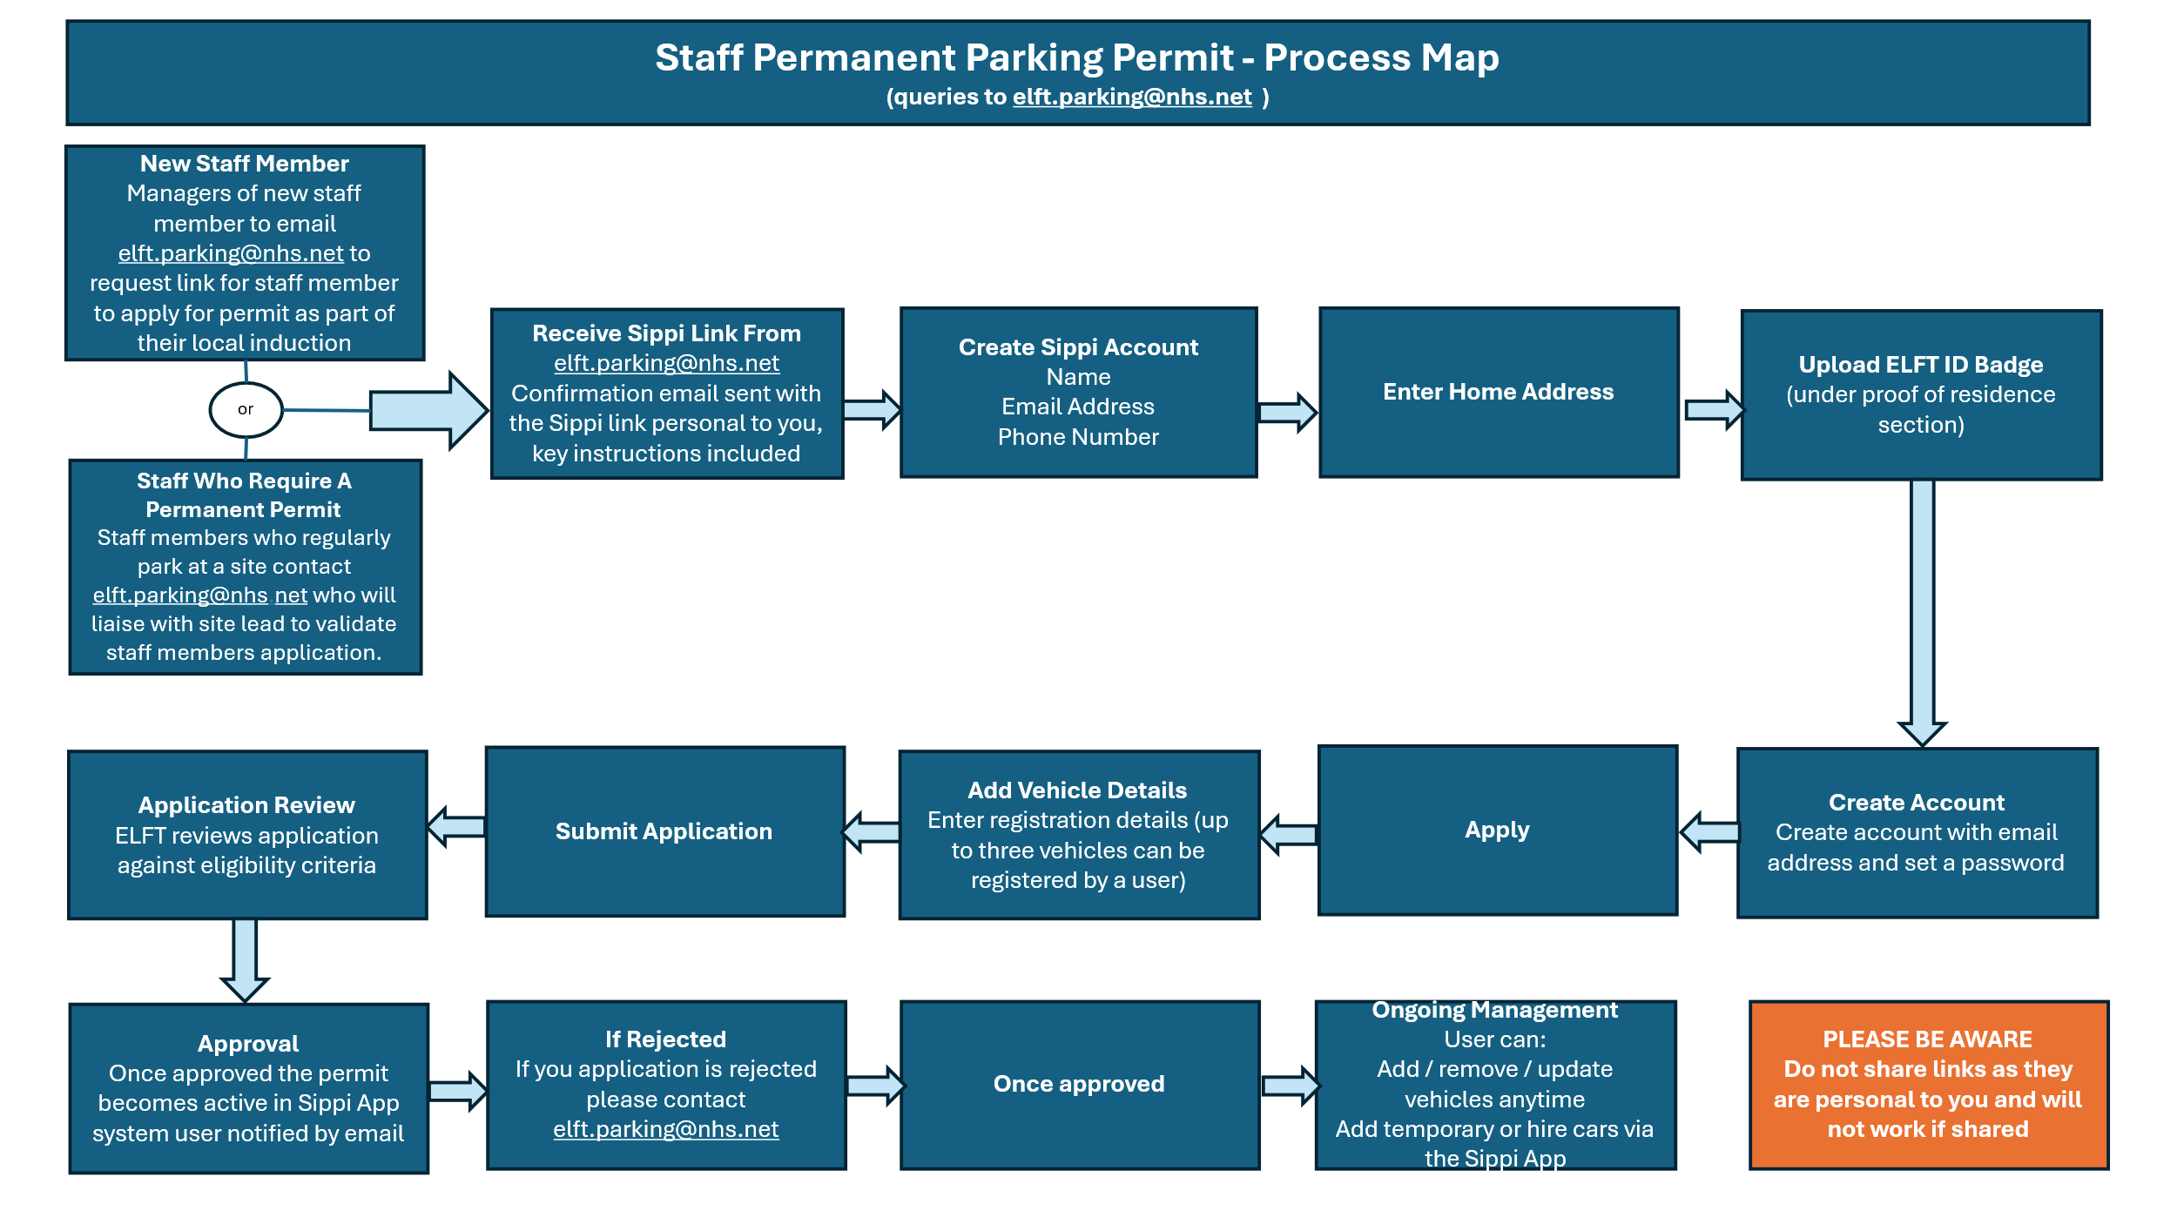

Appendix 3
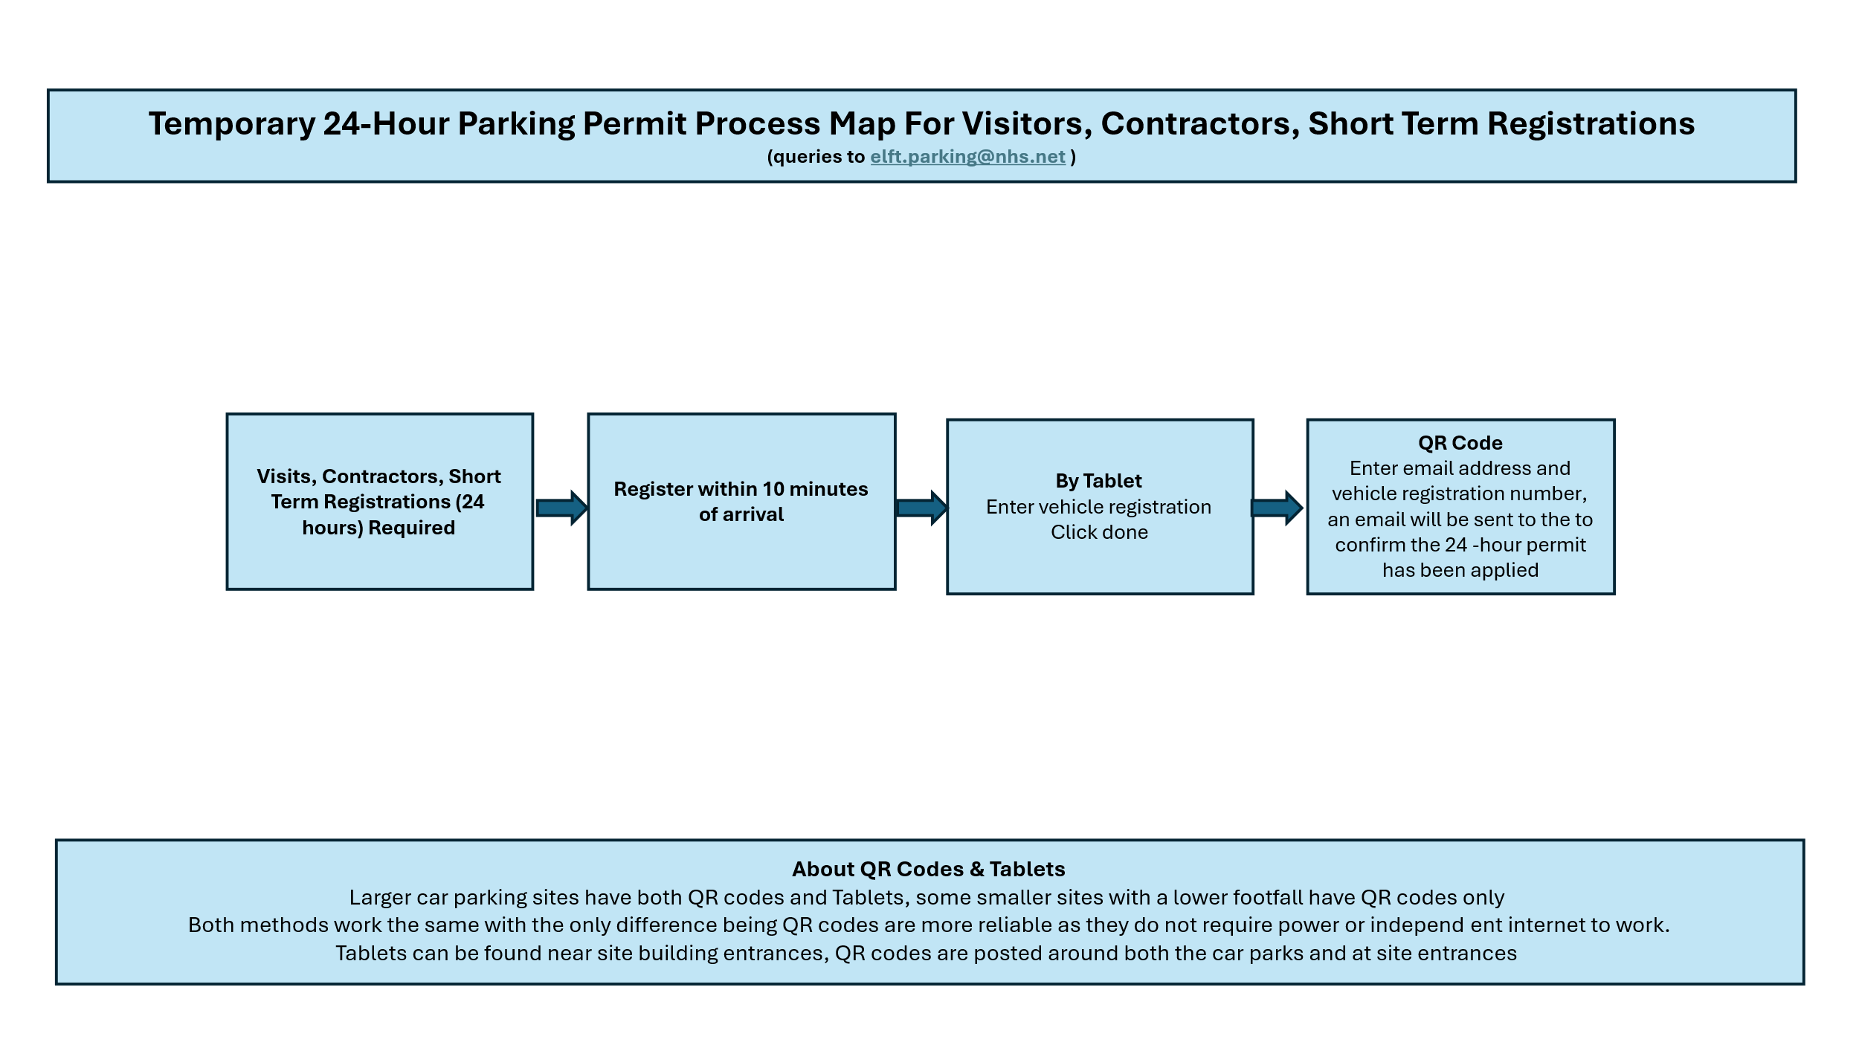

Appendix 4
