Sepsis Policy

Version Number | 1.0
Consultation Groups | Physical Health Committee, Resuscitation Committee
Approved By (Sponsor Group) | Trust Physical Health group and resuscitation Committee
Date Approved | 10 July 2026
Ratified By | Quality Committee
Date Ratified | 02 September 2026
Name of Originator/Author | Lead Nurse Practice Education and Trust Physical Health Lead
Executive Director Lead | Director of Community Nursing
Implementation Date | July 2026
Last Review Date | July 2026
Next Review Date: | July 2029
Services | Applicable
Trust-Wide | X
Mental Health and LD
Community Health Services

Version Control Summary
Version | Date | Author | Status | Comment
1 | April 2026 | Lead Nurse Practice Education and Trust Physical Health Lead | Final | New Policy

Paragraph |  | Page
 | Introduction | 3
 | Scope | 3
 | Purpose | 4
 | Duties and Responsibilities | 4
 | Definitions | 5
 | Recognition and Management of Sepsis  6.1 Clinical Judgement and NEWS2  6.2 Mental Health-Specific Risk Factors | 5
 | Escalation Principles  7.1 Community Health Services and Community Mental  Health Services  7.2 Acute Mental Health Services  7.3 Children and Young People  7.4 Pregnant or Recently Pregnant People  7.5 Urgent Transfer for Patients/Service Users with High-Risk  Sepsis  7.6 Immediate Treatment for Patients/Service Users with  High-Risk Sepsis (Over 16 Years Only)  7.7 Management of Moderate Risk Sepsis  7.7.1 Physiological Assessment  7.7.2 Infection Prevention and Control & Sepsis Management  7.8 Assessing Patients with Darker Skin Tones  7.9 'Soft Signs' of Deterioration  7.10 Consider Any Advanced Planning Requirements | 6
 | Training and Competency | 15
 | Monitoring, Audit and Learning | 16
 | Documentation and Requirements | 16
 | Mental Capacity and Consent | 17
 | References | 18
 | Associated Policies and Procedures | 19
14. Appendices

Appendix 1 | Assessing Sepsis in Community/Custodial Settings | 20
Appendix 2 | Managing Sepsis in Community/Custodial Settings | 22
Appendix 3 | Assessing Sepsis in Acute Mental Health Settings | 23  33FEC851A4FC7ACE
Appendix 4 | Managing Sepsis in Acute Mental Health Settings | 24
Appendix 5 | Assessing Sepsis in Children Under 5 | 25
Appendix 6 | Assessing Sepsis in Children Aged 5–11 | 27
Appendix 7 | Assessing Sepsis in Young People Aged 12–15 | 29
Appendix 8 | Managing Sepsis in Young People Under 16 | 31
Appendix 9 | Assessing Sepsis in Pregnant or Recently Pregnant People | 32
Appendix 10 | Managing Sepsis in Pregnant or Recently Pregnant People | 34
Appendix 11 | SBARD | 35
 | Equality Impact Assessment | 36

- Introduction
ELFT is committed to the early recognition, escalation and management of sepsis across all services to reduce avoidable harm, deterioration and mortality. All staff have a responsibility to recognise possible sepsis, escalate concerns promptly and act in accordance with this policy and associated clinical pathways. The Physical Health Committee will oversee implementation and review of this policy.
Sepsis is a potentially life-threatening condition which is identified as a leading cause of avoidable patient/service user death. Healthcare professionals have a responsibility to ensure that they have the knowledge and skills to effectively recognise the signs and symptoms of sepsis allowing for early intervention and prompt treatment.
Sepsis is ‘characterised by a life-threatening organ dysfunction due to a dysregulated host response to infection’ and occurs when the body’s immune system goes into overdrive leading to shock, multi organ failure and in some cases death.
It is estimated that there are at least 200,000 cases of sepsis every year with around 48,500 deaths and that the cost to the NHS is between £1.5 and £2 billion each year.³
Successful management of sepsis requires a high index of suspicion and early recognition of signs and symptoms. This is especially important where patient/service user are cared for in settings outside of an acute hospital where there may only be access to limited treatment options. This means that there is an increased emphasis for staff to be able to recognise potential sepsis without access to advanced equipment or diagnostic tools. Through this policy, all staff will be encouraged to ‘THINK SEPSIS’ for any patient/service user who has a confirmed or suspected infection.

- Scope
This policy applies to all clinical staff employed by East London NHS Foundation Trust (ELFT), including permanent, temporary, bank and agency staff, who are involved in the assessment, observation, treatment or escalation of patients/service users in inpatient, community, urgent care, crisis, rehabilitation, CAMHS, learning disability and specialist services.
This policy applies to adults, children and young people, and pregnant or recently pregnant people receiving care from ELFT services.
This policy should be read in conjunction with the Trust Deteriorating Patient Policy, NEWS2 Policy, Physical Health Policy, Mental Capacity Act Policy and relevant safeguarding procedures. This policy does not replace clinical assessment or acute hospital sepsis pathways and should be used alongside local emergency response procedures.

- Purpose
The purpose of this policy is to:
- Ensure a standardised trust wide approach to the recognition and management of sepsis
- Raise awareness of the impact of sepsis
- Ensure staff within the Trust are able to recognise the signs & symptoms of sepsis
- Ensure that all staff are aware of the process of escalation if they suspect a patient/service user has sepsis.
- Ensure timely escalation and transfer of patients/service users with suspected sepsis
- Ensure clear standards for documentation, communication and monitoring
- Support compliance with national guidance including NICE guidance, NHS England deterioration guidance and CQC Regulation 12.

- Duties and Responsibilities

Role | Responsibilities
Chief Executive | The Chief Executive has overall responsibility for ensuring that all Trust policies comply with legal, statutory and good practice requirements
Directors of Nursing/Medical Director/Clinical Directors | Ensuring governance, patient safety and assurance systems are in place  Ensuring that this guidance is disseminated to all clinical staff  Ensuring that all relevant staff access education as per the training and support requirements of this policy
Ward Managers/Team Leaders | Ensuring that they and their staff are made aware of their responsibilities under this policy and other relevant and associated policies  Ensuring that all staff within their areas have undertaken relevant training.  Ensuring that all staff within their areas (including students and bank/agency staff are aware of the procedure to be undertaken when sepsis is suspected or confirmed.  Ensure local escalation pathways and emergency contact numbers are readily available to staff.  Monitor compliance with training requirements and escalation procedures
Clinicians and Registered Nurses | Ensuring that they are aware of their responsibilities under this policy and other relevant and associated policies  Respond to all NEWS2 scores, prioritising those which trigger escalation and may indicate sepsis  Ensuring a prompt medical or senior nursing review where there is concern that a patient/service user may have sepsis.  Ensure all assessments, NEWS2 scores, escalation decisions and clinical actions are clearly documented within the patient/service user clinical record.  Ensure that family, carers or advocates concerns regarding deterioration are taken seriously and escalated appropriately.  Escalate concerns regarding deterioration regardless of NEWS2 score where clinical concern exists. Consider Mental Capacity Act principles where a patient/service user refuses treatment or transfer .
Health Care Support Workers | Ensuring that they are aware of their delegated responsibilities under this policy and other relevant and associated policies  Utilising the NEWS2 assessment tool to recognise that a patient or service users condition has deteriorated  Ensuring escalation to support prompt review by a registered practitioner

- Definitions

Sepsis | Sepsis is characterised by a life-threatening organ dysfunction due to a dysregulated host response to infection
Septic Shock | Septic shock is a subset of sepsis where particularly profound circulatory, cellular and metabolic abnormalities substantially increase mortality
Uncomplicated infection | Viral and bacterial infections where there is no evidence of organ dysfunction or tissue hypo-perfusion that accompanies sepsis or septic shock
NEWS2 | National Early Warning Score - a scoring tool used to track patient’s vital signs and to trigger a response when vital signs are abnormal
MEWS | Modified Early Warning Score - a scoring tool used during pregnancy to track patient’s vital signs and to trigger a response when vital signs are abnormal
SBARD | Situation, Background, Assessment, Recommendation, Decision – a tool which can be used to effectively escalate a clinical problem

- Recognition and Management of Sepsis
It is important to take into account factors which may increase the risk of developing sepsis or where there is a risk that sepsis will not be identified properly. These include:
- age: being 75 or over or under 1 year
- ethnicity: being from an ethnic minority background
- clinical features such as:
- frailty
- multimorbidities or severe chronic conditions
- impaired immune function because of illness or medical treatment
- surgery or invasive procedures in the past 6 weeks
- indwelling catheters
- repeated antibiotic use
- breach of skin integrity
- communication challenges, such as with people:
- with learning disabilities
- with cognitive impairment
- who need an interpreter
- drugs or alcohol misuse
- social, economic or environmental factors such as
- homelessness
- living in deprived areas
Staff must make reasonable adjustments to ensure equitable assessment and escalation of deterioration, including use of interpreters, accessible communication methods, carer involvement and adaptation of assessment approaches where required.
6.1 Clinical Judgement and NEWS2. NEWS2 should not be used in isolation.
NEWS2 is an adjunct to, and not a replacement for, clinical judgement. A low NEWS2 score does not exclude sepsis. Staff must escalate any patient with clinical concern, particularly where behaviour, cognition or physical presentation has changed unexpectedly
6.2 Mental Health-Specific Risk Factors
Mental health patients often deteriorate without initially triggering NEWS2 because of:
- sepsis in younger patients
- behavioural change
- delirium
- catatonia
- intoxication/withdrawal
- neuroleptic malignant syndrome
- lithium toxicity
- clozapine-related illness
- Myocarditis,
- Patients receiving clozapine who develop fever, tachycardia or signs of systemic illness require urgent assessment for infection, neutropenic sepsis and clozapine-related myocarditis in accordance with Trust guidance
- rapid tranquillisation,
- Refer to Trust policy as these patients can become septic later post-RT monitoring, respiratory depression and aspiration pneumonia. Patients who have received rapid tranquillisation remain at increased risk of aspiration, respiratory depression and delayed deterioration. Where infection is suspected these patients require enhanced observation and consideration of sepsis even where NEWS2 remains low.
7. Escalation Principles
- Staff should escalate concerns whenever they feel that a patient/service user is deteriorating, regardless of NEWS2 score. Clinical concern should always override numerical scoring tools.
- Concerns raised by relatives, carers, advocates or support staff regarding deterioration must be taken seriously and acted upon appropriately.
- All patients/service users with suspected infection should be assessed for possible sepsis using the relevant Trust screening tool.
EARLY DETECTION OF ALTERED VITAL SIGNS ALLOWS FOR EARLY INTERVENTION AND THE POTENTIAL TO SAVE LIVES
If you suspect that your patient may have sepsis:

Pregnant/had a baby in the last 4 weeks
follow the sepsis screening tool for pregnancy (Appendix 9 & 10)

Children under the age of 16
please refer to Appendices 5, 6, 7 & 8

Mental Health Services
follow the sepsis screening tool for acute mental health for patients aged 16 or over (Appendices 3 & 4 )

Community Health Services
follow the sepsis screening tool for community care for patients aged 16 or over (Appendices 1 & 2)

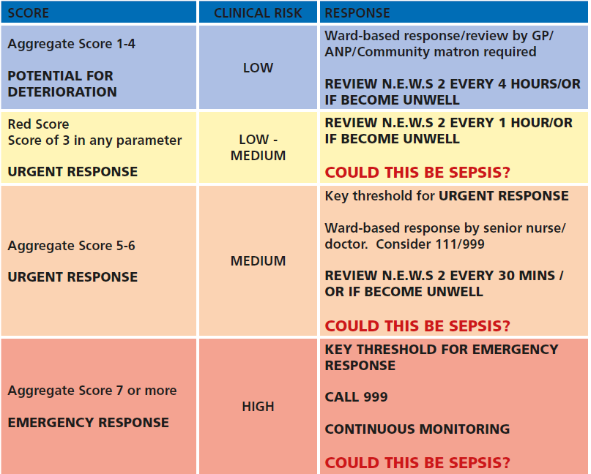

Escalation Timeframes
Clinical Concern | Required Action | Expected Timeframe
High Risk Sepsis | Emergency escalation and 999 transfer or 222 City and Hackney. | Immediately
Moderate Risk Sepsis | Senior clinical review | Within 1 hour
NEWS2 deterioration | Registered practitioner review | Within 30 minutes
Further deterioration after review | Urgent re-escalation | Immediately

7.1 Community Health Services & Community Mental Health Services (See
Appendices 1 & 2)

All staff should be encouraged to THINK SEPSIS in patient/service user who are 16 or over if the patient/service user:
- Is scoring 3 in one parameter or 5 in total on their NEWS2 assessment OR looks unwell OR has abnormal physiology
AND
- Has a confirmed or suspected infection
AND
- Is high risk for sepsis with one or more of the following:
  - Evidence of a new or altered mental state
  - Respiratory rate ≥ 25 bpm
  - New need for oxygen (40% or more) to keep SpO₂ > 92% (or more than 88% in COPD)
  - Systolic BP ≤ 90mmHg (or a drop of > 40mmHG from normal)
  - Heart rate > 130 bpm
  - Not passed urine in 18 hours (<0.5ml/kg/hr if catheterised)
  - Non-blanching rash or mottled, ashen or cyanotic skin (Refer to 7.8 for patients/service users with darker skin tones)
Where medical staff are not immediately available, staff should escalate concerns via the appropriate emergency pathway including GP, urgent care service, NHS 111, on-call doctor or emergency ambulance service depending on clinical urgency.
Where a patient/service user remains in the community or transfer is not immediately required, clear safety-netting advice must be provided to the patient/service user, family, carers or care staff. This should include advice regarding worsening symptoms, when to seek urgent help and who to contact in an emergency. There should be agreement who accepted responsibility for ongoing clinical review, review timeframe, safety-netting advice given and escalation trigger for re-contacting emergency services.
Seek urgent help if:
- increasing confusion
- worsening breathlessness
- rash develops
- not passing urine
- unable to keep fluids down
- becoming difficult to wake

7.2 Acute Mental Health Services (See Appendices 3 & 4)
All staff should be encouraged to THINK SEPSIS in patients who are 16 or over if:
- A patient/service user:
  - Has triggered on their NEWS2
  - Looks unwell
  - Has evidence of organ dysfunction
  - Has a clinical status which gives cause for concern
  - Has a carer or relative who raises a concern
  - Has had recent chemotherapy or is at risk of neutropenia (clozapine)
  - myocarditis
AND
- Has a NEWS2 score of 7 or above
OR
- Has a NEWS2 score of 5 or 6 and one of the following:
  - Any one NEWS2 parameter with a score of 3
  - Mottled or ashen skin (Please refer to Section 7.8 for patients/service users with darker skin tones)
  - Non-blanching rash (Please refer to Section 7.8 for patients/service users with darker skin tones)
  - Cyanosis of skin, lips or tongue (Please refer to Section 7.8 for patients/service users with darker skin tones)
  - Patient/service user looks extremely unwell
  - Patient/service user is actively deteriorating
- Risk of neutropenia (chemotherapy, immunosuppression)
- Clozapine / neutropenia
- Patients/service users prescribed clozapine who present with suspected infection or sepsis should be considered at risk of neutropenic sepsis and urgent medical assessment should be sought.

- Where a patient/service user refuses assessment, treatment or transfer, or there are concerns regarding capacity or advance care planning, staff should follow the guidance in Section 11: Mental Capacity and Consent.

7.3 Children and Young People (See Appendices 5, 6, 7 & 8)
Signs of sepsis in children can vary depending on the age of the child and the underlying cause of the infection. Some common signs and symptoms of sepsis in children may include:
- Fever or Hypothermia: Children with sepsis may have a high fever or, in some cases, may have a low body temperature
- Rapid Breathing: Increased respiratory rate or difficulty breathing can be a sign of sepsis in children
- Fast Heart Rate: Tachycardia, or a rapid heart rate, is a common sign of sepsis in children
- Altered Mental Status: Children with sepsis may appear confused, lethargic, or irritable
- Skin Changes: Skin may appear pale, mottled, or have a bluish tint. In some cases, the skin may feel cool to the touch
- Decreased Urine Output: Children with sepsis may produce less urine than usual or may not urinate at all
- Fatigue or Weakness: Children may appear unusually tired or weak.
- Irritability or Fussiness: Infants and young children may be unusually fussy or irritable
- Poor Feeding: Infants may have difficulty feeding or may refuse to eat
- Severe Pain: Children with sepsis may experience severe pain, especially in the abdomen or chest
It is important to note that these signs and symptoms are not specific to sepsis and can be present in other conditions as well. If there is a concern for sepsis, prompt medical evaluation and appropriate testing are crucial for accurate diagnosis and timely management.
7.4 Pregnant or Recently Pregnant People (See Appendices 9 & 10)
People who are pregnant, have given birth or had a termination of pregnancy or miscarriage in the past 6 weeks are in a high risk group for sepsis. In particular, people who:
- have impaired immune systems because of illness or drugs
- have diabetes, gestational diabetes or other comorbidities
- needed invasive procedures (for example, caesarean section, forceps delivery, removal of retained products of conception)
- had prolonged rupture of membranes
- have or have been in close contact with people with group A streptococcal infection, for example, scarlet fever
- have continued vaginal bleeding or an offensive vaginal discharge
If any high risk criteria are met, refer people with suspected sepsis who are or were recently pregnant and are outside acute hospital settings for emergency medical care.
Use the most appropriate means of transport (usually 999 ambulance).

7.5 Urgent Transfer for Patients/Service Users with High-Risk Sepsis
A patient/service user who looks unwell, has a presumed infection and is displaying at high risk of sepsis (Appendices 1, 2 and 3), will require transfer to an acute hospital as soon as possible. This should be arranged by ringing 999 and asking for an emergency ambulance.
If a patient is detained under the Mental Health Act, please refer to the local policy.
The call to the ambulance service should be undertaken using an SBARD format (Appendix 11) format with direct reference to the acuity of the situation using the term ‘High Risk Sepsis’.
Staff on inpatient wards should ensure that they continuously monitor the patient until an ambulance arrives.
Staff in the community or in the patient/service user’s own home or care setting, should remain with the patient/service user until an ambulance arrives. The case holder must be informed of a patient/service users deteriorating condition.
7.6 Immediate Treatment for Patients/Service Users with High-Risk Sepsis (Over 16’s Only)
These treatment options are not suitable for use in the paediatric patients that are seen in the Trust. If sepsis is suspected in a child under 16 and where they are exhibiting any moderate to high risk, or high-risk criteria as outlined in appendices 4, 5, 6, 7 & 8 they must be referred for emergency medical care by ringing 999 and identifying that they meet the high-risk criteria for sepsis. Children under 16 with suspected sepsis who do not meet any moderate to high, or high-risk criteria are considered low risk⁶ and should be referred to their GP.



Treatment for sepsis, within the limitations of the setting, can be commenced whilst awaiting transfer as there is strong evidence that delivery of fundamental aspects of care can prevent further deterioration and the need for more invasive care in the acute hospital setting³. However, it is understood, that depending upon the setting that the patient/service user is in, the range of treatment available, may be severely restricted.
The key, immediate interventions that increase survival from sepsis are known as the Sepsis Six. These interventions can significantly reduce mortality when implemented in the first hour of recognising that a patient/service user may have sepsis. Some of these interventions may be practical in community or inpatient settings, but implementation of these, should not delay transfer to an acute hospital setting.
The Sepsis Six
- Inform senior clinician
- Give oxygen if required
- Send bloods including cultures
- Give IV antibiotics, think source control
- Give IV fluids
- Monitor

- In all cases of sepsis, a senior clinician should be involved in the patients care, as soon as possible

- Give oxygen if required and if available
If oxygen is available, then it should be administered via a reservoir (non-rebreathe) mask at a rate of 15L/min to aim for oxygen saturations of 94% - 98%. This advice applies to all patients, even if they have risk factors for hypercapnia, until such a time as analysis of blood gas measurements and expert assessment is available⁴.
There is no need for a prescription to deliver emergency oxygen, however, once the patient’s condition has stabilised, oxygen should be titrated according to patient need and prescribed on a medication chart. Oxygen should be administered in accordance with current BTS emergency oxygen guidance while awaiting specialist assessment.
Interventions should only be undertaken by staff who are trained, competent and authorised to do so within local service arrangements

- Bloods and blood Cultures
This is not a treatment option which would currently be considered within the Trust.

- Administer intravenous (IV) antibiotics
This is not a treatment option which would currently be considered within the Trust. However, current evidence from the Academy of Medical Royal Colleges (AoMRC) and NICE, suggest that antibiotics should be given promptly when an infection is suspected or confirmed and then changed or stopped later when more test results are available^{5,6}.

For the sickest of patients i.e., those with a NEWS2 score of 7 or above, antibiotics should be administered within 1 hour of the suspicion of sepsis. It is therefore imperative for staff in the Trust to stress the acuity of the situation when contacting the ambulance service using the term ‘High Risk Sepsis’ and relaying the NEWS2 score as well as identifying that it is not possible to give antibiotics within the patient/service users current setting.

Antibiotics should be reviewed within 48–72 hours and prescribed in accordance with local antimicrobial stewardship guidance.

- Consider intravenous fluids
IV fluids should be considered if:
  - there is a senior clinician available to prescribe them
  - the patient has an appropriately sized cannula or if there is a member of staff available to site one
  - the systolic BP is <90mmHg
Current evidence suggests that that an initial bolus of up to 20ml/kg of crystalloid (Hartmanns, Plasmalyte or Sodium Chloride 0.9%) should be administered within the first hour. This should be delivered in divided fluid challenges of 500mls providing that there is a favourable response after each challenge^{3,6}
DO NOT DELAY other treatment or patient/service user transfer to an acute hospital because of attempts to secure venous access or administer IV fluids.

7.7 Management of Moderate Risk Sepsis (Refer to Appendices 1, 2, 3, 4, 5, 6, 7, 8, 9 & 10)
A patient/service user who looks unwell, has a presumed infection and is at moderate risk of sepsis (Appendices 1, 2, 3, 4, 5, 6, 7, 8, 9 & 10) should be reviewed on the same day by an appropriate senior clinician. A treatment plan should be made and documented in the notes and should include frequency of observations as well as the plan for review. Should it be deemed necessary, urgent referral to an acute hospital should be made.
7.7.1 Physiological Assessment
A full set of physiological observations should be undertaken wherever possible including:
- Respiratory rate
- Oxygen saturations
- Temperature
- Pulse
- Blood pressure
- Level of consciousness
- Urine output where appropriate
Repeat observations should be undertaken at a frequency determined by clinical condition and NEWS2 escalation requirements.
7.7.2 Infection Prevention and Control & Sepsis Management
- Where appropriate, the potential source of infection should be identified and managed promptly. This may include review and removal of unnecessary invasive devices, assessment and management of wound infections, urinary catheter review, and referral to the appropriate acute specialty where definitive source control is required. Source control should not delay escalation or transfer where clinically indicated.
- Standard Infection Prevention and Control Precautions, including hand hygiene and appropriate PPE, must be maintained throughout assessment and management
- Antibiotics should be reviewed within 48–72 hours in line with local antimicrobial stewardship principles where ongoing treatment is prescribed.
Where a confirmed or suspected infection of public health significance is identified (e.g. meningococcal disease, invasive Group A Streptococcus, viral haemorrhagic fever), staff should seek advice from the Infection Prevention and Control Team at elft.infectioncontrol@nhs.net in accordance with Trust policy.
7.8 Assessing Patients with Darker Skin Tones
Extra care should be taken when assessing patients/service users with darker skin tones as some of the most common changes to the skin i.e. pallor, cyanosis, jaundice, redness/erythema are not as easy to distinguish as in those patients with lighter skin tones⁷.
Patients/service users must be assessed in areas with appropriate lighting i.e. ambient or natural lighting and nurses should look for areas of skin which may be showing a change in colour to the rest of the skin. It is important to note that in people who have darker skins tones:
  - inflammation or erythema, may appear as hyperpigmentation, or the skin in the affected area may be slightly to significantly darker than the surrounding skin
  - cyanosis in the lips, tongue and mucous membranes may appear as greyish or white whereas the palms, nail beds, soles of the feet and conjunctiva may have a bluish tinge
  - pallor may present as paleness or greyness in the conjunctiva and mucosa around the mouth. In people with brown skin, the skin may appear yellow-brown and in those with dark brown or black skin, the skin may appear ash grey
  - the blanching response is rare. Check paler areas such as the palms of the hands, soles of the feet, mucous membranes or conjunctiva for erythema, rash or mottled skin

As well as assessing for changes in colour of the skin, the skin can be assessed for changes in localised temperature, pain/discomfort or induration (texture).

7.9 ‘Soft signs’ of Deterioration
Some patients/service users may exhibit ‘soft signs’ of deterioration before the more overt signs become obvious. Understanding and identifying these, can help to support early recognition of deterioration for people not within a healthcare setting, i.e. community-based patients/service users who are in their own homes, service users living in nursing or residential care home or patients/service users with learning disabilities⁸. Patients/service users with learning disabilities, autism or cognitive impairment may present atypically when unwell. Behavioural change, withdrawal, altered engagement or distress may represent early deterioration and should not be attributed solely to underlying diagnosis
It is important to understand what is usual for the person. Often families, friends and carers will pick up on changes in a person’s behaviour, manner or appearance and this may be an early indicator that the person is becoming unwell. It is therefore very important to take these concerns seriously, even if the patient/service user looks well to you.
Soft signs will be different for different people and may depend on the person and the way that they usually are. Examples of ‘soft signs’ may include:
- New or increased confusion, agitation, anxiety or pain
- Changes to usual level of alertness or consciousness
- Sleeping more or less or extreme tiredness or dizziness
- Increased breathlessness, chestiness or a cough or sputum
- Change in usual drinking or dietary habits
- Can’t urinate, no urine or a change in the appearance of the urine
- Diarrhoea, vomiting or dehydration
- Reduced mobility – ‘off their legs’, less co-ordinated or experiencing muscle pain
If you or the patient/services user’s friends, family or carers answer yes to one of more of these triggers, then undertake a set of vital signs and calculate the NEWS 2 score and escalate your concerns to a senior clinician.
Extra care should be taken when assessing patients/service users who cannot give a clear history. This may include people with English as a second language or people with communication challenges i.e. those with learning disabilities. Every effort should be made to communicate with them in a way which is appropriate to their needs.
Early warning scores support but do not replace clinical judgement. Staff must escalate concerns whenever they believe a patient/service user is deteriorating, even where physiological observations do not trigger escalation thresholds.
7.10 Consider Any Advanced Planning Requirements
Where there is a suspicion of sepsis in a community setting, please consider the patient/service users advanced plan when considering the next steps.
8. Training and Competency
All relevant clinical staff are required to complete sepsis awareness and deteriorating patient training appropriate to their role.
Training and will include:
- Recognition of deterioration
- Use of NEWS2/MEWS
- Recognition of sepsis
- Escalation procedures
- SBARD communication
- Emergency response procedures
Training compliance will be monitored through the Trust learning management system. Competence is assessed on the Training and in Simulations as required below
- recognition of deterioration and atypical presentations
- mental health-specific presentations
- News 2
- Soft Signs
- communication using SBARD
- escalation to emergency services
- simulation training
- annual updates
Sepsis training is currently included in the 2-day physical health course undertaken by all staff within mental health settings. It is also included in the induction programme that is delivered to community health nursing staff (‘skills and drills’).
There is Alert Training on the deteriorating Patient and there are regular Simulations throughout the ELFT in-patient s services. There are News 2 e Training on line via and the Royal College of Physicians and updated Nice Guidance.
9. Monitoring, Audit and Learning
All incidents involving delayed recognition, deterioration, unexpected ICU admission or death related to sepsis should be reported via the Trust incident reporting system in accordance with Trust policy.
Themes and learning from incidents involving sepsis will be reviewed through appropriate governance structures. Audit of compliance with this policy will be undertaken annually and may include:
- Completion of NEWS2 observations
- Timeliness of escalation
- Appropriate documentation
- Compliance with transfer procedures
- Training compliance
Findings will be reported to the relevant governance committee.
There is a newly developed Audit tool from trust incident data on the deteriorating patient and after-action reviews when Sepsis cases are presented to learn from the incident in line with evidence-based practice. Ward staff, and Physical Health leads are involved in this Process.
Sepsis-related incidents, unexpected deterioration, intensive care admissions and deaths will be reviewed through the Trust's governance processes. Learning will be shared through clinical governance meetings, mortality reviews, quality improvement programmes and staff education.
10. Documentation and Requirements
The following must be documented within the patient/service user clinical record: Electronic Recording Systems.All observations, NEWS2 scores, escalation actions and clinical decisions must be recorded contemporaneously within the appropriate electronic patient record system.
- Vital signs and NEWS2/MEWS score
- Clinical concerns and suspected source of infection
- Escalation actions taken
- Time senior clinician contacted
- Time ambulance requested (where applicable)
- SBARD communication
- Treatment/interventions commenced
- Response to treatment
- Discussions with family/carers
- Mental capacity assessment where relevant
- Advanced care planning decisions
- Rationale for non-transfer where applicable.
- Time sepsis first suspected
- Time emergency services contacted
- Time handover completed
11. Mental Capacity and Consent
Assessment, treatment and transfer of patients/service users with suspected sepsis must be undertaken in accordance with the Mental Capacity Act (2005), Trust Mental Capacity Policy and, where applicable, the Mental Health Act (1983).
Where a patient/service user refuses assessment, treatment or transfer, staff must assess whether the person has the mental capacity to make the specific decision at that time. Capacity should be assumed unless there is reason to believe it may be impaired. Any assessment must follow the principles of the Mental Capacity Act (2005) and be clearly documented.
If a patient/service user is assessed as lacking capacity, any decision regarding assessment, treatment or transfer must be made in the person's best interests, taking account of:
- the urgency of the clinical situation
- the patient's previously expressed wishes, feelings, beliefs and values
- views of family members, carers, advocates or anyone legally authorised to make decisions on the person's behalf
- any valid Advance Decision to Refuse Treatment (ADRT) or Lasting Power of Attorney (LPA) for health and welfare.
Where patients are detained under the Mental Health Act, staff should refer to the Trust Mental Health Act Policy and seek senior clinical advice where necessary. Detention under the Mental Health Act does not automatically authorise treatment for physical illness where the Mental Capacity Act applies.
The existence of a DNACPR decision, ReSPECT plan or other advance care plan does not automatically preclude assessment, escalation or treatment for suspected sepsis. Decisions should be made following senior clinical review and in accordance with the patient's documented wishes, legal framework and best interests where appropriate.
Where there is uncertainty regarding capacity, consent, best interests or legal authority for treatment or transfer, senior clinical and legal advice should be sought without delaying emergency treatment where this is immediately necessary to prevent serious deterioration or death.

12. References
Singer M, Deutschman CS, Seymour CW, Shankar-Hari M, Annane D, Bauer M, Bellomo R, Bernard GR, Chiche JD, Coopersmith CM, Hotchkiss RS, Levy MM, Marshall JC, Martin GS, Opal SM, Rubenfeld GD, van der Poll T, Vincent JL, Angus DC (2016) The Third International Consensus Definitions for Sepsis and Septic Shock (Sepsis-3). JAMA 315(8):801-10
World Health Organisation (2024) Guidelines on the Clinical Management of Sepsis accessed online at: https://www.who.int/news/item/30-01-2024-guidelines-on-the-clinical-management-of-sepsis on 20.05.24
The UK Sepsis Trust (2024) The Sepsis Manual. United Kingdom
O’Driscoll B, Howard L, Earis J & Mak V (2017) British Thoracic Society Guideline for oxygen use in adults in healthcare & emergency settings. BMJ Open Respiratory Research
Academy of Medical Royal Colleges (2022) Statement on the initial antimicrobial treatment of sepsis. United Kingdom
National Institute of Clinical Excellence (2025) Suspected sepsis in people aged 16 or over: recognition, assessment and early management (NG253). Accessed online at: https://www.nice.org.uk/guidance/ng253/resources/suspected-sepsis-in-people-aged-16-or-over-recognition-assessment-and-early-management-pdf-66144015386053
Pusey-Reid E, Quinn L, Samost M and Reidy P (2023) Skin Assessment in Patients with Dark Skin Tone. American Journal of Nursing 123:3 Pgs 36-43
Wessex Academic Health Science Network (AHSN), now Health Innovation Wessex. 2022. Managing deterioration: Using Soft Signs to Identify early indications accessed online at: https://healthinnovationwessex.org.uk/projects/357/using-soft-signs-to-identify-early-indications-of-physical-deterioration on 25.03.2025
National Institute of Clinical Excellence (2025) Suspected sepsis in under 16’s: recognition, diagnosis and early management (NG254). Accessed online at: https://www.nice.org.uk/guidance/ng254/resources/suspected-sepsis-in-under-16s-recognition-diagnosis-and-early-management-pdf-66144017065669
National Institute of Clinical Excellence (2025) Suspected sepsis in pregnant or recently pregnant people: recognition, diagnosis and early management (NG255). Accessed online at: https://www.nice.org.uk/guidance/ng255/resources/suspected-sepsis-in-pregnant-or-recently-pregnant-people-recognition-diagnosis-and-early-management-pdf-66144018745285 .
Care Quality Commission (2024) Regulation 12: Safe Care and Treatment .
Royal College of Physicians (2017) National Early Warning Score (NEWS2): standardising the assessment of acute illness severity in the nhs. London: Royal College of Physicians. Available at: https://www.rcp.ac.uk/improving-care/resources/national-early-warning-score-news-2/ (Accessed: 1 July 2026).
UK Health Security Agency (2023) Antimicrobial Stewardship: start smart – then focus. Updated September 2023. Available at: https://www.gov.uk/government/publications/antimicrobial-stewardship-start-smart-then-focus (Accessed: 1 July 2026).
NHS England (2023) National Early Warning Score (news2) guidance. Available at: https://www.england.nhs.uk/patient-safety/national-early-warning-score-news/ (Accessed: 1 July 2026).
NHS England (2023) Recognising and Responding to Acute Deterioration: patient safety resources. Available at: https://www.england.nhs.uk/patient-safety/ (Accessed: 1 July 2026).
National Institute for Health and Care Excellence (2023) Acutely Ill Adults in Hospital: Recognising and Responding to Deterioration (CG50). Available at: https://www.nice.org.uk/guidance/cg50 (Accessed: 1 July 2026).

13. Associated Policies and Procedures
This policy should be read alongside the following Trust policies and procedures
- Deteriorating Patient Policy
- Mental Capacity Act Policy
- Safeguarding Adults and Children Procedures
- Medicines Management Policy
- Physical Health Policy
- Lone Working Policy
- Mental Health Act Policy

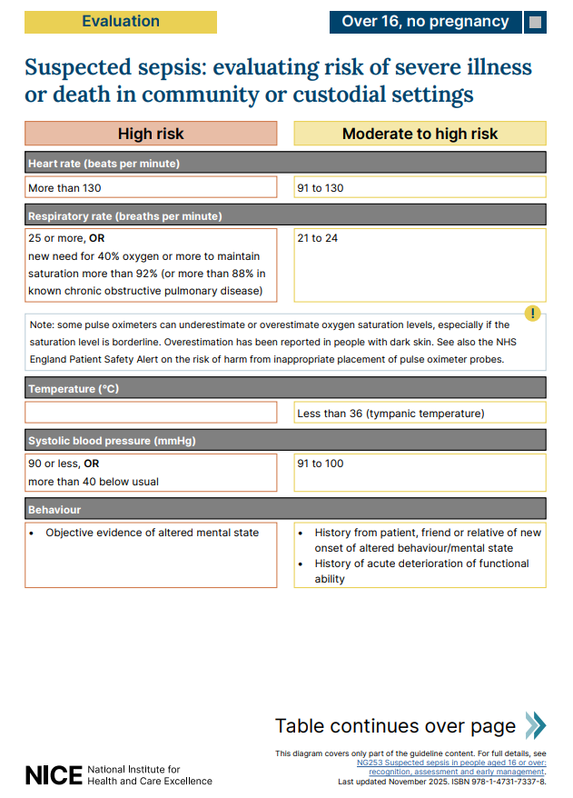
Appendix 1 – Assessing sepsis in community/custodial settings

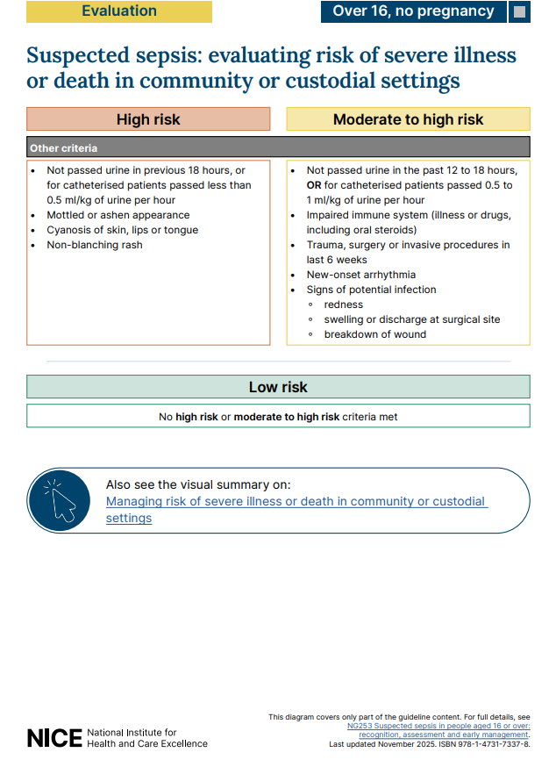
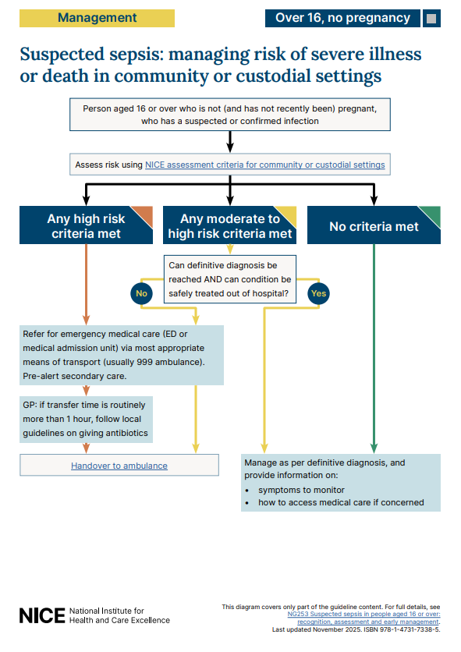
Appendix 2 – Managing sepsis in community/custodial settings

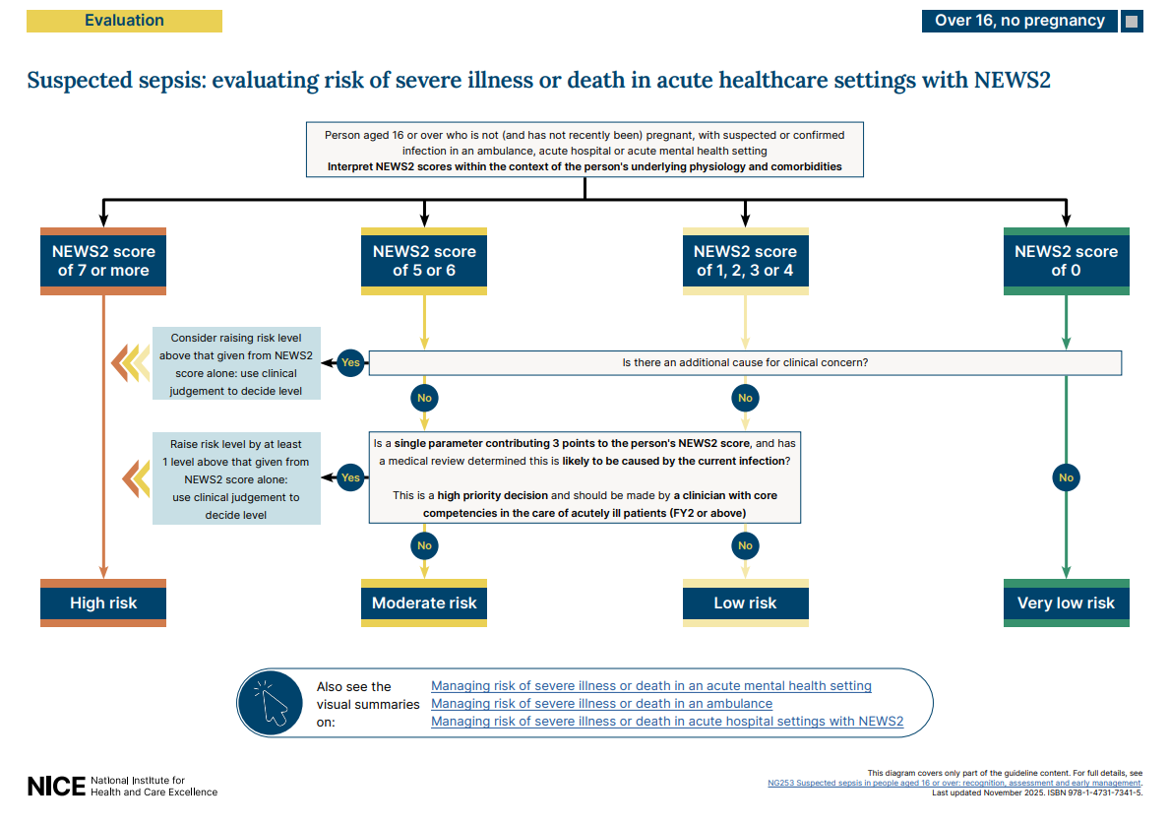
Appendix 3 – Assessing sepsis in acute mental health settings

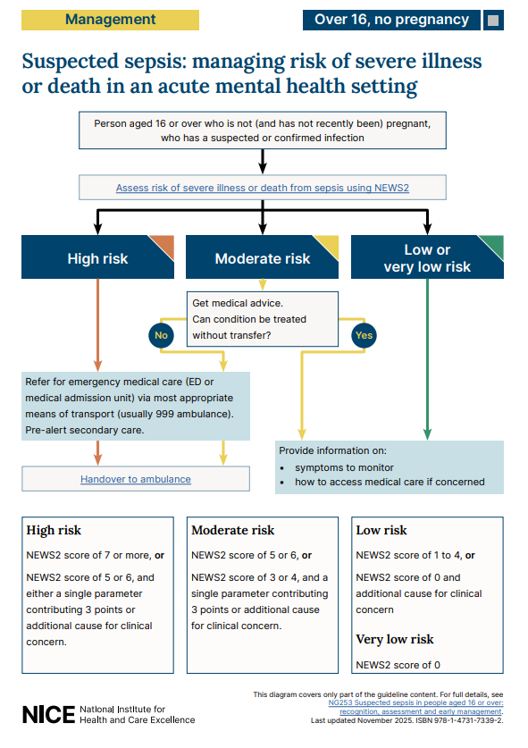
Appendix 4 – Managing sepsis in acute mental health settings
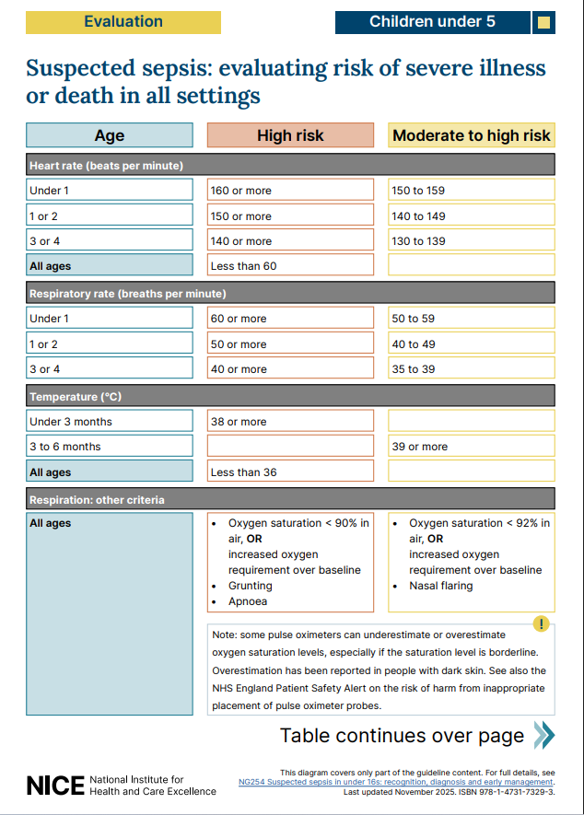
Appendix 5 – Assessing sepsis in children under 5
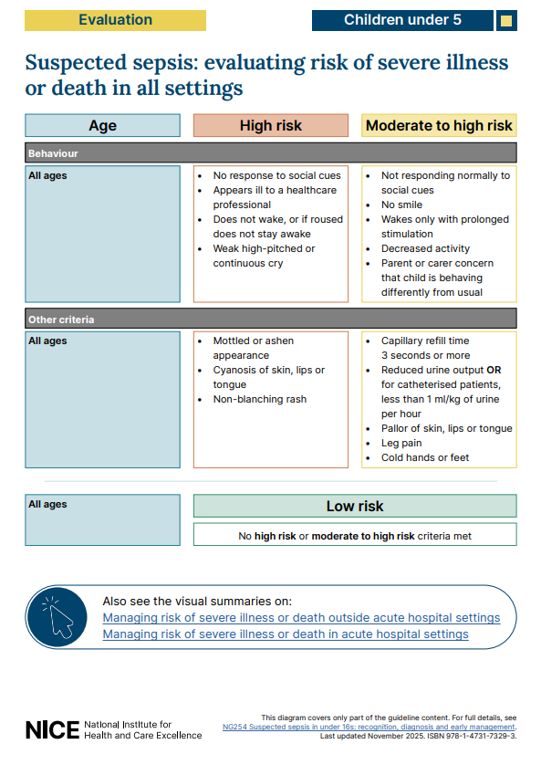

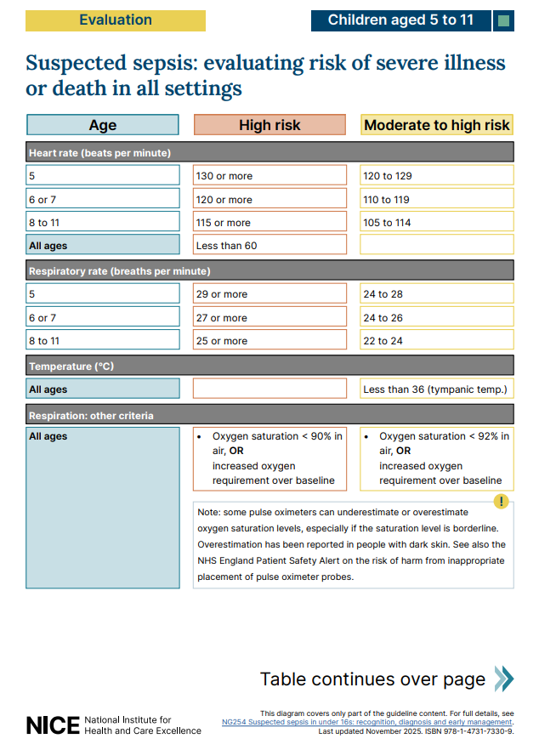
Appendix 6 – Assessing sepsis in children aged 5-11
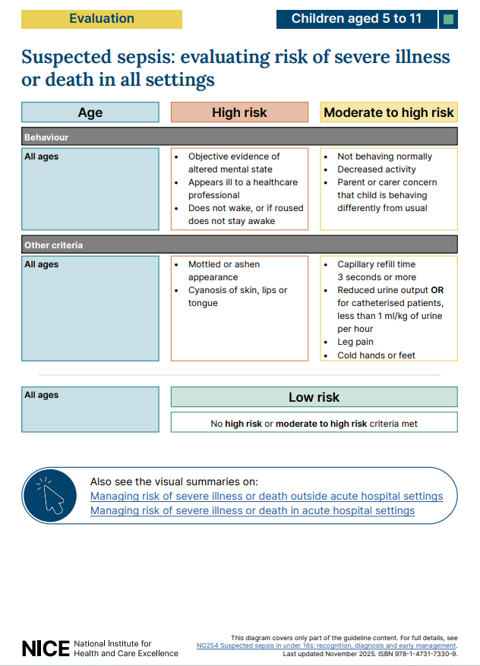

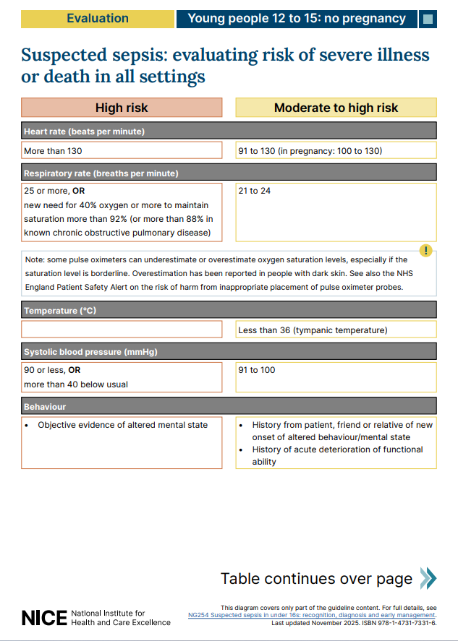
Appendix 7 – Assessing sepsis in young people aged 12-15
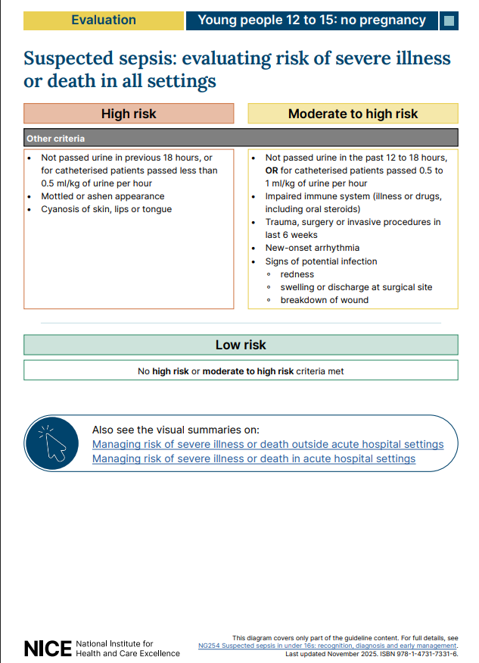

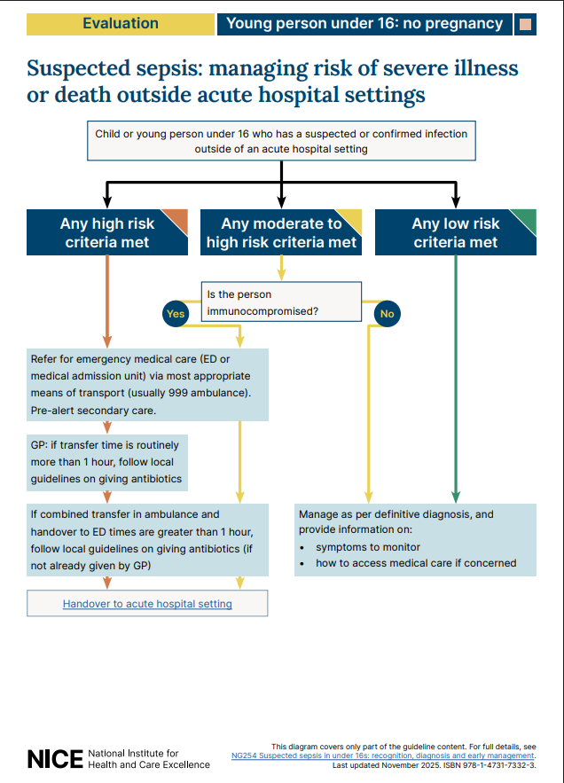
Appendix 8 – Managing sepsis in the young person under 16

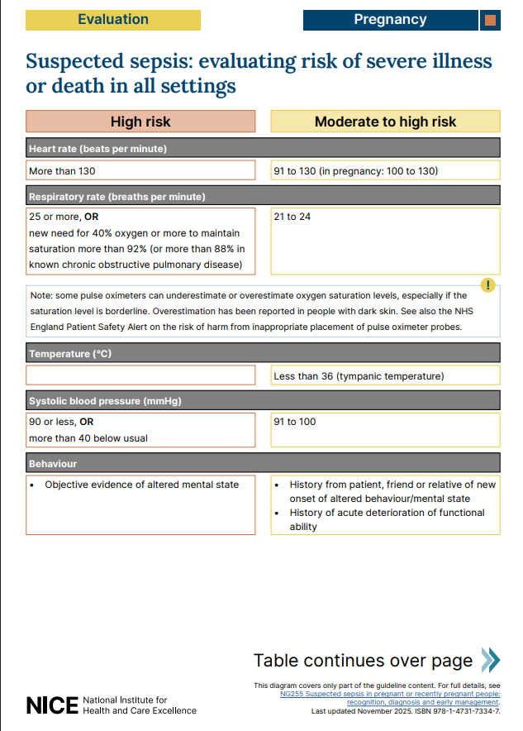
Appendix 9 – Assessing sepsis in pregnant or recently pregnant people

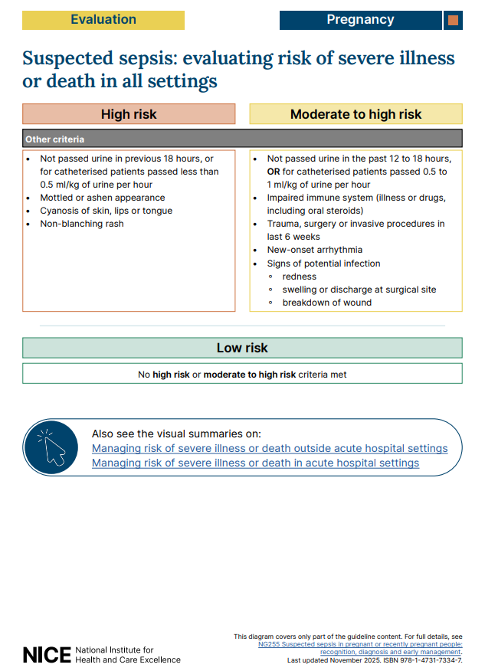

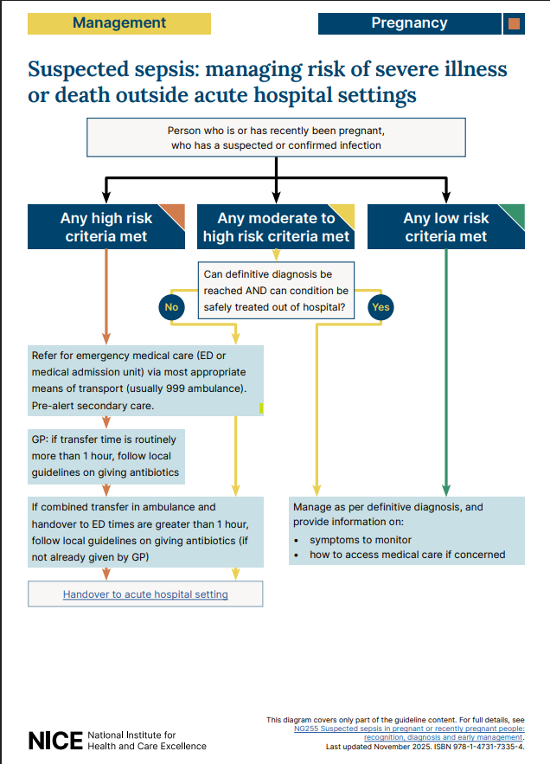
Appendix 10 – Managing sepsis in the pregnant or recently pregnant person

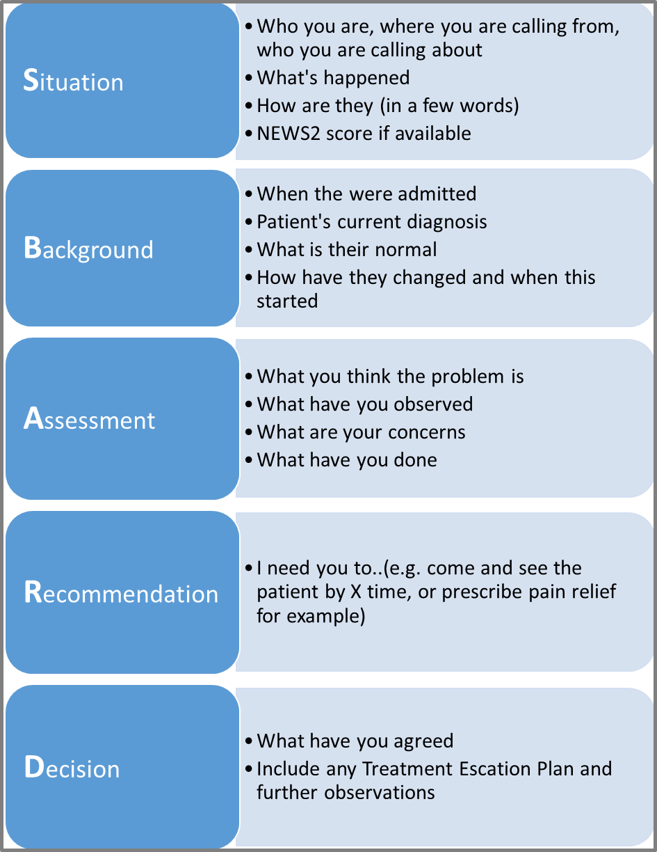
Appendix 11 – SBARD

15. Equality Impact Assessment
Equalities Impact Assessment Question | Yes | No | Always give further information if you answer “YES”
- How does the attached policy/service fit into the Trusts overall aims? | yes |  | The policy will support the aims of the Trust in delivering high standards of effective care adopting current evidence-based procedures.
- How will the policy/service be implemented? | yes |  | The policy will be published on the Trust intranet and will be incorporated into physical health training on the deteriorating patient
- What outcomes are intended by implementing the policy/delivering the service? | yes |  | The intended outcome is that any patient or service user has sepsis, or is at risk of developing sepsis, has their condition recognised and escalated to the appropriate personnel in a timely manner
- How will the above outcomes be measured? | yes |  | Compliance monitoring, incident reporting, audit findings and training compliance data will be reviewed through governance processes.
- Who are they key stakeholders in respect of this policy/service and how have they been involved? | yes |  | Key stakeholders include nursing staff, medical staff, allied health professionals, governance teams, physical health leads, urgent care providers and service user representatives tbc
- Does this policy/service impact on other policies or services? | yes |  | Deteriorating patient policy, Physical health in mental health
- If YES is that impact understood? | Yes
- Does this policy/service impact on other agencies? |  | yes | Transfer checklist  Useful for:  - ambulance handover  - documentation  - observations  - oxygen  - escort requirements  - MCA considerations  Add:  Community-specific escalation examples  Particularly:  - care homes  - lone workers  - prison/custodial settings  - home visits
- If YES is that impact understood? | yes
- Is there any data on the policy or service that will help inform the equalities impact assessment? | yes |  | Recognition of Known Health Inequalities. Evidence demonstrates that deterioration and sepsis may be more difficult to recognise in people with darker skin tones, communication difficulties, learning disabilities, cognitive impairment or social exclusion. This policy seeks to reduce inequity by including specific guidance regarding assessment adjustments and escalation principles.  - darker skin tones  - deprivation  - homelessness  - communication barriers  Extra care should be taken when assessing patients/service users with darker skin tones as some of the most common changes to the skin i.e. pallor, cyanosis, jaundice, redness/erythema are not as easy to distinguish as in those patients with lighter skin tones⁷.
- Are there are information gaps, and how will they be addressed/what additional information is required? |  | No | No Updated in Line with Nice guidance and pathways.
Equalities Impact Assessment Questions | Yes | No | Comment
- Does the policy or service development have an adverse impact on any particular group? |  | No | The policy supports reasonable adjustments through:  - use of interpreters  - carer/family involvement  - accessible communication  - recognition of atypical presentations  - consideration of sensory impairment, autism and learning disability .  - flexible escalation approaches based on individual need
- Could the way the policy is carried out have an adverse impact on equality of opportunity or good relations between different groups? |  | No | The policy seeks to reduce inequalities by:  - promoting escalation based on clinical concern and soft signs, not solely NEWS2  - including guidance on assessment in darker skin tones  - encouraging carer and family concerns to be taken seriously  - supporting use of reasonable adjustments and accessible communication  - recognising atypical presentations in vulnerable groups  - supporting timely escalation irrespective of background or protected characteristic
- Where an adverse impact has been identified can changes be made to minimise it? |  | No | No adverse equality impacts have been identified. Ongoing audit, incident review and governance processes will monitor for any unintended discriminatory impact
- Is the policy directly or indirectly discriminatory, and can the latter be justified? |  | No | This policy aims to improve early recognition and management of sepsis for all patients/service users receiving care within ELFT services.  The Trust recognises that some groups may experience increased risk of delayed recognition or poorer outcomes relating to deterioration and sepsis, including:  - people with learning disabilities  - autistic people  - people with cognitive impairment  - people with communication difficulties  - people requiring interpreters  - people from ethnically diverse backgrounds, particularly where skin assessment may be more complex  - people experiencing homelessness or social exclusion  - pregnant or recently pregnant people  - older adults and young children
- Is the policy intended to increase equality of opportunity by permitting Positive Action or Reasonable Adjustment? If so is this lawful? |  | No | Staff must make reasonable adjustments to ensure equitable assessment and escalation of deterioration, including use of interpreters, accessible communication methods, carer involvement and adaptation of assessment approaches where required

