Mental Health and Wellbeing Resources for Children and Young People

Cancer-related Support and Resources for Young People

Osbourne Trust
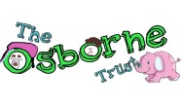
The Osbourne Trust provides support for young people up to the age of 18 with a parent diagnosed with cancer or going through cancer treatment. They offer emotional support for young people and provide support packs for various age groups. They offer practical support, such as local respite.
- Website
- Link to Support Packs
- Referral Form for Osbourne Trust

Hope Support Services

Hope is a registered charity that supports young people aged 5-25 when a close family member is diagnosed with a life-threatening illness, such as cancer. They offer free online one-to-one support via Microsoft Teams or Facebook messenger for young people.
- Website
- Referral Form for Hope Support Services
- Form to complete for MS Teams chat, video or audio call, or email
- Coping with University Life Through a Family Health Crisis

Fruitfly Collective
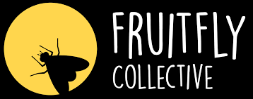
The Fruitfly Collective helps families talk about cancer, death, and grief and support children by providing them with coping tools and the knowledge that they are not alone.
They offer age-tailored tool kits such as arts and crafts, games related to talking about cancer, coping cards, and books about the experience of cancer.
- Website
- Tools

Maggie’s
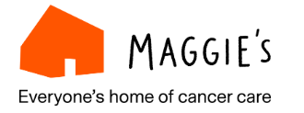
Maggie’s provides information and resources for children, teenagers and young adults affected by cancer and for people supporting them.
- Website

Ruth Strauss Foundation

Charity that provides emotional support for families to prepare them for the death of a parent.
- Website
- Resources for emotional support

National Cancer Institute

When your parent has cancer: A guide for teens

General Mental Health and Wellbeing Services

Bedford Open Door


Bedfordshire Open Door is a counselling service for young people. There is a team of experienced counsellors who offer up to 12 sessions of counselling for young people aged 13-25 for free, who are based in Bedford.

- Website

Bedfordshire Children & Young People Mental Health Resources Padlet
Provides mental health services and resources for children and young people across Central Bedfordshire.
- Website

Young Minds

Young Minds offer tailored information, advice, and support to parents/carers who are concerned about their child or a young person’s mental health. You can speak via phone or chat online.
This service is for parents/carers of children aged 25 and under.
- Website

Bedfordshire Mental Health Services Resources Padlet for Parent/Carers
Provides mental health services and resources for parents/carers of young people who are struggling with their mental health and live in Central Bedfordshire.
- Website

