Milton Keynes Assessment Location Information

What3words: ///frogs.skim.prettiest
You’ll find us here:
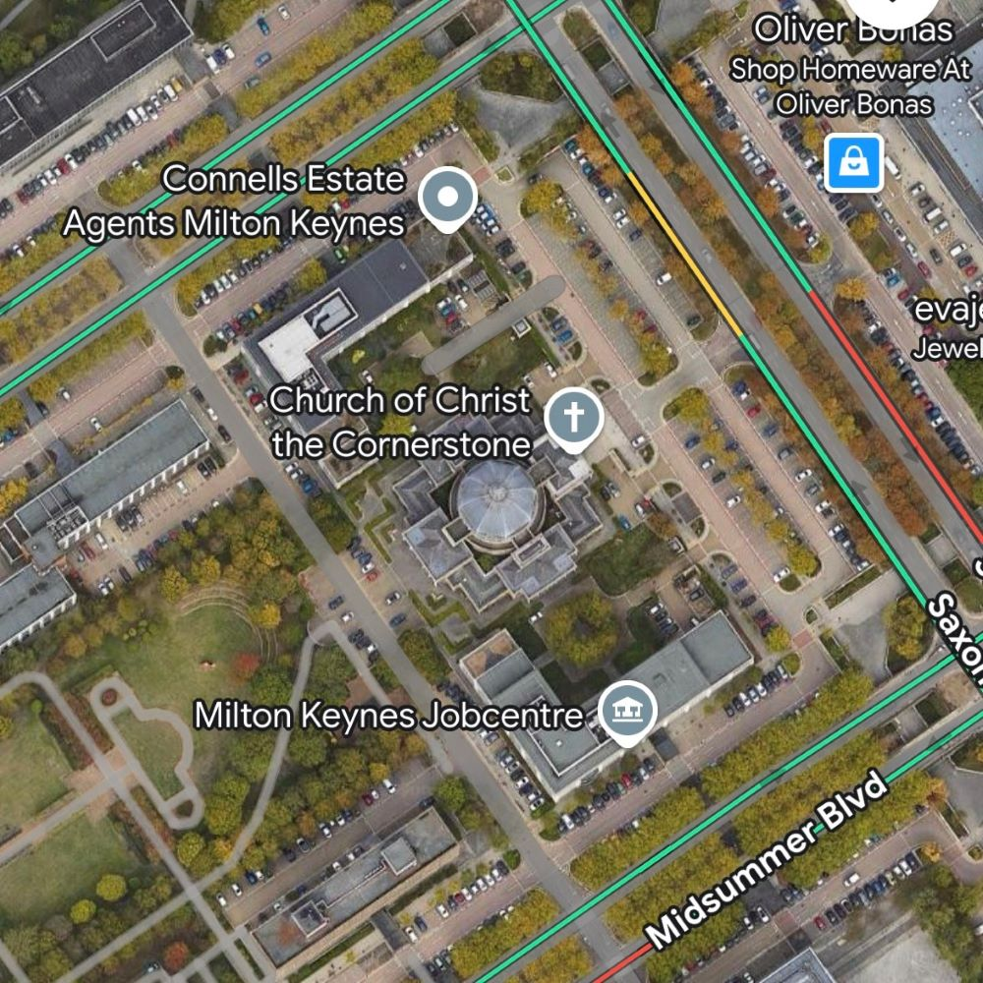
Church of Christ The Cornerstone
300 Saxon Gate
Milton Keynes
MK9 2ES

Parking and Public Transport:
There is a lot of parking directly in front of the church- this is paid parking.
Please note, if you are parking you will need to allocate approximately 2-3 hours of paid parking to cover your assessment period.
There is parking at the back of the church- this is free (see green circle on map) however when you enter the church reception area you will need to put your vehicle registration into the mini computer (staff at the reception can guide you with this). If you park at the back of the church where parking is free, you will need to walk around the side of the church to enter the front of the building.

Entering the building
When you arrive, please enter the building through the main entrance (pictured below). Approach the reception desk and tell them you are here to see ‘ELFT Autism Service and the name of the person you will be seeing. And time of the appointment. They will be expecting you.
Please wait in the waiting area- there are sofas (see below) and a member of the team will come to meet you at the time of your appointment to take you through to your assessment. You do not need to worry about finding your assessment room.
Please bring any items which will support you to manage your sensory experiences, e.g. headphones, sunglasses, fidget toys. Please do bring your own drinks, but do not bring food.

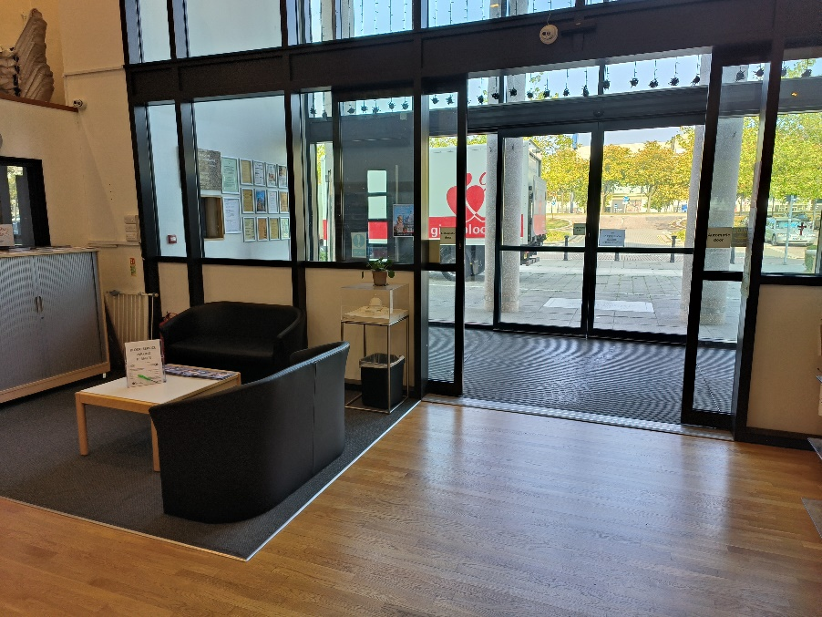
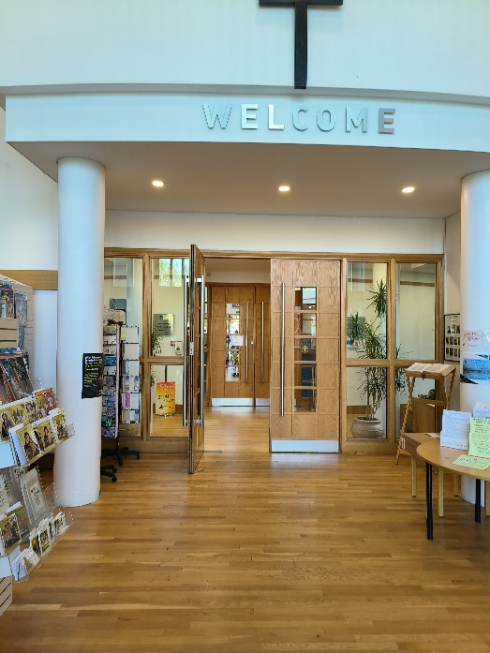

Toilets
There are toilets at the Church. Please ask if you need to use the facilities and staff will direct you.

If you have any concerns or queries, or you wish to discuss additional reasonable adjustments, please contact us via email at elft.blmk.autism.service@nhs.net or call us on 01234 310593.

