Bedfordshire & Luton Community Eating Disorder Team
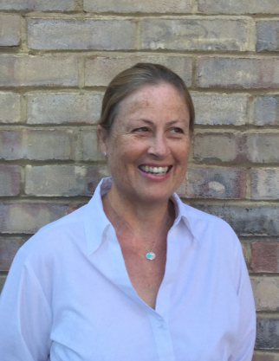
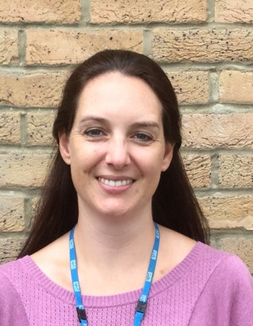
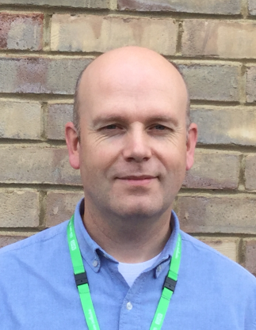

Sarah Fuller Lorraine Jewell Steve Littlewood
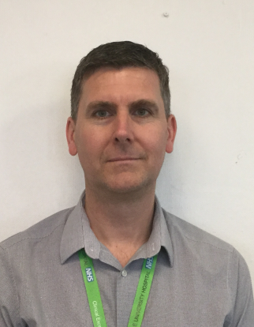
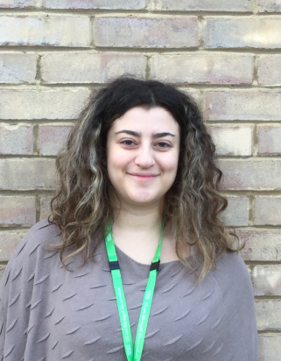
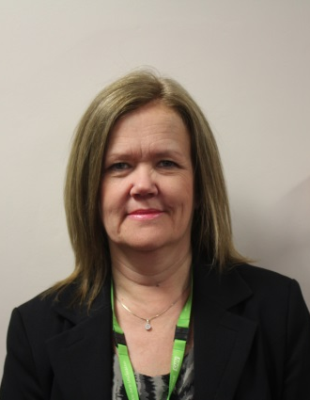
Eating Disorders Dietician Consultant Clinical Psychologist Family Therapist

Linda Hurst Valentini Spyridou Mark Taylor
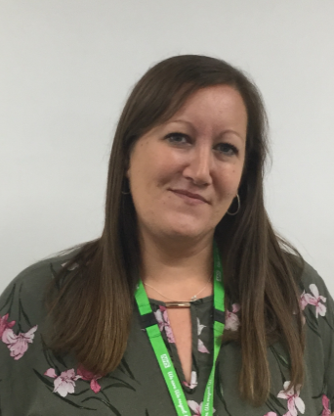
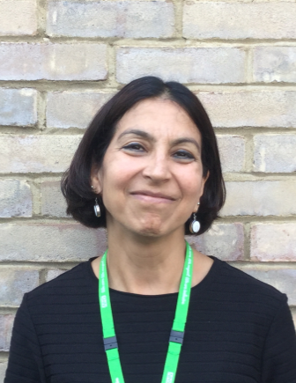
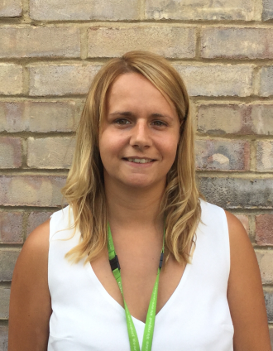
CAMHS General Manager Assistant Psychologist Eating Disorder Nurse

Sammie Skinner Renu Daryanani Nicole Altenbach
Eating Disorder Nurse Consultant Child & Adolescent Team Administrator
Psychiatrist

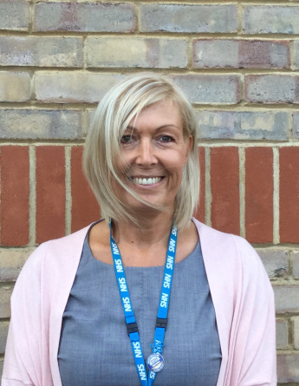

Kate Williamson
Eating Disorder Nurse

