When does my child need to see a physiotherapist?
- If the toe walking causes pain.
- If toe walking is only on one leg.
- If your child cannot get their heels down when standing or walking (with or without you asking them) and you have tried the stretching exercises in this leaflet daily for two months.
Please contact our Service to arrange an assessment:

West Ham Lane Health Centre
84 West Ham Lane
Stratford
E15 4PT
Tel: 0208 586 6380
For Compliments, Comments and Complaints, please contact the Patient Advice and Liaison Service (PALS):
FREEPHONE 0800 783 4839
Email: elft.palsandcomplaints@nhs.net

Toe Walking in Autism

Many children walk on tip toes and this can be a normal part of their development.
It is common for children of 10-18 months to walk on tip toes when they are learning to walk as it can help with their balance. Some children can continue this up to the age of 6-7 years where it usually resolves naturally; however a small number of children may continue to walk this way as they get older.
It is reported that around 1 in 5 children with autism walk on their tiptoes.
There are a number of reasons a child with autism may walk on their toes. These include:
Sensory difficulties
A child with autism could experience anxiety or discomfort feeling certain areas of their feet touching the ground or to increase their body awareness to make themselves feel more secure or alert.

Vestibular difficulties
Vestibular has to do with balance, movement and coordination. This difficulty can cause the child to move their weight forward over their toes, encouraging toe-walking.
Walking on tip toes generally does not cause the child any pain or discomfort and it does not usually result in any type of deformity. Children are able to walk, run and jump on their toes without any problems; as long as their calf muscles are flexible but may tire easily.
To help calf muscles stay flexible:
- Encourage and remind your child to keep their heels down.
Pictures used from www.physiotherapyexercises.com

- Supportive footwear:
- High ankles shoes/boots fastened tightly will hold a child’s foot in the shoe and provide some sensory feedback to help them walk with their heels down
- All children’s shoes should be fitted to correct length and width
- Shoes with lights on the heels may be good prompts for heels down
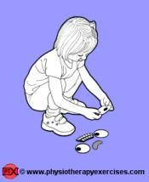
- Don’t worry if your child goes back onto tip toes when bare foot

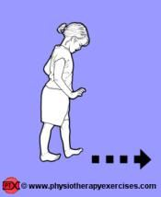
- Activities to help stretch the calf muscles
- Lots of games that encourage squatting with your child’s heels down
- Penguin walking on their heels (with toes up in the air), walking up slopes with knees straight and heels down.

- Stretches: These can help with flexibility while they are still growing.
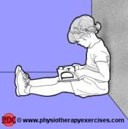
Encourage your child to sit with their back against a surface and legs our straight. Aim to sit for 15 minutes. A stretch should be felt at the back of the leg.

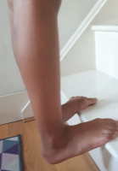
Stand on a step or a large book with your heels over the edge. Slowly lower your heels down until a stretch is felt at the back of the leg. This can be done whilst brushing their teeth in the bathroom using the basin for support if needed.

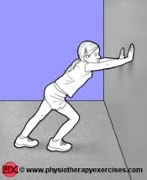
Stand with your arms on a wall and one leg in front of the other. Bend the front knee and keep the back leg straight. Make sure both heels are down. A stretch should be felt at the back ankle. Hold for 20 seconds and repeat three times on each leg.

