When does my child need to seek additional help?
Your child has been assessed by a Children’s Physiotherapist and you have been reassured that there are no concerns. If your child however experiences swelling of a joint, severe pain, changes in skin colour and/or sensation; please seek advice from your GP. A new referral can be made to our Service if needed.
If your child is having problems with activities of daily living, a referral to an Occupational Therapist may be helpful.

West Ham Lane Health Centre
84 West Ham Lane
Stratford
E15 4PT
Tel: 0208 586 6380

For Compliments, Comments and Complaints, please contact the Patient Advice and Liaison Service (PALS):
FREEPHONE 0800 783 4839
Email: elft.palsandcomplaints@nhs.net

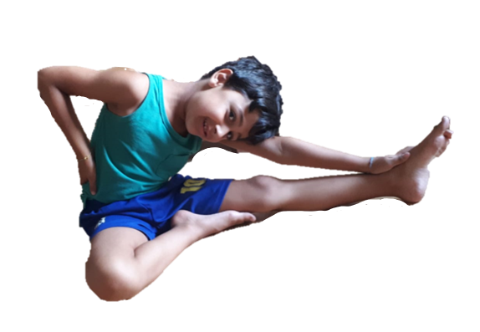

Bendy Joints

Children with ‘bendy joints’ have more movement around their joints.
Find out what the symptoms are and how you can help.

All joints have varying ranges of movement. Ligaments and muscles provide a joint with stability and movement, and receptors in the joints inform us of our position in the environment.
Possible Symptoms
- Fatigue: Children may gain fatigue in a specific joint or muscle because joints are working extra hard or a general overall fatigue due to increased effort to perform activities. This is a sign that the body needs more fitness training and pacing of activities.

- Pain: Increased range of movement can lead to pain around joints, which suggests that the body is not strong enough to do the task.

- Co-ordination: The receptors that tell us the position of our bodies when we cannot see are in our joints. When there is too much movement around the joints, the receptors do not get the same messages as when there is less movement. As a result your child may have poor co-ordination and difficulties with daily activities such as getting dressed.
As a child develops and becomes more active, bendy joints generally become stronger and pain decreases, co-ordination may improve and your child may be less tired. Many children who are flexible experience no symptoms or difficulties; and being flexible is beneficial in a lot of sports.
What can I do to help?
- Strengthen: Encourage regular participation in normal everyday activities and play such as:
- Swimming - Soft Play Areas - Park
- Riding a bike - P.E - Sports

Note: They may need to avoid trampolines and bouncy castles.
- Pain management: Aches and pains associated with bendy joints are usually a result of muscle fatigue, not damage or injury. A warm bath or a hot water bottle may help. Pain killers are not usually effective. Try not to focus on pain and distract your child from dwelling on it. Avoid prolonged periods of rest as this makes muscles weaker.

- Pacing: If muscle pain after exercise is a problem, pacing activities may help. Keep your child active! Pacing means to gradually increase an activity in order to achieve a goal. Do not do too much activity on one day but spread it throughout the week and focus on building more strength and fitness.

- P.E: Unless told otherwise your child should participate as much as they can in P.E as this will help keep joints strong to reduce pain. Avoid unnecessary high impact sports if a child is experiencing discomfort.

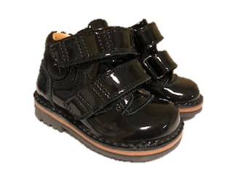
- Supportive footwear: All children benefit from supportive footwear, especially if they have flat feet. When you are buying shoes look for the following:
- Shoes which are stiff around the heel;
- A sturdy sole to act as a shock absorber;
- Soft uppers, preferably with laces or buckles, that support the whole foot;
- Boots that fasten with laces are often very effective and comfortable.

