If you are still concerned having read the leaflet, please contact us to arrange an appointment for further advice and assessment.

West Ham Lane Health Centre
84 West Ham Lane
Stratford
E15 4PT
Tel: 0208 586 6380

For Compliments, Comments and Complaints, please contact the Patient Advice and Liaison Service (PALS):
FREEPHONE 0800 783 4839
Email: elft.palsandcomplaints@nhs.net

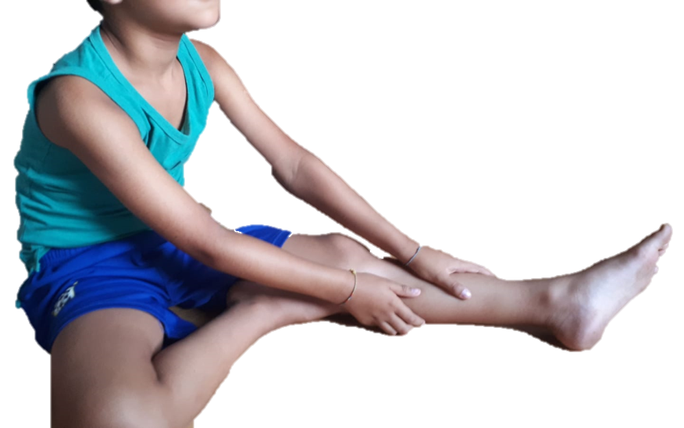

“Growing Pains”

“Growing pains” are common in children and occur mainly in the legs. They are harmless, but can be very painful.
Find out how to help your child through these challenging times.

Growing pains usually start in early childhood, around age 3 or 4. They tend to strike again at age 8 to 12. Growing pains can come and go. They may be experienced for months or even years. Most children outgrow growing pains within a few years.
There is no firm evidence that growing pains are linked to growth spurts. Growing pains may simply be muscle aches due to intense childhood activities (running, jumping, climbing) that can wear your child's muscles out. Growing pains seem to be more common after a child has a particularly full day of sports.
Growing pains are different for everyone.
Symptoms of Growing Pains
- Pain is often felt in both legs, especially in the front of the thighs, back of legs, or behind the knees;
- Pain is felt in the muscles and not the joints;
- Pain is usually felt in the late afternoon and evening; right before dinner time and at bedtime;
- Your child may wake during the night with pain;
- The pain disappears in the morning;
- Pain is more common in active children.
What can I do to help?
- Massaging the legs;
- Stretching the leg muscles;
- Placing a covered hot water bottle on the painful area;
- Warm bath before bedtime;
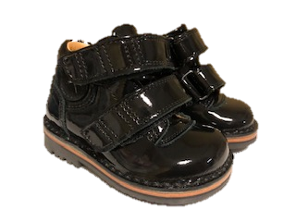
- Encourage them to wear supportive footwear during the day;
- Reassurance – this will help to calm the child and take their mind off the pain;
- Simple pain analgesia may help ease any pain – speak to your Pharmacist for advice.
When does my child need to see the GP?
- The pain carries onto the next morning;
- The pain is in a joint, such as their knees or ankles;
- There is a rash, swelling or unusual bruising on the legs;
- Your child has a high temperature;
- Your child does not want to eat or is losing weight.
When does my child need to see a Physiotherapist?
- Your child has weakness in the legs.
- The pain is only in one leg.
- The pain is bad enough to stop your child walking or makes them limp.

Pain Scores

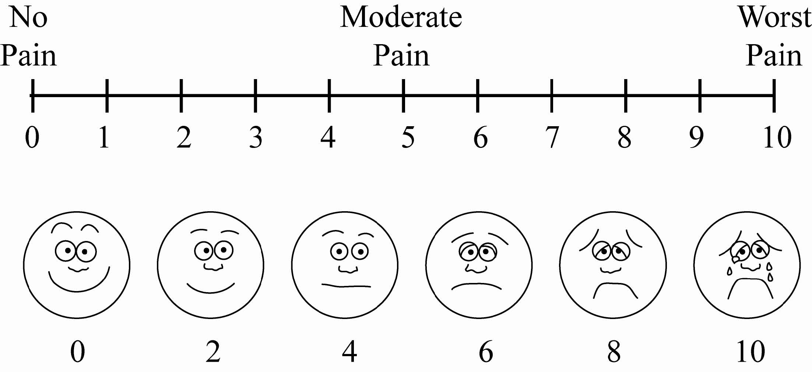
Sometimes children find it difficult to explain how much pain they are in. To work out how high you child’s pain is or if it is becoming worse you could use the pain scores below:

