NeuroDevelopmental Team
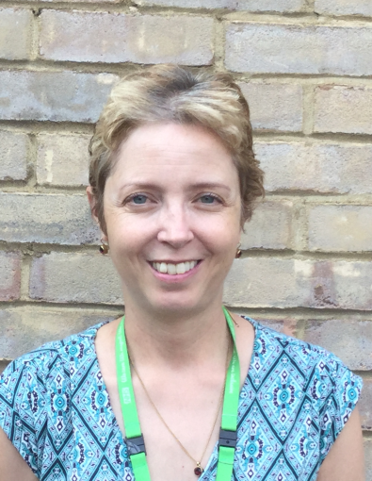
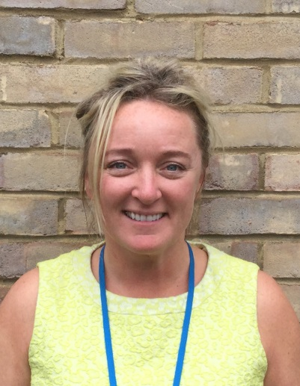

Professor Frank Besag Jo Meehan Alex Harborne
Consultant Neuropsychiatrist CAMHS General Manager Psychological Therapies
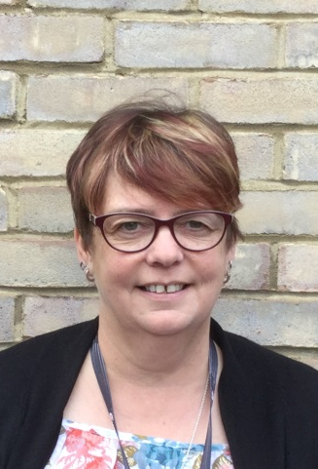
Clinical Team Lead Lead

Bev Edwards Nickie Croft Annette Hawtin
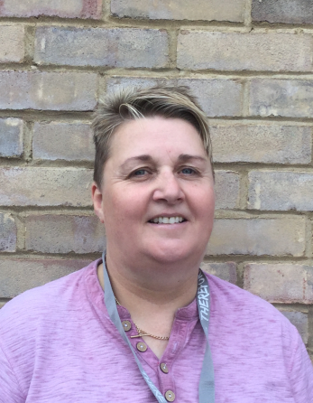
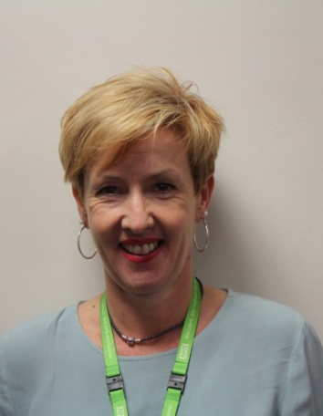
Lead Community Nurse Senior Community Nurse Team Administrator

Niki Scott Joe Hunt
Service User Participation CAMHS School Practitioner

