Bedfordshire Eating Disorder Team
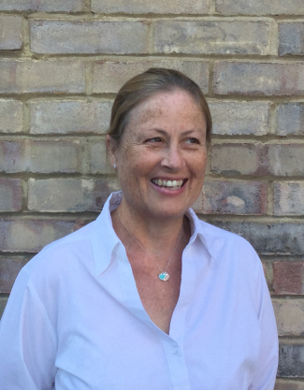
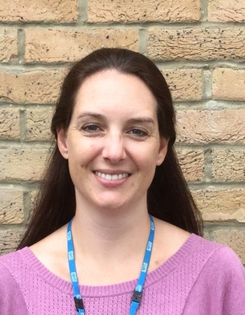

Sarah Fuller Lorraine Jewell
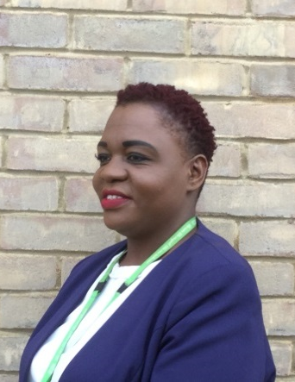
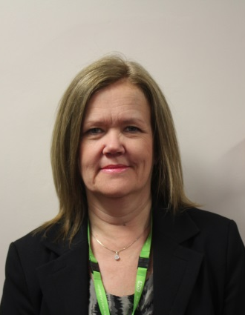
Eating Disorders Dietician Consultant Clinical Psychologist

Linda Hurst Stella Makoni
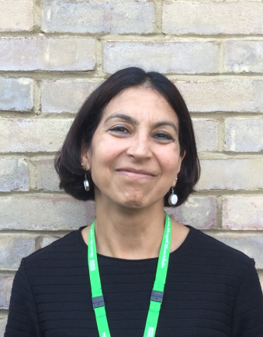
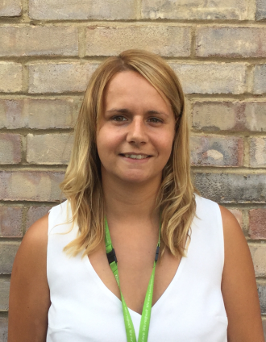
CAMHS General Manager Lead Eating Disorders Nurse

Sammie Skinner Renu Daryanani
Specialist Eating Disorder Consultant Child & Adolescent
Nurse Psychiatrist

