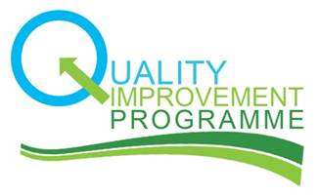

ELFT QI Scale Up & Spread Checklist - Are you ready to spread?
As more of our teams use QI and see improvement in outcomes, the question of ‘spread’ is coming up frequently. It is difficult to spread successful improvement initiatives and maintain the effect size in other settings. Without careful thought and planning, the gains made in the test ward/team will not be replicated.
What do we mean by ‘sustainability’, ‘scale up’ and ‘spread’?
Sustainability is ‘when new ways of working and improved outcomes become the norm.’ In other words, it is when an improvement has become an integrated and the mainstream way of working. It should withstand challenge and variation over time, through a process of continuous improvement’. | Scale Up is the process by which new working methods are tested by an increased number of teams, to increase degree of belief they work, overcoming system/infrastructure issues that arise. | Spread is ‘when best practice is disseminated consistently and reliably across a whole system and involves the implementation of proven interventions in each applicable care setting’.

Below is a checklist to see if you’re ready to think about scale up or spread:
Are you seeing sustained improvement in your test unit?  (improvement in your outcome measure that has been sustained, the changes have become ‘business as usual’ and no further tweaks are being made) | Yes | No
Can you clearly describe the components of the change package that you have implemented? | Yes | No
Does the change represent doing something differently, rather than just doing something better? | Yes | No
Can the changes be packaged in a way that can be easily understood and tested by adopters? | Yes | No
Do you have the relevant documentation to support the work undertaken?  (driver diagram, measures and data as time series analysis, PDSA documentation, flow charts, policies and procedures to support implementation etc.) | Yes | No

If you can answer yes to all of the above, then your project may be ready to considered for spread.
Please download the ELFT QI Spread Planner and Seven Spreadly Sins to help you plan how to spread your project to other settings.
NOTE: Any spread effort needs leadership approval (spread within a directorate needs DMT sign-off, spread across directorates need executive sign-off) as part of the Spread plan.

